D

July 2026
LEAGUE OF WOMEN VOTERS OF CITRUS COUNTY
Vicky Iozzia is the Editor of this newsletter. Our mailing address is LWVCC. P. O. Box 1903, Lecanto, FL 34460 Our website is lwvcitrus.org Our email address is lwvcc2013@gmail.com
On July 8, 2026, our speaker will be Dr. Don Wright, author of The Invading Sea. Candidates for the Florida House of Representatives, JJ Grow,Tod Cloud, and Mark Baker have been invited to a meet and greet.

See Page 7 for upcoming events.

Please visit our Facebook page and "like" us! https://www.facebook.com/leagueofwomenvotersofcitruscounty
We want to thank the following businesses for their cooperation: FGE Printing, Citrus County Chronicle, Pinnacle Printing
THANK YOU TO ALL OF THE BOARD MEMBERS WHO DO SUCH A GREAT JOB EVERY MONTH CONTRIBUTING
TO THIS NEWSLETTER! THANKS TO ALL OF YOU WHO READ THIS. YOUR COMMENTS AND SUGGESTIONS ARE WELCOME!

Table of Contents, July 2026

July calendars Pages 3 and 4

July 4 Event – Wave your American flag Page 5

July 8 meeting, Don Wright, Fl house candidates Page 6

Upcoming meetings Page 7

Restoration of Rights July 25 Page 8

Celebrate America 250! Please donate Page 9

Linda Abels Pages 10 to 11

Vicky Iozzia Page 12 to 13

June 17 Zoom – Health Department Pages 14 to 15

Outreach-Nature Coast Community Band Concerts Pages 16 to 17

Peg Primeau Page 18

Rosemary Nilles Page 19

County Commissioners and Meetings Page 20

Elected Officials Page 21

From Mo Baird, Supervisor of Elections Pages 22 to 29

Speakers Bureau Pages 30 to 31

Cattle Dog Social Page 32

African American Read In Page 33

Dr. BJ Ezell Page 34

In the News Pages 35 to 39

Maxine Connor Pages 40 to 45

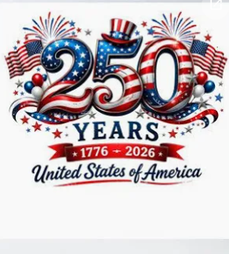

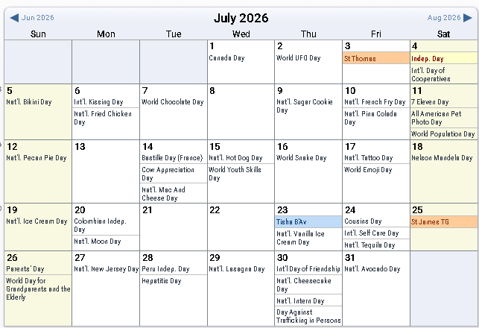
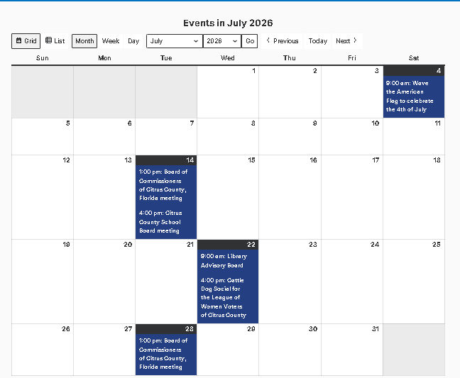
HAPPY JULY EVERYONE!

This calendar is from our website: Lwvcitrus.org
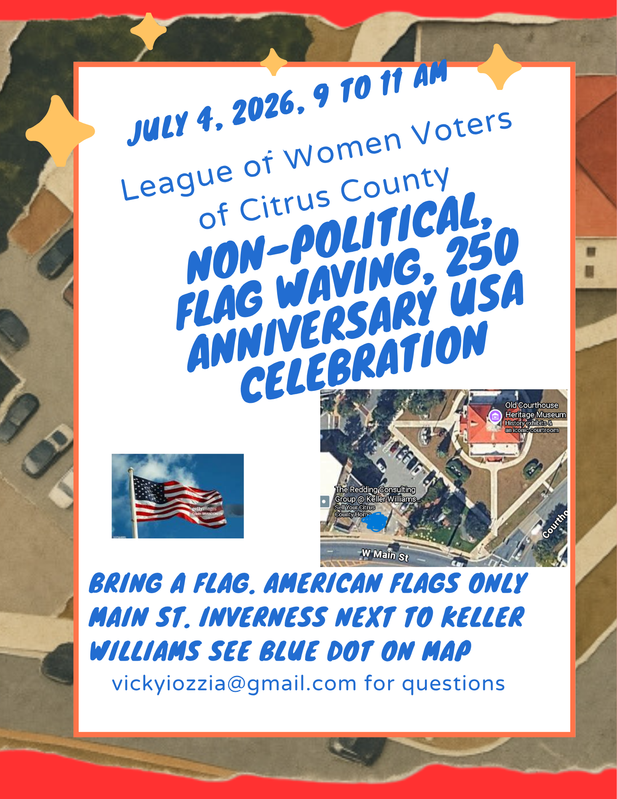

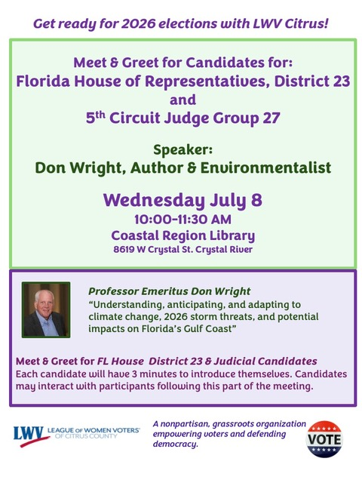

We will have
a celebration of 250 years of the USA
at the Coastal Region Library
on Saturday, August 8,
from 9:15 to 11:15.

There will not be a general meeting on August 12.
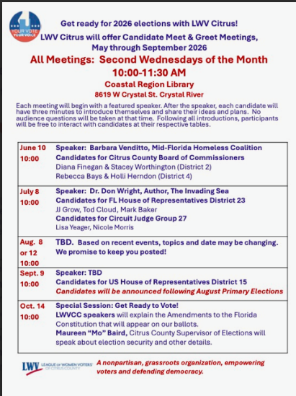

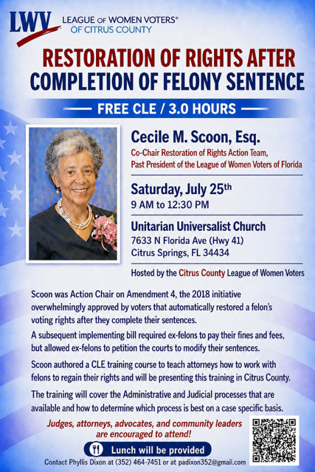

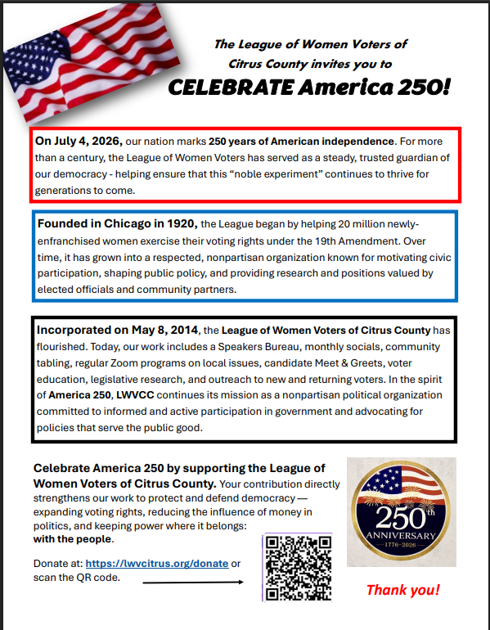

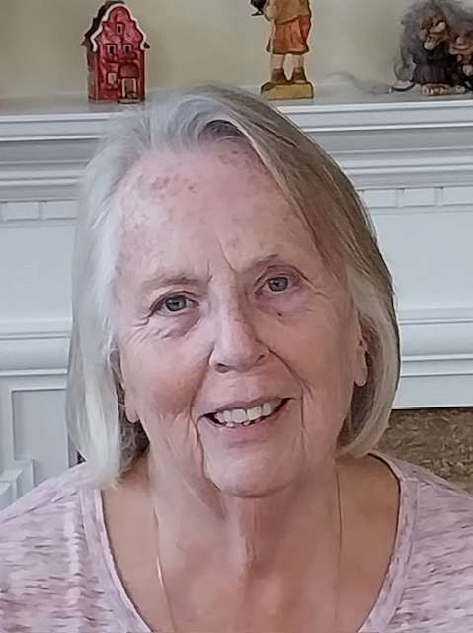

Linda Abels, 2nd Vice President, Membership Chair

Why LWV Membership Matters This July

First, let’s welcome new members, Kelli Parks, Debbie Manning and Denise Myhre. Please introduce yourself to our new members at our next meeting.

As we enter the heart of summer, it’s a wonderful time to reflect on what makes our community thrive: engaged, and informed citizens. That is exactly what the League of Women Voters (LWV) is all about.
Whether you’ve been a member for decades or are brand new, your voice is vital to our mission of empowering voters and defending democracy.

LWV membership is about active participation in our democracy. Together, we:
- Educate: Provide the clear, nonpartisan information our neighbors rely on through educational forums and ballot breakdowns.

- Advocate: Stand together for transparent government, fair representation, and policies that serve the public good.

Beyond the work, the League connects you with passionate, like-minded individuals. Our meetings and committees are where ideas turn into action and lasting friendships are formed. By participating, you become part of a powerful network driving real progress.

Democracy works best when everyone participates. This month, we challenge you to invite one friend, neighbor, or family member to see what the League is all about.

Pass It On: Bring a guest to our next presentation or share this newsletter with someone ready to make a difference.
Thank you for your continued dedication to keeping our community informed, fair, and engaged!

Have a wonderful July,
Linda

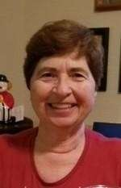

Vicky Iozzia, 1st President, Newsletter Editor,
Webmaster, Speakers Bureau Chair

Sometimes I go to write for this newsletter and the words just pour out. Other times, not so much. Such is this month. The following are my observations and opinions on what is happening in the world now.

The League of Women Voters was founded to get women the right to vote. After that was attained, the League worked to get voters registered. A law in Florida has stopped us from registering voters. The present administration labeled it “harvesting” votes, and if there is a mistake on a paper registration, the person who helped the m register can face a fine up to $250,000.

In our State and in the country, the constitution is being ignored. Examples: there is a part of the Florida constitution, overwhelmingly passed by voters in 2010, that says: “Districts cannot be drawn with the intent to favor or disfavor a political party or an incumbent. They also cannot deny racial or language minorities the equal opportunity to participate in the political process or diminish their ability to elect representatives of their choice.” Ignoring this and timed so that it would be too late to fight (I was told this by an elected official), districts were gerrymandered so that Democratic districts just disappeared.

In our entire country, laws are being flouted by an individual who has done whatever he wants his whole life, and no one has stopped him. He has ruled by executive order without any pushback from his party. Where has our democracy gone?

I watched a show on Netflix recently, with Brian Williams interviewing Tom Hanks. Tom said, “There’s no arguing with crazy no speaking to stupid, and no law against ignorance.”

For how long will we put up with the crazy things coming out of the most powerful people in the world? When will the pushback happen so that we can have a sane world again where laws are followed and the government exists to help the people, not to steal from them?

Now I am watching and reading about people demanding that the data center not be built in Citrus County. I have never seen such political involvement in the 31 years I have lived here. Don’t get me wrong, I think the involvement is great, but I also have to think, where are these people when the other important issues are being decided? Are they okay with what is happening?

At the League we encourage people to vote. That’s as it should be, not the way people are being disenfranchised now. However, in my opinion, people should know what they are voting for. How many people take the time to study the issues so that they know what they are voting for? Do they just listen to sound bites, or go by what “someone” says?

In the last newsletter I wrote about how important outreach events are to us.

The Nature Coast Community Band has scheduled their performances through June, 2027. We will be making and publishing a list of events where we would like to have a table, so that our members can plan to participate. Stay tuned.

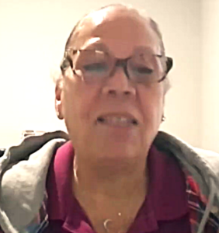

League of Women Voters of Citrus County Presentation on Zoom, June 17, 2026

On June 17 the League of Women Voters of Citrus County had the pleasure of hosting a zoom meeting with Carmen Hernandez, Administrative Services Director of the Citrus County Health Department. The theme of the meeting was “I’ll bet you will learn something about the Health Department that you didn’t know.”
Carmen delivered a thorough, informative presentation on the various aspects of the Health Department and how they serve the community.
She outlined the funding sources, which include State, Federal, County, and Medicaid. We think about the Health Department working to prevent communicable disease control, but they also help keep us safe by monitoring animal bites (which have risen over 400% since 2022), doing inspections of septic systems, and monitoring biological waste. They also inspect tattooing parlors and public swimming pools.
Did you know they have drowning prevention classes with vouchers for those who need financial assistance? They also have classes to help with diabetes and balance issues, programs for maternal and infant health, and can provide and instruct on infant car seat safety.
The Health Department also distributes Narcan nasal spray free to prevent drug overdose deaths. They provide a special needs shelter for those who need it during storms. People born in Citrus County can get birth, death, marriage, and divorce certificates for a fee.

To quote Carmen, “We want to hear from you. We want community involvement. It’s so important because we can’t sit and complain about something that we are not willing to stand up for. If there are things going on in our community that we want to know more about or that we want to have more active participation, Get Involved. Ask the Questions.”

You can watch this https://www.youtube.com/watch?v=G5pLaIeoFIg

Nature Coast Community Band Concerts, June 27 and 28
I received a call from Judy Williams, President of the Nature Coast Community Band. She asked if we wanted to have a table at the concerts they present. They had concerts Saturday, June 27, at the Citrus Springs Community Center, and Sunday, June 28, at Seven Rivers Church.
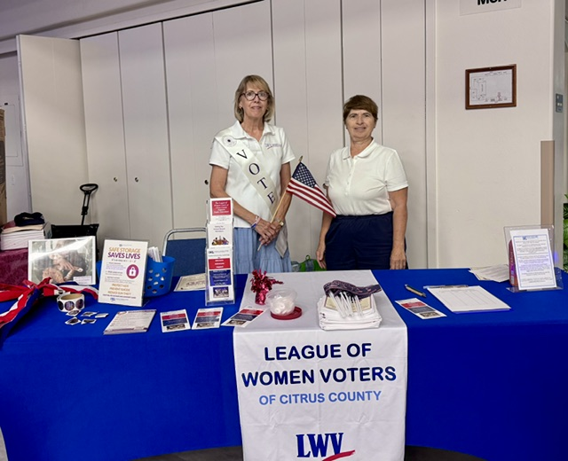
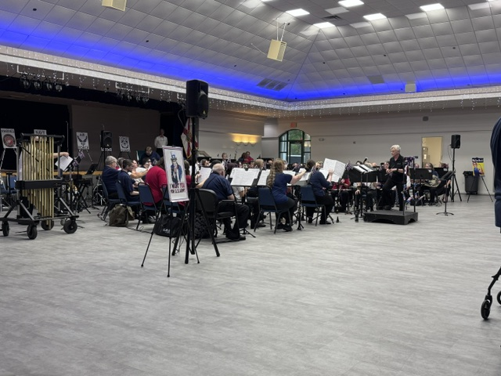
Peg Primeau and I attended the June 27 concert. What a treat! I didn’t even know that this group existed. The program was all patriotic songs. It was well attended and the performers were excellent.
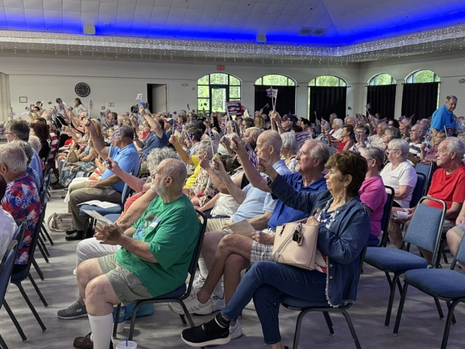
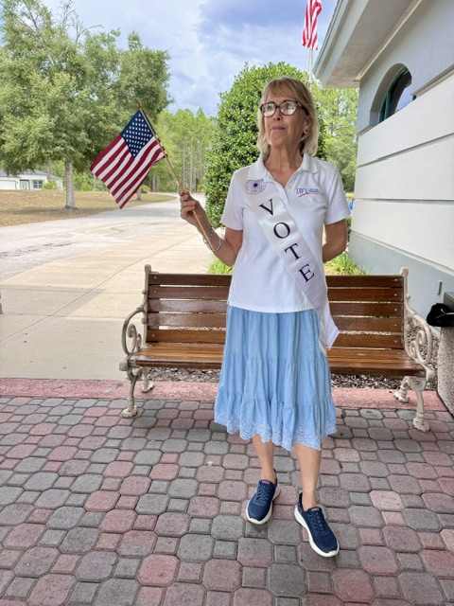
Peg waved the flag welcoming everyone, and the audience enthusiastically waved during the last song.

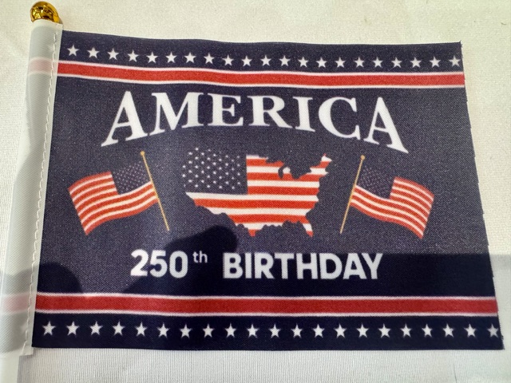
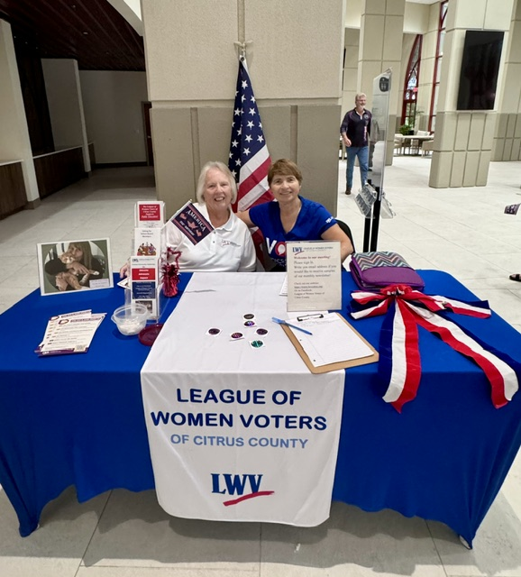
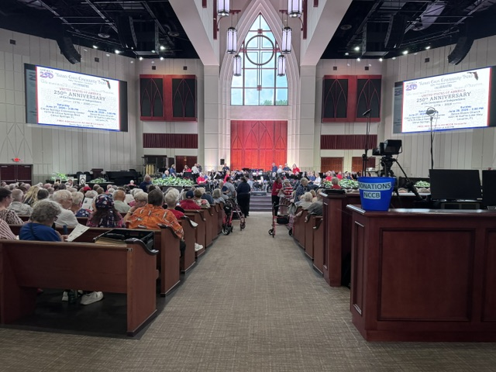
On Sunday, June 28, Linda Abels and I went to the concert, this time at Seven Rivers Church.

Peg Primeau, 2nd President, Treasurer
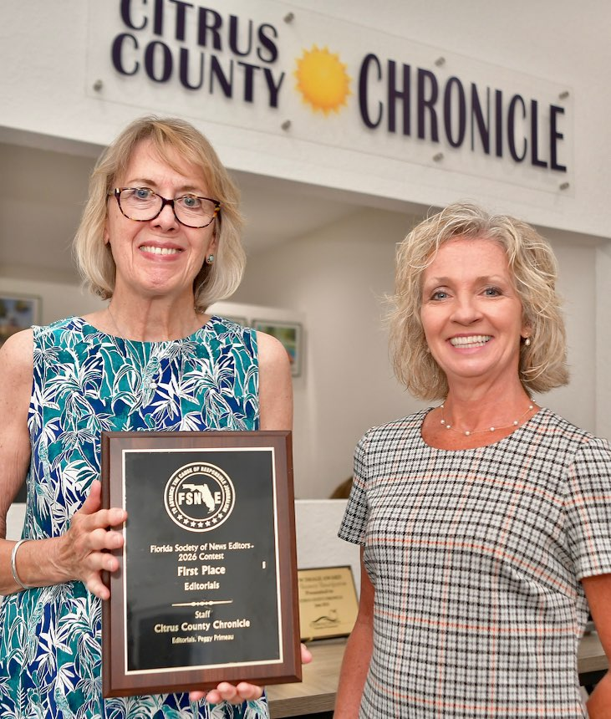

Photo by Matthew Beck

This bears repeating: Here is Peg Primeau, who is on the Editorial Board of the Citrus County Chronicle, receiving her award from the Florida Society of News Editors.

First Place for Editorials. So proud of you, Peg!

The photo is with Trina Murphy, Citrus County Chronicle Publisher.

Rosemary Nilles, 1st Vice Pres, Education, Education Chair, Gun Safety Chair
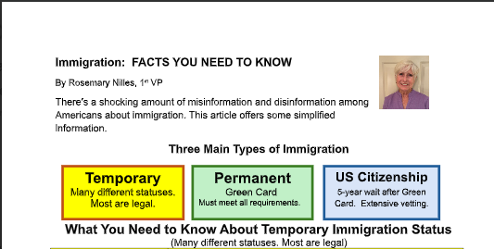

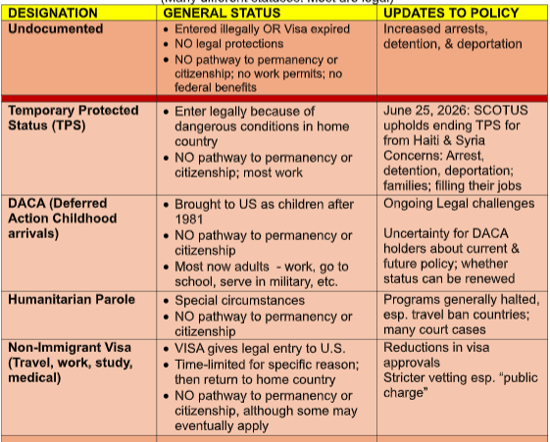

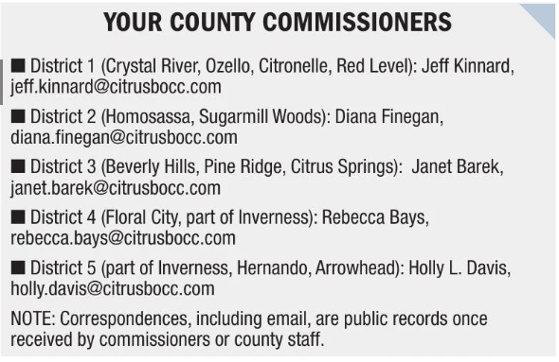

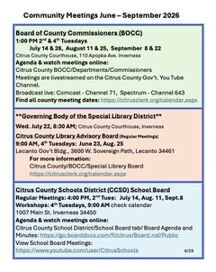

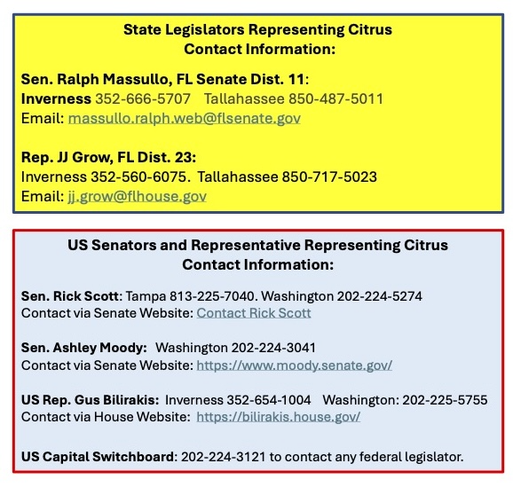

From our Supervisor of Elections, Maureen “Mo” Baird

Did you receive a mailing like this recently? If not you might not be registered. Contact the Supervisor of Elections.

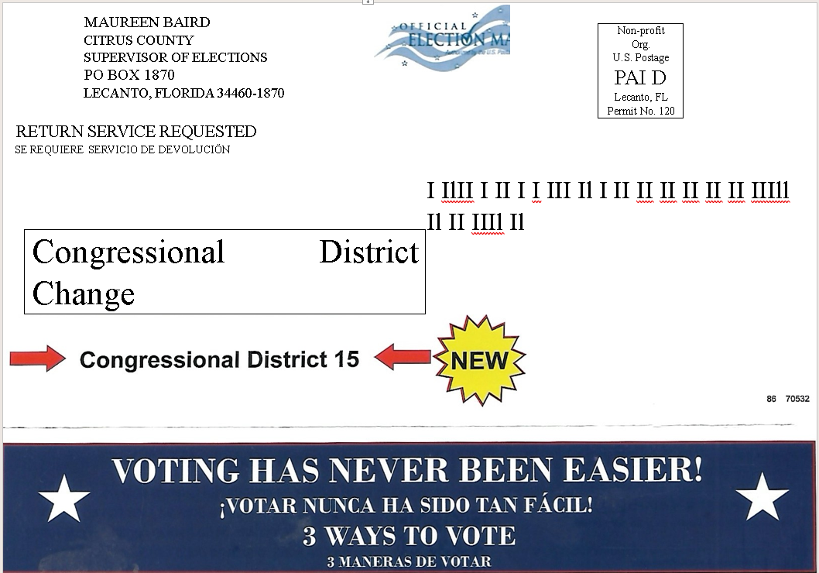
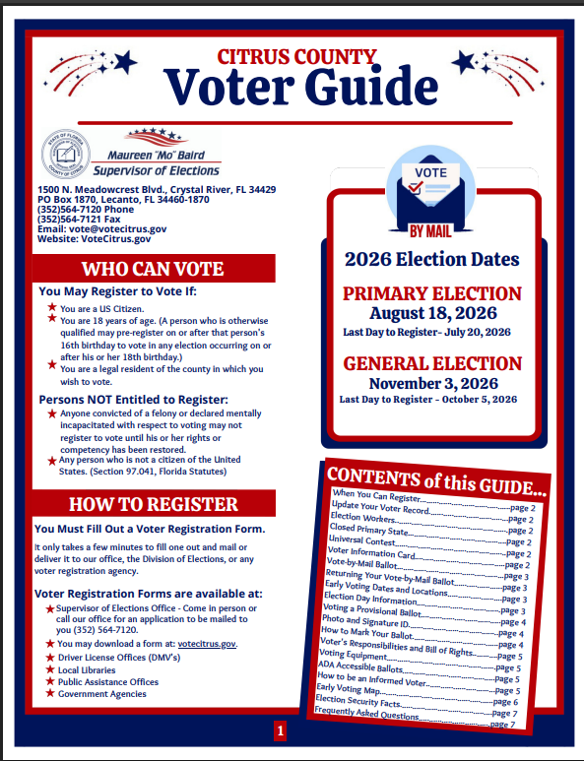

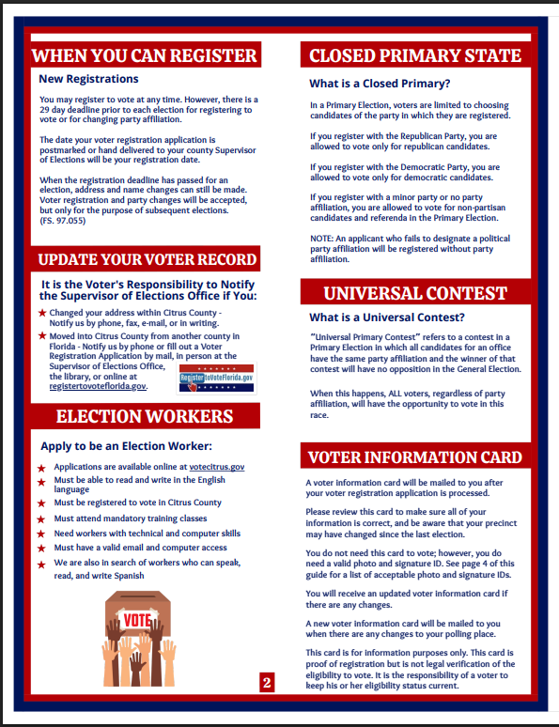

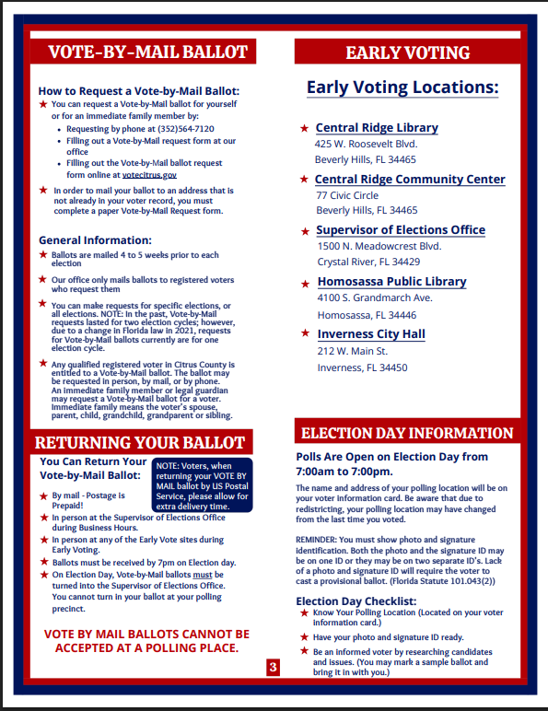
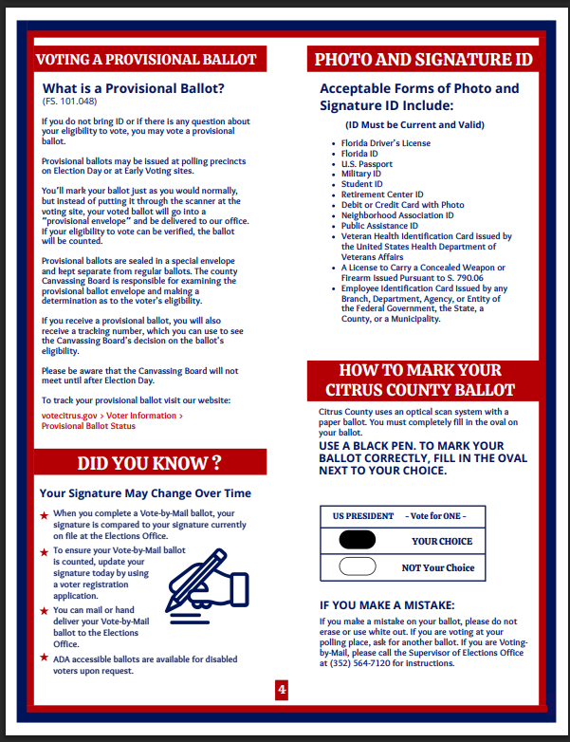

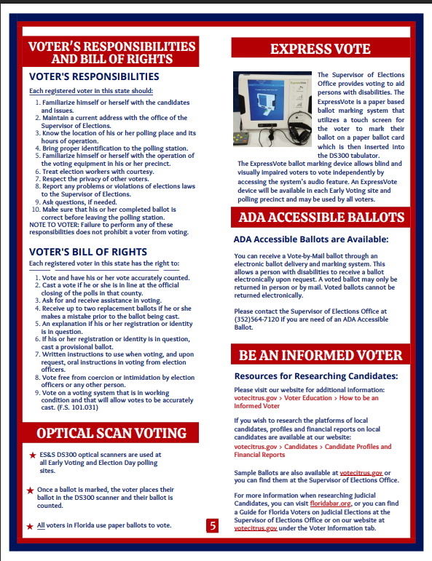

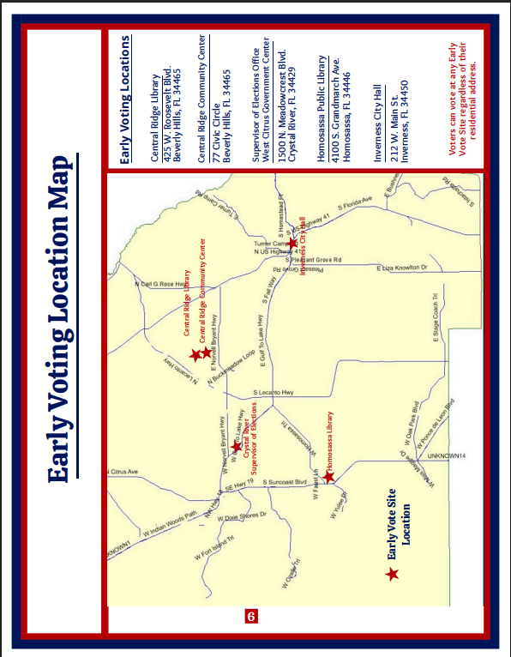

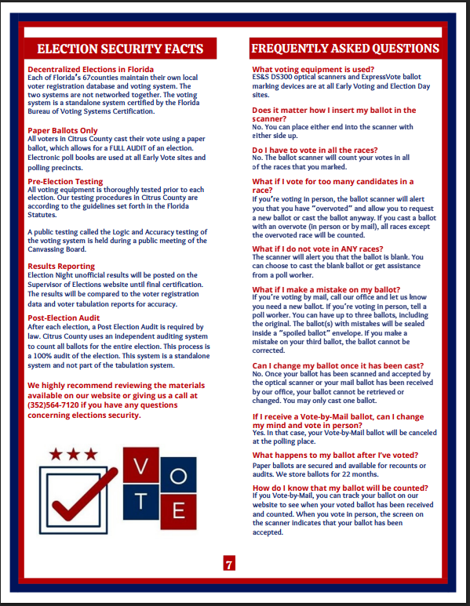

Speaker’s Bureau
Rosemary Nilles is co-chair of the Florida Speakers Bureau
Vicky Iozzia is the chair of the LWV Citrus Speakers Bureau
If your organization is interested in having a speaker, contact Vicky Iozzia at vickyiozzia@gmail.com

Speakers Bureau Presentations as of June 7, 2026
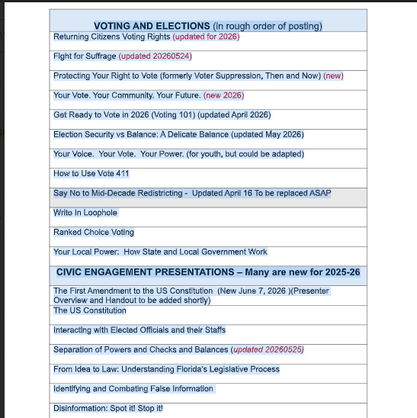

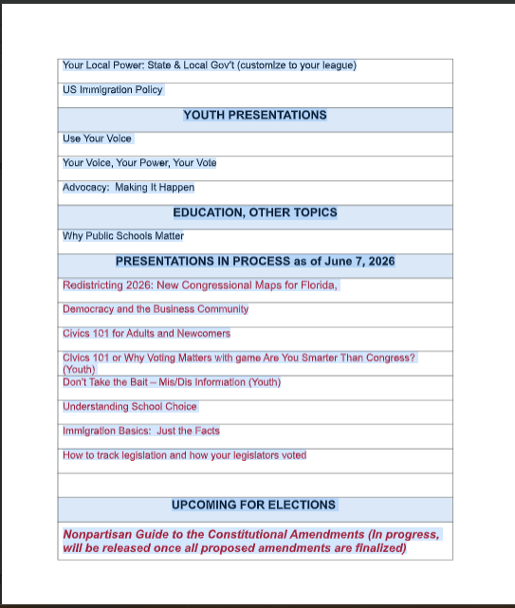

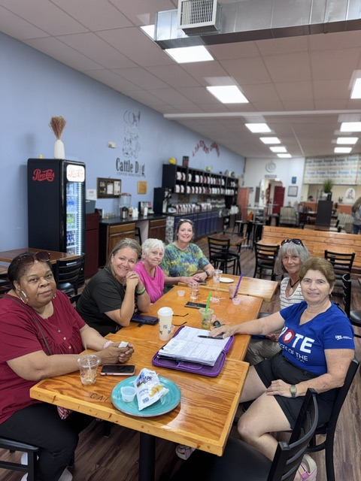

This is from our June 17 Social.
Come join us for our Monthly Social! Have a cup of something or a snack.
Join the conversation or listen.
Our next meeting is at the Cattle Dog Restaurant in Inverness, 4:00,
Wednesday, July 22, 2026

African American Read-in
The 18th Annual African American Read-in took place on Sunday, February 22, 2026, at the Curtis Peterson Auditorium. It was a well-executed presentation which was positive and often emotionally moving. I will be including the literary pieces which were read in future newsletters. Once a year is not enough to enjoy this literature.

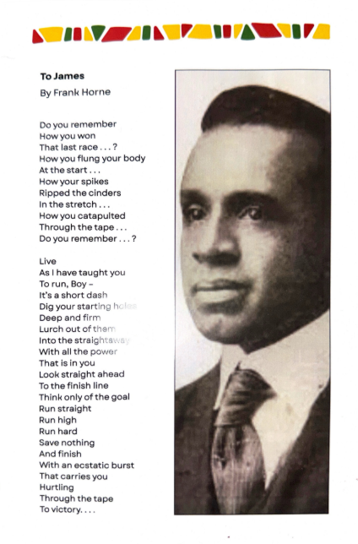

Here is our own Dr. BJ Ezell,
Reading the Emacipation Proclamation
At a Juneteenth ceremony.
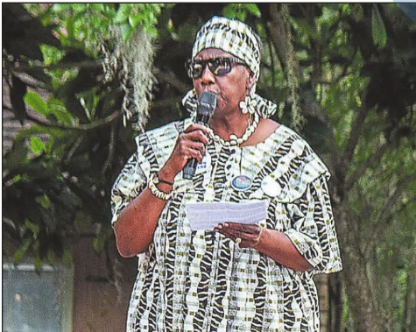

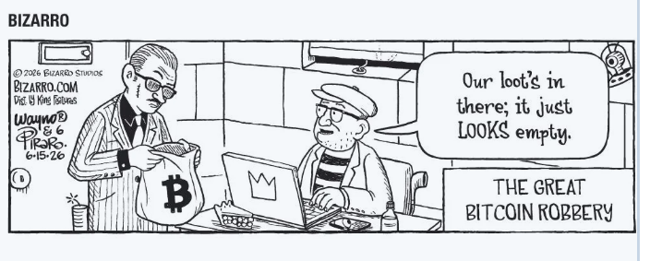
IN THE NEWS

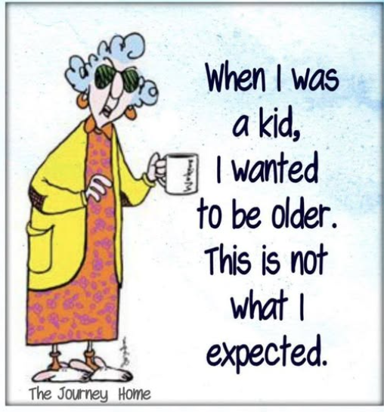

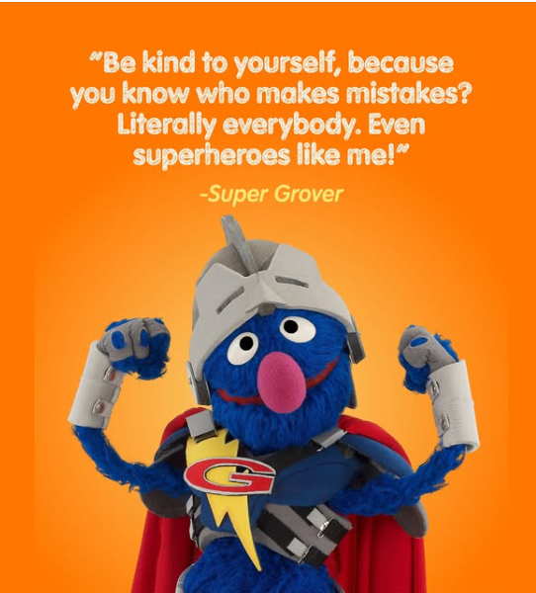

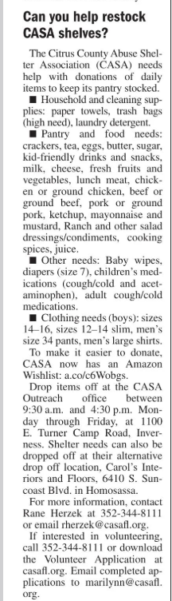
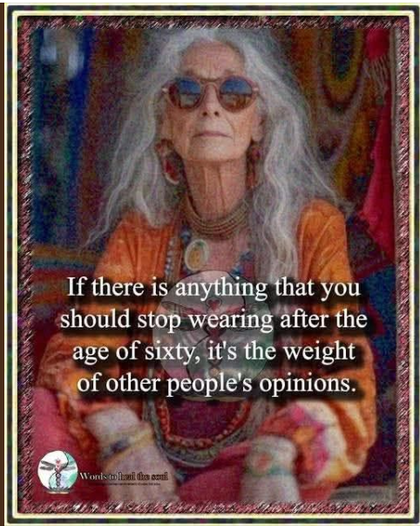



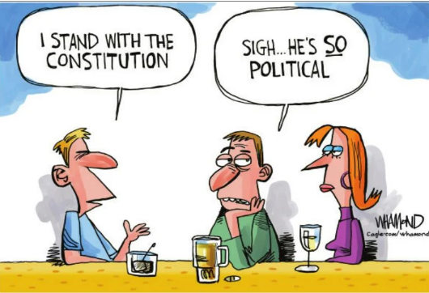



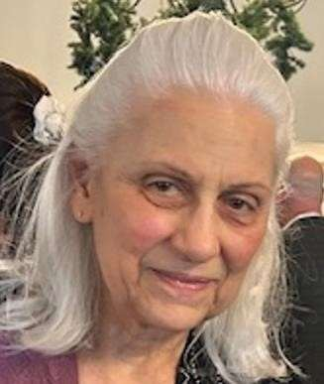

NEWSLETTER ARTICLE FROM LWVCC NATURAL RESOURCES CHAIR
JULY, 2026

“Understanding, Anticipating, and Adapting to Climate Change, 2026 Storm Threats, and Potential Impacts on Florida’s Gulf Coast”
by Featured Speaker:
Don Wright, PhD, Professor Emeritus and Dean Emeritus
Virginia Institute of Marine Science (VIMS)
College of William & Mary
Speaking at LWVCC Meeting @ Coastal Region Library
10 a.m., Wed., July 8

Climate.us Opened June 24, 2026
Replaces Climate.gov
New Website for Public Information from former NOAA Scientists

Citrus County Planning Commission Rejects Data Center
At Holder Industrial Park
Deltona Withdraws Application

Hernando County Commission Approves
Moratorium on Data Centers

Flood Risk to Resilience
Listening Sessions Held for
Tampa Bay Coastal Master Plan
In Citrus and Hernando Counties

Take the Flood Risk Survey for the
Tampa Bay Coastal Master Plan

Florida Climate Week
October 5-11
Virtual and In-Person Events
Hosted by VoLo Foundation

Anticipating and Adapting to Hot Seas
and the 2026 Storm Threats to Florida’s Nature Coast
Featured Speaker: Don Wright, PhD, Professor Emeritus
and Dean Emeritus
Virginia Institute of Marine Science (VIMS)
College of William & Mary
LWVCC Meeting @ Coastal Region Library
10 a.m., Wed., July 8

CRYSTAL RIVER, FL — The League of Women Voters (LWV) of Citrus County invites the public to a pivotal community event on Wednesday, July 8, 2026, featuring a critical briefing on coastal climate risks followed by a Meet and Greet with candidates for the Florida House of Representatives.
The event will be held at the Coastal Region Library in Crystal River, beginning promptly at 10:00 AM.
Gulf Coast storm preparedness: the meeting will open with a presentation by Don Wright, PhD, Professor Emeritus and Dean Emeritus at the Virginia Institute of Marine Science (VIMS), College of William & Mary. A renowned expert and author of numerous publications on coastal climate change, Dr. Wright will share urgent insights regarding the shifting environmental landscape.
"Recent science publications suggest that unprecedented conditions could take place by late summer," says Dr. Wright. "I feel a moral obligation to communicate some important warnings and risk reduction strategies to our county neighbors."
Meet the District 23 Candidates Following Dr. Wright’s presentation, candidates running for Florida House of Representatives District 23 will take the floor. Each candidate will provide a brief introduction, outlining their platforms and priorities for the upcoming term.
The session will conclude with an informal Meet and Greet, providing residents a unique opportunity to speak directly with the candidates, ask questions, and collect campaign information.

Climate.us Opened June 24, 2026
Replaces Climate.gov
New Website for Public Information from former NOAA Scientists

New website for public information from former NOAA scientists: CLIMATE.US opened June 24,2026. This site replaces CLIMATE.GOV
About CLIMATE.US:
Our Mission: Keeping trusted climate information up to date and easy to find.
Climate hazards – both natural and human-caused – are a significant threat to public health and safety, to communities and infrastructure, to the economy, and to forests and other natural resources. Americans who don’t understand climate can’t participate effectively in government decisions about climate policy. They can’t have meaningful conversations with friends, family, and neighbors to find pathways to consensus or compromise. Read more at:
https://www.climate.us/
https://www.npr.org/2026/06/26/nx-s1-5869615/climate-noaa-data-trump-doge

Citrus County Planning Commission Rejects Data Center
At Holder Industrial Park
Deltona Withdraws Application

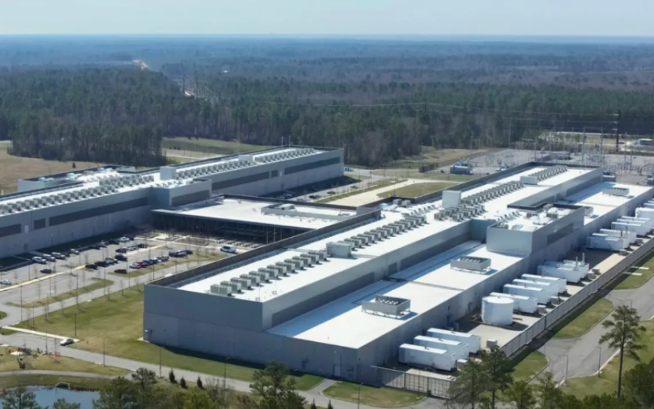

Image: Sierra Club.org

About 200 residents attended a hearing before the Citrus Planning and Development Commission on June 18th to speak out against the proposed expansion of the planned Holder Industrial Park by 823 acres to accommodate a hyperscaled data center. The hearing also considered the request to approve use of the additional land for a hyperscale data center. The Planning Commission denied the application.

Citrus County recently approved a moratorium of up to one year on such centers to provide time for the county to develop comprehensive land use regulations for this newly emerging use of industrial lands.

Before the hearing was held, Deltona requested a continuance until November for the County Commission hearing on the issue scheduled for July 14th. Commissioner Diana Finegan preferred to hold the hearing as scheduled. On Monday, June 22, Citrus Commissioners denied Deltona’s request to continue the hearing. The next day, June 23, Deltona withdrew its application for the data center. That is good news for Citrus.

Adventure Coast Citrus Conservation Committee co-chairs Robin Orlandi and Maxine Connor spoke out at both hearings to recommend caution based on the multiple potential impacts to the community and valuable water resources, wildlife and the environment. The land use change and data center applications have been withdrawn but this isn’t over. Pay attention and follow competent reporting about data centers. The Citrus moratorium is for one year, OR when an ordinance to amend the comprehensive land use plan is amended to regulate data centers. Watch for notice of public hearing and hopefully, workshops.
Article courtesy of Sierra Club Adventure Coast Group.
https://www.fox13news.com/news/citrus-county-data-center-proposal-withdrawn-resident-backlash-hearings-canceled

Hernando County Commission Approves
Moratorium on Data Centers

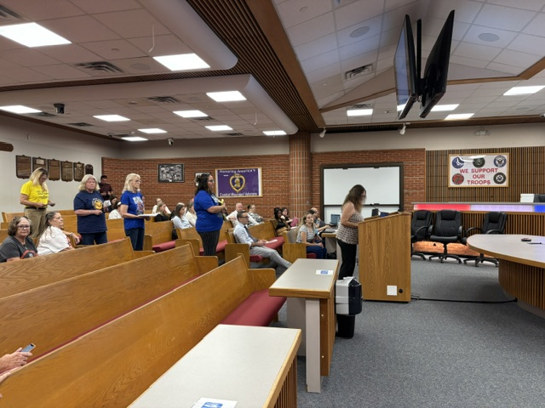
Jennifer Sullivan speaks out against data centers

On Tuesday, June 23rd, Hernando County Commissioners voted unanimously to adopt an ordinance imposing a temporary one-year moratorium on data centers so that an ordinance can be drafted and approved addressing them. Several commissioners indicated that they were in favor of it at the beginning of the meeting and then heard from many residents, all of whom opposed the idea of hyperscale data centers in Hernando. One speaker provided a template for county land use provisions to address data centers.
Sierra Club Adventure Coast Group Chair DeeVon Quirolo echoed the comments of many that, Hernando County is not a good fit for such intensive industrial development. Hyperscale data centers would endanger the conservation integrity of Hernando’s springs, forests and wildlife and are incompatible with our residential, business, rural and agricultural character. The issue of water consumption is one of our top concerns. Our springs are already officially impaired, and we are in a major drought. There is no “extra” water to share with a data center. The County Water Budget already predicts water shortages in coming years. This is a legitimate reason to rethink any hyperscale data centers here in the Nature Coast.
IF the commission decides to allow them, Sierra Club has taken the position that land use regulations can be adopted to accommodate small scale data centers that address the issues of climate, environment, public health and equity outcomes. We can protect the health and avoid economic impacts on communities by utilizing clean energy and on-site battery storage instead of dirty diesel backup generators and costly fossil fuel-fired power plants.
Article courtesy of Sierra Club Adventure Coast Group.

Flood Risk to Resilience
Listening Sessions held
In Citrus and Hernando Counties

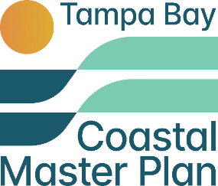

The Tampa Bay region is a flood-vulnerable area, facing extreme risk from storm surge, sea-level rise, and heavy rainfall due to its low-lying geography, extensive coastline, shallow continental shelf, and dense development. Both coastal and inland flooding threatens the safety, property, and livelihoods of Tampa Bay’s communities.
The Tampa Bay Regional Planning Council is developing the Tampa Bay Coastal Master Plan (TBCMP)—a comprehensive, four-year initiative in Citrus, Hernando, Pasco, Pinellas, Hillsborough, Manatee, and Sarasota counties that spans more than 2,200 square miles of coastal and inland communities, estuaries, rivers, wetlands, and barrier islands.
The Coastal Master Plan aims to strengthen regional flood resilience by addressing the impacts of sea-level rise, storm surge, extreme rainfall, and high-tide flooding. The 2026 focus includes hosting public listening sessions to identify flood-vulnerable communities, prioritize restoration and flood-reduction projects, and guide long-term adaptation strategies with equity, innovation, and collaboration.

As partner/collaborators in this effort, Sierra Club Adventure Coast Group and Hernando Audubon hosted three Listening Sessions. Thank you to the partners and facilitators who made each one a success:
- George Washington Carver Community Center, Crystal River. The facilitators were Sierra Club’s Robin Orlandi and Maxine Connor in cooperation with Denise Dookeran—Florida Sierra, Jessica Sirios—TBCMP, and center representatives.
- Weeki Wachee Area Club, Hernando Beach. The facilitator was Sierra Club’s Taylor Masnjak and Tom St. Clair in cooperation with the Weeki Wachee Area Club and Jessica Sirios—TBCMP.
- Ridge Manor Community Center. The facilitator was Lynn Gruber-White, President of the Ridge Manor Property Owners Association in cooperation with Joe Murphy of Sierra Club and Hernando Audubon and Jessica Sirios—TBCMP.
- Special thanks to Delaney Coleman and Lucas Duncan, Sierra Club college interns, and Emily Van Sickle, Sierra Club Student Leader, part of our team, for each workshop.

These efforts ensure that local governments, community organizations, residents, and technical experts all contribute to shaping the plan. This year, the Coastal Master Plan will develop a Regional Flood Risk Assessment that will provide a scientific and analytical foundation for all future project recommendations. By 2027, the focus will be to design, screen and evaluate projects in priority areas based on community feedback. In 2028 the plan will be released.
Article courtesy of Sierra Club Adventure Coast Group

Take the Flood Risk Survey
for the Tampa Bay Coastal Master Plan

The Tampa Bay Regional Planning Council is creating the Tampa Bay Regional Resilience Coalition—a voluntary alliance of local governments and partner organizations working together to strengthen the region’s ability to adapt to climate change. By aligning with the Coalition’s shared goals, the Tampa Bay Coastal Master Plan (TBCMP) advances coordinated, region-wide resilience strategies that reflect local priorities and foster long-term collaboration across jurisdictions. The study area spans over 4,400 square miles of diverse inland and coastal ecosystems across Citrus, Hernando, Pasco, Pinellas, Hillsborough, Manatee, and Sarasota counties—home to more than 4 million residents.

The Tampa Bay region faces escalating climate-related risks, including sea level rise, storm surge, extreme rainfall, and high-tide flooding. These threats are compounded by rapid population growth and limited regional coordination on flood mitigation. Efforts have often been fragmented and lacked a cohesive, long-term strategic framework.

Sierra Club Adventure Coast Group has agreed to become a collaborating partner and leaders have participated in training sessions which have now been followed by planned community listening sessions.

The Tampa Bay Coastal Master Plan (TBCMP) enhances regional resilience by addressing flooding impacts through a coordinated, data-driven, and community-based planning process. Over the course of this four-year, grant-funded initiative, the TBCMP will identify flood-vulnerable communities, prioritize restoration and flood-reduction projects, and guide long-term adaptation strategies.

Take the flood risk survey at:

https://www.coastaltampabay.org/get-involved

Article courtesy of Sierra Club Adventure Coast Group

Florida Climate Week
October 5-11
Virtual and In-Person Events
Hosted by VoLo Foundation

Florida Climate Week is an annual hybrid (in-person and virtual) event hosted by VoLo Foundation. This year’s event runs from October 5-11. The deadline to submit an application is July 17, 2026. Apply here: https://floridaclimateweek.org/

“VoLo Foundation is a private family organization that exists to accelerate change and global impact by supporting science-based climate solutions, enhancing education, and improving health.” Learn more at their website; link is below.

https://www.facebook.com/VoLoFoundation/videos/1321987590066209/
https://volofoundation.org/news/florida-climate-week-belongs-to-you/
https://www.youtube.com/playlist?list=PLzDGN_mfeF78_Lq7l6oLaQQmo691Xfq9s
VoLo Foundation official website:
https://volofoundation.org/?gad_source=1&gad_campaignid=21996048236&gbraid=0AAAAACX1GSEkpX1xUTCBMVcPNik3XWz2h&gclid=CjwKCAjw6f3RBhApEiwAMaCqWaGJLcxfyQ69c1h0NIbYT8mD-cMQnw8bU6RCeMbmDIfimfdycFW02BoCdlIQAvD_BwE

Updated 6/26/26

