
NOVEMBER, 2025
LEAGUE OF WOMEN VOTERS OF CITRUS COUNTY, FLORIDA
Vicky Iozzia is the Editor of this newsletter. Our mailing address is LWVCC. P. O. Box 1903, Lecanto, FL 34460 Our website is lwvcitrus.org
Our email address is LWVCC2013@gmail.com
Our November 5 zoom will be with candidates Ash Marwah and Ralph Massullo. Registration is required. See page 4
Our November 12 meeting features retired Judge Trish Thomas. To talk about due process. See Page 5
*******************************************************************************
Our December 10 meeting is a double-header featuring Sheriff David Vincent and Superintendent of Schools Scott Hebert. It will be at Glory Days Restaurant in Lecanto. To register, pick out your meal, and pay, go to lwvcitrus.org, click on Upcoming Events, and scroll down below the calendar. See Page 6
Please visit our Facebook page and "like" us! https://www.facebook.com/leagueofwomenvotersofcitruscounty
We want to thank the following businesses for their cooperation: FGE Printing, Glory Days Restaurant, Citrus County Chronicle, Pinnacle Printing


HAPPY NOVEMBER EVERYONE!


November 21 is World Vasectomy Day.

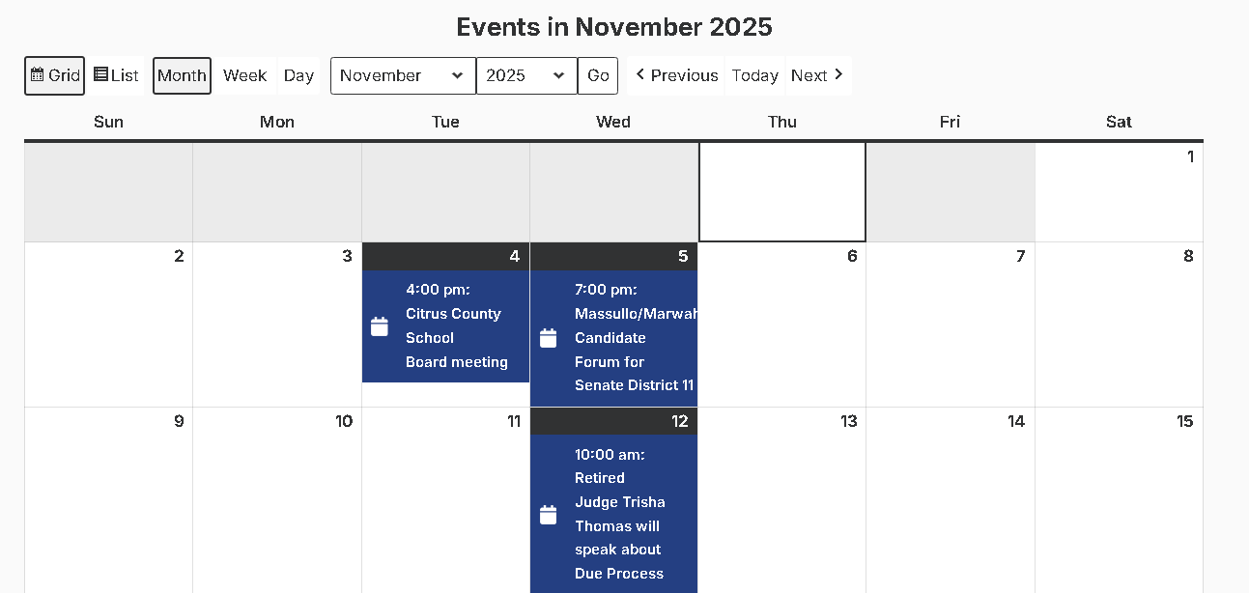

This calendar is from our website:
Lwvcitrus.org

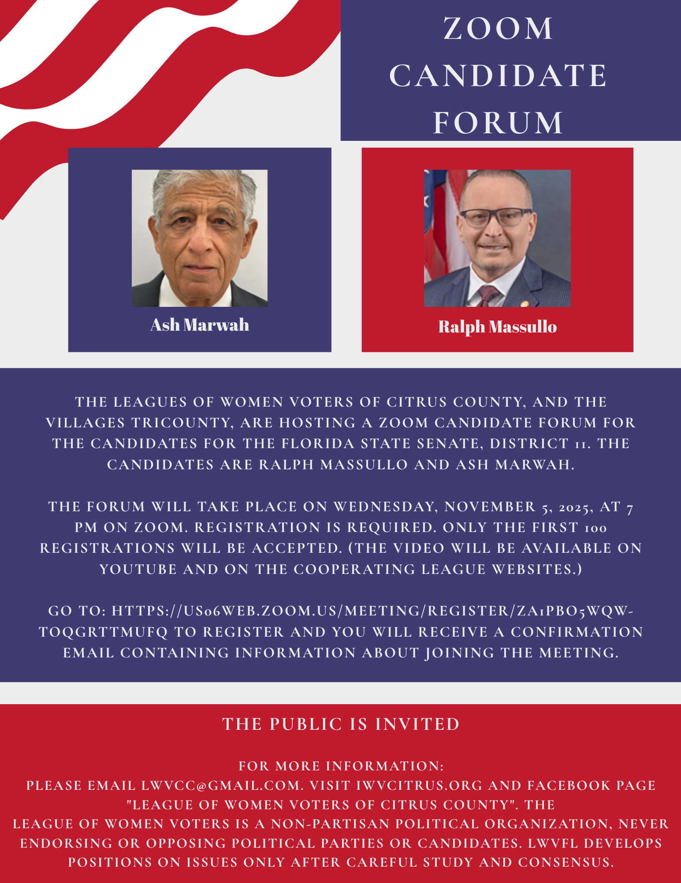
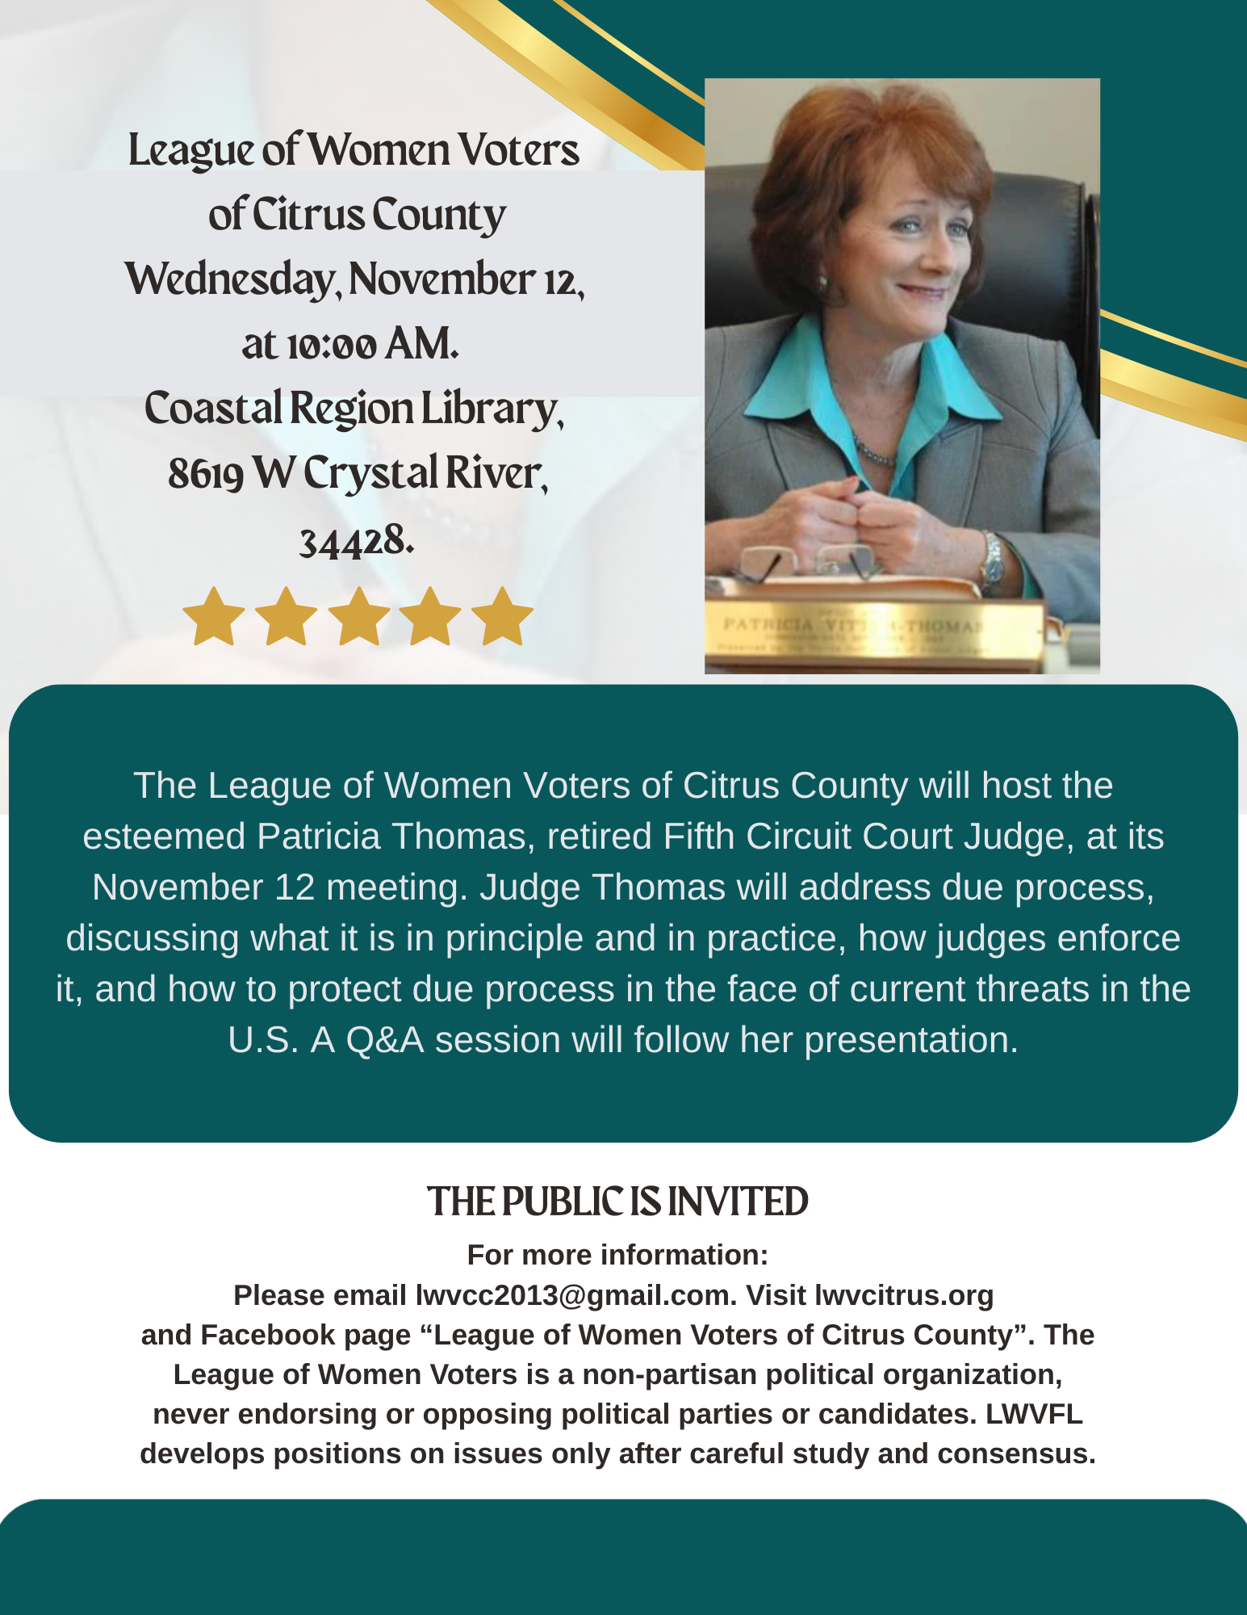

The League of Women Voters of Citrus County
December 10, 2025 Luncheon, 9:30 am
With Guest Speakers
Citrus County Sheriff David Vincent and
Dr. Scott Hebert, Superintendent of Citrus County Schools
Held at
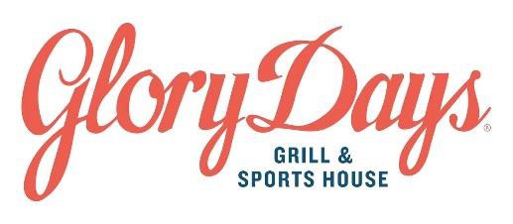
Please choose from:

All American Burger
Served with lettuce, tomatoes, onions and topped with Cheddar cheese. Served with a side of crispy seasoned fries or steamed broccoli.
GDG’s Big Fabulous Fish Fry
Wild, line-caught Haddock, beer battered with Stella Artois, served with crispy seasoned fries and tartar sauce.

Grilled Chicken Sandwich
Bacon, Swiss cheese, lettuce, tomato, onion and honey mustard on a toasted brioche bun.
Served with crispy seasoned fries or steamed broccoli.

Grilled Chicken Caesar Salad
Fire-grilled chicken, romaine lettuce, shaved Parmesan mixed with classic Caesar dressing and topped with homemade croutons.

GDG’s Crave A’ Bowl
Basmati rice, broccoli, tomato and cucumber, hummus, Feta, garlic aioli and lemon wedge.
Topped with Fire-grilled chicken.
Vegetarian GDG Crave A’ Bowl
Basmati rice, broccoli, tomato and cucumber, hummus, Feta, garlic aioli and lemon wedge.

$25 per person includes meal, soft drink, and tip
Pay online, You must pay in advance. lwvcitrus.org, click on Upcoming Events. Scroll down to below the menu options. Choose your lunch from the drop-down menu. Submit, and click on the green events button to pay. Doors open 9:30, program begins at 10 promptly, lunch at 11:00
Questions? Contact Devora Stager, (207) 323-8246, or email at devorastager@gmail.com

Make your reservation early, because we are expecting a large attendance.

TABLE OF CONTENTS – NOVEMBER, 2025 LWV CITRUS NEWSLETTER

October meeting, the YaYas Page 4
October 15 zoom with Jeff Kinnard Page 5
November 12 meeting with Trish Thomas – due
Process Page 6
Linda Albels, Membership Chair Page 8
Vicky Iozzia, How you can help our League Page 8 to 11
Your County Commissioners: contacts, meetings Page 12
SOE Mo Baird, Sept 10 meeting, election dates,
Vote by mail, Voter brochure Page 13 to 17
League Social at Cattle Dog Restaurant Page 18
From the LWV Impact on Issues- Presidency Page 19
Legislative Contacts Page 20
Peg Primeau will be back Page 21
Rosemary Nilles, Representative Democracy vs, Constitutional
Republic Pages 22 to 23
In the News Pages 24 to 31
At Goodwill to register voters Page 32
From the Department of Health Page 33 to 34
Maxine Conner, Natural Resources Chair Pages 35 to 44
Jan Hall will be back Page 45



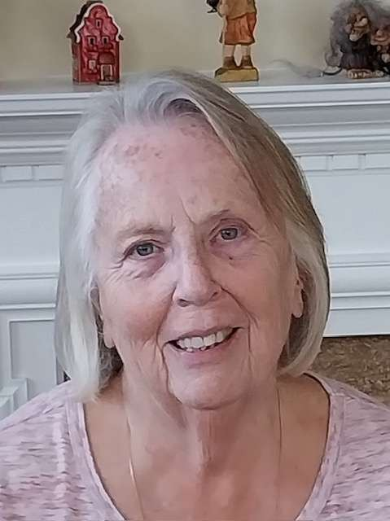

Linda Abels, Membership Chair

Happy November! When I think of November, I think of Thanksgiving and all the things I have to be thankful for. I am particularly thankful for my family and friends. I am also thankful for the LWV and our members who work tirelessly to educate the residents of Citrus County on various topics concerning our community, state and country.

I know the LWV Citrus County Board is thankful for all our 69 members. Our group has been growing over the last year or two and the board is thrilled by your interest in your community and state.

Our local chapter of the League of Women Voters was restarted in 2013 by a small group of women. Four of our current members were there at the beginning; Linda Abels, Jan Hall, Vicky Iozzia and Mary Perry. Let's continue to grow our League and work together to educate the residents of Citrus County.

I wish you all a Very Happy Thanksgiving ! Linda

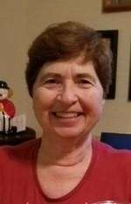

Vicky Iozzia, 1st President, Newsletter Editor,
Webmaster, Speakers Bureau Chair

Our world lost an angel in October. Jane Goodall breathed her last. Netflix taped an interview with her to be shown upon her passing. It is a moving testament to her life and her work. Have some tissues handy and watch “Famous Last Words: Dr. Jane Goodall”.

I was present at the “No Kings” rally on Saturday, October 18. I would not have missed it for the world. I am proud that I protested the war in Vietnam many years ago, and I know that this rally is the right thing to do.

It was sponsored by the Citrus Coffee Coalition. What I love about it is that there are so many different signs, so many different peeves and ideas. Below are some of my favorites:
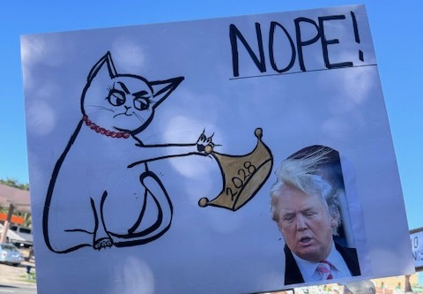
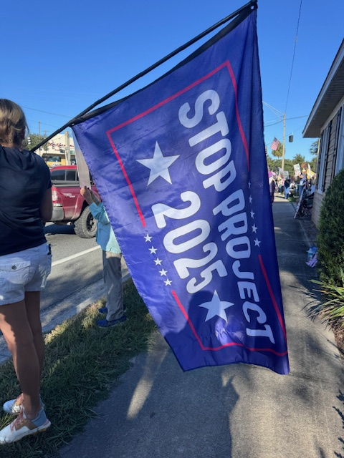

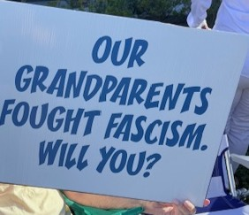
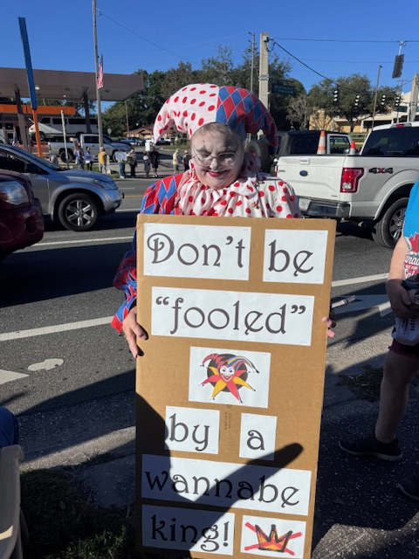

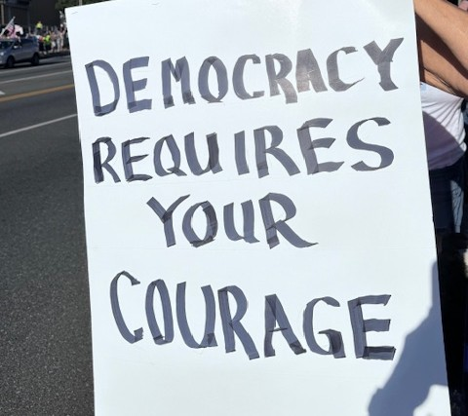

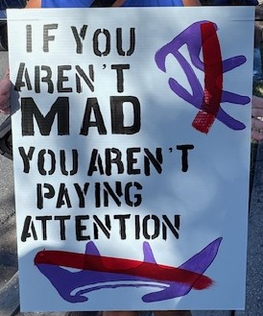

The crowd was overwhelmingly senior citizens, some with lawn chairs. (I brought my camping chair). Where were the young people, I wonder? The demonstration was peaceful. The mood was different from other demonstrations I have been to. It seemed more resolute, confident, and happier. There were many, many honks from cars in support. There were still some people who couldn’t resist yelling out of their car windows. I heard someone in a pickup truck call us “losers”’, and I had to smile.

It seems that people are not only waking up, but willing to appear in public to defend our democracy. The next question is, what’s next? How, and who stops the illegal things that this government is doing?

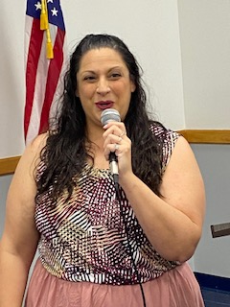

YaYAS Executive Director, Nichelle Mohre-Cassidy spoke at our October 8 meeting

We have been lucky to have very good speakers at our meetings. You know this if you attend our meetings or watch it on youtube. Nichelle’s presentation was very well done: interesting, informative, entertaining, emotional, and real.

I started her introduction with this quote:

“Some People Make Things Happen,

Some Watch Things Happen,

While Others Wonder What Has Happened.”
In preparation for my introduction, I looked up the author, and it was none other than Eleanor Roosevelt.
The task which Nichelle and the YaYAS tackle is complex. It is helping young people, from 16 to 24 years old, who are homeless, is a daunting task.
There are over 800 homeless youth in Citrus County – yes, right here in our own back yard. Some have parents who are incarcerated. Some receive the cruel birthday present of “You’re 18. You’re on your own. Get out.”
Serving this population takes dedication, collaboration, and heart. None of the YaYAS staff take a salary.
The services vary according to each client’s needs. It might be clothing, food, car repair, transportation, a place to show, study, or sleep, or therapy. My bet is that this organization helps youth just by showing that they are important and that someone cares about them.
Presently YaYAS works with other agencies when appropriate to help these youths. The program has big plans for expansion in the future.
Right now the master plan is to have a youth and young adult shelter built in three years. A facility that will house between 40 and 50 16 to 24 year olds.
What do they need and how can you help?
- You can go to their website, yayasofcitrus.org and donate. Large or small donations will all help.
- You can watch the video of Nichelle’s excellent presentation at
https://youtu.be/kN87kTmh8YE and hear the stories of what the needs are.
- If you know someone who likes to fundraise, they can use such a person.
- Nichelle’s cell number is 352 587-5155.
- You can email the YaYAS at executivedirector@yayasofcitruscounty.org

If you have not heard me say or write it before, We Need Your Help.
I am proud of what our Board and members have been doing, but there are many more things we can do. Below are the areas where we need volunteers:

Fund raiser – to develop a plan to raise money for our League and implement it, recruiting other volunteers to help you.

Voter services chair – represent us at Florida League monthly zoom meetings.
Arrange for community outreach to register voters.
Recruit people to participate in these outreaches.
Arrangements with Goodwill in Crystal River have already been made.

Tech person – to record general monthly meetings, edit, and put on youtube.
Vicky can brief person interested.

People to attend community meetings – Attend Board of County Commissioners, Library Board, and School Board meetings.

I am sure that many of you are thinking, “What can I do to help?” The present political situation can make us feel helpless, but we will not let that happen. Working together as League members, we can make a difference. If you have any questions, send us an email at lwvcc2013@gmail.com

Voting rights act and Redistricting Vicky Iozzia
After the Civil War, when black people gained the right to vote, they were denied their voting rights in the South with things like having to pay a poll tax, taking a test that no one could pass, or estimate how many jellybeans were in the jar.
Over the years laws were adopted to protect voting rights. The Voting Rights act of 1965 was signed by President Lyndon Johnson. It:
- Outlawed literacy tests
- Provided federal examiners to register voters
- Required jurisdictions to get clearance prior to change any voting procedures
- Prohibited abridgement of the right to vote on the basis of race or color.
- Prohibited racial gerrymandering. Gerrymandering means changing the geographical boundaries of a Congressional District to allow a political party to stay in power.
The Supreme Court Case Louisiana v Callais has already heard oral arguments. The decision will come in early 2026. The issue is redistricting.
Maps are supposed to be redrawn every 10 years, after the census. Florida, Missouri, North Carolina, Texas, Ohio, Indiana, Maryland, Kansas, Utah, Louisiana, New York, and Illinois are now attempting to redistrict instead of waiting, so that their party can gain a political advantage.
When I presented the League of Women Voters information on gerrymandering, I brought a deck of cards. I asked someone in the audience to play poker with me.
I had set the cards up so that I would have all aces. The poor person playing with me didn’t realize they didn’t have a chance to win. That’s how I see gerrymandering.
Reuters calls this Supreme Court case is a “near death sentence” for the Voting rights act. Redistricting will help determine who wins Congressional seats nationwide and could determine who wins the national elections.

From Rosemary Nilles, 1st Vice President and Florida League co-chair for the LWV Speakers Bureau:
Gov. DeSantis also is looking towards mid-decade redistricting in Florida. The Florida House Speaker has already set up a committee to study and plan. So far they have not yet convened.

Florida also has a committee in place to study mid-decade redistricting. LWV and LWVFL oppose mid- decade redistricting! In Florida, our state Constitution prohibits it! Members, watch for more information from LWVFL on ways to speak out.

For groups who are interested in learning more, LWVFL Speakers Bureau has prepared two presentations on this topic: Understanding Mid-Decade Redistricting is strictly educational with no positions offered. Say No to Mid-Decade Redistricting explains the process but also offers LWV Florida’s position against it.
Check our website to request a speaker.
https://www.lwvcitrus.org/speakers-bureau/

County Meetings

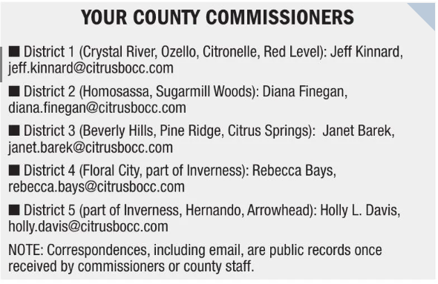

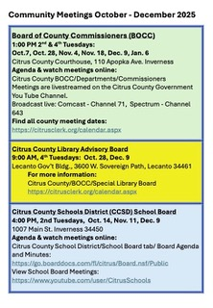

More from our Supervisor of Elections, Maureen “Mo” Baird



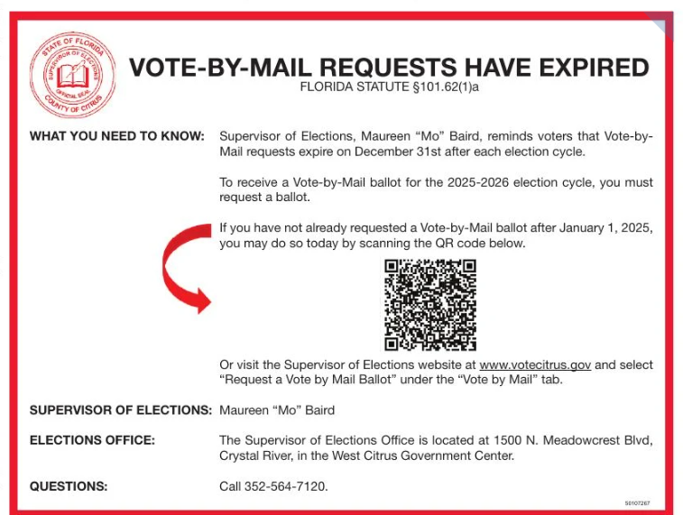


Even more from Mo Baird

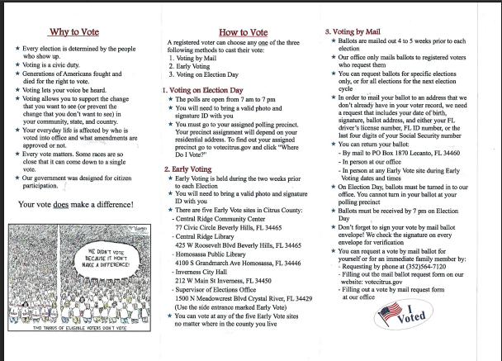

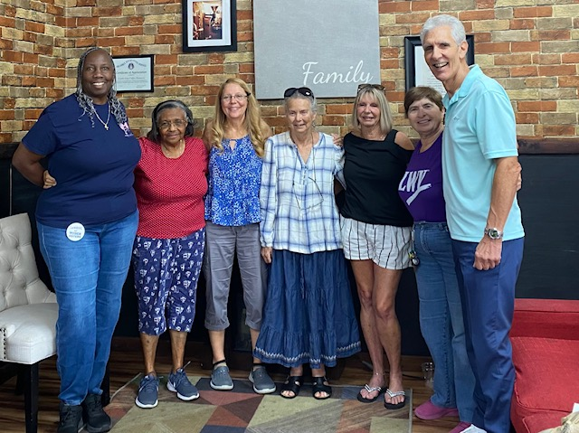

League of Women Voters Social
At Cattle Dog Restaurant in
Inverness, September 2025

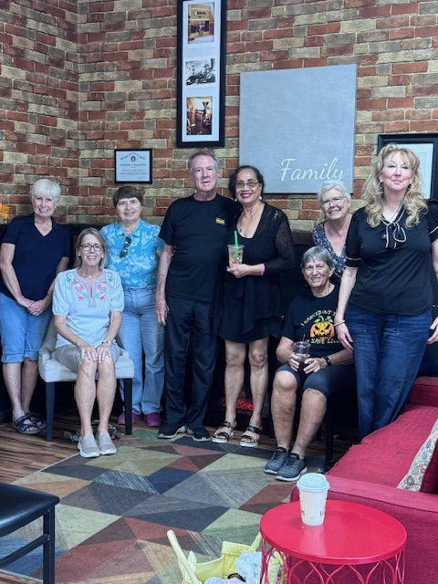

League of Women Voters Social
At Cattle Dog Restaurant in
Inverness, October 2025

Come, join us! Have a cup of something or a meal. Join the conversation, or listen.
Our next meeting is at the Cattle Dog Restaurant in Inverness, 4:00, Wednesday, November 19

From the new League of Women Voters Impact on Issue

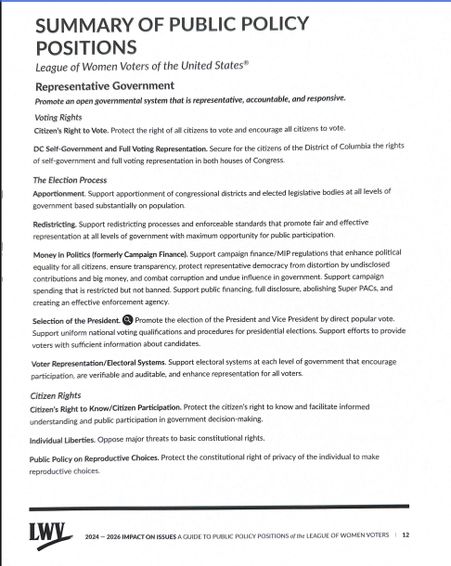

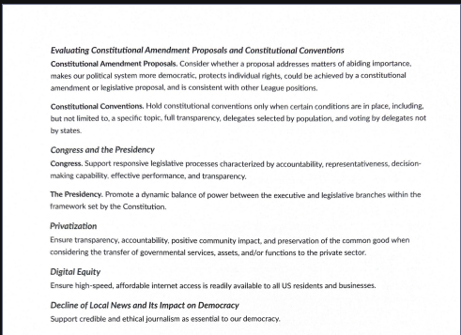

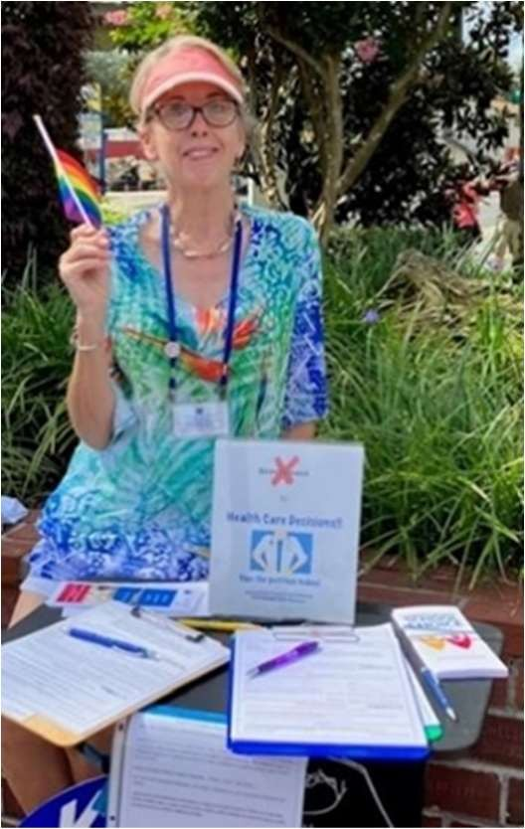

Peg Primeau, 2nd President, Reproductive Rights Chair
Our 2026 Legislative Advocacy Starts Now
The LWVFL Reproductive Health and Justice Action Team (RH&J) is encouraging members to sign and share this petition from Reclaim Choice Florida to inform our state government of the problematic nature of supporting anti-abortion centers with our tax dollars. There is a petition for medical providers as well.

A bill to support: Reclaim Choice Florida is garnering support for Representative Kelly Skidmore's sponsored bill, HB6001, for the 2026 Legislative Session. HB 6001 seeks to repeal Section 381.96, Florida Statutes, a portion of Florida law that permits taxpayer dollars to be used for these centers.

Bills to oppose: Senator Erin Grall (the sponsor of Florida's near-total abortion ban) refiled two of her most extreme bills. RH&J is still analyzing these proposed changes to Florida law, and here's what we know so far:
SB166: An attack on the rights of minors: This bill would ban STI treatment, crisis mental health resources (like a suicide prevention hotline), health surveys, and birth control for minors who can't involve a parent.
SB164: An expansion of Florida's abortion ban: This deceptive bill would grant an embryo the same rights as a living child. This could jeopardize IVF, chemotherapy, and abortion access if the partner (or abuser or rapist) of a pregnant patient is able to sue for the loss or termination of the pregnancy.
We need to keep an eye on these bills and contact our own representatives as well as committee members if and when the bills are heard.

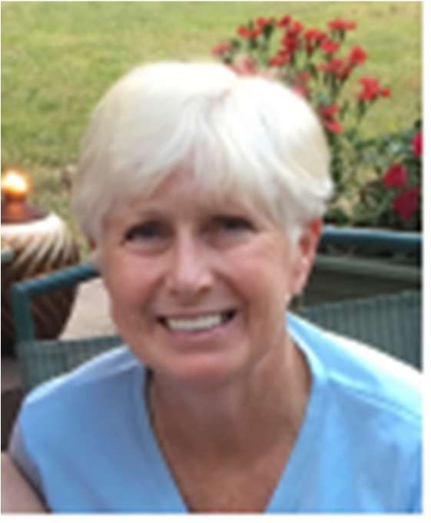

e

Rosemary Nilles, 1st Vice President, Gun Safety Chair, Education Chair
Education Roundup by Rosemary Nilles
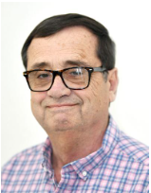
Happy November! No, that’s not my photo! I had planned to
write about Florida’s latest efforts to diminish public
schools. But my friend and colleague, Jim Gouvellis,
Executive Editor of the Citrus County Chronicle, has
already said it so much better! In this latest episode of his
series called Tallahassee Gone Wild, our state leaders are
erasing more local control from our schools. Thank you to
Jim for allowing LWVCC to publish your Oct. 20 column in our newsletter!
https://tinyurl.com/yuszcufk
“Florida’s newest education experiment could one day land a for-profit
charter school inside a Citrus County campus – and leave local taxpayers
helping to pay the bills.
“That’s the concern raised by Citrus County Schools Superintendent Scott
Hebert, who told the Chronicle editorial board last week that while no local
schools currently qualify under the new state rules, that could change in the
future. Hebert said he’s concerned about what the law could mean for local
schools if enrollment numbers or state definitions shift.
“The issue stems from the latest expansion of the state’s ‘Schools of Hope’
program, which now allows charter school companies to co-locate rent-free
inside district-run schools that have open seats.
“This is kind of scary. A private charter operator could set up shop in space
built and maintained by our community, use district utilities and support
services – and still collect public funding as if it were a separate school.
Meanwhile, the district would remain responsible for much of the upkeep
and shared costs.

“That’s not partnership. That’s privatization disguised as efficiency.
“The ‘Schools of Hope’ program began in 2017 as an effort to help families
in communities with “persistently low-performing” schools – campuses that
had received D or F grades year after year. The idea was to recruit proven
charter school operators to open nearby and offer students another choice.
“But the program has drifted far from that original intent.
“And how did the latest change get through? Quietly. Lawmakers tucked it
into a 300-page education bill in the final hours of the legislative session –
a familiar Tallahassee move that keeps controversial policies from standing
on their own. There was no floor debate focused on this specific expansion,
no meaningful public discussion about its local impact, and no chance for
school boards or parents to weigh in.
“Now, thanks to that rewrite, charters can seek space in almost any under-
enrolled school – even high-performing ones – and claim it’s an
‘opportunity zone.’ One Miami-based company, Mater Academy, has
already requested to occupy parts of 27 schools in Broward County,
including several A-rated campuses.
“Critics call it what it is. A real estate grab funded by taxpayers.
“’This is no longer about helping children in failing schools,’ said Rep.
Robin Bartleman, D-Weston. ‘It’s about getting free real estate.’
“Here in Citrus County, our schools aren’t “A” schools across the board, but
they’re well-run, stable, and deeply tied to their communities. They don’t
need outside management to tell them how to serve students. What they
do need is fair funding and consistent support – not the prospect of having

to share space, resources, and budgets with a for-profit operator chasing
enrollment numbers.
“The premise behind this new rule is that ‘unused capacity”’equals ‘wasted
space.’ But school enrollment ebbs and flows. A school that’s at 80 percent
capacity this year could be full again in three years as neighborhoods grow
or programs expand. Local school boards are best equipped to manage
that – not distant charter corporations armed with state-level spreadsheets.
“And when those private operators move in, they don’t answer to local
voters. They’re run by boards often based in other counties, or even other
states, with little accountability to the families whose schools they share.
“That’s not local control. That’s a loss of ownership – one classroom at a
time.
“Citrus County may not be in the crosshairs yet, but the trend is clear. Each
legislative session brings another law blurring the line between public
education and private enterprise. Once “Schools of Hope” are allowed to
set up inside our own campuses, it’s hard to imagine where it stops.
“If Tallahassee truly wants to help students, it should invest in the schools
that already serve them – not invite private companies to move in rent-free
and siphon resources from the communities that built them.
“Public schools belong to the public. We shouldn’t have to share them with
Corporations.”

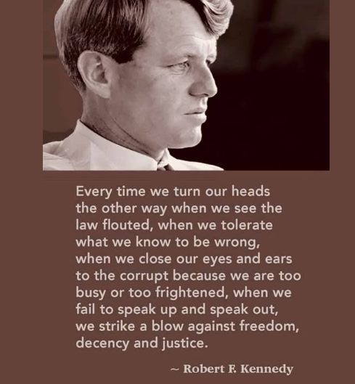
IN THE NEWS

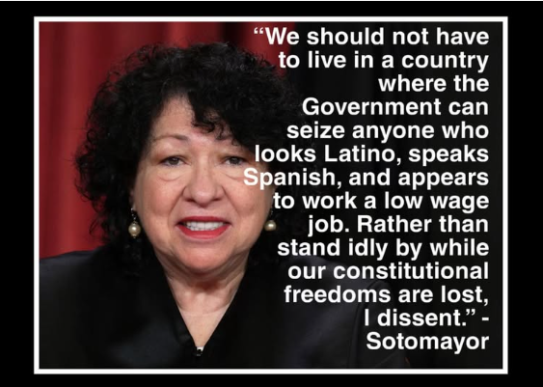

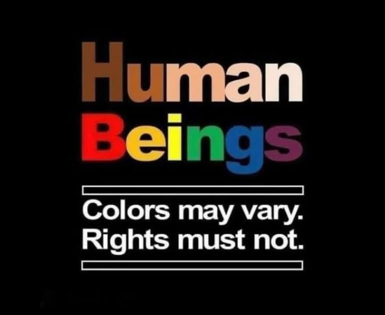
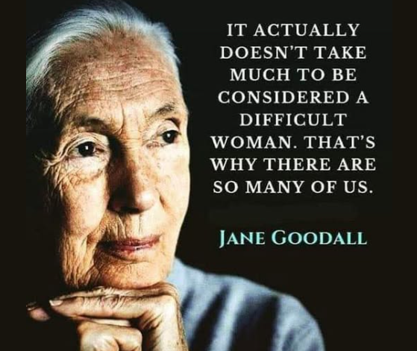


From the ACLU

This administration's attacks on our rights and liberties have only continued to escalate. President Trump and his allies are going after anyone who doesn't agree with them – including students, journalists, comedians, and protesters.
Make no mistake: These attacks are egregious and unconstitutional – and thanks to the support of Guardians of Liberty like you, we are fighting back with everything we have – in the courts, the legislatures, and communities across the country.
BOSTON – A federal appeals court today denied the Trump administration’s request to stay a preliminary injunction that preserves access to passports with accurate sex designations for many trans, nonbinary, and intersex U.S. citizens. The injunction remains in effect, and certain class members may still apply for passports.
BOSTON — A federal appeals court in Massachusetts today upheld a block on President Trump’s executive order that seeks to strip babies born in the United States of their U.S. citizenship. The case is New Hampshire Indonesian Community Support v. Donald J. Trump.

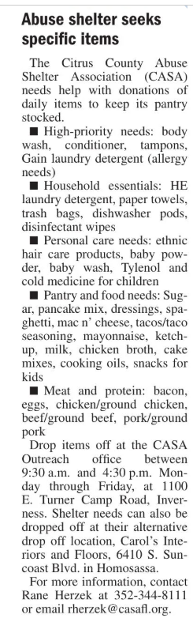


FROM THE DEPARTMENT OF HEALTH

\

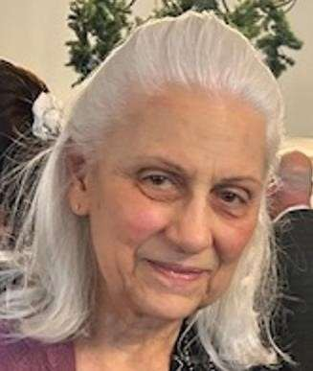

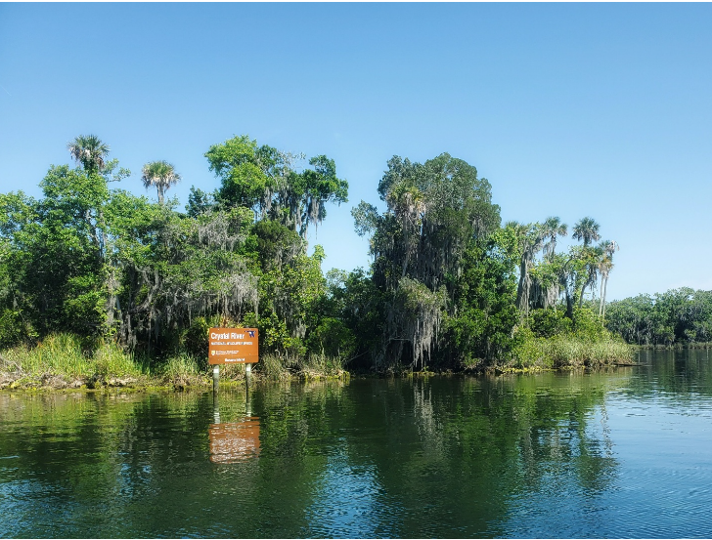
Maxine Connor, Natural Resources Chair

Citrus County Adopts Rainy Season
Fertilizer Ban, Crystal River Ban Passed

On September 23rd, the Citrus County Commission discussed and then voted unanimously to add a rainy season fertilizer ban to its current fertilizer ordinance. The rainy season ban will protect our local springs, rivers, aquifers, and Gulf from nutrient pollution during the months of highest rainfall: June to September. The county is planning an educational outreach campaign, and Adventure Coast Group
has offered to collaborate with them. Studies show that once made aware of the rainy season rules, landscapers and residents alike usually follow them.

On October 13th, Crystal River’s City Council discussed and approved the introduction of Ordinance 25-O-14, amending their current ordinance to incorporate a similar rainy season ban to that in Citrus and set a public hearing on the matter for October 27th - where the City Council voted unanimously to pass a rainy season ban! Adventure Coast Group leaders attended and spoke out in support of this
low-to-no-cost way of protecting our springs.

The Citrus County adopted ordinance, effective immediately, will: *Add a rainy season ban on nitrogen (N) and phosphorus (P) fertilizer from June 1 through September
30 (in the current fertilizer ordinance, there is already a dormant season ban on N fertilizer from November through March).
*Add phosphorus to the nitrogen ban during the dormant season (November through March).
*Require at least 65% of applied nitrogen to be slow release.
*Cap total annual nitrogen use at 4 pounds per 1,000 square feet.
*Cap application of nitrogen at ½ of one pound of readily available nitrogen per one thousand square
feet of area.
*Maintain the existing 25-foot fertilizer-free buffer zones near waterways and wetlands (updated to include fertilizer containing nitrogen and/or phosphorus.
*Remove the commercial applicator exemption.
*The existing ordinance already restricts applying fertilizer to newly laid sod for thirty days, as is included in most other fertilizer bans statewide.
*Adds a restriction to not allow phosphorus application without a soil test for deficiency.
*Adds fruit trees and vegetable gardens to exemptions.

The Crystal River ordinance is similar.

The Florida Department of Environmental Protection’s Basin Management Action Plans for Citrus County predicts that the rainy season ban would reduce nutrients by 146,796 pounds of nitrogen a year of a total of 448,323 pounds of nitrogen pollution a year from various inputs. The BMAP plans for Crystal River/Kings Bay indicate that urban fertilizer contributes 22.3% of the nitrogen pollution, so reducing the inputs from the county and city of Crystal River will make a big difference in meeting
goals to improve water quality.
Article courtesy of Sierra Club Adventure Coast Group

Commission Backs Donor-Funded Conservation Study
By MICHAEL D. BATES Chronicle Reporter - Oct 24, 2025
County Commissioner Holly Davis got enough support at Tuesday’s commission meeting to move forward with the first step in her Forever Nature Coast initiative, a study designed to preserve farmland and conservation land in Citrus County.
Davis has already secured $43,000 in private donations to fund the study, the county’s first land-conservation plan paid entirely by donors, rather than through tax dollars or county funds. Once the study is completed, and if commissioners choose to continue with the initiative, the county may consider other funding sources for implementation.
The board voted 4-1 to back Davis’ plan. Commissioner Janet Barek said a land trust is a good idea, supports local farms, and wouldn’t cost taxpayers. Still, she voted against the plan, without giving a clear reason.
Davis said her goal is to create a local land trust that would address Citrus County’s infrastructure backlog while protecting the area’s natural character and farmland.
“The backlog is enormous, and addressing it will take time, discipline and continued investment,” Davis said. “Yet even as we focus on catching up, we must not lose sight of what makes Citrus County unique.”
She cited the county’s recent progress, including record investments in road resurfacing and better use of impact fees. But more investment is still needed, she said. At the same time, she said it’s important to protect what defines Citrus County: its environment, agriculture and quality of life.
To achieve that, Davis has proposed contracting with the North Florida Land Trust (NFLT) to develop a Forever Nature Coast “greenprint” – a conservation and land-use strategy tailored to the county. The plan would help the county decide which areas to protect – such as wildlife habitats, water recharge zones, parks and farmland.
Even though about half of Citrus County is already protected, the greenprint would help make sure future growth fits with the county’s long-term conservation goals. Those goals include keeping local farming a part of Citrus County’s economy and identity, protecting
land to make the community stronger and more resilient, and creating more quiet, natural parks for people to enjoy.
“They (NFLT) have done this with great success in many other counties, and each county’s result is as unique as a human fingerprint,” Davis said.
Citrus County, she said, is “blessed with a large state forest, an extraordinary foundation that adds up to roughly 38 percent of our total land area that is preserved.”
Add wetlands and water, and more than half of Citrus County is already protected,” Davis said. Founded in 1999, NFLT has helped preserve tens of thousands of acres through land donations, purchases and conservation easements across North Florida.
Michael D. Bates is a staff writer with the Citrus County Chronicle and can be reached
at mbates@chronicleonline.com.
https://www.chronicleonline.com/news/local/commission-backs-donor-funded-conservation-
study/article_7c42391c-4444-5cba-ba0a-3720cfbdd0ed.html

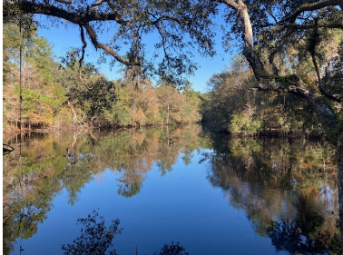

Paradise Meadows RV Park
Reset for Hearing Nov. 4

Image by Wendy Melnik

Plan to attend the Citrus County Commission meeting scheduled for Tuesday, November 4 , at 5:01 p.m. at 110 North Apopka Avenue, Room 100, Inverness, FL. 34450. In September, the Citrus County Planning and Development Board denied this application to develop 49 wooded acres on CR 39 (1135 E. Withlacoochee Trail) in Dunnellon into a 230-unit RV park bordering the Withlacoochee River that is designated an Outstanding Florida Water. Robin Orlandi spoke as the Sierra Club Adventure Coast

Group Citrus Conservation leader, raising our concern about the impacts of proposed on-site wastewater treatment since this property is within a coastal lakes flood zone and has flooded in the recent past.
Local residents organized “Save Our Withlacoochee River” and over 40 attended to oppose the Planning meeting. They objected to the intensity and environmental impacts of this large-scale development on the area’s wildlife corridors and the Withlacoochee River. Concerns were also raised about increased traffic on County Road 39 and noise disturbances in the surrounding communities.
Sierra Club Adventure Coast is concerned with the impacts of the proposed on-site wastewater treatment since this property is within a coastal flood zone that has flooded in past storms. On-site drain fields here would not adequately contain waste generated by the RV’s, clubhouse, bath houses, restaurant and other facilities to prevent impacts to groundwater and river water quality. Concentrated RV holding tank blackwater is overlooked as a hazard.
Article courtesy of Sierra Club Adventure Coast Group

FDEP: Deny the Permit - Track Line Rail LLC

Thousands of retired, creosote-soaked railroad ties bordering residential areas in Chatmire and less than a mile from Rainbow River; Image via Rainbow River Conservation, Inc.

In the wake of a proposed establishment of a creosote-treated railroad-tie shredding and grinding facility by Track Line Rail LLC, the Dunnellon City Council, during a special meeting on October 27th, voted unanimously to send a letter to the Florida Department of Environmental Protection (FDEP) opposing a potential hazardous railroad operation. The City Council was overflowing with concerned residents and environmental advocates.
Marion County Commissioner Kathy Bryant was present and noted that Marion County has already notified the company of its violation of Marion County code. If the ties are not removed in 14 days, an injunction will be filed by the County. She also noted that even if FDEP approves the permit, the company would have to apply for a special-use permit, as the land CSX owns for this project is zoned for Agricultural Preservation. See the WCJB 20 news story following the meeting.

Concerned Dunnellon and Chatmire Residents overflowing outside of the Dunnellon City Council
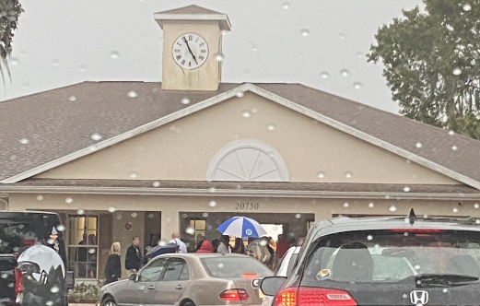

(image taken by Denise Dookeran).

Creosote is a coal-tar derivative and is a known carcinogen that contains polycyclic aromatic
hydrocarbons (PAHs), substances linked to cancer and other serious health problems (Creosote; Murty, 2025). The proposal has significant environmental concerns as “The mounds and proposed processing site are less than 1,000 feet from the Rainbow River” (Murty, 2025), and the runoff from the facility would contaminate the Rainbow River watershed.

There are serious health and environmental justice concerns as the “grinding site sits right behind the predominantly Black Chatmire neighborhood” (Schnabel, 2025). The proposed grinding facility would release dust and particulate matter into the air, endangering residents - “According to documents submitted for the company’s air permit, the grinding process could release up to 59 tons of tiny, airborne particles per year, more than the weight of a loaded 18-wheeler” (Schnabel, 2025).

Track Line Rail LLC “tried to establish its first Florida site in Newberry earlier this year but left the city after regulators discovered its grinders were running without permits” (Schnabel, 2025). Plus, the FDEP required the company to clean up the Newberry site before vacating, since an “analysis found high levels of some volatile organic compounds that were of concern to health and the environment”
(Schnabel, 2025).

Tell the FDEP to deny Track Line Rail LLC’s air quality permit application for the destruction of railroad ties! Call FDEP at 850-717-9000 or email agency_clerk@dep.state.fl.us.

References
Environmental Protection Agency. (n.d.). Creosote.
EPA. https://cfpub.epa.gov/ncea/iris2/chemicalLanding.cfm?substance_nmbr=360
Murty, J. H. (2025, October 23). Environmental concerns arise over creosote-tie grinding facility
application near Rainbow River. Ocala Gazette. https://www.ocalagazette.com/environmental- concerns-arise-over-creosote-tie-grinding-facility-near-rainbow-river/
Schnabel, R. (2025, October 25). Railroad tie grinding company ousted from Newberry tries again in
Dunnellon. WUFT. https://www.wuft.org/business-news/2025-10-24/railroad-tie-grinding-company- ousted-from-newberry-tries-again-in-dunnellon
Article courtesy of Sierra Club Adventure Coast Group

Stop the Sandmine

Image compliments of Colleen Farmer

George Southworth submitted a land use change application to Citrus County seeking approval to mine for sand on about 320 acres of land in Citrus County of which he was trustee and that is adjacent to the Suncoast Parkway Extension. The application was denied at the June 27th Citrus County Special Master hearing because it failed to meet the final site restoration requirements of the comprehensive land use plan. A subsequent hearing before the Citrus Board of County Commissioners set for August 12th was cancelled at the request of the applicant. On August 6th, the Florida Department of Transportation (FDOT) deposited $2.2 million into the Citrus County Registry to acquire about 50 acres of the parcel bordering the Suncoast Highway extension by eminent domain – possibly to mine for sand for the Suncoast Parkway. According to an August 11th article in the Citrus County Chronicle, the ownership of the remaining property has transferred from the previous applicant, George Southworth, to 3KS Family Limited Liability Partnership.

FDOT held an Open House on the Suncoast Parkway Extension in Citrus County on Thursday, October 9 in Lecanto. Sierra Club Adventure Coast’s Citrus Conservation Committee leaders Maxine Connor and Robin Orlandi attended the open house and asked questions about the Citrus Sand Mine issue. The Southwest Florida Water Management District (SWFWMD) is processing the Environmental Resource Permit, and FDOT is evaluating the property. FDOT staff were cordial but made no specific commitment on how they would handle this issue. Learn more at the website: www.SuncoastParkwayPDE.com

Please send in your concerns to FDOT to: Anil J. Sharma, P.E. Consultant to Florida’s Turnpike Enterprise, at Anil.Sharma@dot.state.fl.us, via mail to P.O. Box 613069, Ocoee, Florida 34761-3069, or call (407) 264-3041. Adventure Coast Group is concerned about the applicant’s failure to assess the potential on-site impacts to the aquifer due to the proximity of the interconnected surficial and Floridan aquifer identified in the hydrogeological survey. Crystal River Springs Complex is a designated Outstanding Florida Spring that is located within the Springs Priority Focus Area for the FLDEP Basin Management Action Plan. We will continue to seek protection for our springs and aquifer. Local citizens have organized Stop the Sand Mine and are concerned that the public is being denied a voice in the matter. Visit StoptheSandMine.com. Contact them at stopthesandminecc@gmail.com.
Article courtesy of Sierra Club Adventure Coast Group

SIGN UP TO BE A SPRINGS ADVOCATE:


Sign up here for updates on threats, victories, and ways to defend our waterways.
To act fast when it’s time to make a difference, opt in for text alerts too. No spam, no fundraising, just urgent alerts delivered straight to your phone when it matters most.
Check the Florida Springs Council’s website for updates on current issues and legislative session: https://www.floridaspringscouncil.org/

Check the Florida Springs Council’s Facebook page for updates:
Watch for Springs Advocacy Facebook/YouTube learning sessions. View past recordings.
https://www.facebook.com/floridaspringscouncil

Florida Springs Council
teosnpdorS21l6t90h99f24185g1lt375h16hll0h5160hh48fc590cahi18 ·

What if…hear us out…instead the state used these funds to acquire one of the high priority projects on the Florida Forever list, for example:
Florida’s First Magnitude Springs - $60.8 million to acquire the project’s remaining 6,771 acres Wakulla Springs Protection Zone - $75.5 million to acquire the project’s remaining 3,296 acres Aucilla/Wacissa Watershed - $81.9 million to acquire the project’s remaining 41,129 acres https://www.facebook.com/floridaspringscouncil#?hda

Daytona Beach News-Journal ·
tonospdSeru:s2Paltu 80095m5f 602086Mm1uugtA2f31l4 1c960 t952
U.S. Rep. Randy Fine, R-Florida, has proposed a bill seeking to study converting Ocala National Forest into a national park to better protect springs. Florida Springs Council

September 18 at 11:08 AM ·

“An environmental group, the Florida Springs Council, has been fighting for years to get DEP to follow the law, so far with little success. I was curious about what their longtime executive director, Ryan Smart, thought of Fine’s national park proposal.
The answer: Not much. “I can’t see any way in which it will benefit Florida’s springs,” he told me.” https://floridaphoenix.com/2025/09/18/national-park-proposed-for-florida-springs-doesnt-spring-from- desire-to-fix-problems/?fbclid=IwY2xjawNE PJleHRuA2FlbQIxMQABHnaFbJFDo5F-hdynq0XC_QZKr6-
kARe1NEOJqGfKM7ln5uUC0Pd4PB01-P91_aem_8vyP52-3NnrHyfiXivs5Bg
Craig Pittman
September 18 at 9:06 AM
The push to create a Florida Springs National Park doesn’t spring from a desire to really fix what’s wrong with the springs. My latest column for Florida Phoenix News also features shout-outs to Samuel Taylor Coleridge and the Fantastic Four.

Florida Springs Council
tonospdSere:e2Paltu 11095m5f 60y086Mm1utsrYaf31l4d2c960 t952 ·

·The Florida Springs Council is interested in seeing the results of the study and what the benefits and possible additional protections would be for Florida’s springs. However, we do have concerns with having these areas that are already protected as state parks and
state forests instead be managed by federal agencies as well as the impact of converting the Ocala National Forest into a national park.
We applaud the state for how well they manage the state parks and state forests and don’t want to risk the protections, management and recreational opportunities that are already in place. We’d like to learn
more about the changes in protections and public access that would result from the study area becoming a national park.
​
UPDATE ON THE NONPROFIT FLORIDA SPRINGS COUNCIL TAKING LEGAL ACTION AGAINST THE FLORIDA DEPARTMENT OF ENVIRONMENTAL PROTECTION (FDEP) RE: THE SPRINGS HARM RULE SPRINGS HARM RULE LEGAL CHALLENGE
FSC is taking legal action to Protect Springs from Over-Pumping
UPDATE August 14, 2025
On Aug. 13, FSC filed an appeal with the 1st District Court of Appeal to overturn the decision made by the Administrative Law Judge on the “Springs Harm Rule”—our legal challenge against FDEP’s weak
water use permitting rules proposed for Outstanding Florida Springs.

FDEP’s Rules are an unlawful end-run around the Legislature’s mandate in section 373.219(3), Florida Statutes, that FDEP (Florida Dept. of Environmental Protection) adopt rules that prevent groundwater withdrawals from harming Outstanding Florida Springs. The new Outstanding Florida Springs permitting standard in 373.219(3), Florida Statutes, required FDEP to adopt new CUP (Consumptive Use Permit)
rules that prevent harm specific to Outstanding Florida Springs. FDEP instead re-adopted existing rule language already applicable to all water bodies generally. As a matter of law, this Court should reverse the ALJ’s (Administrative Law Judge) ruling upholding the Rules because: (1) the ALJ misinterpreted Supreme Court precedent that a judge need not make a threshold determination of statutory ambiguity before turning to available tools of statutory construction; and (2) the ALJ misinterpreted the statute’s plain language.
​
FSC (Florida Springs Council) staff and our attorneys have been hard at work on the appeal, and we’ll continue to provide updates as this moves forward.”
Read the rest of the history on this issue here: https://www.floridaspringscouncil.org/springsharmrule

RESTORE COMMUNITY PLANNING – FIX SENATE BILL 180 – ACTION ALERT - ACT NOW – TELL YOUR LEGISLATORS TO FIX SB 180 – THERE IS A PRE-WORDED MESSAGE WHICH YOU CAN SEND AS IS, CUSTOMIZE TO YOUR LIKING, OR DELETE AND WRITE YOUR OWN MESSAGE Click on the link to the 1000 Friends of Florida Website to learn about SB 180 and its damaging
impacts. Read the legal analysis. SB 180 was presented as a storm recovery measure, but it has stripped local governments of their ability to plan responsibly for growth, flooding, and disaster resilience. Communities like ours need the freedom to protect neighborhoods, natural areas, and infrastructure -- especially as we face more
intense storms and rapid development, and especially since we are a coastal community.
Ask your legislators to restore local planning authority by fixing this dangerous law. Local voices should guide local growth and development decisions -- not one-size-fits-all rules from Tallahassee.

TELL YOUR LEGISLATORS TO TAKE ACTION ON SB 180 HERE:
https://1000fof.org/priorities/restorecommunityplanning/#/19/

TALKING POINTS FOR SB 180:
https://1000fof.org/priorities/restorecommunityplanning/upcomingmeetings/

OTHER UPDATES FROM FACEBOOK PAGES OF FLORIDA SPRINGS COUNCIL’S AND OTHER PERTINENT ONES
Rainbow River Conservation, Inc.
January 21 nSdptosroe0iyhu2224n6u0lg50aJ65h8t1cc17 6712tcra39a5a9af1244 ·
RRC would like to extend its gratitude to everyone who attended, making it an incredible event. The presentations were highly informative, and we hope attendees left with a better understanding of the
potential negative impact of the proposed Paradise Meadow RV Park on the Rainbow and Withlacoochee Rivers. We appreciate Ryan Smart from the Florida Springs Council for emphasizing the need to unite in the fight for springs protection, legal action, and advocacy.
Florida Springs Council rnSesodtop87h3m1J 33:11aum500tggf1l 8aM 43m7i0u3a y00Pi3gf37 ·
#DYK To use more than 100,000 gallons of water per day requires a consumptive or water use permit issued by one of Florida’s water management districts. To receive a consumptive use permit, an applicant must meet what is called the three prong test:
Reasonable/Beneficial
Does not interfere with existing uses
IN THE PUBLIC INTEREST
In the four water management districts containing springs, a permit has not been denied for the potential to cause harm to the water resources over a decade.
Watch our Springs Advocacy 101 Players &amp; Policies Discussion on YouTube to learn more Link in bio! In the YouTube video, Consumptive Use Permits are discussed from 25:05-30:45

https://linkin.bio/floridaspringscouncil/?fbclid=IwY2xjawMcptpleHRuA2FlbQIxMABicmlkETFNMzJhY1Jw bkExTTlqUE9xAR6MjW60FfdITCH4tyxxRfcw9GWe8GW3ihyD9Xs4KNKWnf71rKVKoYNI6eJoUw_aem_RNT
3Qou8UUq8fp1zEUn5Yw

Florida Springs Council
View the video of the live discussion, Springs Advocacy 101, for a deep dive into Minimum Flows and

Levels, Recovery Strategies &amp; Water Use Permitting - PART 3 OF THE SPRINGS ADVOCACY 101 SERIES -
This LIVE DISCUSSION was hosted on the Florida Springs Council&#39;s Facebook and YouTube on Wednesday, September 24 at 6:30 p.m.
https://www.facebook.com/floridaspringscouncil/videos/1433188544430306

FEDERAL CLEAN ENERGY POLICY UPDATES:
Clean Energy Tax Incentives Ending this year: The “Big Beautiful Bill” that was passed in July, 2025
imposes new end dates for many IRA clean energy programs &amp; incentives including:
• Electric Vehicle Tax Rebates ENDED 9/30/25
• Solar &amp; energy efficiency upgrades Tax Rebates END 12/31/25
• For details, see article below:

Take Advantage of Clean Energy Tax Incentives Before It’s Too Late (by Serena Golden for SACE 8/19/25) The Trump Administration’s one big budget bill eliminates clean energy tax
incentives on an aggressive timeline. Some tax credits that were previously scheduled to be available through 2032 are now ending as early as Sept 30, 2025. Here are the tax credits you should consider using while there’s still time.
https://cleanenergy.org/news/take-advantage-of-clean-energy-tax-incentives-before-its-too-late/

To read more about recent federal policy changes visit the Southern Alliance for Clean Energy (SACE) website: https://cleanenergy.org/our-views/?visc-qf news_tax_filter_topic%5B%5D=energy-policy

Inside the EPA’s Disastrous Proposal to Eliminate the Endangerment Finding: (by Chris Carnevale SACE 9/9/25) EPA political appointees have proposed prohibiting federal limits on greenhouse gas climate pollution. https://cleanenergy.org/news/inside-the-epas-disastrous-proposal-to-eliminate-the-
endangerment-finding/?emci=0de24c08-fa8f-f011-b484 6045bdeb7413&amp;emdi=63164526-9a94-f011-
b484-6045bdeb7413&amp;ceid=6152255

Southern Alliance for Clean Energy Comments on Proposed Rescission of the Endangerment Finding (by Chris Carnevale SACE 9/23/25) SACE strongly opposes the EPA’s proposal to rescind the Endangerment Finding, which threatens vital climate protections. Our official comments emphasize stronger scientific evidence and affordable clean energy solutions that reinforce the finding’s importance. https://cleanenergy.org/news/sace-comments-on-proposed-rescission-of-the-
endangerment-finding/
https://cleanenergy.org/news/sace-comments-on-proposed-rescission-of-the-
Transportation Electrification in the Southeast: Sixth Annual Report Sept 2025 (by M. Vining &amp; M. Khatib for SACE) (45 pages) This report discusses the progress of southern states in EV sales and charging infrastructure https://cleanenergy.org/wp-
content/uploads/Transportation%20Electrification%20in%20the%20Southeast%202025.pdf
For continuing updates on clean energy in the southeast including Florida, visit:
https://cleanenergy.org/

Updated 10/28/25

