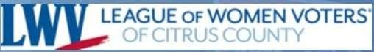
January, 2026
LEAGUE OF WOMEN VOTERS OF CITRUS COUNTY
Vicky Iozzia is the Editor of this newsletter. Our mailing address is LWVCC. P. O. Box 1903, Lecanto, FL 34460 Our website is lwvcitrus.org
Our email address is lwvcc2013@gmail.com
Our January 14, 2026 Guest Speaker will be Damaris Allen and Ami Marie Granger Welch of Families for Strong Public Schools. It will be at the Coastal Region Library, 10 am. See page 4

Our January 14 Zoom features County Administrator Steve Howard, who will inform us about the state of our roads. It will be on Wednesday, January 14, at 7 PM. See Page 5 to register.

Our February 14 General Meeting features Tiarra Alexander as guest speaker. Tiarra is very active in volunteering and working for our community. It will be at the Coastal Region Library, 10 am. See page 6

Please visit our Facebook page and "like" us! https://www.facebook.com/leagueofwomenvotersofcitruscounty
We want to thank the following businesses for their cooperation: FGE Printing, Glory Days Restaurant, Citrus County Chronicle, Pinnacle Printing


HAPPY NEW YEAR EVERYONE!

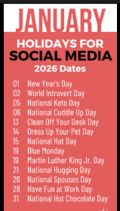
.

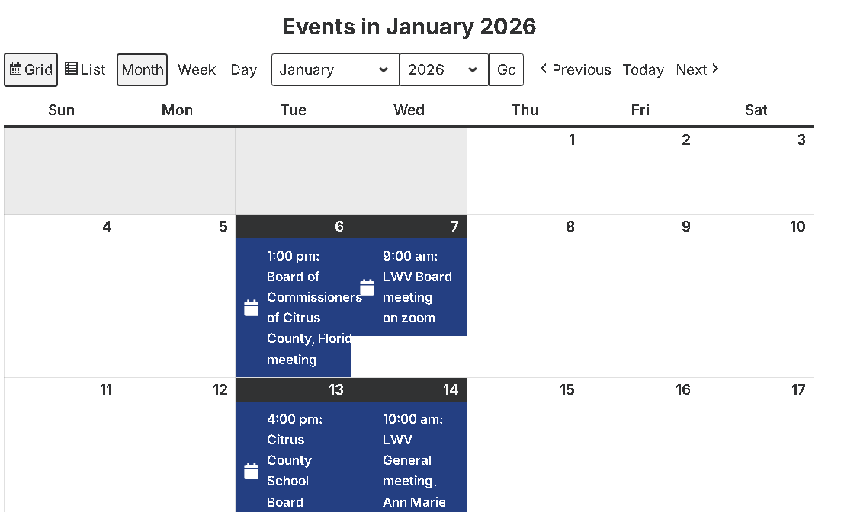
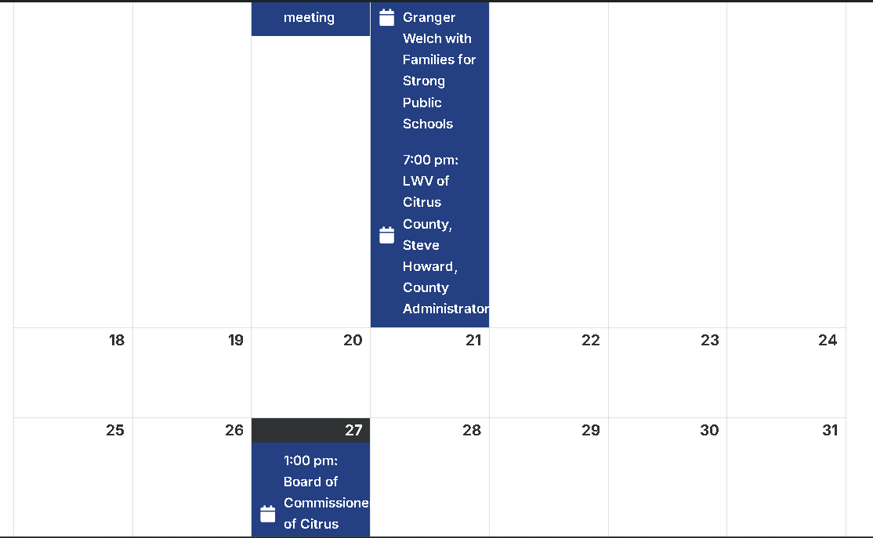
This calendar is from our website: Lwvcitrus.org
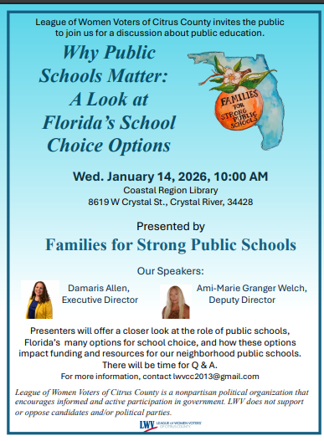

I would strongly suggest that you watch the following video to prepare for the following meeting: https://www.youtube.com/watch?v=9AfP4Qd9Acw
This video, from September 2024, describes what the County is facing, and what has been done in resurfacing.

The League of Women Voters
of Citrus County presents a Zoom meeting,
Wednesday, January 14, 2026, at 7 PM
“Roads in Citrus County: Past, Present, and Future
County Administrator Steve Howard

Are you wondering what’s going on with the roads in Citrus County? County Administrator Steve Howard will present information regarding the almost 2,000 miles of roads in our County.
To register:
Go to lwvcitrus.org
Click on Upcoming Events
Click on the link: https://us06web.zoom.us/meeting/register/0Zs4B7TFRAKvPHBoCHuPLwlick o
Fill in your information and you will receive an email with the link to attend.
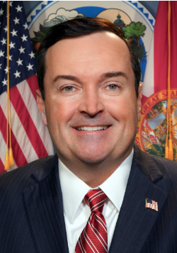

County Commissioner
Steve Howard

The Public is invited. For more information call 352 613-5056 or email lwvcc2013@gmail.com. Visit lwvcitrus.org and our Facebook page, “League of women voters of Citrus County”
The league of Women Voters is a non-partisan political organization, never endorsing or opposing political parties or candidates. LWVFL and National LWV develop positions on issues only after careful study and consensus.


TABLE OF CONTENTS – JANUARY, 2026 LWV CITRUS NEWSLETTER

January14 meeting with Ami Marie Granger
Welch of Families for Strong Public Schools Page 4
January 14 Zoom meeting with Steve Howard Page 5
February 11 meeting with Tiarra Alexander Page 6
Linda Abels, Membership Chair Page 8
Vicky Iozzia, Page 9 to 10
December Luncheon with Scott Hebert and
David Vincent Pages 11 and 12

Peg Primeau, New Year’s Insight, Manatees Pages 13 to 16 Rosemary Nilles, Legislative Watch, Redistricting,
Letter to Chronicle about veteran suicide and firearm
Safety Page 17 to 21
Kwanzaa by Dr.BJ Ezell Page 22
Wanda Brown scores a Grant! Page 23
County information Page 24
Legislator Contact Information Page 25
From SOE Mo Baird Page 26
League Social at Cattle Dog Restaurant Page 27
From the LWV Impact on Issues – Redistricting Page 28 to 29
In the News Pages 30 to 33
From the ACLU Pages 34 to 38
From the Florida LWV – Legislative Plan Page 39
National League of Women Voters Page 40
Jan Hall Archives – April 2016 – talk on the Homeless Page 41
Maxine Conner, Natural Resources Chair Pages 42 to 54

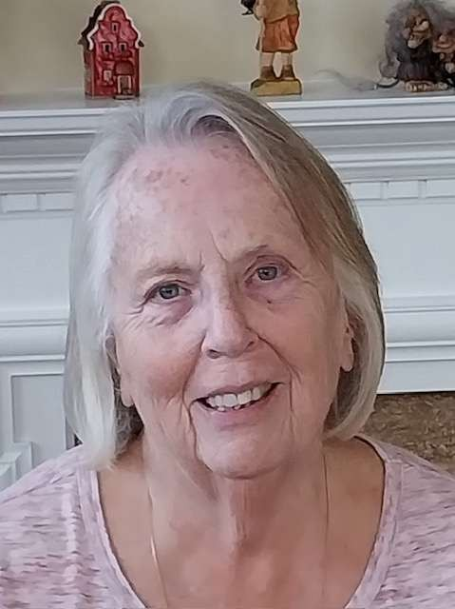

Linda Abels, Membership Chair
Happy New Year! I hope everyone had a wonderful holiday season. As we head into January, many of us are focused on health and fitness goals—but I hope you’ll also consider a resolution to get more involved with the League of Women Voters!
We have so many ways to make an impact this year, and our committees could truly use your unique talents:
- Education: Rosemary can always help tracking proposed legislation that affects our schools, writing letters, etc.
- Environment: Maxine is working diligently on local environmental issues and needs extra hands.
- Voter Outreach: We are already preparing for candidate meet-and-greets for the primary elections.
- Special Projects: We need help with fundraising, advocating for the restoration of rights and publicity.
If any of these sparks your interest, please reach out to a board member. We’d love to find a spot that fits your passions!
Finally, please join me in giving a warm welcome to our newest member, Karen Rittweger. We look forward to meeting her at our next gathering!
Linda

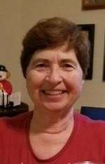

Vicky Iozzia, 1st President, Newsletter Editor,
Webmaster, Speakers Bureau Chair

2026.. By the time you read this, 2025 will be over. I can’t say that I am sorry to see 2025 go. So many bad things happened to me personally and to the world.

The ritual begins again. Somehow people buy into the myth that a brand-new year will bring changes. That’s simply not true. The brand-new year will only bring changes if we make them happen.

So many people I know are overwhelmed by life. Just getting by day-to-day is almost more than they can handle. They can’t bother watching the news or researching things that they don’t understand. They are worried about their finances, their family. They just try to keep their heads down and hope that nothing else bad will happen.

Others watch tic-toc with silly videos to keep entertained.

What will 2026 bring us? I pray that Americans have had enough of the lies and that the democracy we sadly took for granted survives. I hope it brings sanity and pride to our country again. We are not free until everyone is free.

I don’t do New Years resolutions. I have plenty of resolutions that I work on during the year. Statistically people break their resolutions by the second Friday in January, I read. It is even called “Quitters Day.” Better that we pick ourselves up and re-resolve when the resolution slips.

As far as the League is concerned, our Board is working toward another successful year. Our monthly general meetings have been successful, as have the Zoom meetings in the evening for people who work during the day.

I am proud to be working with the wonderful Board. They work hard, have great ideas, and are a pleasure to work with.

I have put many pieces in this newsletter asking for people to help us. I will not put them in anymore. (Thank you, Linda, for your column.) However, we are always willing to work with people who want to get involved.

When I attend Zoom meetings with other Leagues from our state, they are able to do much more because they have more people involved.

We have a League election coming up in March. I am happy to say that most of the Board wants to continue as last year. Me too. You will hear more about this in the next newsletter.

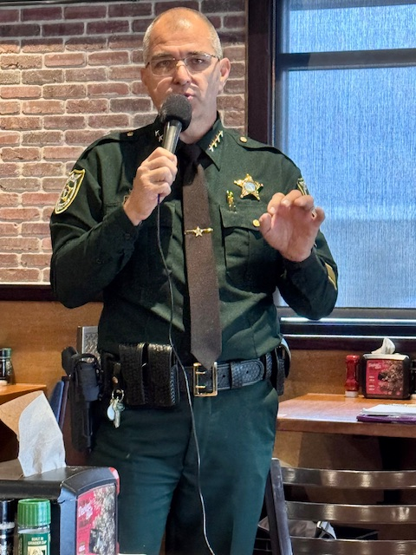
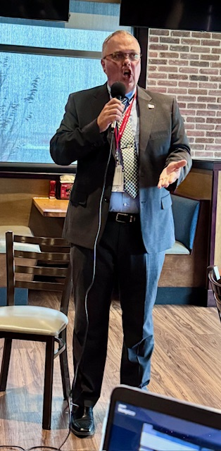

Superintendent Scott Hebert and Sheriff David Vincent dazzle the crowd at Glory Days on Wednesday, December 10, 2025, at our Holiday Luncheon at Glory Days in Lecanto.

For our Holiday luncheon, we wanted to have something festive. You know lately as we look at the news it is a downer. We hit it out of the park with this double-header of speakers: two honest, upbeat, positive, and informative speakers who wowed us all.

I am proud to know both men. I believe in them, and appreciate all that they have done, before and after their election to their respective positions.

I introduced them with a list of their experience and many accomplishments. It’s really stunning to see. (Check the link at the end of this article). When they saw the two microphones they were ready to do a boy band lip synch. Darn! I didn’t have the right music!

The audience responded with much applause, before they even spoke, and interrupting as they made points describing what they have done.
I am going to summarize some of the points for each servant/leader. For our Sheriff:
- Making his employees’ lives better by switching healthcare plans to save them money.
- Creating a positive environment such that former employees are returning to work.
- Purchasing bodycams and the required infrastructure for all the Deputy Sheriffs.
- The bodycams provide livestreaming, so command decisions can be made immediately.
- Sponsors deputy sheriff candidates so that they can get paid training
- More applicants for positions
- Obtained COPS grant to employ more deputies
- Initiating a salary study to figure out how to increase staff salaries
- Partnering with the School District to train teenage drivers
- Close partnership with the Superintendent
Superintendent Hebert spoke about:
- Dealing with the deaths of people in the District
- Sheriff Vincent mentoring the current Chief of Police
- 80% of the families in the district choose public schools
- 92% graduation rate
- “B” District
- Career technical opportunities being afforded the students
- Superintendent’s Counsels for community people, business owners, teachers, and support staff
- Taking a group of students to Tallahassee to see how State government works
(Do you know where the term “lobbyist” came from? I didn’t know. You’ll have to watch the video to see).
- Partnering with the College of Central Florida to enable students to take dual enrollment courses on campus.
- Expanding evening courses.
- New logo for the District, which cost the district $0 (yes, that is zero)
- Goal of 100% graduation rate
- Working on improved healthcare and higher salaries for staff. (Administrators have not received salary raises)
- Improving use of technology
- Preparing our kids for the future, whatever jobs may exist then
(By the way, I used AI from Zoom to summarize this meeting).
You can view the entire meeting by clicking on this link: https://youtu.be/VkSG3258x1A

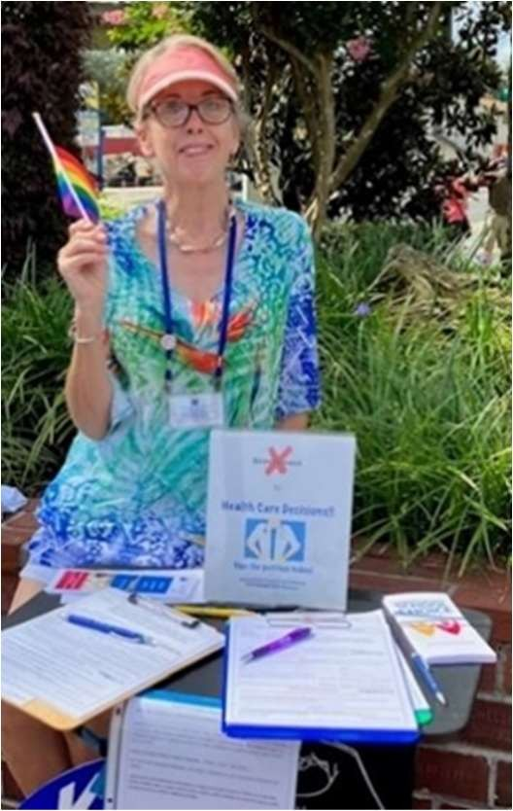

Peg Primeau, 2nd President, Reproductive Health & Justice Chair
Sex Education in Florida
New Year’s Insight
Question: “If legislators in FL just vote with the party, what’s the point of contacting them on issues?”

Answer: It can be a default position rather than an active choice. Legislators have to vote on so many bills about such diverse topics, they can't possibly be knowledgeable on everything. They don't have time to do deep dives on their own.

This was the perspective presented by Rep. Kelly Skidmore (Dis. 92) during a recent advocacy zoom. It is her first thought when reaching across the aisle to create collaborations.

For the individual voter, it means that just because I'm immersed in an issue doesn't mean my elected representatives know much of anything about it. Worse, they may have only negative misinformation so far.

So, it's our job to educate lawmakers on the facts as we express our views. Calmly and objectively, as Rep. Skidmore advises.

Let's not presume our messages fall on deaf ears. Let's make enough noise with facts to be sure our lawmakers vote with eyes wide open during the 2026 session.

Stay tuned for Action Alerts. Take a moment to get the facts, then reach and teach.

Peg wrote this for the editorial page of the Chronicle.

Endangered and threatened species are endangered—again
- Dec. 13, 2025 Citrus County Chronicle
Here’s what our manatees are probably thinking right now: “This new Kings Bay eelgrass is truly delish.”
Also: “What the heck is the Department of the Interior up to? We’re a sentinel species – we thought the U.S. Fish and Wildlife Service had our backs!”
Apparently not.
Last month, the U.S. Fish and Wildlife Service proposed changes to the Endangered Species Act (ESA). Passed in 1973, the ESA has prevented the extinction of hundreds of species and has saved more than 99 percent of species listed under its protection.
The stated purpose of the changes is to expedite decisions under the Act and to prioritize economic interests.
Problematic proposals include the elimination of the ESA’s “blanket rule.” This rule provides protections for threatened species equivalent to those for endangered species, including habitat protections.
Without it, protections for threatened species – such as manatees – would be determined case by case. Advocates for each species and habitat would have to argue for them every time they’re challenged.
The ESA helped Florida manatees rebound from barely 1,300 animals in 1991 to the current estimate of 8,350–11,730. That growth is heartening. However, the proposed ESA changes would mean heightened vulnerability for manatees when a coastal crisis occurs.
We face sudden seasonal disasters in Florida, such as lengthy freezes or major hurricanes. We also face sudden manmade disasters, such as Gulf oil spills or vegetation die-offs from pollution – as in the recent Indian River Lagoon crisis, where more than 1,200 manatees died.
Abrupt surges in manatee mortality can easily approach the tipping point for survival, which is the loss of 10 percent or more of the population in a single year. The Indian River Lagoon deaths were right on the edge of that 10 percent mark.
This is true for other animals and plants as well. The case-by-case plan to protect threatened species and their habitat will be too little, too late for Florida.
Another concerning change is a rule that reduces interagency cooperation. Currently, impact assessments involve input from all relevant agencies. This shift away from foresight and transparency would allow hasty shortcuts for private development, accelerating habitat loss.
The new rules also allow “consideration of economic impacts” in decisions about habitat protection. The administration claims these changes are intended to support energy independence. The ESA already includes provisions for permitting “resource extraction.” Critics warn that if a narrow cost-benefit analysis outweighs science, the result will be detrimental to species and habitat.
Bringing the issue back home, we know the health of manatees reflects the health of our waterways. We can do our own cost-benefit calculation: manatees pull their weight when it comes to tourism and the dollars it brings in.
Protections for manatees and their habitat are protections for our coastal economy and our pride in this unique environment. This benefit is important not just to our region, but to the state.
It’s true for many threatened species, but we are especially attached to our gentle giants. Manatees have flippers, not flip phones. We can speak for them – and for other wildlife. The public comment period on these proposed ESA rule changes is open until Dec. 22.

Let the U.S. Fish and Wildlife Service know that the existing Endangered Species Act is working just fine. We do not want it chipped away for the benefit of a few business interests at the expense of the public’s commitment to protecting endangered and threatened wildlife and habitat.
Go to: federalregister.gov/agencies/fish-ad-wildlife -service.

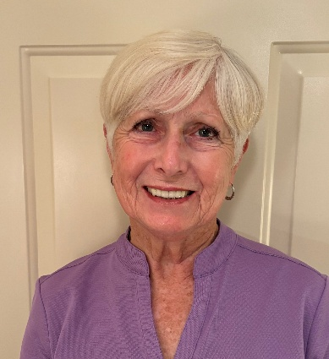

2026 Legislative Watch

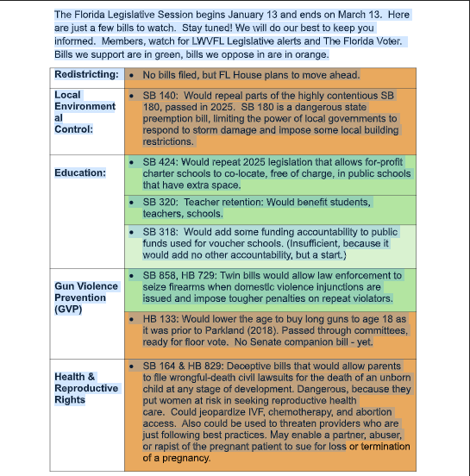

Rosemary Nilles, 1st Vice President, Gun Safety Chair,
Education Chair

Wondering Why Florida Is Planning a Mid-decade Redistrict?
by Rosemary Nilles

We’ve all heard that Florida politicians want to redistrict in 2026. But why? Florida just redistricted in 2022, following the 2020 census.

Below is a timeline of various justifications for mid-decade redistricting
made by politicians. One may draw their own conclusions.

June 9, 2025:
• Texas lawmakers first discussed redistricting after President Trump’s political
team urged them to redraw some of their 38 US House districts in order to
gain additional seats in Congress in the 2026 midterm elections. 1, 2

July 15, 2025:
• President Trump told reporters that he is pushing Texas Republicans to
redraw the state’s congressional maps to create at least five House seats
favorable to his party for the 2026 midterms. He added, “we have a
couple of other states where we’ll pick up seats also…” 3

July 24, 2025:
• Gov. Ron DeSantis stated that it was “appropriate” for the state to conduct a
mid-decade congressional redistricting because he contends Florida was
“gypped” in the 2020 Census. He said Florida should be given an
additional Congressional seat, increasing Florida’s seats from 28 to 29.
• Even without an additional Congressional seat, he advocated for mid-decade
redistricting, stating the population within Florida has shifted.
• Gov. DeSantis also cited the Florida Supreme Court decision (July 17) as a
reason for redistricting. The decision upheld the maps he drew in 2022, which
left no Black-majority voting district in North Florida, and undercut some of
Florida’s redistricting standards, particularly regarding racial considerations. 4,
5, 6

August 11, 20, 2025:
• Gov. DeSantis stated that he and Attorney General James Uthmeier wrote a
letter to the Department of Commerce to request an additional seat in
Congress, and that they supported an update to the 2020 Census. (Note:
That would mean another state would have to lose a seat in Congress.)
• The Governor again cited the recent Florida Supreme Court decision
upholding his North Florida Congressional maps as a reason for redistricting.
• He also cited the anticipated SCOTUS decision on Louisiana v. Calais, on
whether race should be a consideration in determining districts. 7, 8, 9, 10

OCT 6, 2025:
• Regarding a possible SCOTUS decision on whether it is legal to draw districts
based on race (Louisiana v. Calais), Gov. DeSantis posted on X:
• “... If the Court rules that racial gerrymandering violates the
Constitution, that would have implications for mid-decade redistricting
in a number of states, including Florida.” 11

OCT 29, 2025:
• Republican Party of Florida Chair Evan Power continued to call for
redistricting, stating that he thinks three to five GOP seats could be
added. He added that Democrats have had an unfair advantage in other
states. 12

DEC 3, 2025:
• Gov. DeSantis responded to objections by voting rights advocates, who say
that mid-decade redistricting in Florida would violate Florida’s Fair District
Amendments passed in 2010. These amendments clearly state that no
reapportionment plan or individual district can be drawn “with the intent to
favor or disfavor a political party or incumbent.” Gov. DeSantis denied
that political favoritism or partisanship would be taking place, stating
that lawmakers are “not allowed to use partisan data.”
• Instead, DeSantis stated his justification for redrawing congressional districts
as Florida will “be forced to do it because the Supreme Court’s Voting
Rights Act decision is going to impact the current map. No matter what
else, that is going to have to be addressed.” 13

Dec. 10, 2025:
• FL House Speaker Daniel Perez stated that he has had no direct or indirect
conversation with the White House or had any outside pressure about
mid-decade redistricting.
• Instead, he said, the House is moving forward in response to the state
Supreme Court decision last summer that undercut some of Florida
redistricting standards, particularly regarding racial considerations. 14

Dec. 10, 2025: Other perspectives:
• Election Attorney Andy Bardos told lawmakers regarding Louisiana v. Calais,
“In terms of binding effect, it has binding effect on Louisiana. Whether Florida
chooses after Callais to keep its maps in place, await either the next
cycle, or await litigation, or redraw its districts, that will be a judgement
call made when we see the Callais decision.” 15
• Jessica Lowe-Minor, president of the Florida League of Women Voters,
commented after the second House Committee meeting on redistricting:
“This all feels like a pretext for partisan gerrymandering. The president
has essentially asked states to gerrymander their maps to favor his party, and
given that context, how can the Florida Legislature be engaged in
redistricting and have voters feel that it is not a clear violation of our
state constitution?” 16
In another interview, she said, “In this highly partisan national context,
this really creates deep suspicion about why the Legislature would move forward
with this plan.” 17
References:
1. https://www.nytimes.com/2025/06/09/us/politics/trump-texas-redistricting.html?smid=nytcore-ios-
share&amp;referringSource=articleShare#
2. https://www.texastribune.org/2025/06/09/texas-redistricting-congress-house-republicans-midterms/
3. https://vimeo.com/1101631279
4. https://floridaphoenix.com/2025/07/24/desantis-says-its-appropriate-to-redistrict-congressional-districts-before-next-election
5. https://www.wlrn.org/government-politics/2025-07-24/gov-ron-desantis-may-seek-to-redraw-congressional-districts-before-
2030
6. https://www.pbs.org/newshour/politics/florida-supreme-court-upholds-congressional-map-that-eliminates-a-majority-black-
district
7. https://www.wcjb.com/2025/08/11/gov-desantis-calls-mid-cycle-congressional-redistricting-after-north-florida-map-upheld
8. https://www.tallahassee.com/story/news/local/state/2025/08/11/desantis-uthmeier-redistricting-census/85608955007
9. https://www.theguardian.com/us-news/2025/aug/16/ron-desantis-florida-redistricting
10. https://floridaphoenix.com/2025/08/20/florida-to-feds-give-us-another-congressional-seat-or-more-federal-funds/
11. https://www.tallahassee.com/story/news/local/state/2025/10/06/florida-desantis-redistricting-scotus/86547622007/?gnt-
cfr=1&amp;gca-cat=p&amp;gca-uir=true&amp;gca-epti=z117444d00----v117444d--83--b--83--&amp;gca-ft=72&amp;gca-ds=sophi
12. https://www.wusf.org/politics-issues/2025-10-30/florida-gop-chair-state-send-extra-republicans-congress
13. https://floridaphoenix.com/2025/12/03/desantis-says-florida-will-be-forced-to-redistrict-because-of-pending-u-s-supreme-

court-decision/
14. https://www.politico.com/news/2025/12/10/florida-gop-house-speaker-insists-white-house-is-not-pushing-redistricting-
00684542
15. https://floridaphoenix.com/2025/12/10/attorney-its-a-judgement-call-whether-florida-redraws-its-congressional-map
16. https://www.tallahassee.com/story/news/local/state/2025/12/10/florida-house-speaker-says-trump-isnt-driving-
redistricting/87690086007/
17. https://www.youtube.com/watch?v=-tCcbGvkH-c
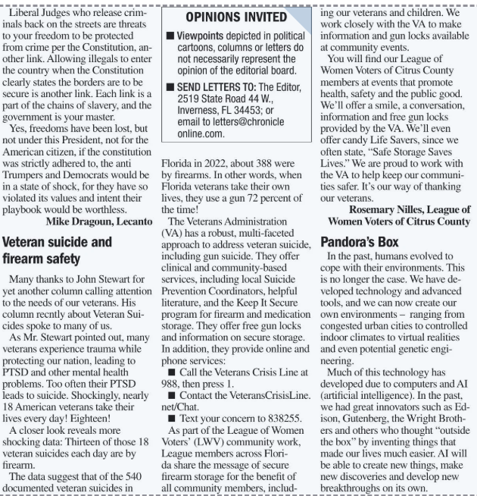

From Dr. BJ Ezell
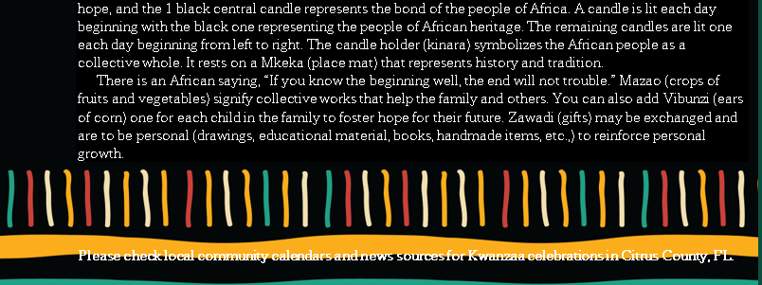


Wanda Brown

Member Wanda Brown has been working diligently for over a year to work with the prison population, to educate them on how to get their voting rights back. She recently wrote a grant and will be receiving $1000 from the League of Women Voters of the US

CONGRATULATIONS, WANDA!

From Ellen Sears
Coordinator, Civic Learning and Impact

Congratulations! LWVEF is pleased to offer your League funding of $1000 for your Justice Impacted Voter Registration Project (formerly Former & Currently Incarcerated Persons). The grant amount will be disbursed in two payments, the first payment being 75% of the total funds and the second payment being 25%, sent upon completion of the final report. The grant period is from January to November 2026.

County Meetings
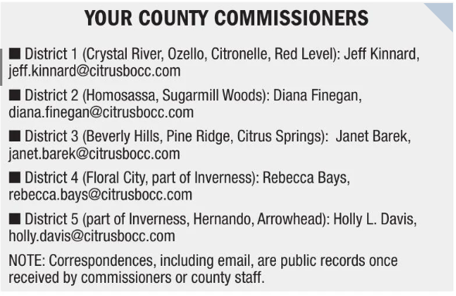

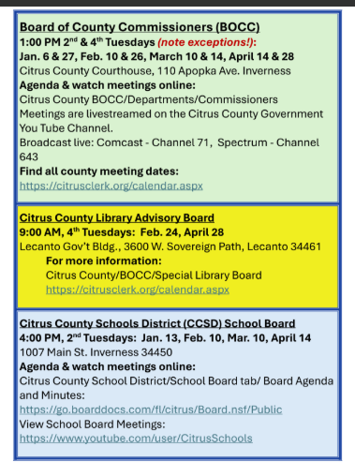

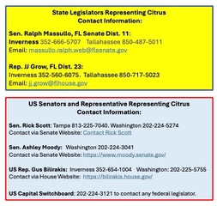

From our Supervisor of Elections, Maureen “Mo” Baird

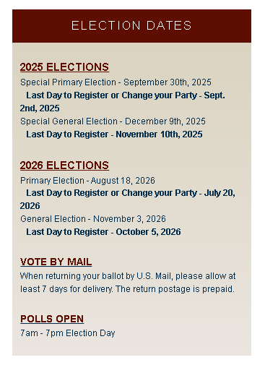

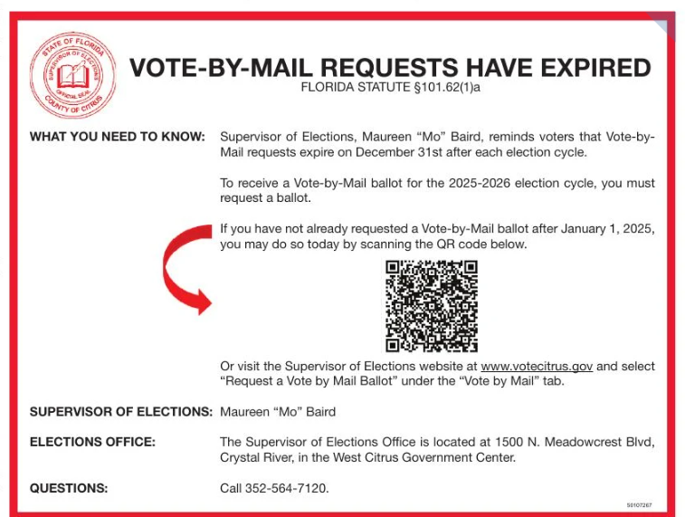

Come, join us for our Monthly Social! Have a cup of something or a meal. Join the conversation or listen.
Our next meeting is at the Cattle Dog Restaurant in Inverness, 4:00,
Wednesday, January 21, 2026
Wednesday, February 25, 2026
Wednesday, March 25, 2026

From the new League of Women Voters Impact on Issue
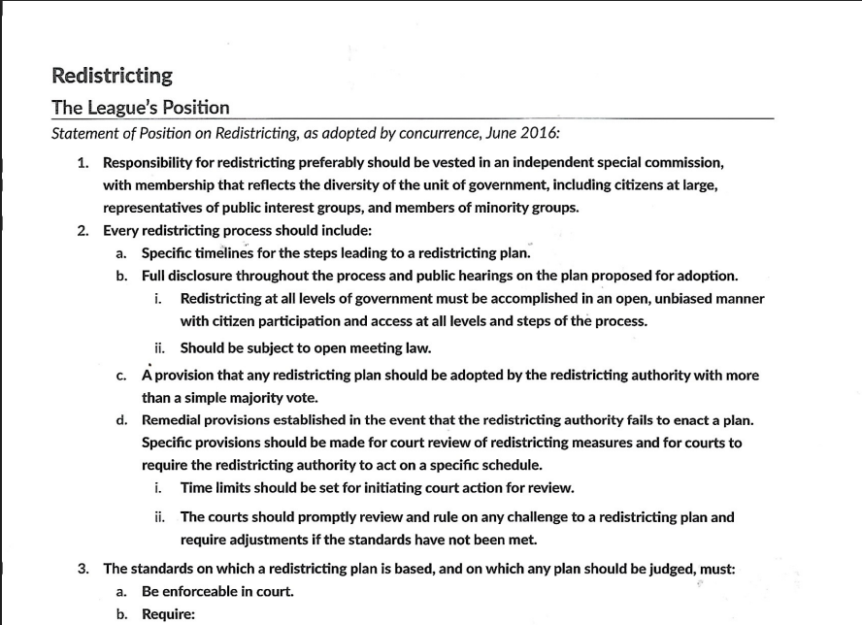

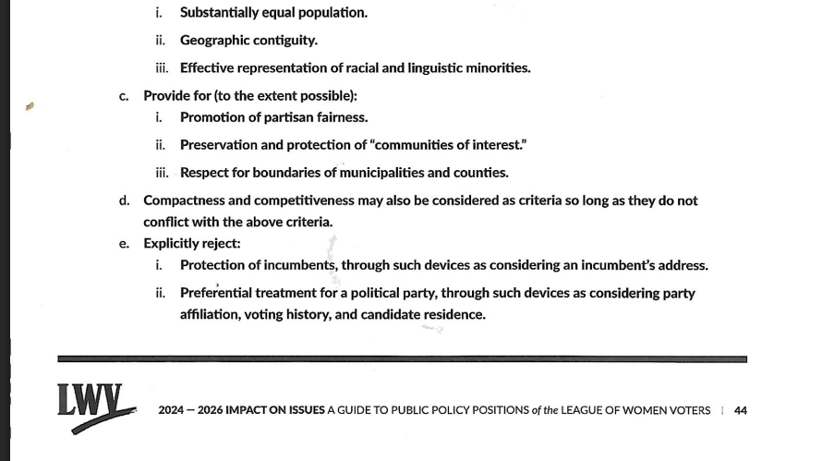

IN THE NEWS

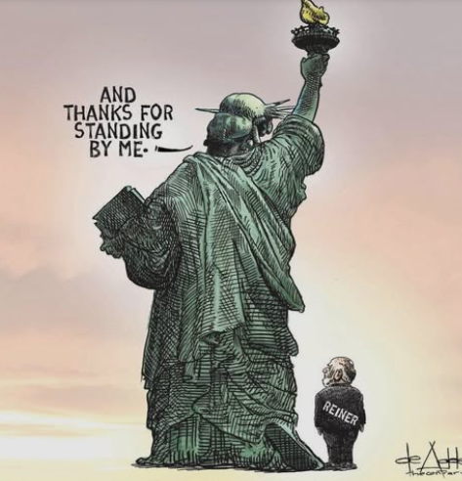







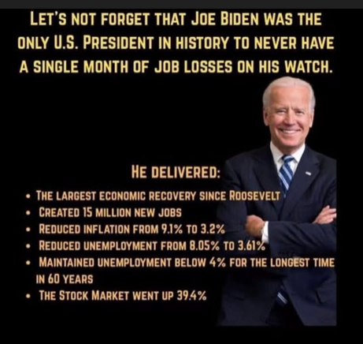

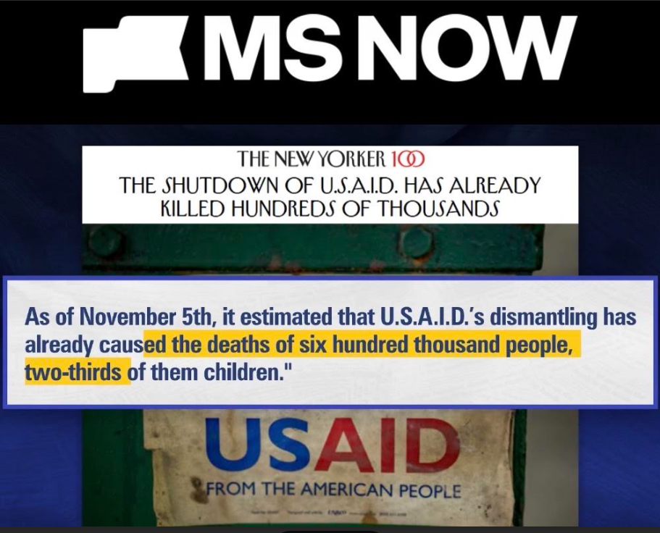

How many of these goals have been achieved?
How many are in process?
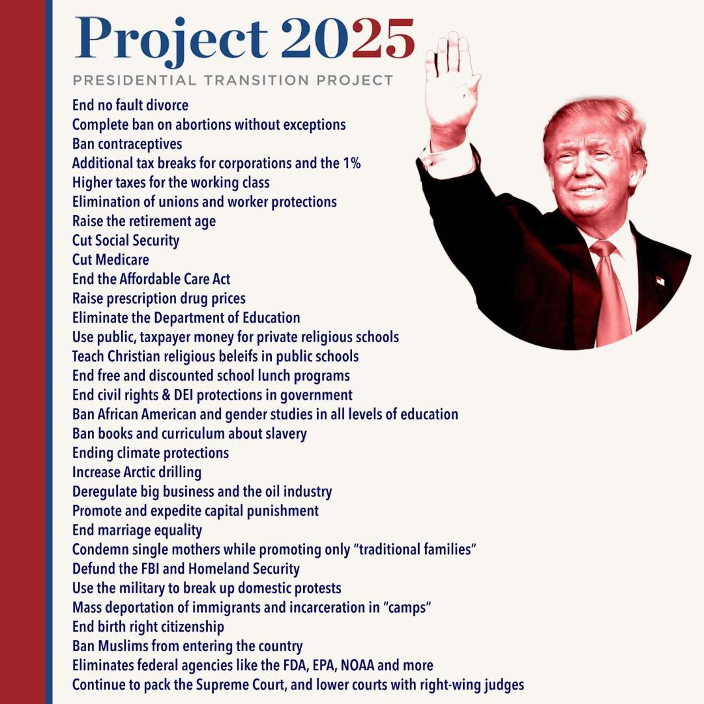

From the ACLU
Anti-abortion extremists are trying to:
- Prohibit abortion coverage in private insurance plans for millions of people who purchase their insurance in the ACA marketplace
- Impose the first-ever federal ban on abortion coverage in private health plans, and push care out of reach for pregnant patients across the country, even where abortion is legal
- Disproportionately harm those who already face the greatest barriers to care, including people of color and those with low incomes
What Gives Me Hope
https://www.youtube.com/watch?v=YysO5Xohhm4
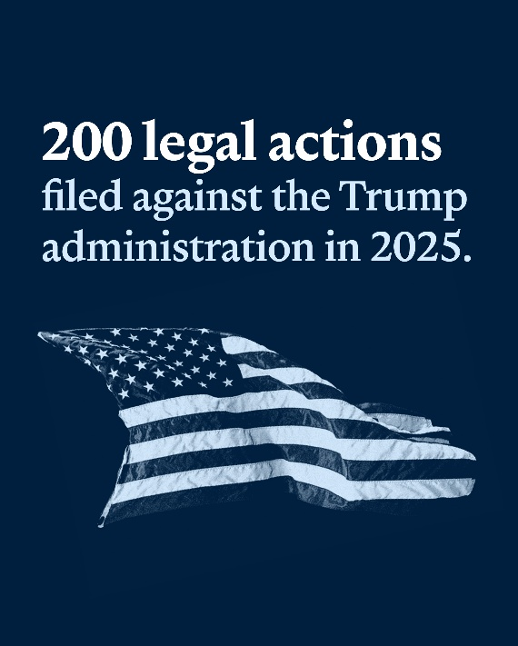
To date, we've taken 231 legal actions against the Trump administration to protect our rights.
That includes…
- 132 lawsuits
- 75 FOIA requests
- 22 amicus briefs
- 2 agency complaints
Seven of our cases protecting civil rights and liberties – including cases reining in state-level attacks and shoring up some of our most fundamental freedoms – reached the Supreme Court.
- This term, we've re-argued an essential case to protect Black voters
- In the New Year, we'll be arguing to protect trans kids' right to be equal participants in school sports
- We'll also be arguing to protect birthright citizenship – ensuring that every baby born on U.S. soil is granted the same rights and protections promised by our Constitution
Because of this work…
- Over 25,000 detained immigrants have been guaranteed access to counsel at ICE facilities that were unlawfully restricting communication with lawyers
- The legal status of 660,000 people in the country with temporary protected status was ensured, blocking the unlawful termination ordered by the Department of Homeland Security
- 310,000 parents and children can still access early childhood education despite attempts to exclude immigrant children from the Head Start program
- $45 million was restored in Title X family planning funding for preventative reproductive health care like birth control
- An estimated 2,075 potential grant recipients can still apply for over $62 million in federal arts grants – without restrictions disqualifying applicants for "promoting gender ideology"
- Over 2,000 transgender people currently incarcerated in federal prisons can access critical health care
- Peer-reviewed medical research was restored to the country's leading patient safety resource, despite President Trump's attempts to ban the words "LGBTQ" and "trans(gender)" from federal research sites



From day one in Congress, we've fought relentlessly against bills restricting our fundamental rights – and for legislation that would protect them. We've been organizing in communities across the country to demand change.
Together, we've…
- Arranged 206 meetings between constituents and congressional offices on both sides of the aisle – putting the people who will be directly impacted by this legislation in front of their lawmakers
- Built a volunteer force of over 800,000 people through our People Power program
- Helped organize No Kings events in June and October, with the fall mobilizations drawing 7,000,000 people to events across the country
And our digital community was right there with us. Supporters like you:
- Took action over 3,000,000 times to advance policies that protect our rights, condemn the worst of the Trump administration's attacks, and urge our lawmakers to truly represent the interests of their constituents

- Joined over 84,000 ACLU supporters in virtual Know Your Rights trainings to ensure that everyone is equipped to respond to policies impacting our neighborhoods
Here's what that meant…
- We protected approximately 12,000 people a year from extreme federal imprisonment by defeating a bill that would've imposed unprecedented sentences on asylum seekers, teenagers, and immigrant families
- Jimmy Kimmel's show was restored to air after the FCC pushed to censor speech that the government disagreed with, with his return being announced just hours after thousands of ACLU supporters joined to decry this government censorship
- The White House "border czar" complained that Know Your Rights trainings like the ones we've been conducting for years interfere with the administration's cruel mass deportation and detention plans, claiming that immigrants are "very difficult to arrest" when they're "educated" about their rights
- This article was updated Dec 5, 2025.
- Today, the Supreme Court announced that it will hear oral argument in our birthright citizenship case. The case blocks President Donald Trump's executive order seeking to take away the right to birthright citizenship for many native-born American children, even though the 14th Amendment guarantees that right.

AN FRANCISCO – Seven people detained by Immigration and Customs Enforcement (ICE) sued the Trump administration over inhumane conditions at California’s largest immigration detention center, the privately owned California City Detention Facility located in Kern County.
The plaintiffs, who seek to represent a class of all people held at California City, describe in their complaint:
- Punishing conditions including dirty housing units, inadequate food and water, very cold temperatures, and restrictions on family visits
- Enforced isolation caused by frequent lockdowns, no access to programming, and excessive solitary confinement
- Terrifyingly inadequate medical care that deprives people of critical treatment for cancer, life-threatening heart conditions, diabetes and other serious medical needs
- Neglect of people with disabilities including failing to provide sign language interpreters, wheelchairs, and other necessities people need to live safely
- Encroachment on freedom of religion, including confiscation of prayer mats, head coverings and even holy texts
- Denial of access to counsel, with weeks-long delays for legal calls and long waits for in-person visits

The current administration stopped the following report from being broadcasted in the United States. It is about the Venezuelan men who were sent to an El Salvador prison without due process. To see it, click here: https://www.youtube.com/watch?v=_QmW99SqBuw

LWVFL 2026 Legislative Plan

Since the beginning of the year, we have observed more threats to democracy than at any time since the Voting Rights Act of 1965 was passed. Therefore, the primary focus for LWVFL in the 2026 Legislative session is on all issues related to election law. Bills are being filed and will continue to be filed after the session begins on January 13. This requires advance development of general statements and plans related to election law.

For other important issues not related to election law, LWVFL will plan to support coalition members and encourage individual members to promote actions, but we do not plan to do independent LWVFL actions.

- Mid-decade redistricting: Advocate against this clearly unconstitutional action. Advocate for compliance with Fair District Standards for the redistricting of Congressional and Florida Legislative Districts.
- Voter registration: Advocate for status quo and against any changes that would require in-person documentation of citizenship. Additionally:
  - Support Association of Supervisor of Elections request to “Require DHSMV to treat the new DL or ID number assigned to a voter as a change in the voter registration and to provide such information to the appropriate local Supervisor and allow the Supervisor to update such information from the DHSMV during petition verification.”
  - Support Association of Supervisor of Elections request to “Specify that when an inactive voter is verified to have signed a petition that this is considered ’activity’ and the voter must be deemed active.”
- Vote-by-mail: Advocate for status quo and against any changes that would reduce access to vote-by-mail, especially as presented in 2025 legislative session. Additionally:
  - Support Association of Supervisor of Elections request to “Add affirmative notation on certificate envelope to act as a continuing request for vote-by-mail request provided that the personal identifying information of the voter has previously been provided and verified and the ballot is approved to be tabulated.”
- In-person Voting: Advocate for status quo and against any changes that would hinder voting, especially bills that would reduce the identification types a voter can use or reduce early voting time periods. Additionally:
  - Monitor any bills dealing with any type of gun at polling locations.
- Restoration of Rights Database: Advocate for bills that make it easier for returning citizens to determine if their right to vote has been restored.
- National Popular Vote: Advocate for bill if it is introduced.
- Florida Voting Rights Act: Advocate for bill if it is introduced.
- Closing the write-in candidate loophole: LWVFL is not promoting such a bill as we did in 2025 legislative session. However, we will advocate for such bill if it is introduced.
- Open Primary Election System: Advocate for bill if it is introduced.

From the National League of Women Voters
- March 2025 — President Trump’s Anti-Voter Election Order: President Trump’s “plainly unlawful” Executive Order would require documentary proof of citizenship to register to vote, prohibit the counting of absentee and mail ballots received after Election Day, and give the Department of Government Efficiency (DOGE) the authority to review states’ voter rolls. Through litigation, the League permanently blocked the provision that purported to require documentary proof of citizenship to register using the federal registration form.
- April 2025 — A Constitutional Crisis: LWV declared that the US was in a constitutional crisis and launched the campaign Unite and Rise 8.5 to mobilize voters in defense of democracy.
- September 2025 — USCIS Suppresses New Citizen Voters: The US Citizenship and Immigration Services (USCIS) released revised policy guidance barring nonpartisan organizations (like LWV) from registering voters at naturalization ceremonies. In November 2025, the League filed a federal lawsuit against USCIS, seeking to block the policy change.

From Jan Hall – the photo Archives
From April 2016, Mama Jo LeCount and Barbara Wheeler
Spoke about the Homeless
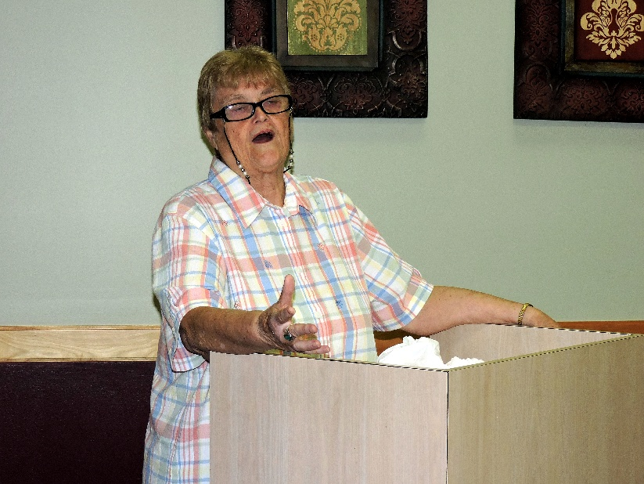
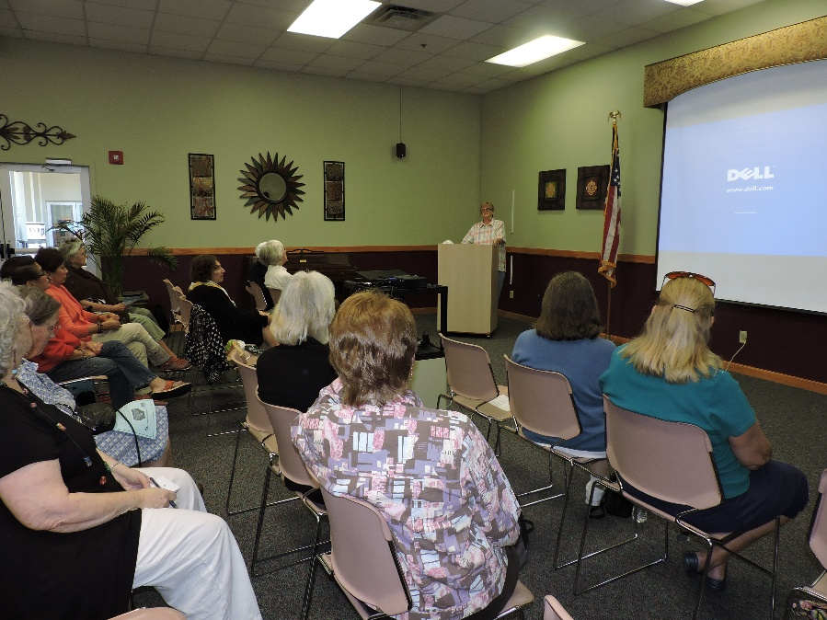
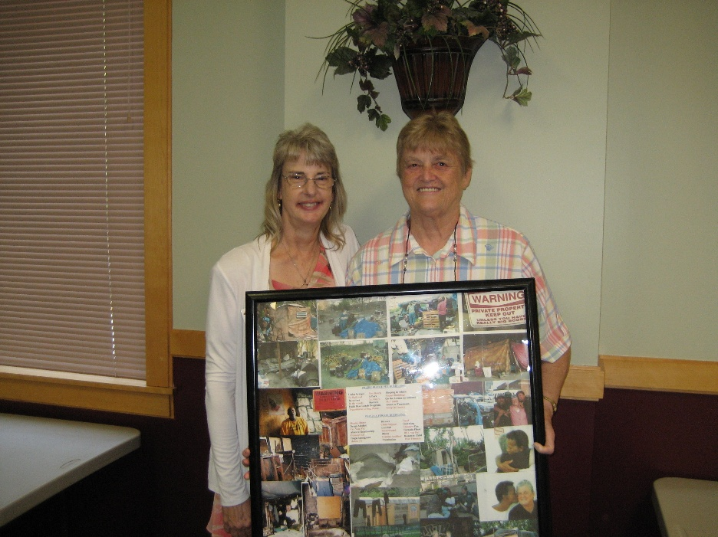
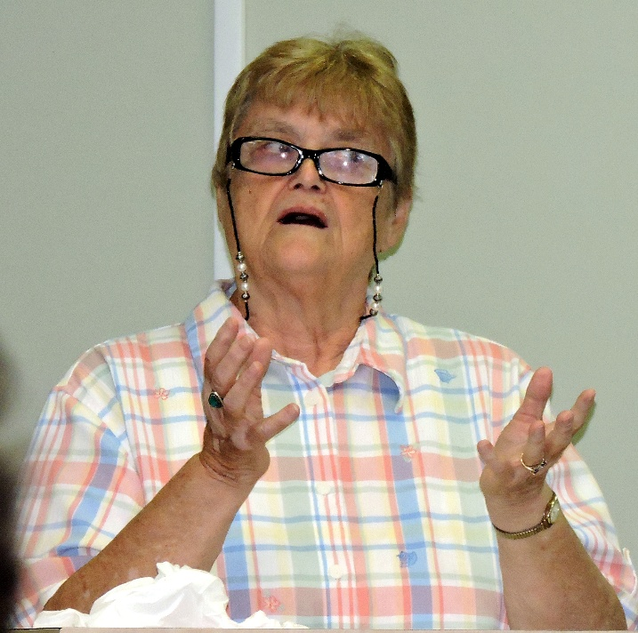

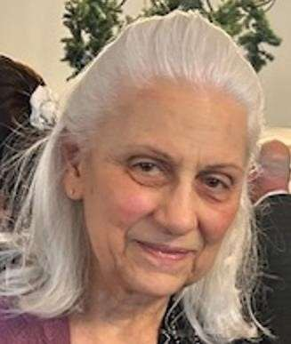

Maxine Connor, Natural Resources Chair