
LEAGUE OF WOMEN VOTERS OF
CITRUS COUNTY FLORIDA
NEWSLETTER, OCTOBER, 2023
Vicky Iozzia is the Editor of this newsletter.
Our mailing address is LWVCC. P. O. Box 1903,
Lecanto, FL 34460
OUR NEXT MEETING IS ON OCTOBER 10, 2023, AT THE COASTAL REGION LIBRARY IN CRYSTAL RIVER, AT 10 AM. SCROLL DOWN TO THE END TO SEE THE FLYER
Please visit our facebook page and "like" us!
https://www.facebook.com/leagueofwomenvotersofcitruscounty

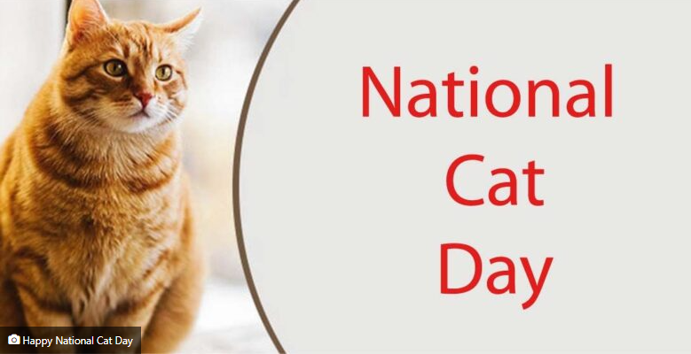
October 29 is National Cat Day!
Contents:
Nancy Tomaselli, article Page 3
Nancy Tomaselli, letter to Chronicle Page 5
Cecile M. Scoon, Debra Chandler Page 6
Peg Primeau Page 7
Linda Abels Page 9
Maxine Connor Page 10 - 11
Jan Hall Page 11 - 13
Vicky Iozzia, last meeting Page 14 - 16
BJ Ezell Page 17 - 18
Vicky Iozzia, what’s wrong Page 18 - 19
Speakers Bureau information Page 20
October meeting flyer Page 21
November meeting flyer Page 22
Membership application Page 23

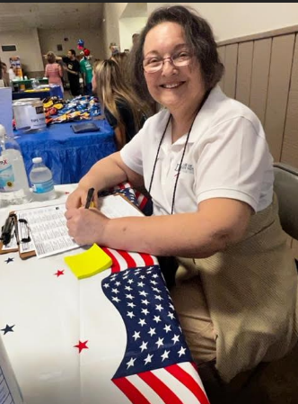
Nancy Tomaselli, Co-President
How to Respond to Police while Registering People to Vote
Every other week we have a LWVFL educational meeting called Lunch and Learn. The presentation and discussion today prepared us with advice on how to proceed if we are approached by the police when registering people to vote. A representative from the National Association of Criminal Defense, Ramon de la Cabada, Esq, shared information about how we can protect ourselves if we are questioned by the police while registering people to vote. This was followed by discussion, questions, and answers.
He advised us to make sure that when we select a location, we must be sure that it is legal to engage in registering people to vote in that location. He said if we are questioned by the police it is appropriate to ask for identification. He stressed the importance of not challenging the police by saying things like, “We have the right to help people register to vote”. He said it is best to leave the environment if possible, politely. If the police want information he said to try not to engage in conversation because anything we say can be used as evidence. He advised us to tell them, “Thank you, I will have my lawyer call you”. They told us to feel free to email or call either or both co-Presidents of the league,Cecile Scoon, Esq and Debbie Chandler, Esq.
A question that was raised was whether or not we should record the incident as it is developing. He advised us to use our judgment, as sometimes this could provoke an escalation. Someone raised concern also about the new election police that have been appointed. Because of geography it was felt that if the police were to intervene, it would be local police.

With the new technique of educating people to register to vote on the internet and just handing out voter registration forms so people can complete the process independently, the process should be less complicated. Don't let unnecessary fears stop us from trying to register people to vote. We don't want the effort to stifle votes with intimidation to be successful.

Nancy Tomaselli, co-President
LWVCC

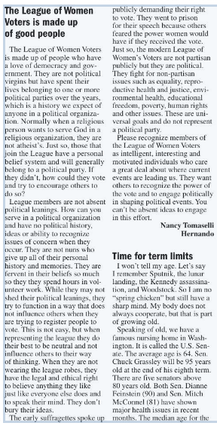

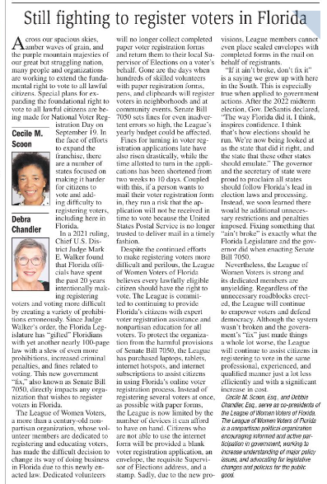
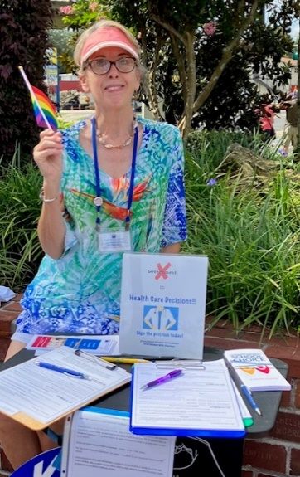
Peg Primeau, Secretary
ARE YOU FERTILE IN FLORIDA?
News on Reproductive Health & Justice

We await the Florida Supreme Court’s decision on the challenge to HB5, the 2022 law imposing a 15-week limit on legal
abortions. If the Court rules that HB5 does not violate Article 1 Section 23 of the Florida Constitution, the 2023 ban imposing a 6-week limit on legal abortions will go into effect after 30 days.
New Court decisions are posted on supreme court.flcourts.gov . each Thursday at 11am.
The Constitution says “Every natural person has the right to be let alone and free from government intrusion into the person’s private
life.” This amendment, passed by voters in 1980, has been interpreted in multiple cases since then to mean privacy in reproductive choice. In order for the current Court to exclude
abortion as a private matter, it has to decide that the original amendment was not intended to do so, and that previous Florida Supreme Court Justices were wrong.
Attorney Whitney L. White of the ACLU masterfully presented the plaintiffs’ pro-privacy arguments to the Court. It is worth watching this extremely well-prepared and articulate woman. Search Youtube for “Oral Arguments Sept 8 Florida Supreme Court.” The event is a window into the minds of the Justices.
Polls show that the majority of Floridians do not want government intrusion into their private lives, and definitely do not want punitive, discriminatory abortion bans. We have been disappointed by the Legislature, and expect to be disappointed by the Supreme Court. That’s why Floridians Protecting Freedom launched the citizen initiative (petition drive) to amend the Constitution. LWVFL agrees: let the voters decide!
We have 3 months to collect another 300,000 signatures. When the threshold for validated petitions is reached early next year, the Amendment to Limit Government Interference with Abortion will qualify to be on the 2024 ballot.
You’ve signed your petition already, right? For petitions and FAQs go to floridiansprotectingfreedom.com .
Want to help collect petitions? Call Peggy 708-466-1676.

From Linda Abels,
Membership Chair

Dues were due on June 1, 2023 and many members have forward their dues others have not. The dues for an individual membership are $65 and household membership $90. A large percentage of the dues received is forwarded to the National and State Leagues to support their efforts in voting rights, health issues, environmental issues, etc. Our local league keeps approximately $20 of each individual’s dues. We use this money to print educational materials, keep our website and Facebook page up to date, and to continue to work on the Leagues issues locally.

We appreciate your support of our League and ask that if you have not paid your dues to please forward your check to the League of Women Voters, P.O. Box 1903 Lecanto, FL 34460. If you prefer you can pay with a credit card via the league website: www.lwvcitrus.org

Again we appreciate your continued support of the League and look forward to working together in the coming year.


Maxine Connor,
Natural Resources Chair
NEWSLETTER UPDATE FOR LWVCC NATURAL RESOURCES
OCTOBER, 2023

LWVFL MONTHLY CLEAN ENERGY ACTION TEAM SEPTEMBER ZOOM CALL
WEDNESDAY, OCTOBER 18, 5-6 PM

Speakers to be announced. Members of the League of Women Voters of Citrus County will receive an email invitation.

FLORIDIANS, PLEASE SIGN THE PETITION
FOR THE RIGHT TO CLEAN AND HEALTHY WATERS

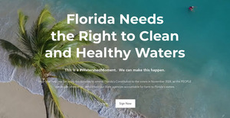
https://www.floridarighttocleanwater.org/

Florida registered voters, please go to https://www.floridarighttocleanwater.org/ to sign the statewide petition to get a state constitutional amendment for Right to Clean Water (RTCW) on the ballot for the 2024 election. The League of Women Voters of Florida supports this and the LWVFL Natural Resources Chair has made it a legislative priority. This is a grassroots citizen effort. Contact maxineconnor@gmail.com if you would like to help work on this in Citrus County.

We are continuing to work on this. I would be happy to collect your petition and send it in. We will collect petitions at any League event. Let us know of other groups you belong to or that we can talk to or you could bring the petitions to a meeting. Please email maxineconnor@gmail.com for assistance or questions.


Jan Hall
The more things change,
the more they stay the same
Jan will be going through the archives of notes from our League and sharing them with us. The following was written by Mary Pettibone in 2014.
THE LEAGUE OF WOMEN VOTERS OF CITRUS COUNTY
Missed Opportunities
The 2014 legislative session has come to a close and it will go down as a session full of missed opportunities.
Those missed opportunities include but are not limited to:
>Refusing to extend healthcare coverage to Florida’s uninsured our state loses $7 million dollars a day, and nearly 1 million working Floridians are not afforded the basic healthcare coverage they need and deserve.
>Turning down nearly $51 million in federal dollars our state has lost out on an enormous economic stimulus that included approximately 120,000 new, high-paying jobs.
>Ignoring online voter registration (OVR) which would have made the process a lot smoother and less costly. The state of Arizona even determined that processing paper registrations costs $.83 per registration while the cost for online registration was merely $.03 per registration.
>Continuing to focus on expanding an alternate education system instead of working to improve our public schools. Private schools who accept students on the Florida Tax Credit Scholarship do not require teachers to be certified or students to take the same standardized tests as public schools. On the final day of session, the zombie-like legislation on vouchers once again rose from the dead and was finally passed, diverting millions of taxpayer dollars
from public schools into private institutions with little accountability.
The League of Women Voters has been vigilant in our concern for our Florida legislative actions. Our concern for targeted areas that affect all of us is our primary objective. While maintaining a non-partisan stance on issues can be challenging, the League works hard to study every issue and determine a position after consensus has been reached. How the League approaches an issue is in itself a long process. Every member of the League is encouraged to participate in the process of “study and action” in its entirety, from the adoption of a study, through the achievement of a consensus, to its ultimate conclusion with action.
Our mission statement: The League, a nonpartisan political organization, encourages informed and active participation in government, works to increase understanding of major public policy issues, and influences public policy through education and advocacy.
An example of this can be found in the recent study of Charter schools and other private educational institutions. In 2012-13, the League initiated a study to better understand the oversight of public moneys that are allocated to charter schools and other private educational institutions. The League recognizes first and foremost it is a paramount duty of the state to provide for education and that charter schools, while privately owned and managed, are under contract to public school districts, funded by the public and must be accountable to the public. The League does not support direct or indirect tax credit funding for private schools. Local leagues were asked to participate in this study, conducted studies and held consensus meetings to formulate the League’s positions on school choice.
The League has supported protection of Florida’s Land and Water Legacy from early legislation in 1972, the Environmental Land and Water Management Act to the current support of a Yes vote on Amendment 1 on the November ballot: The League of Women Voters of Florida has endorsed a proposed amendment to Florida's constitution that would protect hundreds of thousands of acres of land needed to ensure the state's clean water supply and wildlife habitat for generations to come. The amendment would dedicate one-third of existing documentary stamp tax, which is paid when real estate is sold, to restore the Everglades, protect drinking water sources, and revive the state's historic commitment to protecting natural lands and wildlife through the Florida Forever Program. The amendment would provide more than $5 billion for water and land conservation in Florida over the next 10 years without any tax increase. It would take effect in 2015 and expire in 2035.
While we lament that this legislative session has missed opportunities we are hopeful that the next year will provide another chance to get it right. The League of Women Voters will continue to implement its mission and keep a vigilant eye on the workings of our legislature.

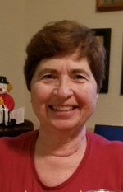
Vicky Iozzia, Vice President,
Speakers Bureau Chair,
Newsletter Editor

Our Tuesday, September 12, 2023 meeting
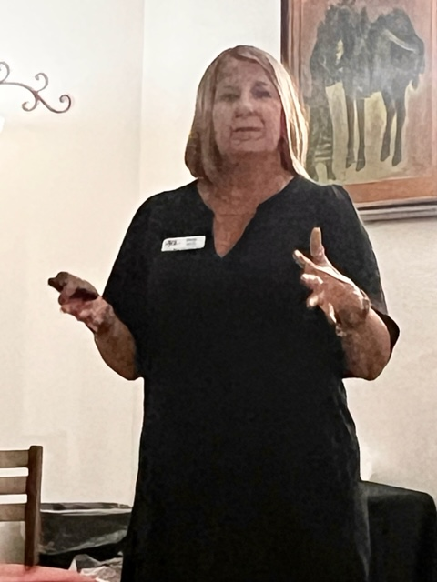

Our last meeting, at Café Aromas in Lecanto, featured our guest speaker, Ginger Mundy, Co-chair of the League of Women Voters of Florida Reproductive Health and Justice Action Team. Her presentation was titled, “Reproductive Health is a Personal Matter.”
She reported on the current law, which makes abortion legal up to 15 weeks. SB 300 was signed into law in April of this year and would make it illegal to have an abortion after 6 weeks gestation. It is currently being argued in the Florida Supreme Court.
Below are her suggestions on what those who disagree with SB300 can do:
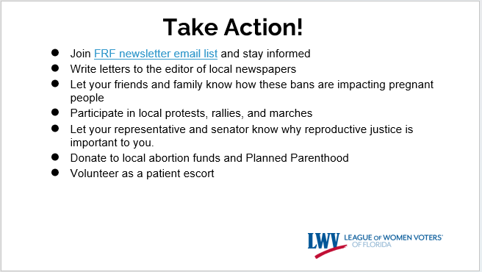
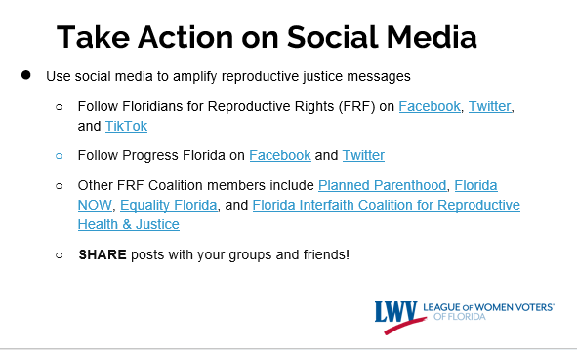

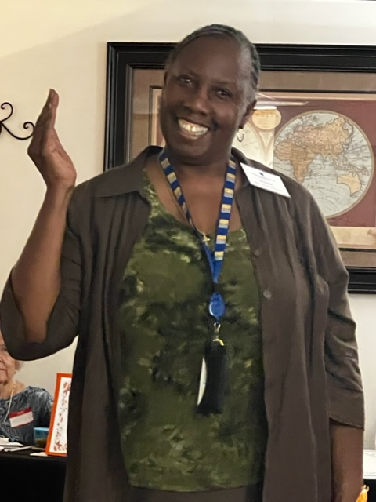
BJ Ezell
BJ informed us about the following with her Health Department knowledge:
There were 142 Covid cases in April, 1,035 in August.
There were 14 Covid hospitalizations in April, 60 in August.
There were 6 Covid deaths in April, 16 in August.
Covid shots are now available.
We were warned not to eat armadillos, or be near them, because they can causes Jansen’s disease, otherwise known as leprosy.

We are glad that BJ shares her knowledge with us at our meetings and after,
From the CDC website:
"Beginning [Monday] September 25, every U.S. household can again place an order to receive four more free COVID-19 rapid tests delivered directly to their home. Before You Throw Out "Expired" Tests: Check FDA's website to see if your COVID-19 tests' expiration dates have been extended."

Here's the link to check expired dates on existing COVID test kits AND to order your new test kits:

https://special.usps.com/testkits

Also, read the information on the same web page that reminds you to check your expiration dates on any existing COVID test kits you may have on hand already. You can key the info requested into the website and learn the new extended expiration date.

What is wrong with this country? By Vicky Iozzia
Recently I wrote a PowerPoint presentation called “What is the League of Women Voters?” I presented it to my Toastmasters club for practice.
I asked for comments and suggestions and one person said, “It seems that people just don’t want to get together to solve problems.”
When I first heard this I thought it sounded naïve, but upon some thought I think he cut through to the essence of what is wrong with this country now.
I remember when Barack Obama became President. Many of us had so much hope that he could lead important changes. The first thing that Mitch McConnell said was, “We need to make sure that Obama is a one term President.”
President Obama said that he was disappointed that more people weren’t interested in solving problems. He did not get to make many of the changes he had hoped his administrations could make.
Congress is deadlocked and gridlocked. Problems that are threating the country: environmental, immigration, women’s health, voting rights, among others, are not being discussed or addressed by the people who are elected to make changes.
Abraham Lincoln said, “A house divided cannot stand.”
We are like a push-me-pull-you animal.
How can we make any progress when both sides are so convinced that they are completely right that they refuse to listen to each other?
What will it take for Americans to act like Americans instead of enemies in red or blue states?
I pray that America is spread with the fairy dust of common sense so that we can work together instead of pulling us all apart.



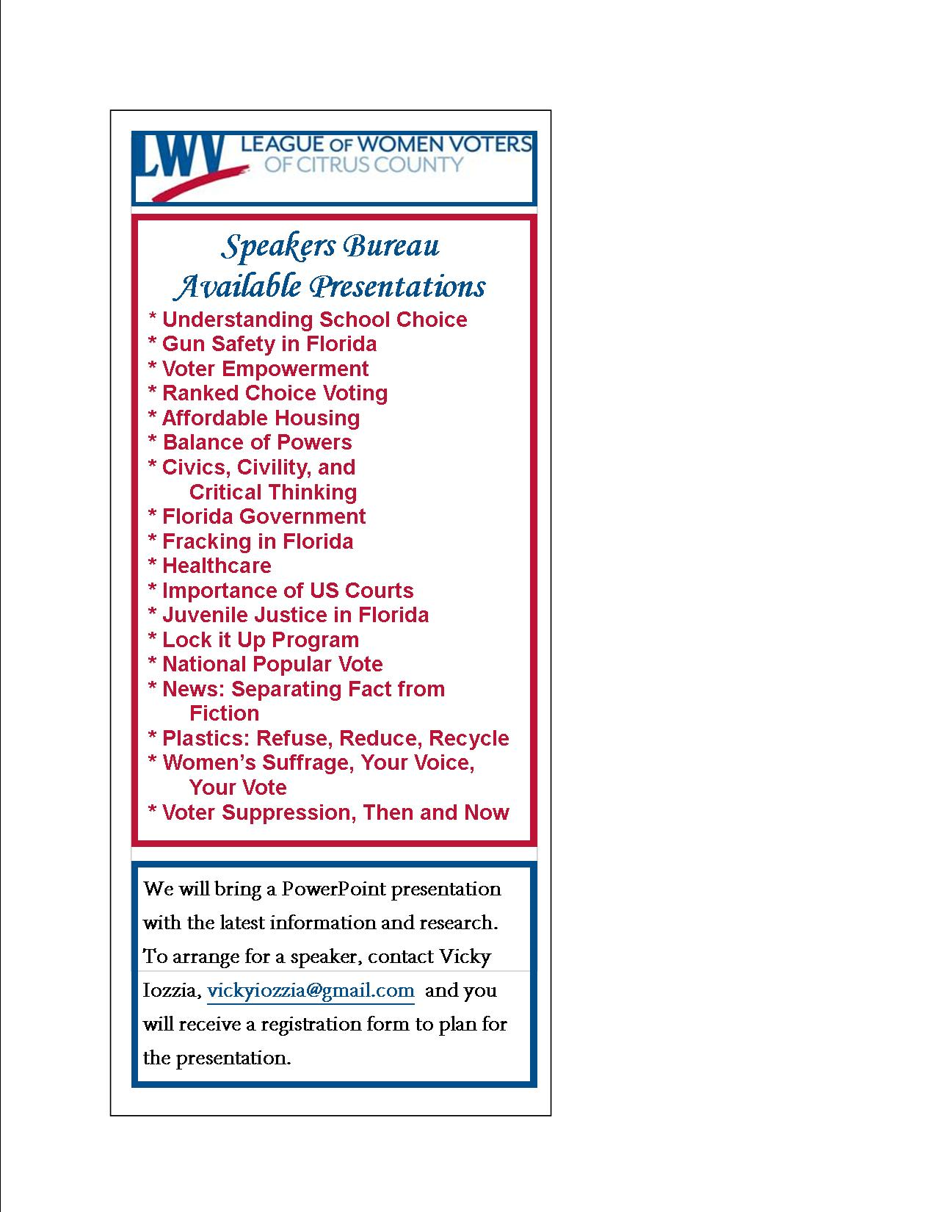

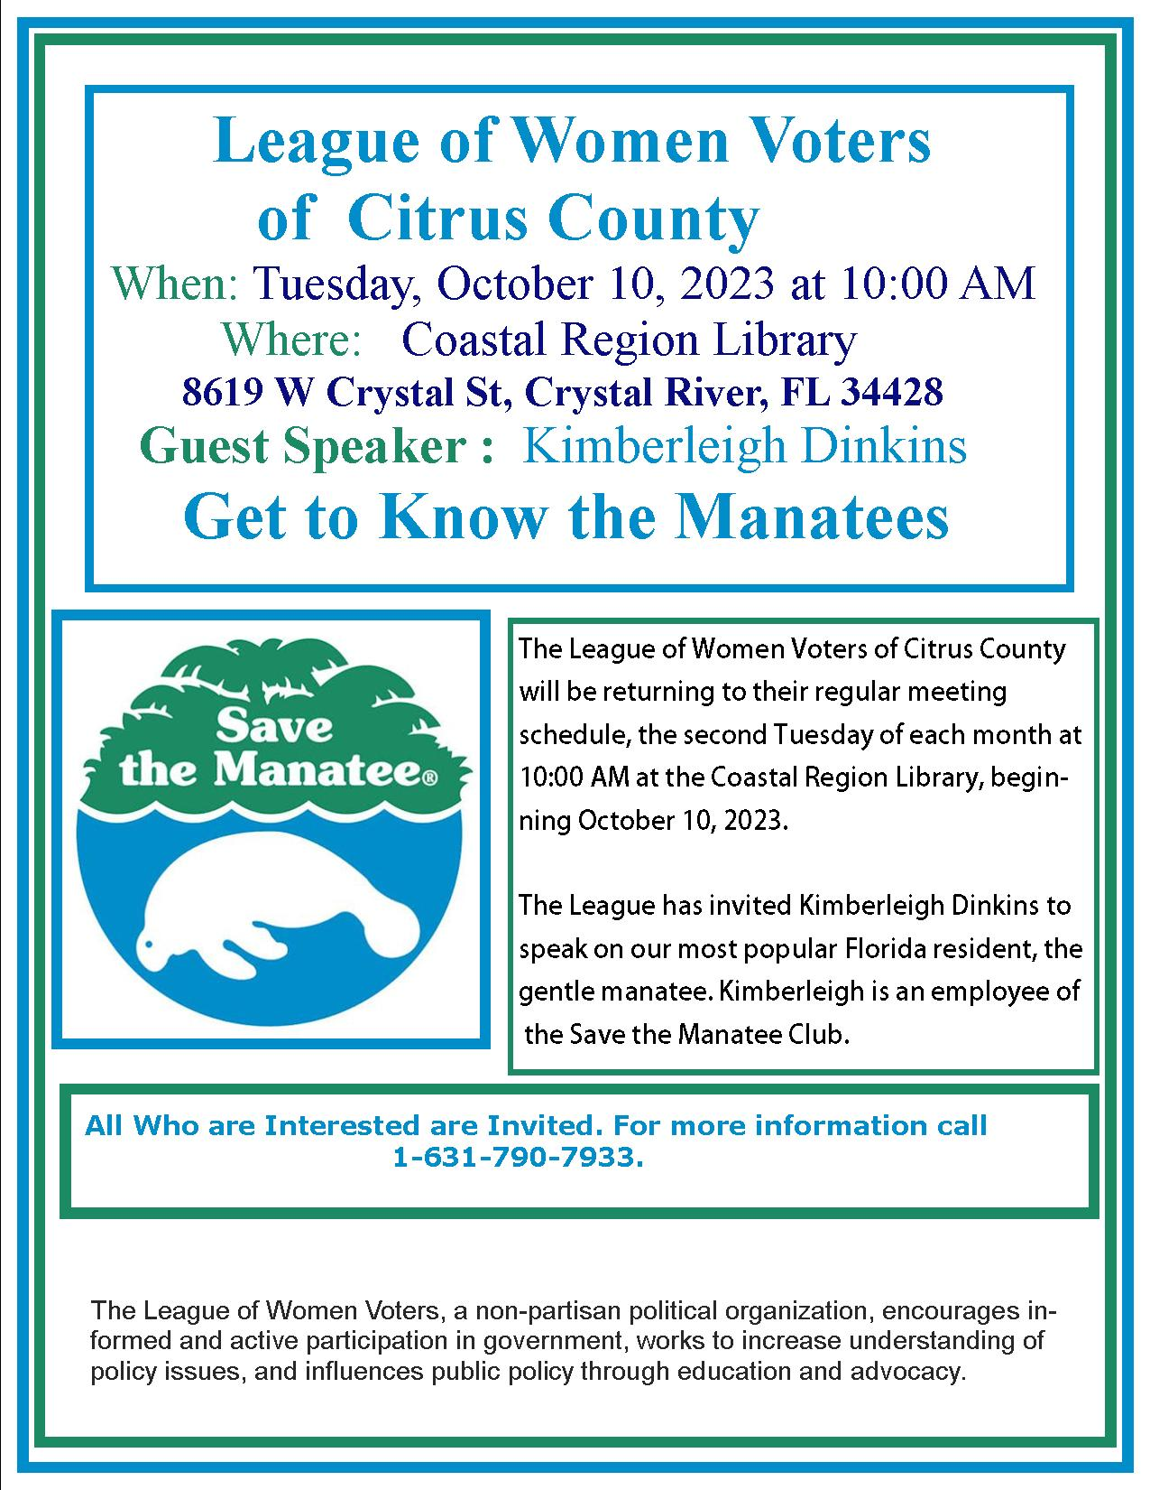
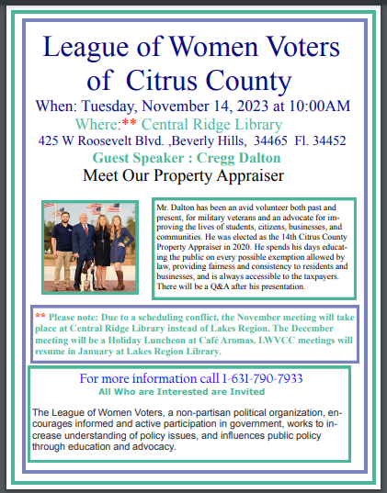


If you are interested in joining the
League of Women Voters of Citrus County,
Fill out the form below and mail it to us at
LWVCC, P. O. Box 1903, Lecanto, FL 34460

Name_______________________________
Address_____________________________
____________________________________
Email address_________________________
Phone (home)_________________________
Phone (cell)___________________________
Individual $65______
Household $90
Student Free
Susan B. Anthony $105*
Household $150*
*Includes $40 donation
Credit card name__________________________
Credit card number ________________________
Expiration Date, month and year______________

