LEAGUE OF WOMEN VOTERS OF
CITRUS COUNTY FLORIDA
Vicky Iozzia is the Editor of this newsletter.
Our mailing address is LWVCC. P. O. Box 1903, Lecanto, FL 34460
Our website is lwvcitrus .org
OUR MAY 8, 2024 MEETING INCLUDES 1st VP ROSEMARY NILLES WHO WILL SPEAK ABOUT AMENDMENT 1: PARTISAN SCHOOL BOARD ELECTION. MEET AND GREETS FEATURING SCHOOL BOARD CANDIDATES WILL FOLLOW.
SEE FLYER AT THE END OF THE NEWSLETTER
IT WILL BE AT THE COASTAL REGION LIBRARY IN CRYSTAL RIVER.
********************************************************
OUR JUNE 12, 2024 MEETING WILL BE A MEET AND GREET FOR THE CANDIDATES FOR CITRUS COUNTY SUPERVISOR OF ELECTIONS AND THE FLORIDA HOUSE OF REPRESENTATIVES.
SEE FLYER AT THE END OF THE NEWSLETTER
IT WILL BE AT THE CITRUS SPRINGS COMMUNITY CENTER
OUR JULY 10, 2024 MEETING WILL BE A MEET AND GREET WITH BOCC CANDIDATES. IT WILL BE AT THE CITRUS SPRINGS COMMUNITY CENTER.
Please visit our Facebook page and "like" us!
https://www.facebook.com/leagueofwomenvotersofcitruscounty
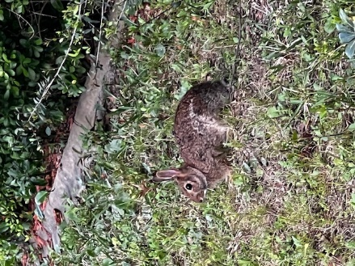
HAPPY MAY TO EVERYONE!
Contents:
Vicky Iozzia Pages 3 to 4
Our April meeting with Todd Hockert
and Sheriff candidates, Recent Bills, **Special meeting**
June27 with Jim Gouvelis Pages 5 to 6
Peg Primeau Page 7 to 11
Rosemary Nilles Page 12 to 15
What is our League Doing? Page 16 to 18
Your County Commissioners Page 19
Your elected officials Page 20 to 21
Linda Abels, Membership Chair Page 22
Dr. B J Ezell, Healthcare Page 23 to 24
Maxine Connor Page 25 to 26
Mo Baird, Important election dates Page 27 to 28
May, Education, School Board Candidates Page 29
June, Supervisor of Elections, House of Representatives Candidates Page 30
Upcoming Meetings, Page 31
Join us! Page 32

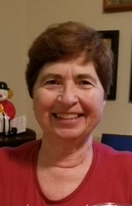
Vicky Iozzia, Co-President,Speakers Bureau Chair, Newsletter Editor, Webmaster
“Be afraid. Be very afraid.” These words were first spoken on film by actor Geena Davis. In the movie, “The Fly”, her character watches her boyfriend turn into a dangerous, unrecognizable monster.
Sometimes I feel this way about my country. I am frightened about the rhetoric and the amount of hatred and bigotry that I see. It would be easy to crawl under a rock and not come out.
More and more I am feeling differently. Because of my work with the League, I meet amazing people who care and work to defend democracy. The “cards” may seem to be stacked against us, but I believe that we can work together to make sure that the country makes sense again.
Jan Hall and I recently worked with volunteers to send postcards to non-violent felons to give them information on how to get their right to vote back. The following members participated: Scott and Karen Baldwin, Lynn and Michael Fonfara with others from the Kiwanis Club, Nora Cloud, Joanne Jordan, and Wanda Brown.
Read in this newsletter about the fairs that our members have attended to educate the public. That said, there is so much more we could be doing if we had more volunteers who could give their time working with us.
We have a challenge. We have an opportunity. I for one don’t want any regrets about not being part of the team. The League of Women Voters of Florida is working hard to provide the local Leagues with resources to do the right thing by our county and our state.

Although I am afraid of what could happen in this country, I want to do all that I can to make sure that our state and our country abide by the constitution and the laws of the land.
The response to our Meet and Greets with local candidates has been so good that we have outgrown the Coastal Region Library. We will be there for our May 8 meeting, but our June 12 meeting will be at the Citrus Springs Community Center.

I will be at the College of Central Florida on Thursdays, 10 am to 1 PM, with a table to give registration information to the public. I will be there with someone else or by myself. If you want to be there with me, please contact me. It would be a great opportunity to learn about the League in a pleasant and relaxed environment.
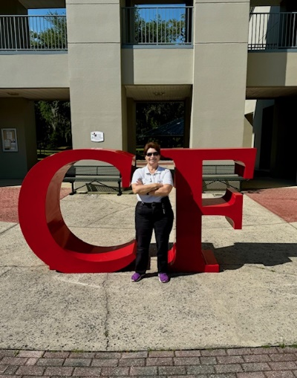

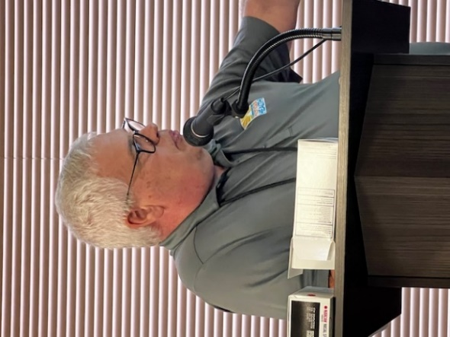
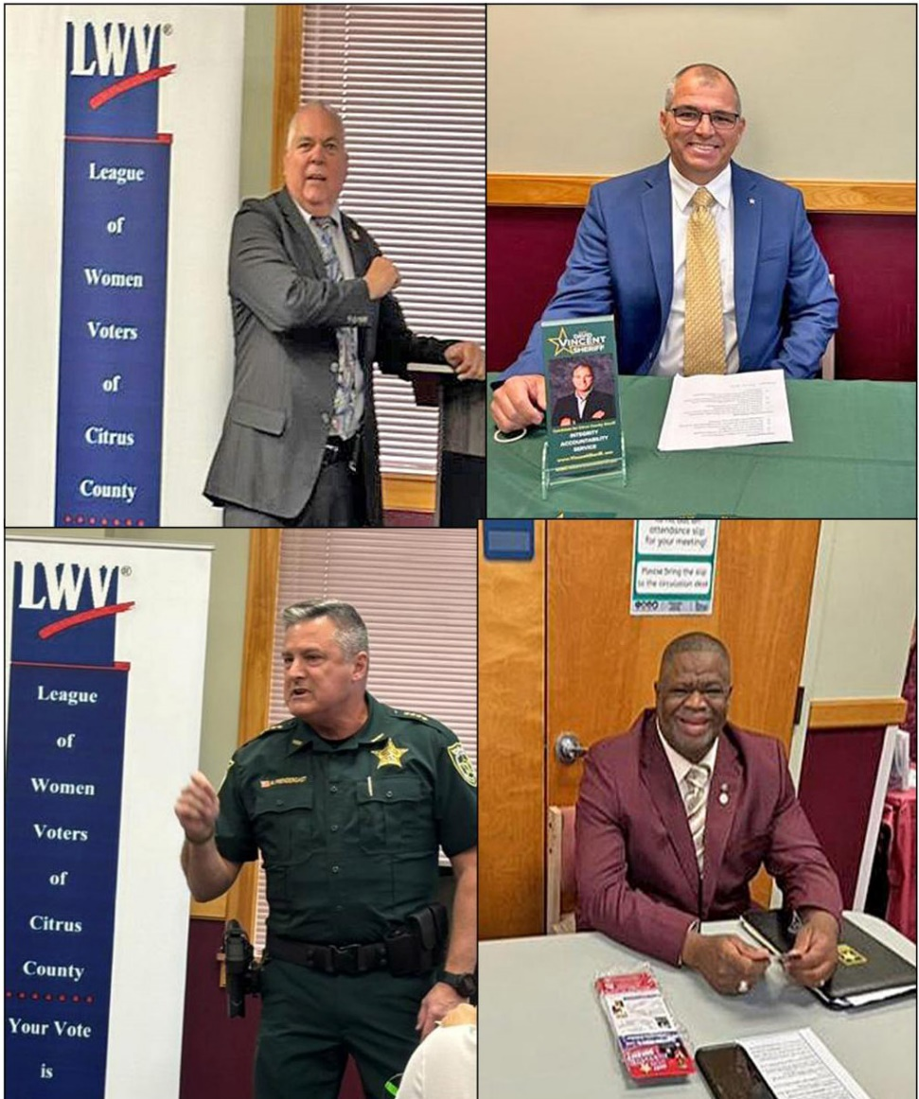
OUR APRIL 10, 2024 MEETING WITH TODD HOCKERT, SHERIFF CANDIDATES
What an exciting meeting this was! It started with Todd Hockert from the Citrus County Opioid Task Force, who gave us the numbers of drug deaths here in Citrus County.
All four Sheriff candidates responded to the invitation to speak. They spoke for a maximum of three minutes, and then the audience was invited to ask them questions at their table.
The response was invigorating! We had over 100 people attend, so many that we are outgrowing the room. Later in this newsletter you will see the dates of our next meetings. Please read it carefully because we will be moving after the May meeting.

If you want to see and hear the meeting, here is the link: https://youtu.be/ehWmYVAzGGI
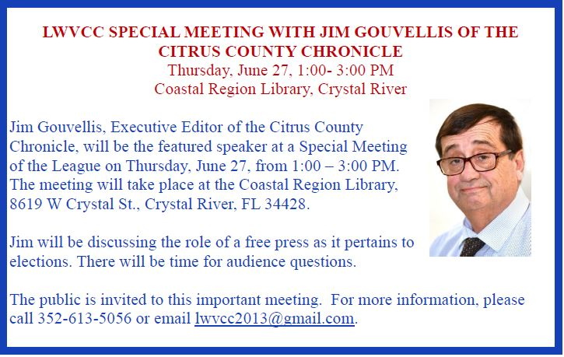

HERE IS A SUMMARY OF SOME OF THE RECENT BILLS SIGNED IN FLORIDA.
On April 18, Governor DeSantis signed a bill that allows volunteer school chaplains in public schools in Florida.
The Governor also signed a bill mandating that communism history be taught in the public schools in Florida.

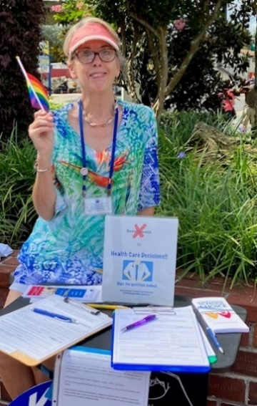

Peg Primeau, Secretary, Reproductive Health & Justice, LWVCC Second President
Great Rally! Now Let’s Get Out the Vote!

To quote Florida Supreme Court Chief Justice Carlos Muniz, “The people of Florida aren’t stupid. I mean, they can figure this out.”
He was referring to the clarity of the language in the Amendment to Limit Government Interference with Abortion during oral arguments back in February. The justices, in a 4-3 decision, finally approved the amendment language, thereby assuring that voters could make their voices heard on the issue.
Indeed, Florida voters do understand the concept of keeping their healthcare decisions private, between patients and their providers, without the interference of legislators. Would you consult your congressperson about your appendix? Your pacemaker? your vasectomy? Of course not. That is why Amendment 4 has wide appeal.
More than 1500 people gathered in Orlando on April 13 to launch the campaign for Yes on 4, and to protest the six-week ban on abortion that goes into effect across Florida on May 1. The scene was inspiring: all ages, colors, and biologies! Brave people—mothers, spouses and doctors—shared their stories of facing barriers to necessary and urgent medical care, including patients whose intended pregnancies were doomed. Sponsors highlighted how crucial it is to educate and mobilize voters to vote Yes on 4 in the November election.
Making the rally comfortable as well as memorable, the League of Women Voters of Florida provided a space nearby for members to gather, hydrate, and connect. LWVUS even provided lunch. It was a treat to see members of other chapters in person whom we usually know only by their zoom faces.
The League of Women Voters of Florida supported the petition drive organized by Floridians Protecting Freedom, and now supports voting Yes on Amendment 4.
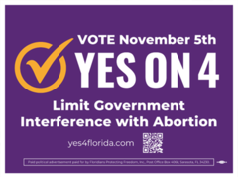
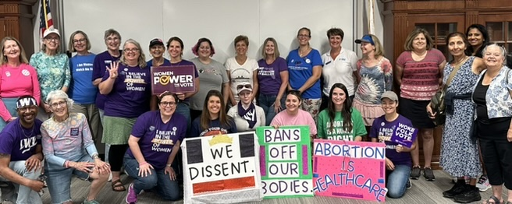
LWVFL marchers met up for a little social time. Peggy Primeau, Mary Hedges, and LWVFL Co-President Debbie Chandler at left in back row.
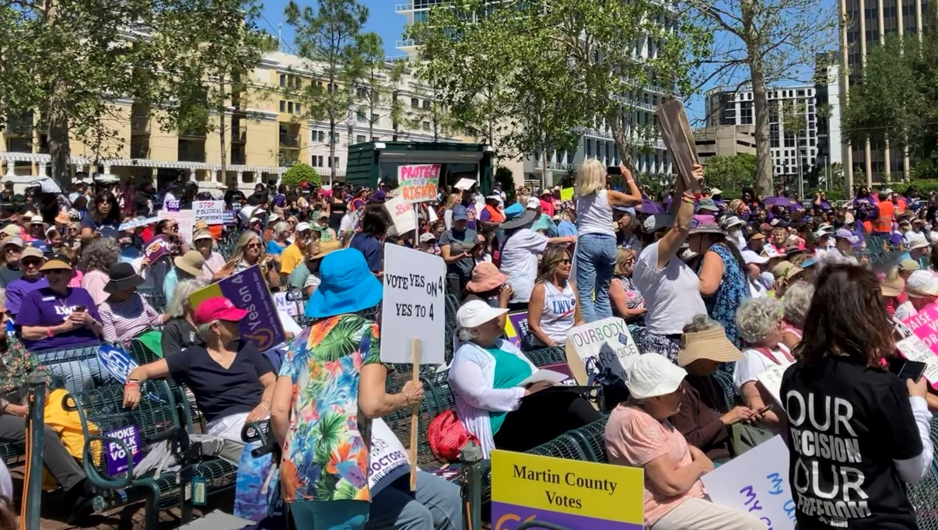

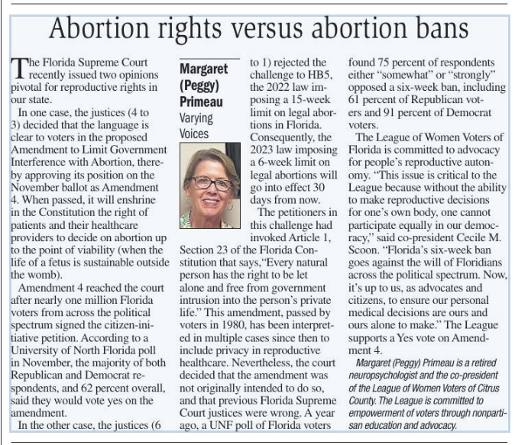

The Healthcare Landscape Changes on May 1
Peggy Primeau, RH&J
May 1 marks the day Florida’s six-week abortion ban takes effect. Most people do not realize they are pregnant at this early point. For them, this is the same as a total ban. For those seeking an abortion within this time limit, other barriers will be present.
The law requires that abortion care be provided in person by a physician. Telemedicine and in-state mailing of mifepristone/misoprostol are not allowed.
The 24-hour waiting period means patients must make two (or three) in-person visits. For many this entails transportation, lodging, and childcare as well as time off work.
Although the law has ostensible provisions for abortion after rape, human trafficking or incest (before 15 weeks of pregnancy), the survivor must provide acceptable medical, police or court records to prove the assault.
Ostensible exceptions are also included to save the life of the mother, or to intervene for fatal fetal abnormalities. Specifically, two physicians must certify, in writing, that in their judgment an abortion is necessary to save the pregnant woman’s life or avert a serious risk of substantial and irreversible physical impairment of a major bodily function. Likewise, two physicians must certify, in writing, that in their reasonable medical judgment the fetus has a fatal fetal abnormality. However, the experience of patients and doctors in other states with severe bans has been that because the legal lines are ambiguous and consequences for doctors are extreme, these decisions often are not made in a timely way or at all.
What are the options? A person might contact an abortion fund for help with travel to a state where reproductive healthcare will be provided.
Abortion funds are grassroots organizations that support people seeking abortion access, wherever that may be. Funds include:
- Broward Women’s Emergency Fund
- Emergency Medical Assistance, Inc.
- Florida Access Network (FAN)
- Tampa Bay Abortion Fund
- Women’s Emergency Network
- Access Reproductive Care Southeast (ARC)
- National Network of Abortion Funds

Rosemary Nilles, LWVCC Education Chair, 1st Vice President 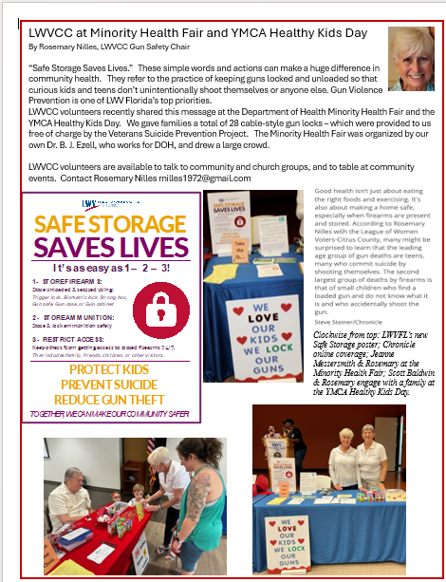

Rosemary has been working with the Florida League on education issues. Below is the brochure she worked on regarding voting for School Board members. Please read and pass on this information.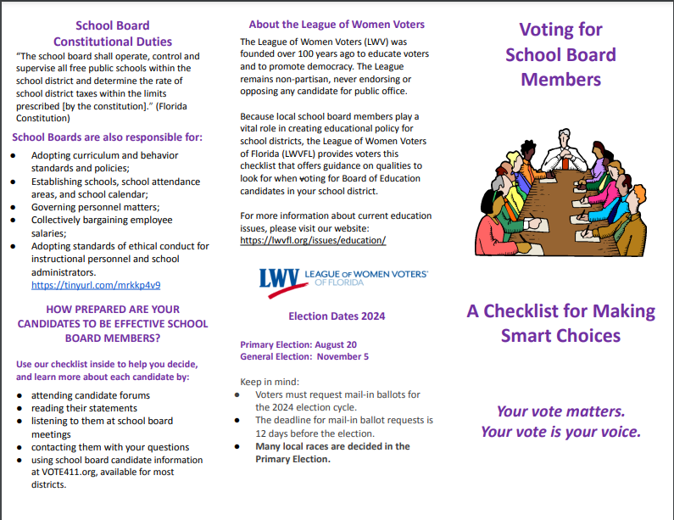
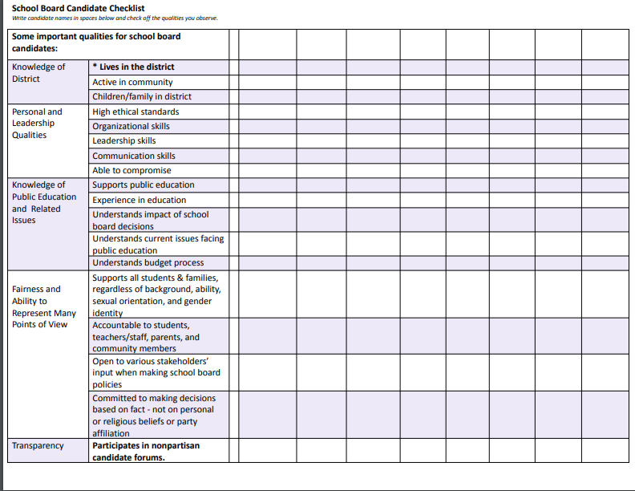
In addition, Rosemary has worked on the following trifold folder on
nonpartisan school board elections.

WHAT IS YOUR LEAGUE DOING? LOOK BELOW:

League members are participating in these events.
Great news below!!!!!!!!!!!!!

From the April 23, 2024 Chronicle article by Jim Gouvelis

The Chronicle Forum
We (The Chronicle) will be hosting a candidate forum July 9 at the Citrus County Fairgrounds. This year the Citrus County Chapter of the League of Women Voters will be assisting us. Members of our editorial board will be asking the candidates questions. It will be a good way for you to see the candidates live and judge for yourself how they are at fielding questions.
Many thanks to Rosemary Nilles and Peg Primeau, who have been working with the Chronicle to make this possible.
IFAS environmental fair at the office on Sovereign Path, Lecanto, Saturday, April 20, 2024
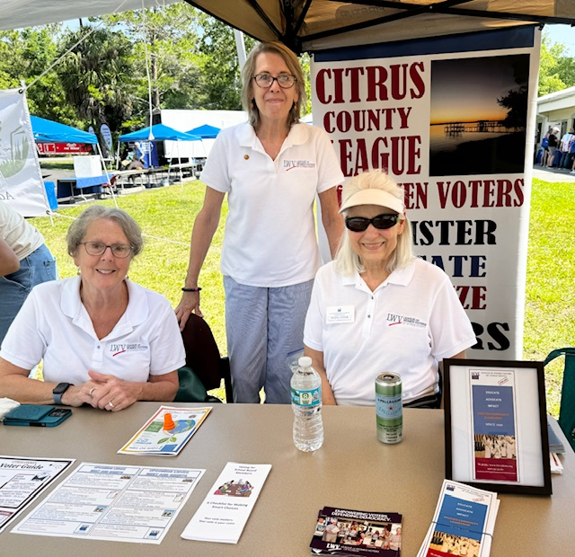
Devora Stager, Peg Primeau, and Maxine Connor represented our League.

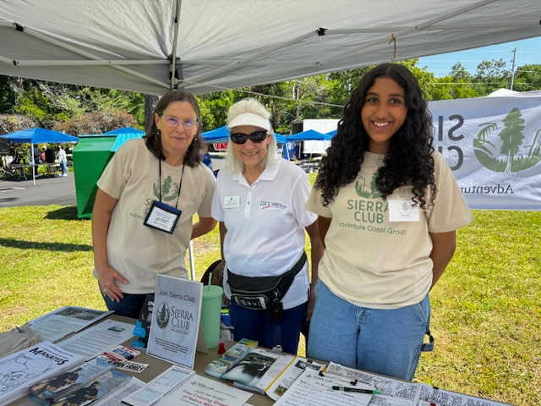
Maxine also was there with the
Sierra Club
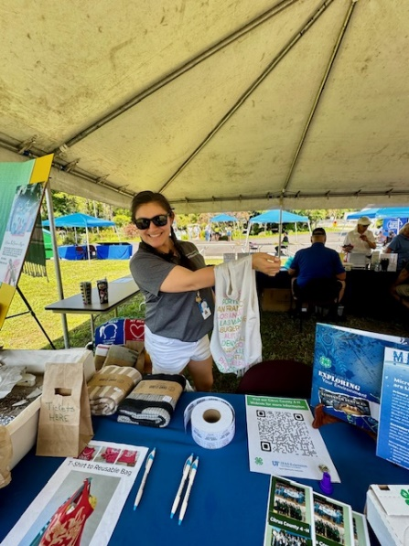
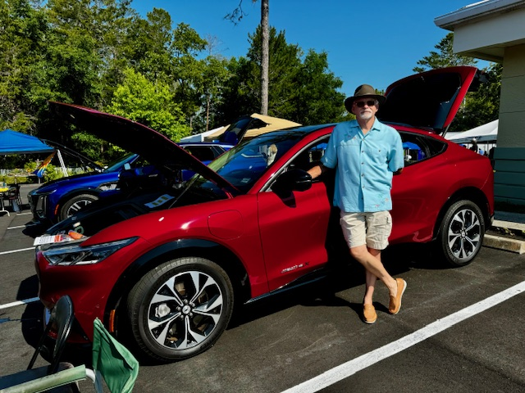
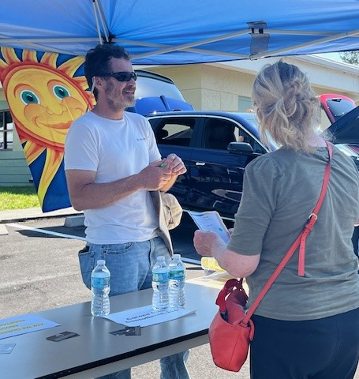

“Ask a Solar Question” at the Solar Education Table Manned by Matthew Corona, Manager of Corona Solar Consultants, LLC

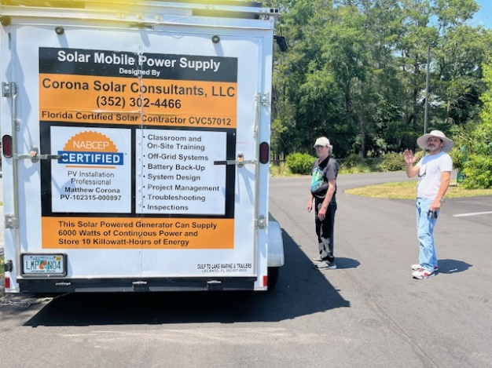

There were electric cars and fun activities for young and older!

The Healthy Kids YMCA Fair, Saturday, April 20, 2024 – see Rosemary’s article

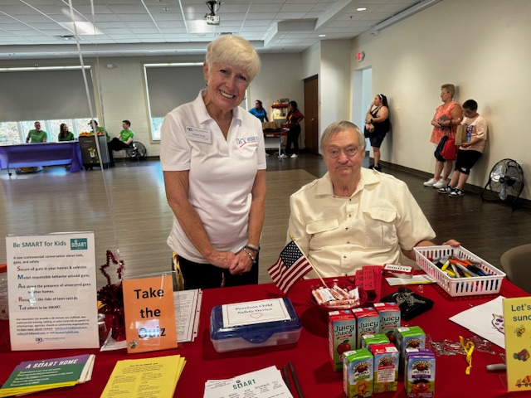

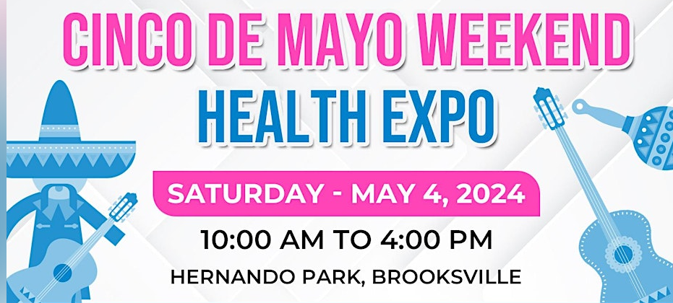
Vicky Iozzia will be at the Cinco de Mayo Fair in Brooksville on Saturday, May 4, 2024, sponsored by the Cancer Tamer Foundation.

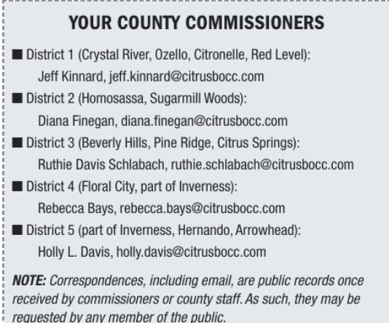

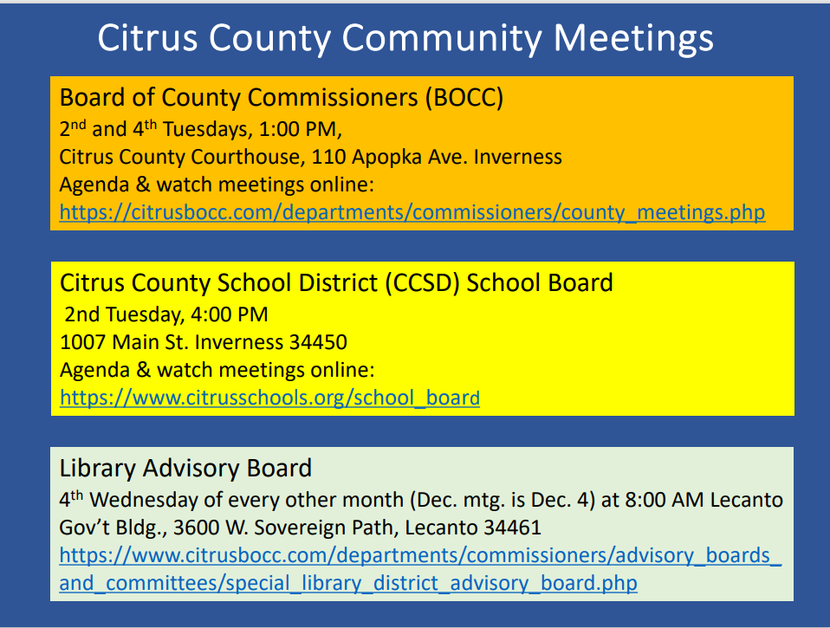
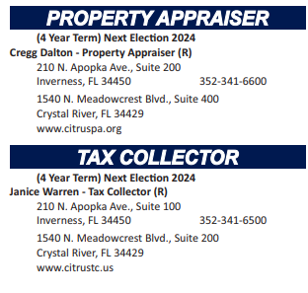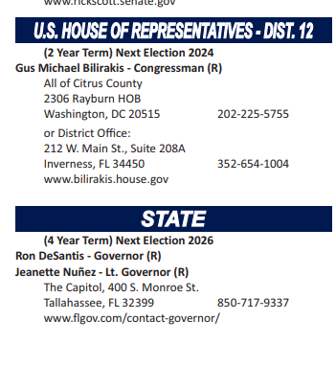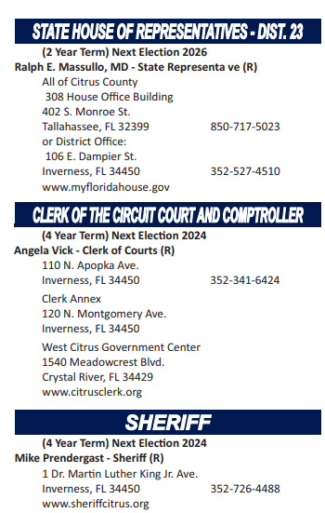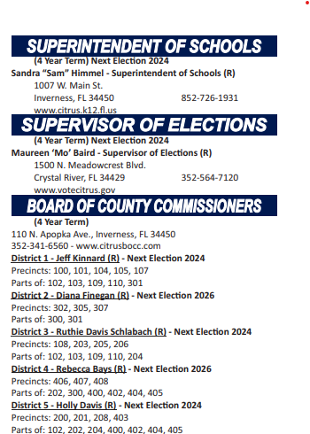

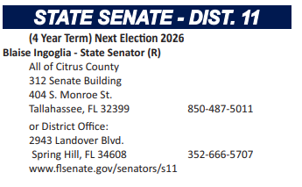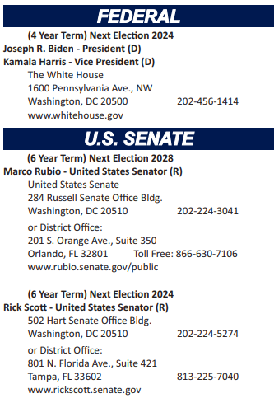

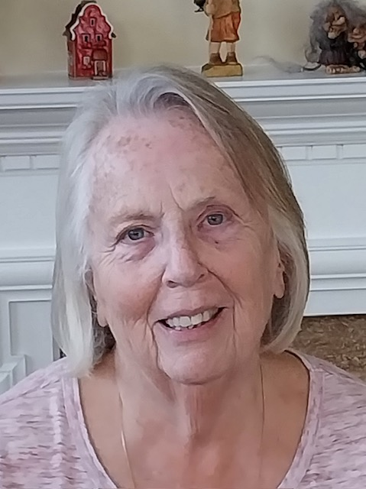
Linda Abels, Membership Chair
WELCOME to new members, Bonnie Fleck, Sally Smith-Adams and Judith Vowels. We all look forward to greeting you at our next meeting. Should you have any questions or comments or wish to help with any of our programs, please feel free to contact one of the officers.
A large number of our members have an annual membership renewal date of June 1, 2024. I sent our reminder notices last month via the League of Women Voters of Citrus County email, if you haven't received it please contact me at either LWVCC2013@gmail.com or my personal email address at labels58@aol.com and I will look into it.
To renew your membership you can either pay by mailing a check or credit card through Paypal. The dues are remaining the same for this year, $65 for an individual membership, $90 for a household membership and Susan B. Anthony Membership is $105. You can pay your dues by mailing a check to the LWVCC, P.O. Box 1903, Lecanto, FL 34460, using a credit card and pay via Paypal or you can bring a check to our regular meetings.
Have a wonderful Spring and I look forward to seeing you at our up coming meetings.

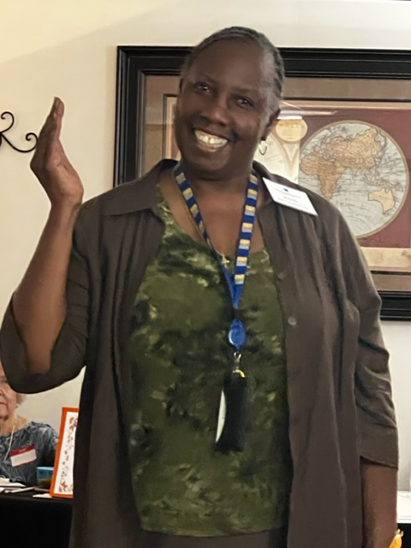

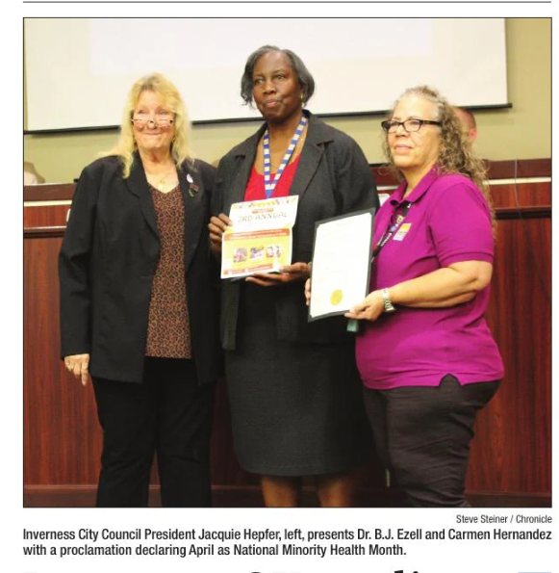
Dr. B. J Ezell has been busy, as always!

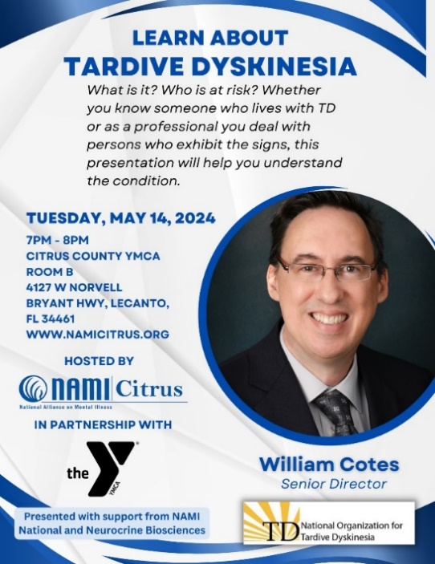

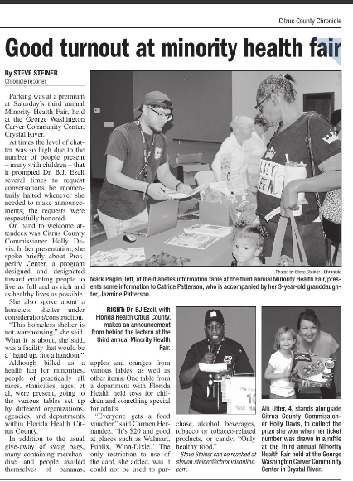

From

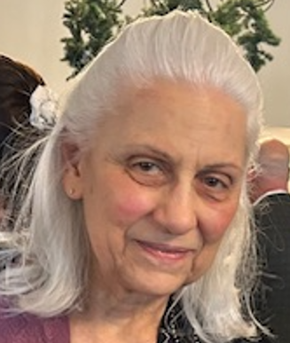

Maxine Connor, Natural Resources Chair

On Saturday, April 20, our County held its annual Earth Day Event at UF/IFAS Extension Citrus County in Lecanto. It is a fun learning event for all ages. Among the County features were: Ask a Master Gardener, a Storybook Walk, Youth Activities, and the Trash to Treasure Showcase. The County’s other features included Florida Friendly Gardening & Landscaping, Bee Keeping, the Solid Waste Division and Mosquito Control Divisions. There were many other vendors, including educational and craft vendors, including education on buying fabrics and clothing free from plastics and making a “hands-free” tote bag from a t-shirt. Attendees were free to stroll along a walkway through the lovely Florida Friendly plantings under a giant canopy of trees that provide shade and keep us cool.
Our local League and the Florida League Clean Energy Team had a strong presence there and each had a table. Our Citrus County League table was manned by Peg Primeau and Devora Stager. They assisted attendees with voter and membership information and advertised our upcoming meetings and events. The Clean Energy table was manned by Maxine Connor with many solar and electric vehicle educational handouts. Featured was an electric vehicle (EV) Show and Tell with owners present who enthusiastically answered questions about their vehicles. We had these all-electric vehicles: a Cadillac Lyriq, a Ford Mustang Mach E, and a Tesla Model Y.
Also featured was the Solar table with “Ask a Solar Question” featuring Matthew Corona, Manager of Corona Solar Consultants, LLC. He brought along his solar educational trailer towed by the Tesla Model Y. A demonstration was done in which the solar trailer was collecting photons from the sunlight shining on the photovoltaic (solar) panels, which converted the particles of sunlight into DC (direct current). An inverter converted the direct current into AC (alternating current), which then was stored in a large battery in the solar trailer. The Tesla was then plugged into the battery and was

charging. Periodically, the Tesla performed its “Light Show” function. It played a peppy tune, all the exterior lights flashed in time with the music, the windows went up and down, and the trunk opened. A pretty talented car all the way around!
Thank you to Solar United Neighbors for providing many solar and electric vehicle educational flyers. Another big thank you to all the volunteers who patiently manned tables, that brought their electric vehicles, towed the solar educational trailer, demonstrated the solar panels, charging, and Tesla Light Show, and patiently answered all the questions that the Earth Day participants asked.
Our next-door neighbor table was Sierra Club Adventure Coast Group providing local environmental education and membership opportunities. They handed out the Springs Guide produced by the Florida Springs Council, the only statewide organization focused on protecting our iconic springs. FSC memberships are free; join and stay informed at FloridaSpringsCouncil.Org.
Thank you to the Citrus County Extension Office for being our cordial hosts. It was a great day for the Earth!

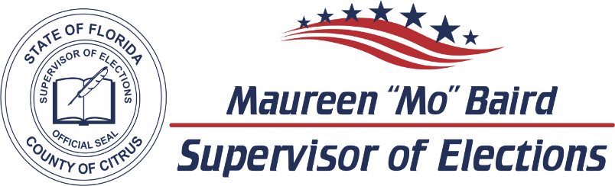

2024 CANDIDATE DATES TO REMEMBER

ELECTIONS
Primary Election | August 20, 2024
General Election | November 5, 2024

LAST DAY CANDIDATES CAN CHANGE PARTY FOR 2024 ELECTIONS  F.S. 99.021
Judicial April 23, 2023
County Office June 11, 2023

PETITIONS DUE  F.S. 99.095
Judicial Noon, March 25, 2024
County and Special District Noon, May 13, 2024

VALID PETITIONS NEEDED
Constitutional, County Commission, and School Board 1,222
Special District 25

RESIGN TO RUN  F.S. 99.012
Judicial April 12, 2024
County and Special District May 31, 2024

QUALIFYING PERIOD  F.S. 99.061
Judicial Noon, April 22, 2024 to Noon, April 26, 2024
County and Special District Noon, June 10, 2024 to Noon, June 14, 2024

Per Florida Statute, we may accept and hold qualifying papers 2 weeks prior to qualifying.

REGISTRATION BOOK CLOSINGS  F.S. 97.055
Primary Election | July 22, 2024
General Election  EARLY VOTING  F.S. 101.657 | October 7, 2024
Primary Election | August 9, 2024 to August 17, 2024
General Election | October 21, 2024 to November 2, 2024

Primary Election dates listed are tentative and subject to change by the Florida Legislature.
VoteCitrus.gov 352-564-7120
Citrus County Supervisor of Elections ~ PO Box 1870 ~ Lecanto, Florida 34460

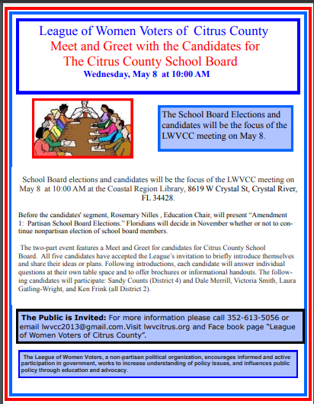

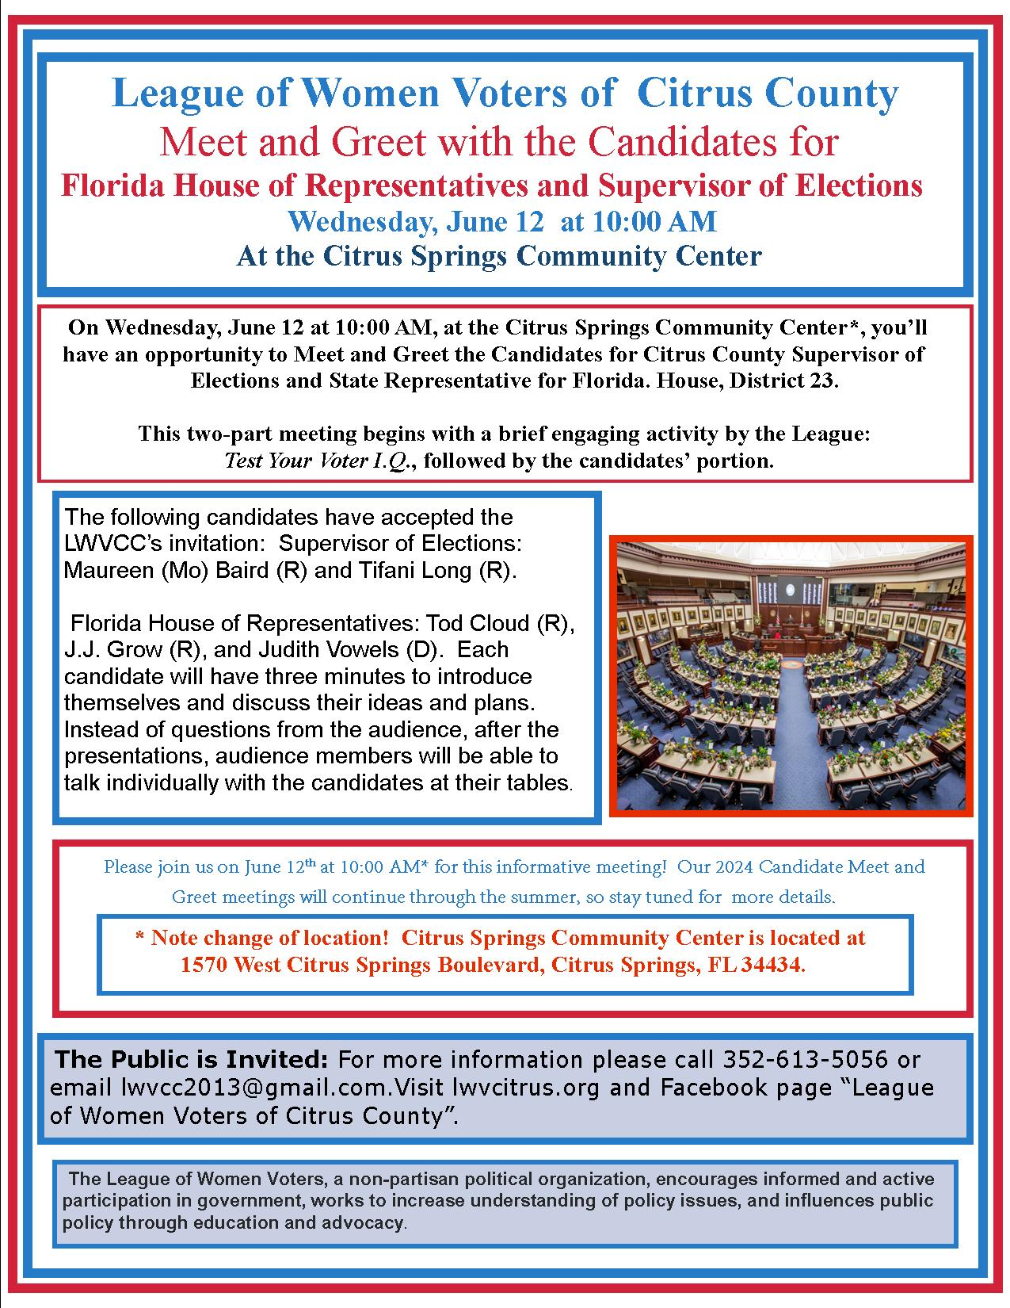

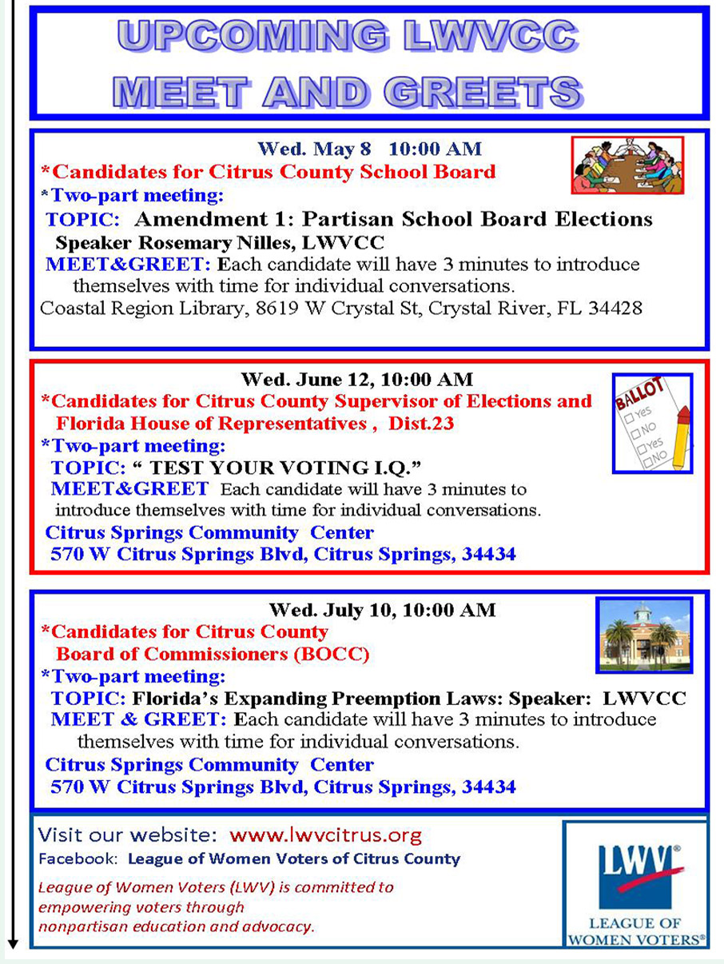

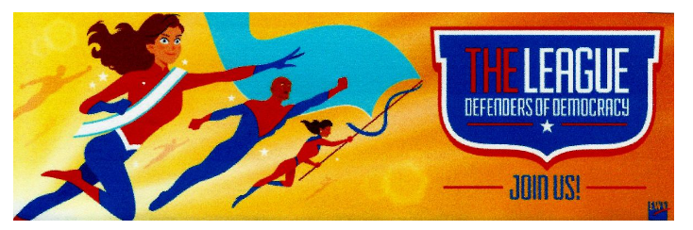
If you are interested in joining the League of Women Voters of Citrus County,
Fill out the form below and mail it to us at
LWVCC, P. O. Box 1903, Lecanto, FL 34460
Name_______________________________
Address_____________________________
____________________________________
Email address_________________________
Phone (home)_________________________
Phone (cell)___________________________
Individual $65______
Household $90
Student Free
Susan B. Anthony $105*
Household $150*
*Includes $40 donation
Credit card name__________________________
Credit card number ________________________
Expiration Date, month and year______________

