LEAGUE OF WOMEN VOTERS OF
CITRUS COUNTY FLORIDA
NEWSLETTER, APRIL, 2024
Vicky Iozzia is the Editor of this newsletter.
Our mailing address is LWVCC. P. O. Box 1903, Lecanto, FL 34460
OUR APRIL 10, 2024 MEETING INCLUDES GUEST SPEAKER TODD HOCKERT FROM THE CITRUS OPIOD TASK FORCE, AND SHERIFF CANDIDATE MEET AND GREET. SEE FLYER AT END OF NEWSLETTER.
OUR MAY 8, 2024 MEETING INCLUDES 1st VP ROSEMARY NILLES WHO WILL SPEAK ABOUT PARTISAN SCHOOL BOARD ELECTIONS. MEET AND GREETS FEATURING SCHOOL BOARD CANDIDATES WILL FOLLOW. SEE FLYER AT THE END OF THE NEWSLETTER
Please visit our Facebook page and "like" us!
https://www.facebook.com/leagueofwomenvotersofcitruscounty
HAPPY APRIL, 2024!

Contents:
Vicky Iozzia, Article, Registering Pages 3 to 4
Our March meeting with Gerry Mulligan Pages 5 to 6
Recent Florida bills and results from LWVFL Pages 7 to 9
Our Board of Directors Page 10
Peg Primeau Reproductive Rights Update Pages 11 and 12
Rosemary Nilles Voting for School Board Page 13 to 15
What is our League Doing? Page 16 to 18
Your County Commissioners Page 19
Your elected officials Page 20 to 21
Linda Abels, Membership Chair Page 22
Dr. B J Ezell, Healthcare Announcements Page 23 to 24
Letter by member Dr. Elizabeth Orsay Page 25
Jan Hall, Regarding our Luncheons Page 26
Mo Baird, Important election dates Page 27 to 28
Maxine Connor Page 29 to 30
April, Sheriff Candidate Meet and Greet Page 31
May, Education, School Board Candidates Page 32
Join us! Page 33 to 34

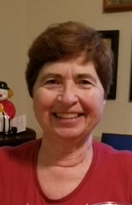
Vicky Iozzia, Co-President,Speakers Bureau Chair, Newsletter Editor, Webmaster
Unrealistic Expectations
I plead guilty of having unrealistic expectations for my country, the States of America (we are absolutely not united), and my chosen state, Florida.
I expect the following:
That when one uses the word freedom that it means freedom for all, not just for those who go to their church, live in their community, look like them, behave in a way others tell them to act, or read the books, listen to the music, or watch the movies they say they should watch.
Our elected officials are our public servants, not our power grabbers who legislate restrictive laws which persecute selected groups of people. Children should be educated in a free education system where the truth is not hidden. They should not be taught to be quiet and be afraid of the people who are supposed to be helping them to grow up and be who they were meant to be, happy, functional adults who can think for themselves.
That people treat each other with respect, dignity, and compassion. I expect them to enact common sense laws that protect all the people, not just the privileged or powerful.
That people should be careful with their language so that they don't purposefully target groups or individuals to hurt them.
I believe that we can no longer afford to be part of a passive democracy. We need to first of all be aware. The truth is there if we open our eyes and ears and use our common sense to see it.
We need to participate in government by not being afraid to express our views and discuss issues.
Most importantly we need to express our sacred right to vote by making an intelligent decision based on the truth and the real self-interest of the voter, not what others manipulate them into believing.
Vicky Iozzia, Beverly Hills, Published in the Citrus County Chronicle February 19, 2024
I will be at the College of Central Florida on Thursdays, 10 am to 1 PM, with a table to give registration information to the public. I will be there with someone else, as I was with Devora Stager, or by myself. If you want to be there with me, please contact me. It would be a great opportunity to learn about the League in a pleasant and relaxed environment.

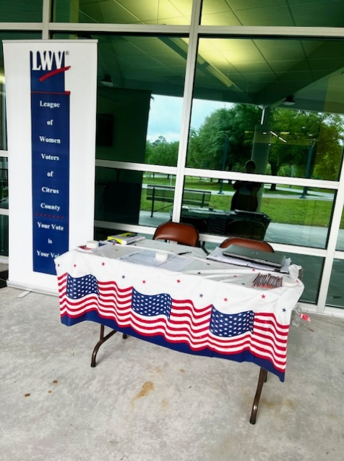
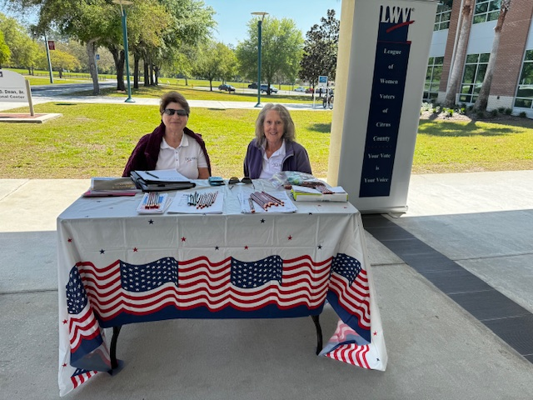

OUR MARCH 13, 2024 MEETING WITH GERRY MULLIGAN
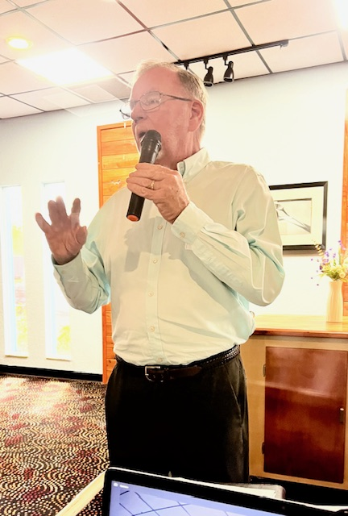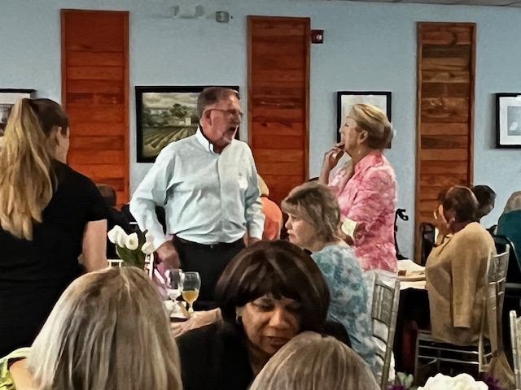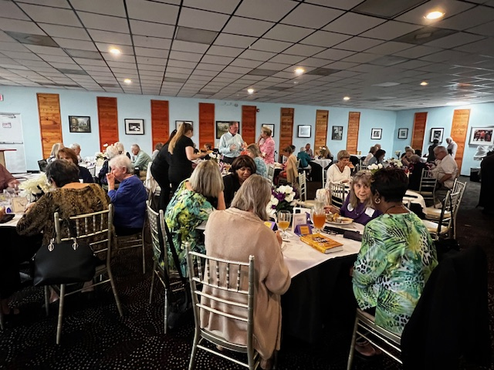
Gerry Mulligan spoke at our March 13, 2024 meeting to a huge crowd at Café Aromas in Lecanto, Florida. Many people came just to hear him speak.
Gerry was the editor of the Citrus County Chronicle for 43 years! He shared his experiences and wisdom for us at the meeting. The video of his presentation will be available with the link in the April newsletter.
He has written a book, titled “Out the Window, 43 Years on the Beat”. It is available on Amazon.
I am including some direct quotes from his presentation:
“Facts are being questioned everyplace. We are not longer debating issues with agreed upon facts.”
“The integrity of the press has been challenged and undermined.”
“Politicians are stronger if they are not questioned.”
“Anybody can put up a social media website.”
“Thomas Jefferson said that newspapers were one of the most important institutions we have.”
“When you can’t agree on what the basic facts are, we are really in trouble.”
Listen to the rest of his speech by following the link on the April 2024 newsletter.
We want to thank Gerry for taking the time to speak to our group.
If you missed this meeting, you can watch it on youtube.
https://www.youtube.com/watch?v=jypmYuPhIXU&t=484s

HERE IS A SUMMARY OF THE RECENT BILLS IN FLORIDA AND THEIR RESULTS.
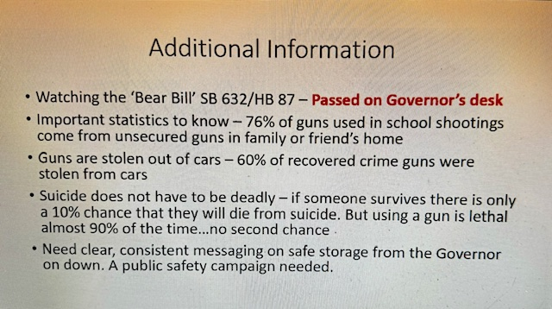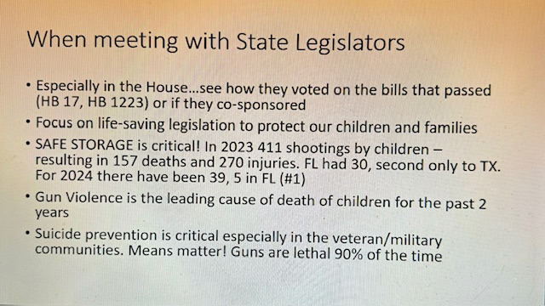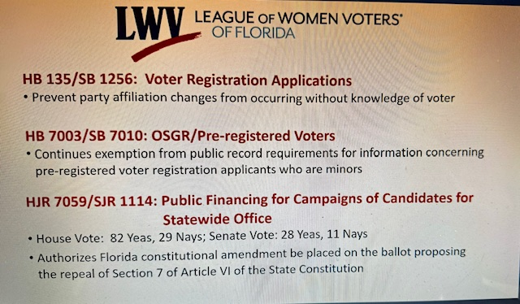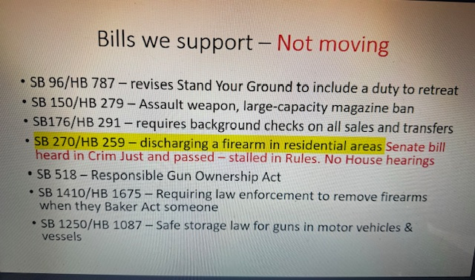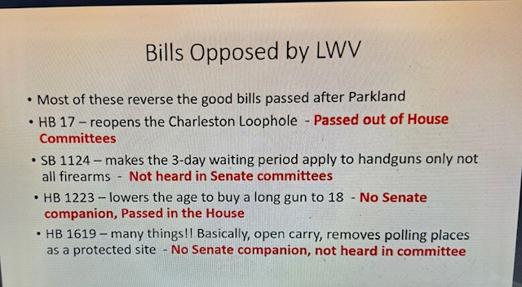

Our Board officers:
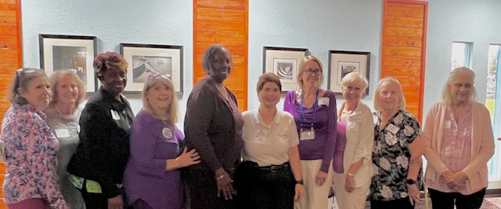
Pictured are Leslie Begelman, newly elected Secretary, Devora Stager, newly elected Treasurer, Beverly Brown, Board member at large, Jan Hall, 2nd Vice President, BJ Ezell, Board member at large, Vicky Iozzia, 1st President, Peg Primeau, 2nd President, Rosemary Nilles, First Vice President, Linda Abels, Membership Chair, and Maxine Connor, Natural Resources Chair

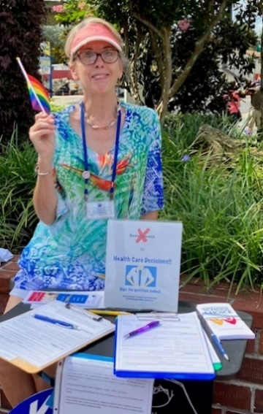

Peg Primeau, Secretary, Reproductive Health & Justice, LWVCC Second President
Reproductive Health & Justice Notes

“We dodged a bullet,” as the hosts said at the latest LWVFL Lunch & Learn about the 2024 Florida Legislative Session.

Several bills unfavorable to reproductive rights either did not make it out of the committee process or were defeated in floor votes. These include:
- a total abortion ban,
- a bill that would potentially empower abusers to sue over abortion and would give fetuses civil rights,
- a bill to prevent provision of sex education to minors, and several anti-LGBTQ+ bills (a bill prohibiting the pride flag at public buildings, a bill requiring insurance coverage of so-called conversion therapy for LGBTQ+ persons, and a measure that increased insurance rates for trans people).
- a bill about fetal personhood, withdrawn after the Alabama Supreme Court’s extremely unpopular judgment in an IVF case.

The FL Supreme Court has until April 1 to post its decision about the clarity of language in Amendment 4, the Amendment Limiting Government Interference with Abortion, so that it can appear on the November ballot. In any case, the 2023 6-week abortion ban hangs over us while the FL Supreme Court decides the case of the current 15-week ban.

What can you do now? Join the rally in Orlando April 13 to (optimistically) launch the Yes on 4 campaign and to make our position on reproductive rights known to the people and politicians of Florida!

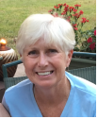
League of Women Voters of Citrus County Supports Our Public Schools!
By Rosemary Nilles, LWVCC Education Chair
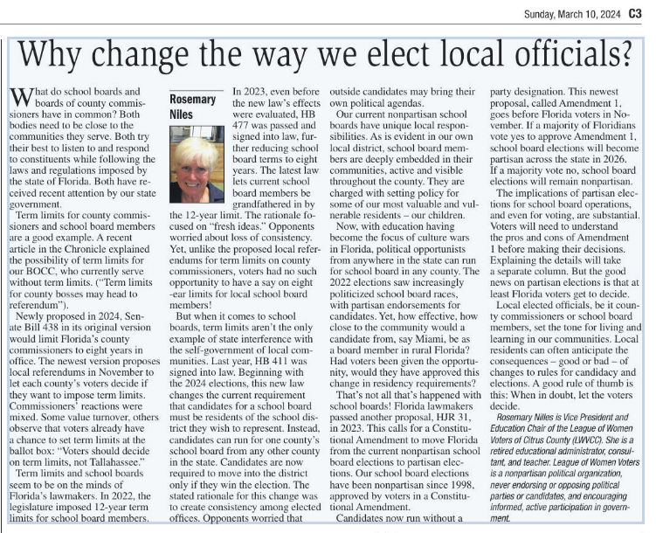
Note: The bill that Rosemary wrote about “died on calendar,” according to the Florida Senate website

Rosemary has been working with the Florida League on education issues. Below is the brochure she worked on regarding voting for School Board members. Please read and pass on this information.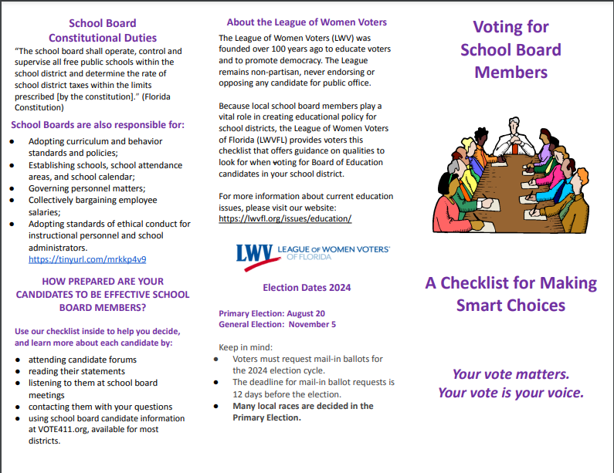
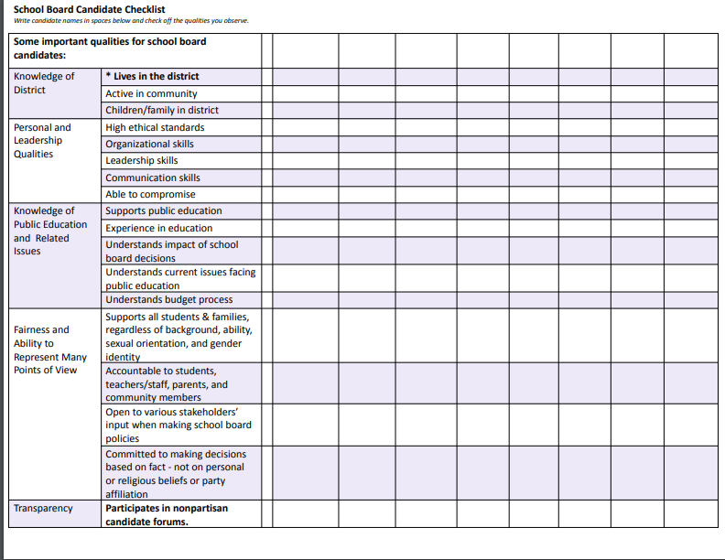

WHAT IS YOUR LEAGUE DOING? LOOK BELOW: League members are participating in these events.

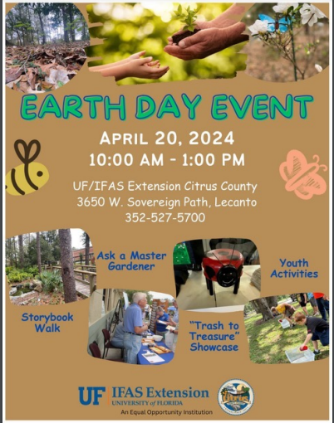

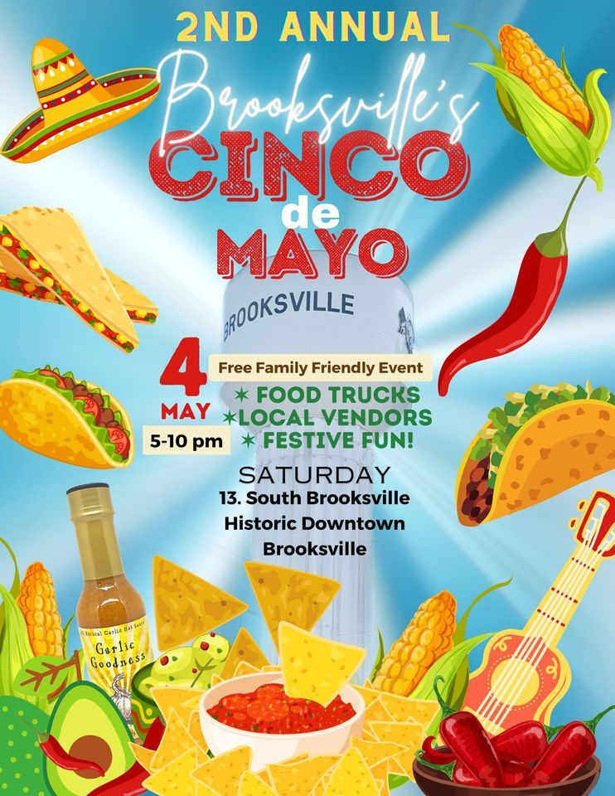

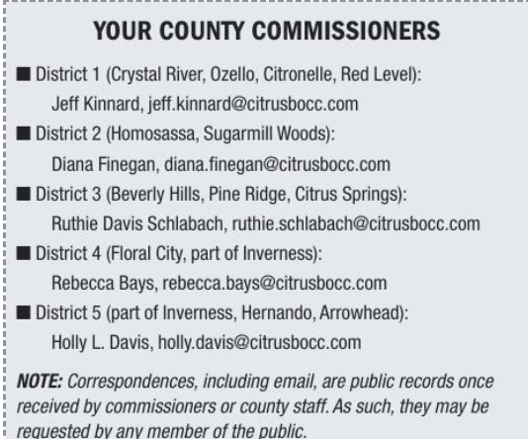

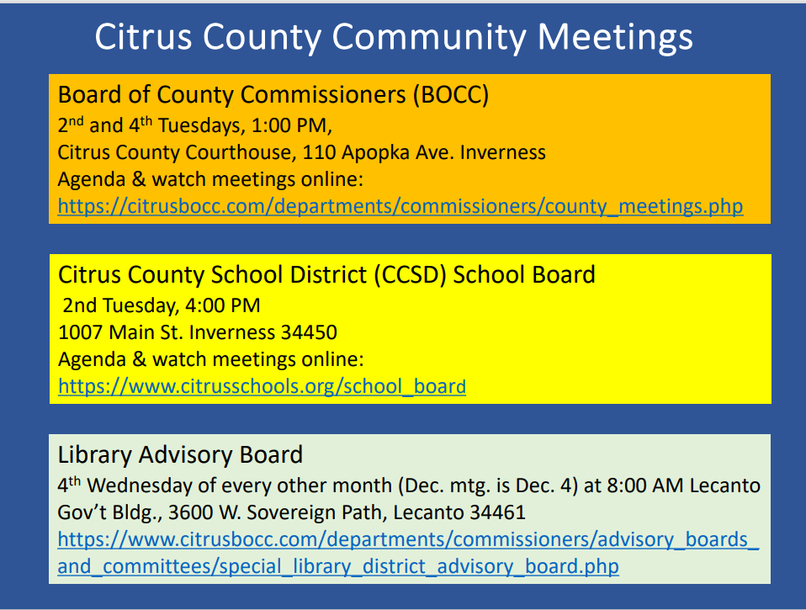

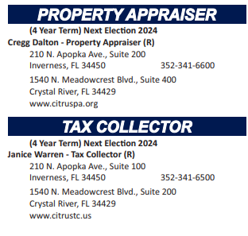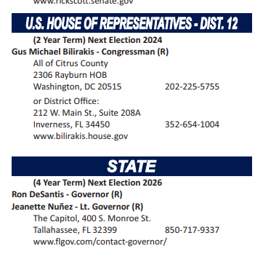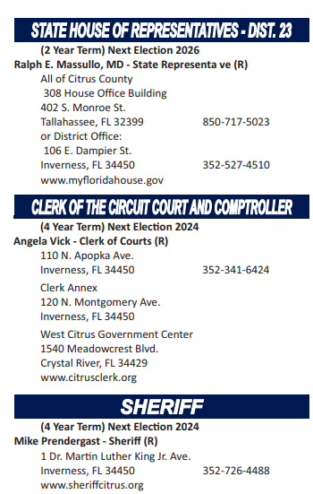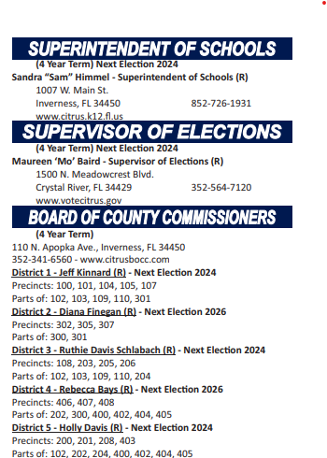

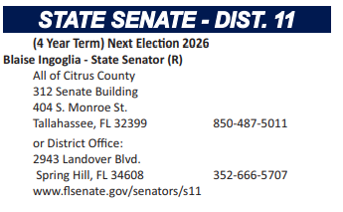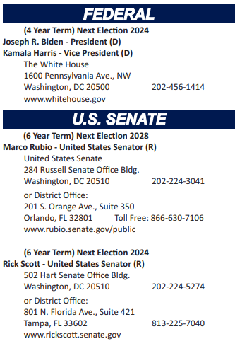

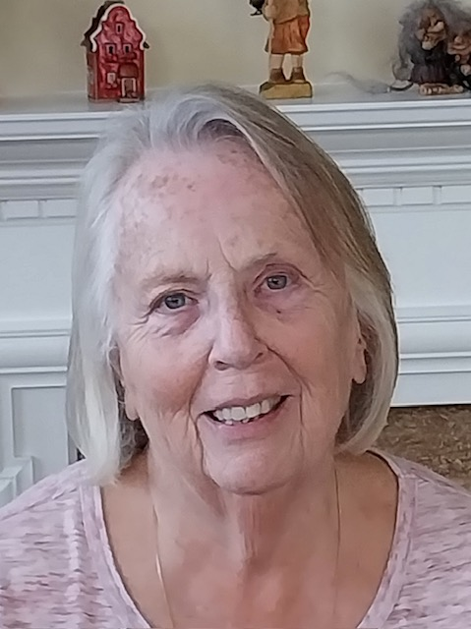
Linda Abels, Membership Chair

WELCOME to our newest members: Karen Crawford, Elaine and Ronald Lewis, Shyni Skowronski, Laura Gatling-Wright, Marilyn Campbell, Leslie Begelman and Elizabeth Griego. We all look forward to seeing you at our monthly meetings and having a chance to welcome you in person. Currently we have 55 members and growing. The last few months have seen an increase in membership as we move into a season where it's so very important to learn about the issues facing us as a community and a country.

I will be sending out dues notices the beginning of April. Most of our members have a June 1 membership renewal date. The notices will come from the LWVCC gmail account. The dues are remaining the same for this year, $65 for an individual membership, $90 for a household membership and Susan B. Anthony Membership is $105. You can pay your dues by mailing a check to the LWVCC, P.O. Box 1903, Lecanto, FL 34460, using a credit card and pay via Paypal or you can bring a check to our regular meetings.

If by chance you receive a dues notice and you have either already paid or don't think you are due, please email me and we'll straighten it out.

Thank you all for your continued support of the LWV and I look forward to working with you.

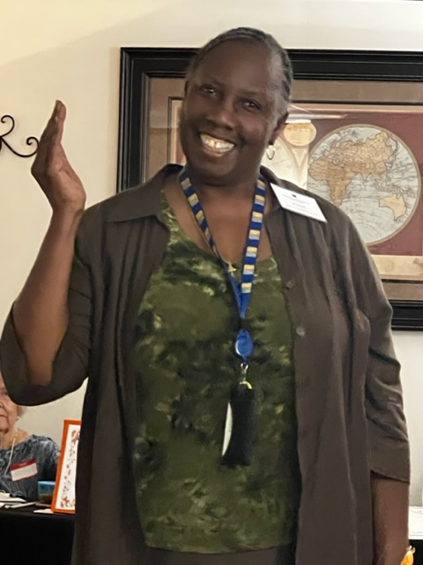

Dr. B. J Ezell has shared the following information

There is a job opportunity advertised by the Health Department:
Nursing Program Specialist. Check myflorida.com if you or you know someone who is interested.

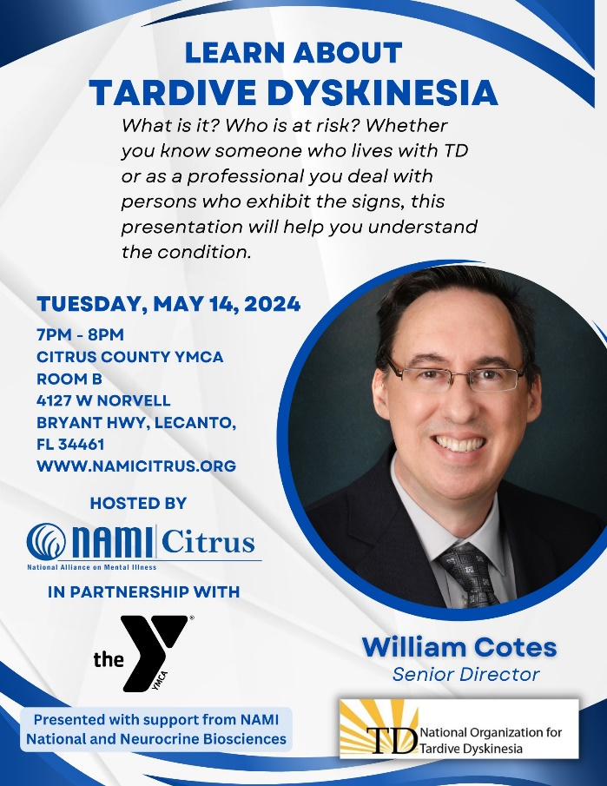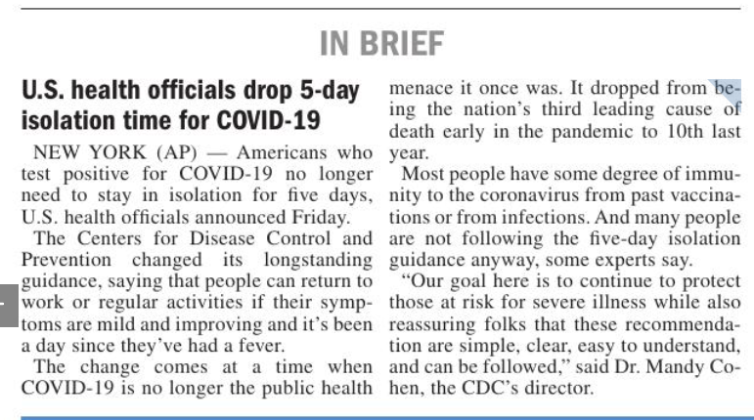

The following letter is written by member Elizabeth Orsay. It was published in the Chronicle on January 11, 2024

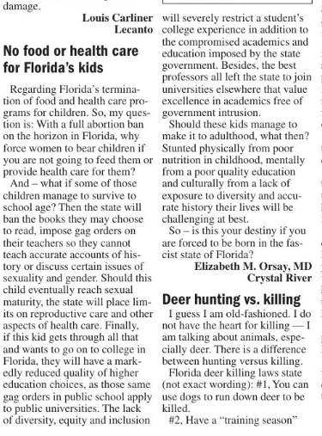

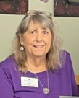
Jan Hall

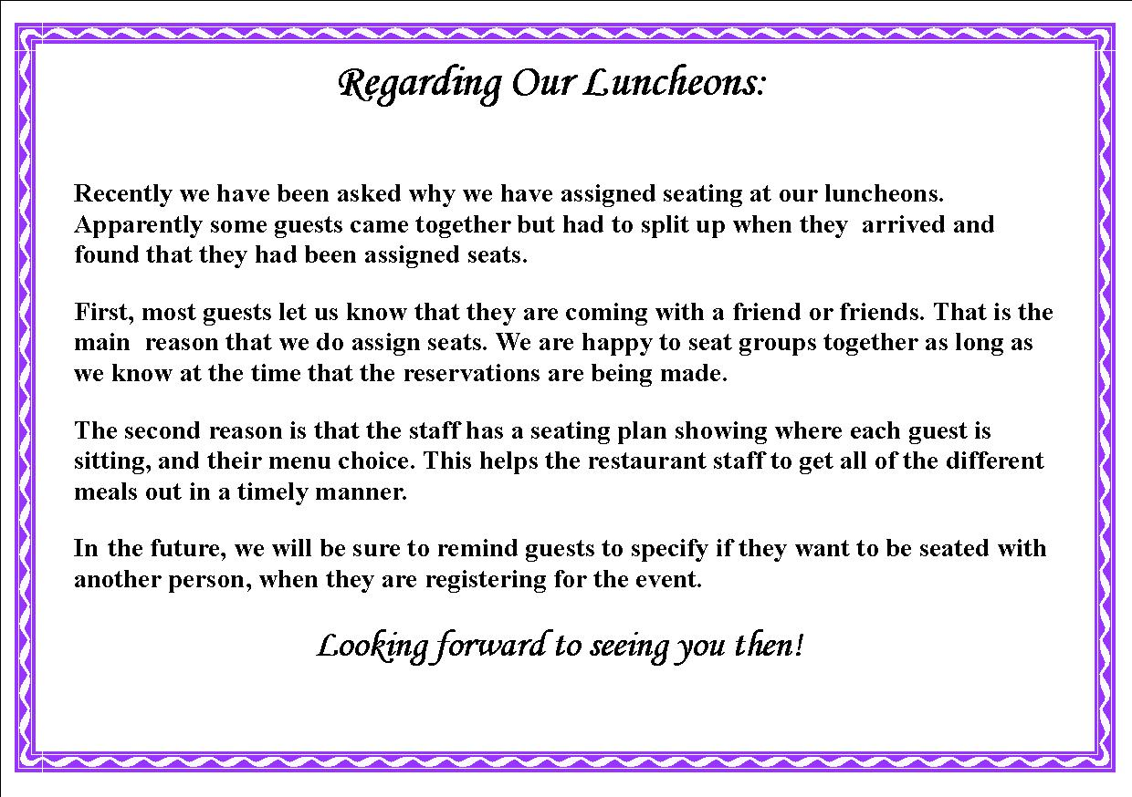

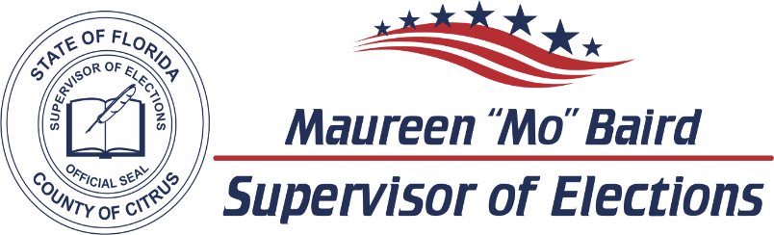

2024 CANDIDATE DATES TO REMEMBER

ELECTIONS
Primary Election | August 20, 2024
General Election | November 5, 2024

LAST DAY CANDIDATES CAN CHANGE PARTY FOR 2024 ELECTIONS  F.S. 99.021
Judicial April 23, 2023
County Office June 11, 2023

PETITIONS DUE  F.S. 99.095
Judicial Noon, March 25, 2024
County and Special District Noon, May 13, 2024

VALID PETITIONS NEEDED
Constitutional, County Commission, and School Board 1,222
Special District 25

RESIGN TO RUN  F.S. 99.012
Judicial April 12, 2024
County and Special District May 31, 2024

QUALIFYING PERIOD  F.S. 99.061
Judicial Noon, April 22, 2024 to Noon, April 26, 2024
County and Special District Noon, June 10, 2024 to Noon, June 14, 2024

Per Florida Statute, we may accept and hold qualifying papers 2 weeks prior to qualifying.

REGISTRATION BOOK CLOSINGS  F.S. 97.055
Primary Election | July 22, 2024
General Election  EARLY VOTING  F.S. 101.657 | October 7, 2024
Primary Election | August 9, 2024 to August 17, 2024
General Election | October 21, 2024 to November 2, 2024

Primary Election dates listed are tentative and subject to change by the Florida Legislature.
VoteCitrus.gov 352-564-7120
Citrus County Supervisor of Elections ~ PO Box 1870 ~ Lecanto, Florida 34460

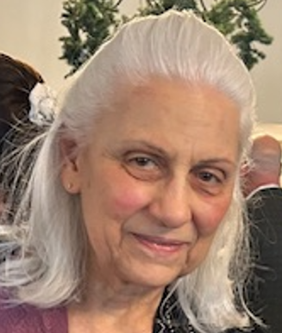
From Maxine Connor, Natural Resources Chair

Please join us for the Earth Day Event at UF/IFAS Extension Citrus County, 3650 West Sovereign Path, Lecanto, on Saturday, April 20 from 10:00 am to 1:00 pm. Bring a child, grandchild, or a friend. The County will feature: Ask a Master Gardener, a Storybook Walk, Youth Activities, and the “Trash to Treasure Showcase,” which will amaze you. The event is a fun learning experience and you can stroll along a walkway through the lovely Florida Friendly plantings under a giant canopy of trees that shade you and keep you cool.
See the Facebook announcement:
https://www.facebook.com/photo/?fbid=786112770216137&amp;set=pb.100064522638876.-
2207520000
There will be many tables. We will table for the League of Women Voters of Citrus County and the League of Women Voters of Florida Clean Energy Action Team. Our neighbor table will beSierra Club Adventure Coast Group. For our Clean Energy

theme, we will have handouts from Solar United Neighbors about solar, solar co-ops, and electric vehicles. We will also have handouts from Florida Springs Council. We have hosted two solar co-ops and we can do it again. There will be a small electric vehicle show featuring at least three all-electric vehicles: a Ford Mustang MachE, a Tesla, and a Cadillac Lyriq. Back by popular demand will be a friend who is a solar installer who trains other installers using his solar training trailer. He will again this year demonstrate collecting solar energy with solar panels, storing the electricity in a big battery, and then charging the Tesla from the storage battery right before your eyes! I will invite back the bicycle shop owner who displayed two electric bikes for us last year that generated a lot of interest. Let me know if you would like to volunteer for the LWVCC or Clean Energy tabling. Email maxineconnor@gmail.com. Hope to see you there!

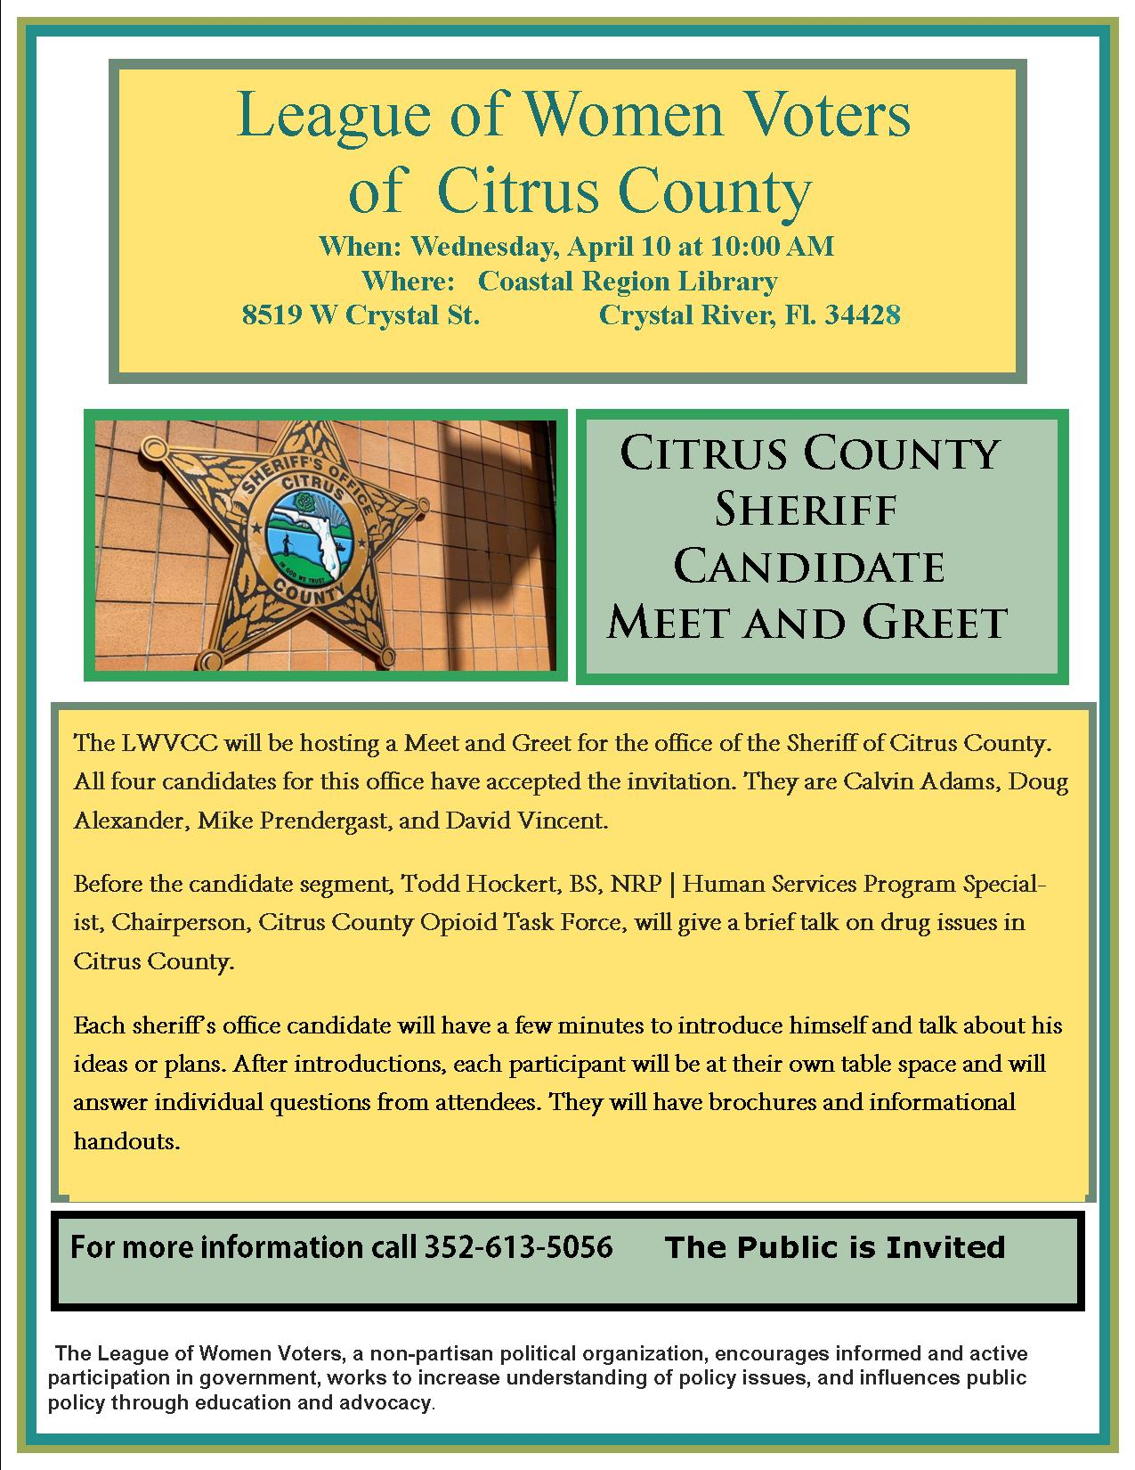
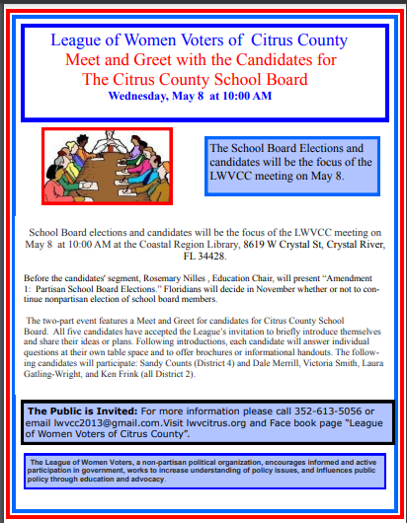

If you are interested in joining the
League of Women Voters of Citrus County,
Fill out the form below and mail it to us at
LWVCC, P. O. Box 1903, Lecanto, FL 34460

Name_______________________________
Address_____________________________
____________________________________
Email address_________________________
Phone (home)_________________________
Phone (cell)___________________________
Individual $65______
Household $90
Student Free
Susan B. Anthony $105*
Household $150*
*Includes $40 donation
Credit card name__________________________
Credit card number ________________________
Expiration Date, month and year______________

