LEAGUE OF WOMEN VOTERS OF
CITRUS COUNTY FLORIDA
NEWSLETTER, MARCH, 2024
Vicky Iozzia is the Editor of this newsletter.
Our mailing address is LWVCC. P. O. Box 1903, Lecanto, FL 34460
OUR MARCH 13, 2024 MEETING FEATURES GERRY MULLIGAN, RETIRED EDITOR OF THE CITRUS COUNTY CHRONICLE. SEE THE FLYER AT THE END OF THE NEWSLETTER TO MAKE YOUR RESERVATION FOR THE LUNCHEON AT CAFÉ AROMAS IN LECANTO.
OUR APRIL 10, 2024 MEETING INCLUDES GUEST SPEAKER TODD HOCKERT FROM THE CITRUS OPIOD TASK FORCE, AND SHERIFF CANDIDATE MEET AND GREET. SEE FLYER AT END OF NEWSLETTER.
Please visit our facebook page and "like" us!
https://www.facebook.com/leagueofwomenvotersofcitruscounty
HAPPY MARCH, 2024!

March Holidays: March 1 Zero Discrimination Day, Employee Appreciation Day
March 2 Read Across America Day, Caregiver Appreciation Day
March 3, World Wildlife Day
March 10 Harriet Tubman Day
March 12 Plant a Flower Day
March 15 World Sleep Day
March 20 International Day of Happiness
March 30 Doctors’ Day
March 31 International Transgender Day of Visibility
Contents:
Vicky Iozzia Pages 3 to 4
Our February meeting, Dr. Lavon Wright Bracy Page 4 to 7
Davora Stager, assistant treasurer Pages 7 to 8
Citrus logo shirt information Page 8
Peg Primeau, So I had this weird dream Page 9
Florida Women’s Freedom Coalition Page 10
Rosemary Nilles, support for public education Page 11
BOCC Information Page 12
Elections coming up Page 13 to 14
Linda Abels, Membership chair Page 15 to 16
B J Ezell Page 16 to 18
Jan Hall, How our League came to be Page 19 to 21
Mo Baird, Important election dates Page 22
The African-American Read-In Page 23 to 26
Maxine Connor Page 26 to 28
March Annual Luncheon with Gerry Mulligan Page 29
Sheriff Candidate Meet and Greet Page 30
Join us! Page 29-30
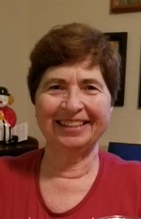
Vicky Iozzia, Co-President,Speakers Bureau Chair, Newsletter Editor, Webmaster
This letter was published in the Citrus County Chronicle on January 29, 2024

These are scary times we live in. It is important that we stay aware of what is going on, not be afraid of “Woke”.
We need to register voters. Although present Florida regulations make this very difficult for an organization like the League, who accuse us of “harvesting” registrations, we must remain vigilant.
The link below is an article in USA Today titled “Women aren’t showing up to vote. It could lead to disaster in 2024” We cannot let the state of Florida deny people their constitutional right to vote!
https://www.usatoday.com/story/opinion/2024/02/20/women-voters-primary-2024-election-biden-trump/72657970007/
“They” always say the Presidential Election is the most important. THIS one truly is. Please encourage every woman you know to vote.
To this end I have spoken with the College of Central Florida. I will be informing you of the times and dates we will be permitted to go there to attempt to register people. I will be asking for volunteers to help when I get the dates and times verified. It will be a good opportunity for new members to be able to work with more experienced members. All you will have to do is sit and give people information.
SPEAKING OF ELECTIONS, OUR ELECTIONS FOR OFFICERS WILL TAKE PLACE AT THE END OF OUR MARCH MEETING.
OUR LEAGUE IS CELEBRATING OUR TENTH ANNIVERSARY. HELP US CELEBRATE AT OUR MARCH MEETING!

Our February 13, 2024 meeting
at the Coastal Region Library
Dr Lavon Wright Bracy
spoke about her personal experiences
with integration.
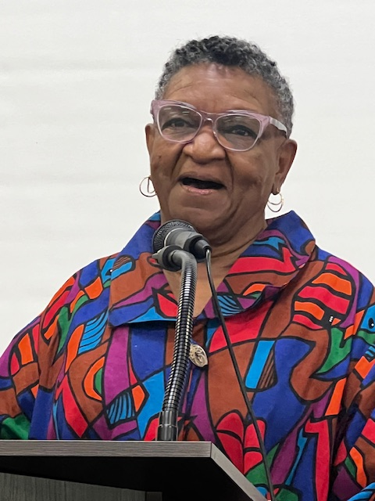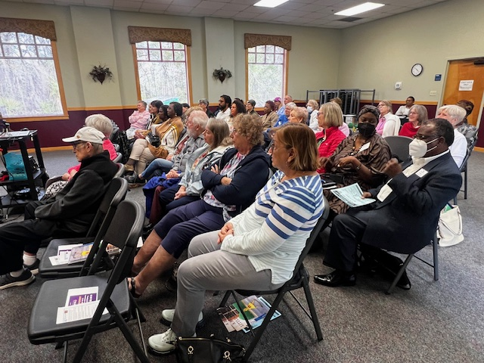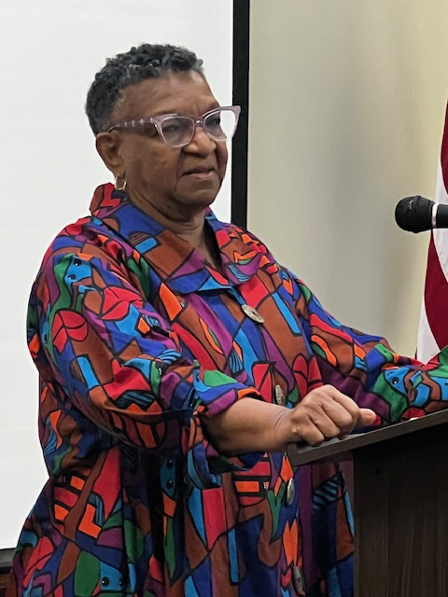

Dr. Lavon Wright Bracy

One of the wonderful privileges I have as President of the League is to get to meet some great people who speak for us. Such was the case this February. Our audience was treated to a part of history that for some reason has become controversial. The truth is the truth.
Dr. Lavon Wright Bracy is an unassuming hero. With calm and poise, she told of experiences of her life, growing up as an African American.
These experiences include having her father considered a troublemaker because was an advocate with the NAACP for the rights of black people, leaving their home in the middle of the night and being told to hide on the floor of the car so no one would see them, and having a cross burned on their front yard by the KKK. Her mother, a reading teacher, lost her job, even though she was the best reading teacher there, because of her father’s political activities.
As the first black person to graduate from Gainesville High School, her senior year was a nightmare. She was spat on, ostracized, downgraded, and physically beaten. She was totally alone. She survived on pure courage.
Dr. Bracy has written a book called “A Brave Little Cookie” where she describes her experience.
If you were not at the meeting (You are missing so much!). Here is the link to her speech: https://www.youtube.com/watch?v=XowlvAXLMkc&t=3324s

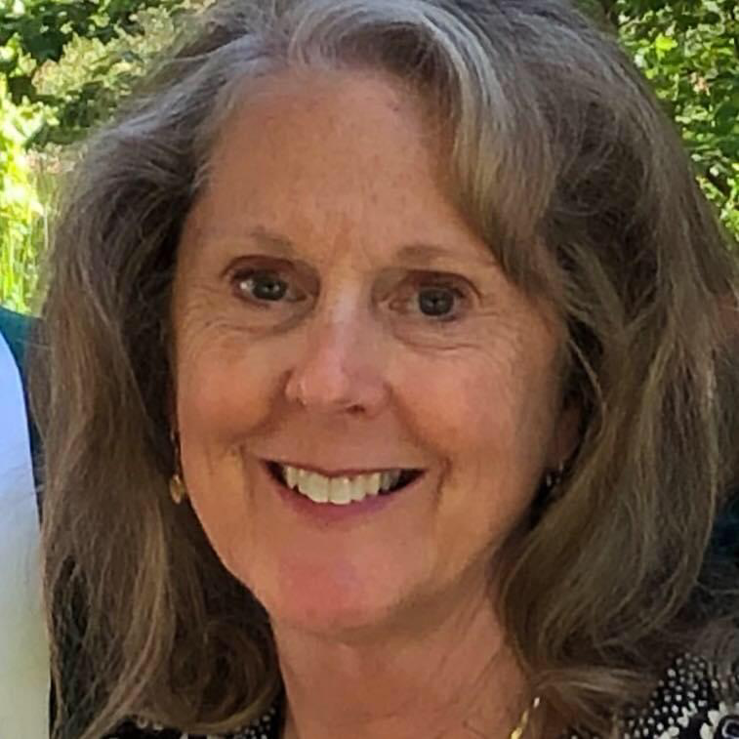
Welcome Devora Stager, to the Board,
Assistant Treasurer

Devora Stager started life in Connecticut, where she lived for thirty years. Following high school she attended a two-year business college. Employed for six years in the business world, Devora changed course and returned to school at the University of Connecticut, graduating with a Bachelor of Science in education.
Always an outdoors person, Devora was enchanted by the offer of a real change in lifestyle, spending the next twenty years living on a mountain in Maine where she practiced self sufficiency and organic farming while operating a summer children’s camp program.
Deciding to return to the world of public education, Devora then joined the staff at an elementary school, eventually teaching at all K-12 levels. After earning a Master’s Degree in Special Education and School Administration, Devora accepted the position of Special Services Administration at the Maine District where she had been teaching. This was an extremely rewarding experience, working with children and families throughout the District.
She finished her career as an elementary school Principal.
As a lover of nature throughout her life, Devora has been pressing flowers and other botanical materials
for forty-five years, using them to create different products including notecards and framed collages.
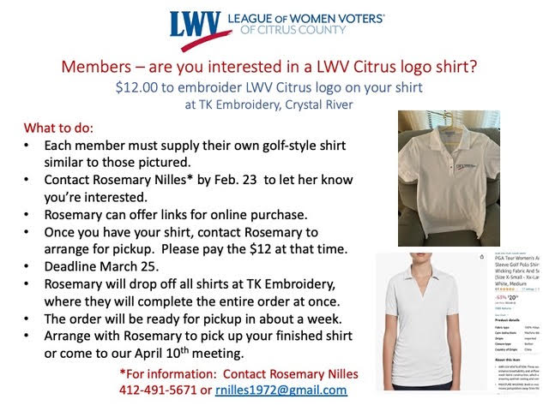

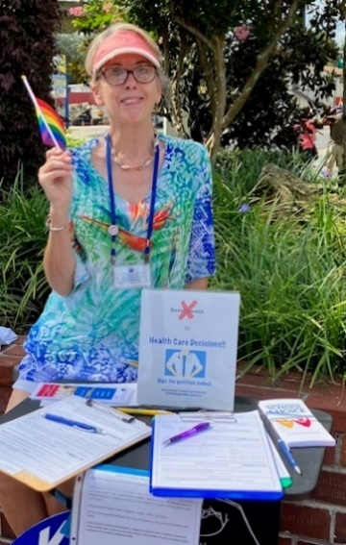
Peg Primeau, Secretary, Reproductive Health & Justice
So I had this weird dream…
Peggy Primeau, Secretary

I don’t know if it was the nightly news or the upcoming Chapter meeting or what, but the other night I woke up from this dream. A colleague and I were preparing to teach high-schoolers a lesson on the French Revolution. For some reason the room we were using was more causal than a classroom but a bit more adult, too. As students gathered, we were frantically looking for the projector to show the documentary we had on what the Revolution was all about and what happened after. Couldn’t find it! (Typical anxiety dream so far….)
Then we found it in a cabinet, and began to set up. There was a prominent tag on the reel that said, “Don’t pour soda on the film.” Huh?
Here’s my take: substitute Kool-Aid for soda and U.S. History for documentary film, and this dream clearly means STOP censoring history. Let the students study the facts and be able to see where we have been and where we may be going! Restore the resources and authority our teachers need to do their jobs.
As we say in the League, empower voters and defend democracy.

Below is from the beginning of February.
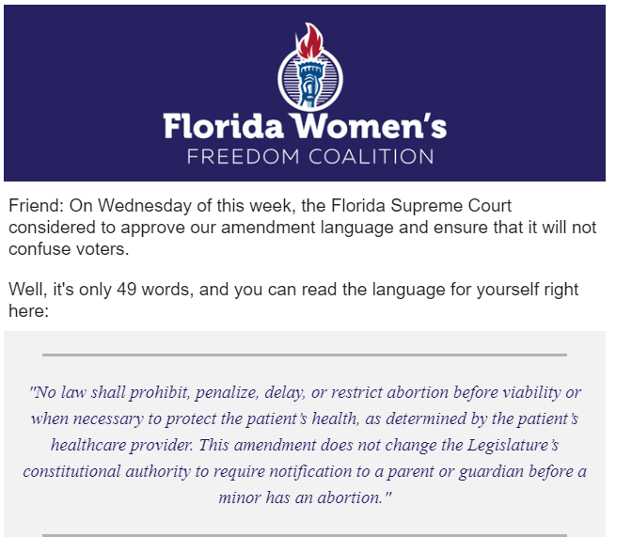

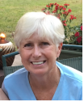
League of Women Voters of Citrus County Supports Our Public Schools!
By Rosemary Nilles, LWVCC Education Chair
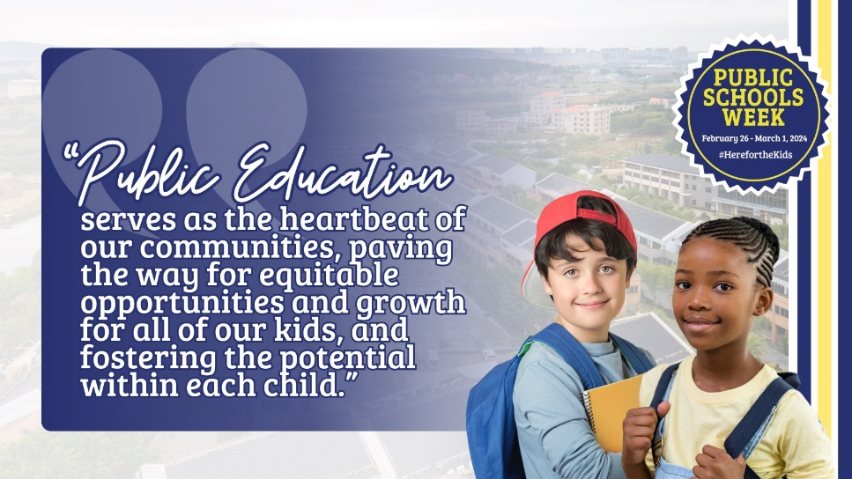

Feb. 26 to March 1, 2024 has been designated as Support Public Schools Week.
It’s a time to celebrate public schools as the cornerstone of a democratic society. And a time to acknowledge the great work that our public schools do – to provide every student a free and fair public education.
In public education, ALL means ALL - regardless of wealth, religion, race, disability status, gender and gender identity, and zip code. Public schools welcome the students with special needs, the English Language Learners, kids with behavioral issues, kids from dysfunctional families, homeless kids, foster kids, immigrant kids, everyone.
These things alone are worthy of celebration!
Let’s continue to support and acknowledge the work of our dedicated teachers, staff, and administrators.

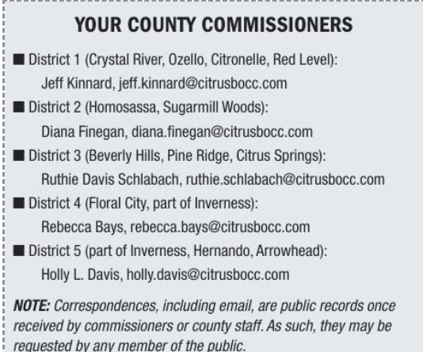

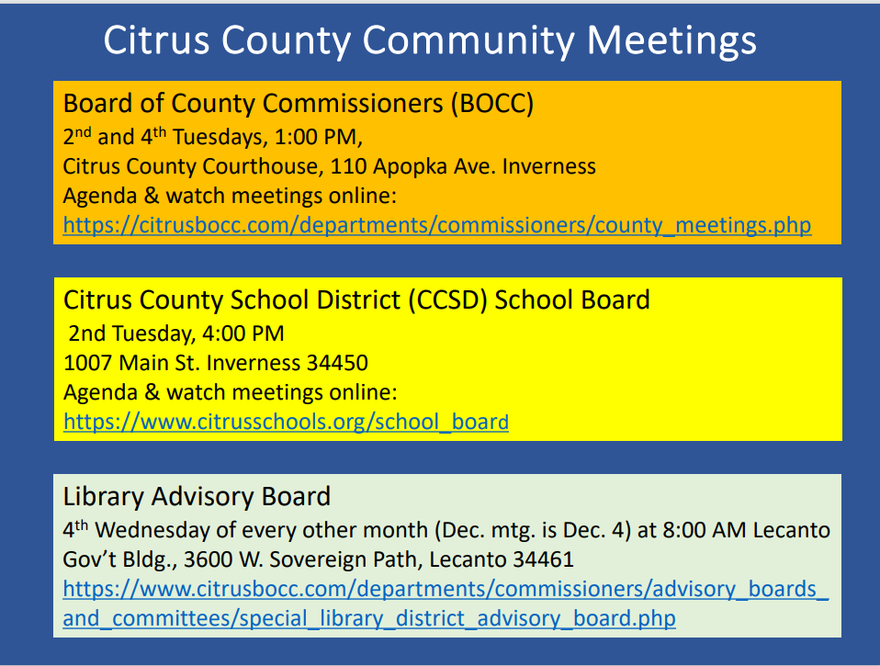
Elections coming up
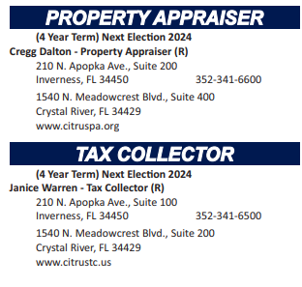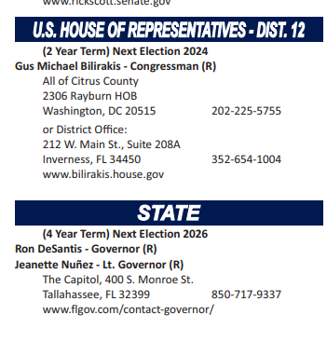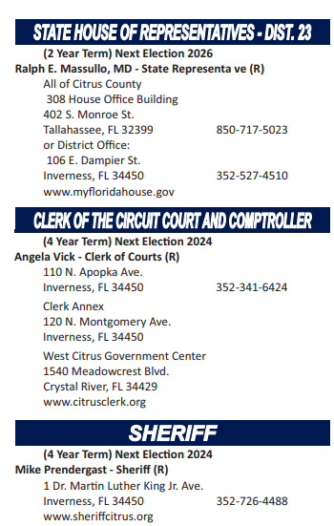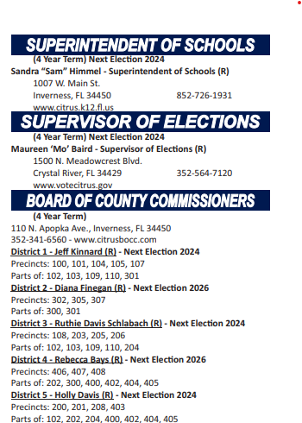

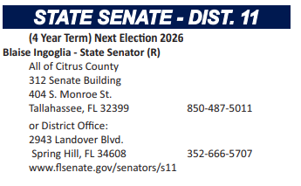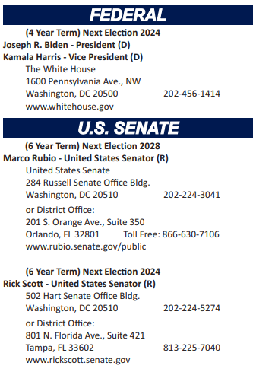

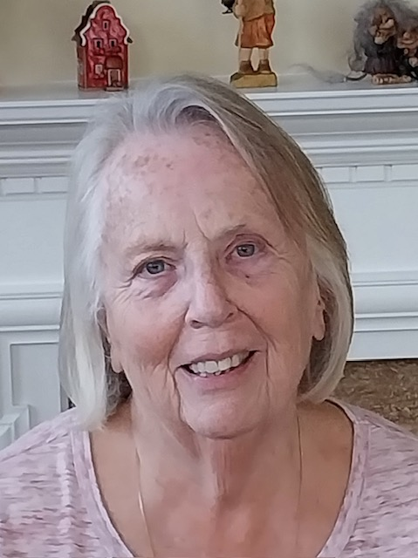

Linda Abels, Membership Chair

Happy almost Spring! I would like to welcome our newest members to the LWV of Citrus County. They are Norma Haas, Sonja Wilson, Karen Crawford, and Elizabeth Orsay. We welcome back Sandy Counts. Susan got busy with other things for a while but has rejoined us. I look forward to meeting you all at our monthly meetings. We welcome your input and help in any and all of our activities.

Just a quick reminder to members that have a renewal date of June 1. I will be sending out renewal notices the beginning of April. The dues will remain $65 for an individual membership and $90 for a household membership.

If you have friends that might be interested in joining, please invite them to a meeting. We have some interesting meetings planned for the upcoming months.

We also welcome back Susan Moore who was an original member of this League Chapter. Susan was an original co-President of the League.

Below is a photo of Susan and co-President Marie Pettibone.
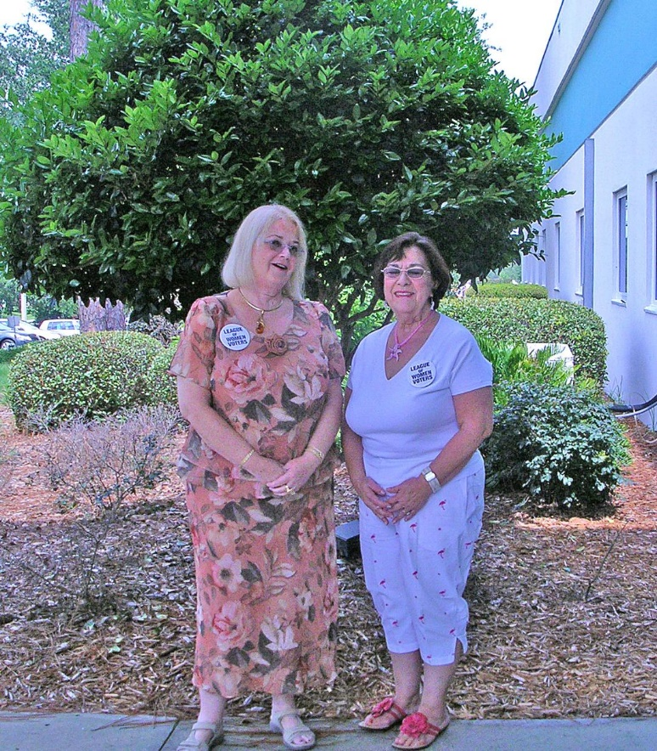

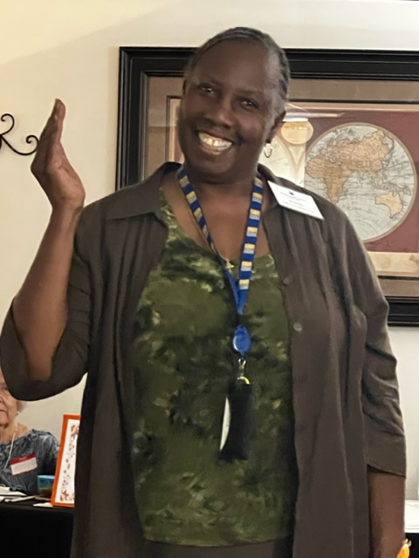
Dr. B. J Ezell has shared the following information:

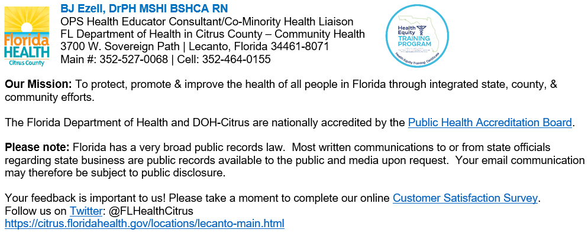
Citrus County BOCC
Office of Communications
FOR IMMEDIATE RELEASE: Thursday, February 1, 2024
Contact: Mike Bridges, Communications Manager
pio@citrusbocc.com
CHANGES TO ANIMAL SERVICES COMMUNITY CAT PROGRAM
CITRUS COUNTY, Fla. — Due to staffing limitations, Citrus County Animal Services (CCAS) will suspend their Community Cat Trap-Neuter-Vaccinate-Return (TNVR) program Saturday, February 6, 2024.
Beginning Saturday, February 13, Community Cat intake will be capped at 15 trapped cats per week, accepted on a first come, first served basis – no exceptions.
It is recommended that healthy cats found outside are left alone during the week services are suspended at the shelter. Nationally, only 2% of cats are picked up by their owners when they end up in shelters – but are up to 13 times more likely to make it home when allowed to remain in the community.
For more information, contact Citrus County Animal Services at (352) 746-8200, or visit the county’s
website www.citrusbocc.com.

CLERK OF COURT OFFERS PUBLIC INFORMATION SESSION
Inverness, Fla. -- The Citrus County Clerk of Court and Comptroller’s office will hold its third Clerk Services Public Information session on Thursday, March 14, 2024, providing citizens an opportunity to learn more about navigating the Clerk’s office website, services, and initiatives. The session will be held from 9 a.m. to 11 a.m. at the West Citrus Government Center, located at 1540 N. Meadowcrest Blvd, Crystal River, FL in the Property Appraiser’s Training Room.
The information provided will include, but is not limited to:
• JustFOIA – Public Records &amp; General Information questions
• BOCC Meetings / Minutes
• Role of the Clerk as the County Recorder
• Recording Activity Notification (RAN) – how to sign up
• Online Jury Excusal process
• Online Official Records Search
• Passports and Marriage Licenses
• Dedicated to Excellence – Office Culture
Seating will be limited; advanced registration is required. To register, contact our office at 352-341-6424, option 9; or by email at pio@citrusclerk.org.

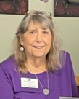
Jan Hall
“We stand on the shoulders of those who walked before us.”
Jan will be going through the archives of notes from our League and sharing them with us.
Our League of Women Voters of Citrus County is celebrating our tenth year. Here is an article from when we began.

How the Citrus League of Women Voters came to be
By Linda Myers, written in 2013
If you moved to Citrus County after 2000 you might have noticed there was no League of Women Voters, “since Nancy Campbell died.”,
During Primary election season last year (2012) there were many “meet the candidate” programs in the county. However, no one was explaining the many constitutional amendments where were to be on the November ballot.
Members of the local Unitarian Universalist Fellowship took matters into hand. We booked Judy Johnson to speak about the Amendments at UU in August. Judy is an attorney, quite conversant with Florida's constitution and is also a co-President of Marion County LWV. UU overflowed with interested people (about 120). Nancy Kennedy covered the talk and used Judy's points in her front-page story in the paper.
We were asked why we don't form a League in Citrus. UU supported this idea and made space available. A presentation was made, and interest expressed. A volunteer board and officers were selected and in a short time a local unit was approved – The League of Women voters of Citrus County. The meeting place was moved to the Central Ridge Library, due to conflicting space needs at NCUU. We have about 30 paid members, meet monthly, and are hosting the Supervisor of Elections on July 9 to bring us up to date on new changes to voting procedures.
These photos celebrate our first anniversary.
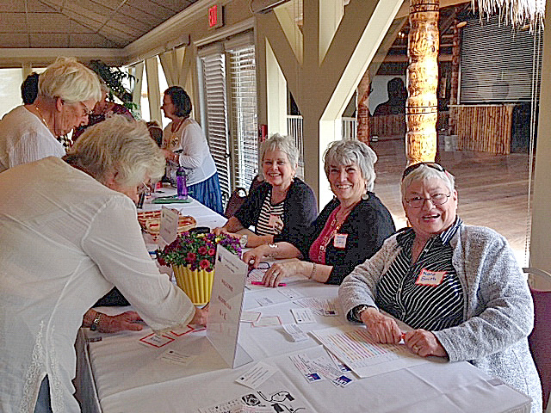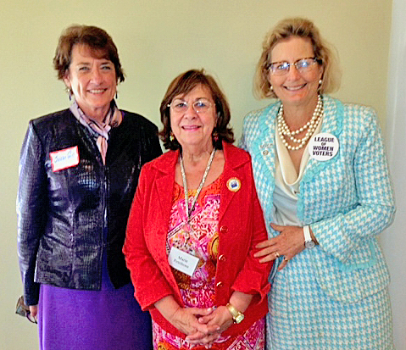

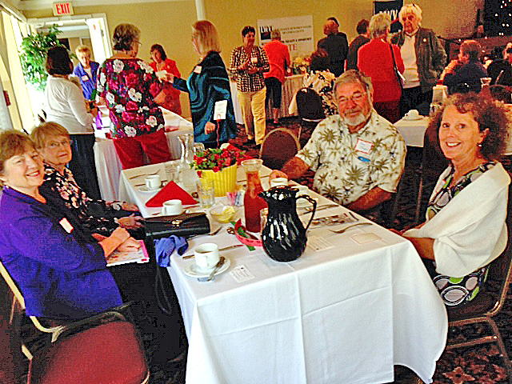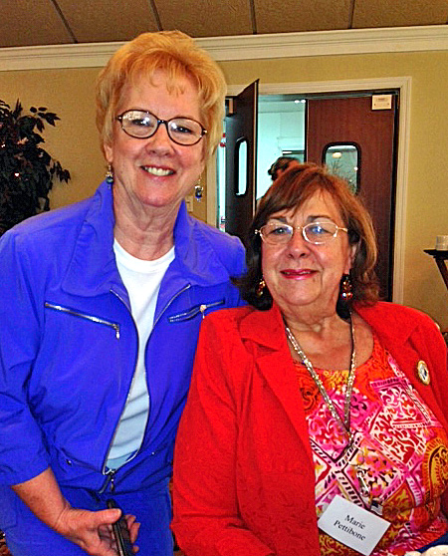
Photos:
First photo: Sheila Jacobs and Kate Smith
Second photo: Susan Gill, Marie Pettibone, Deidre McNabe
Third photo: Devora Stager with smiling friends
Fourth photo: Kate Betsko and Marie Pettibone

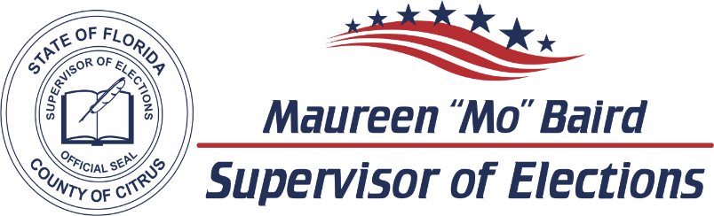

2024 CANDIDATE DATES TO REMEMBER

ELECTIONS
Primary Election | August 20, 2024
General Election | November 5, 2024

LAST DAY CANDIDATES CAN CHANGE PARTY FOR 2024 ELECTIONS  F.S. 99.021
Judicial April 23, 2023
County Office June 11, 2023

PETITIONS DUE  F.S. 99.095
Judicial Noon, March 25, 2024
County and Special District Noon, May 13, 2024

VALID PETITIONS NEEDED
Constitutional, County Commission, and School Board 1,222
Special District 25

RESIGN TO RUN  F.S. 99.012
Judicial April 12, 2024
County and Special District May 31, 2024

QUALIFYING PERIOD  F.S. 99.061
Judicial Noon, April 22, 2024 to Noon, April 26, 2024
County and Special District Noon, June 10, 2024 to Noon, June 14, 2024

Per Florida Statute, we may accept and hold qualifying papers 2 weeks prior to qualifying.

REGISTRATION BOOK CLOSINGS  F.S. 97.055
Primary Election | July 22, 2024
General Election  EARLY VOTING  F.S. 101.657 | October 7, 2024
Primary Election | August 9, 2024 to August 17, 2024
General Election | October 21, 2024 to November 2, 2024

Primary Election dates listed are tentative and subject to change by the Florida Legislature.
VoteCitrus.gov 352-564-7120
Citrus County Supervisor of Elections ~ PO Box 1870 ~ Lecanto, Florida 34460

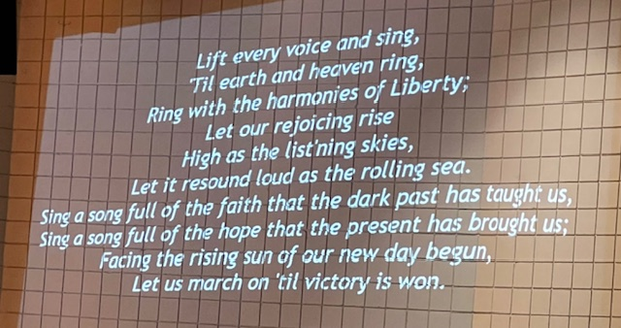

The Read-in included community members listed and pictured below, including our very own Dr. B J Ezell. If you missed it, you missed some wonderful readings of great literature. The next one is February 24, 2025, so you can mark it on your calendar now!
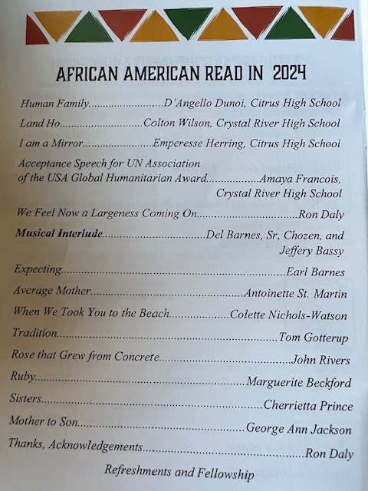
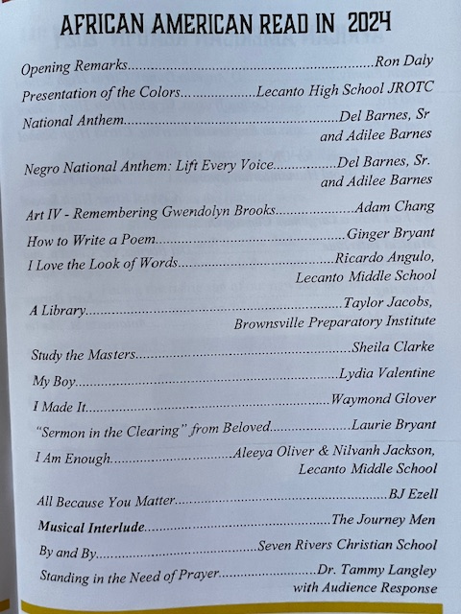

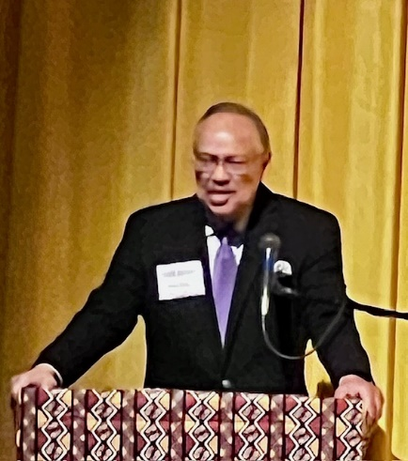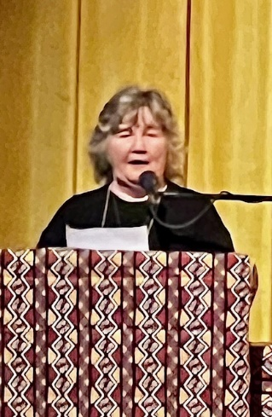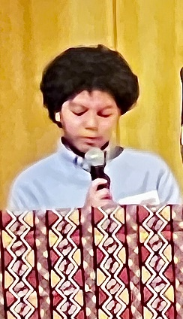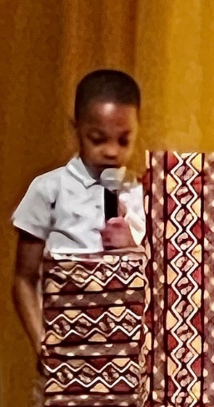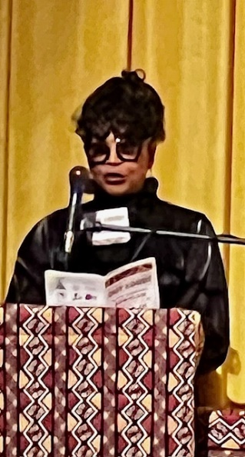
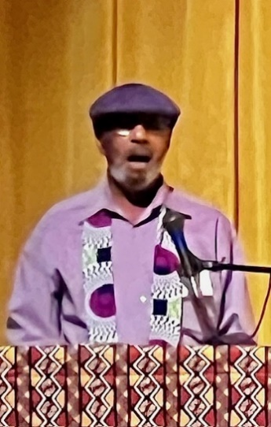
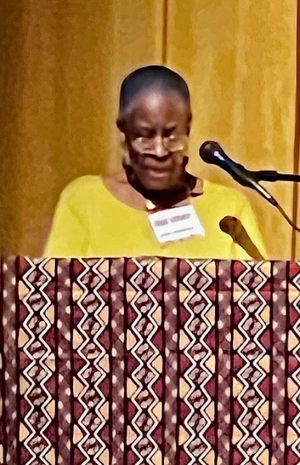
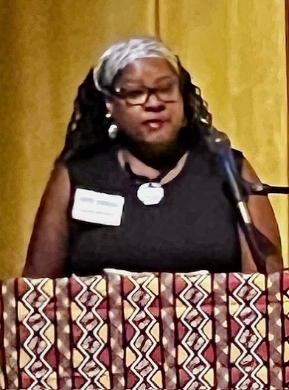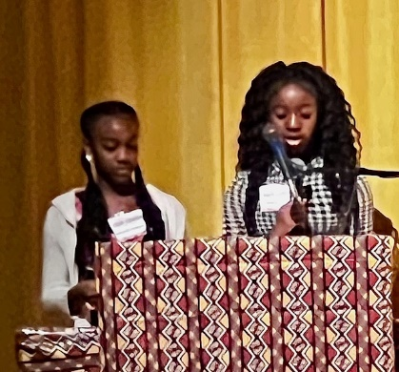
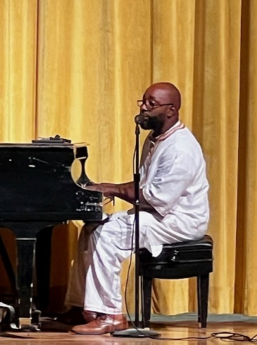
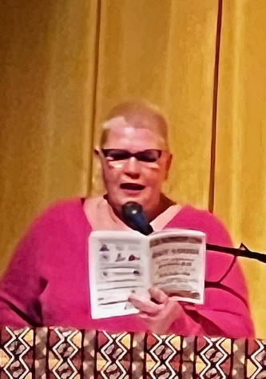
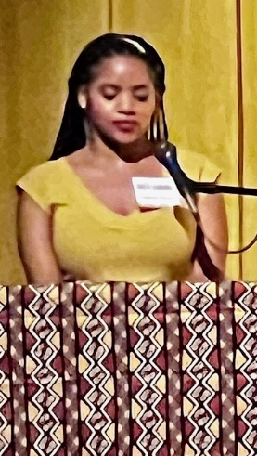
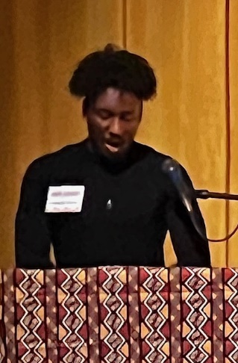
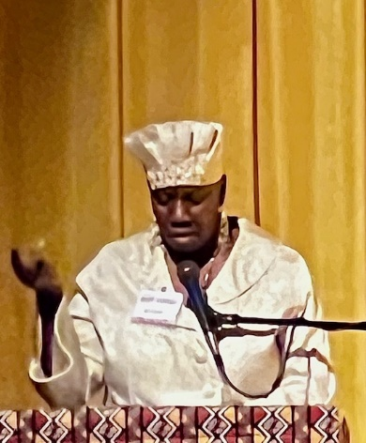
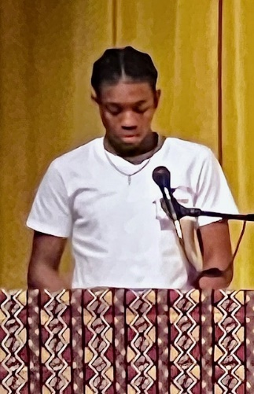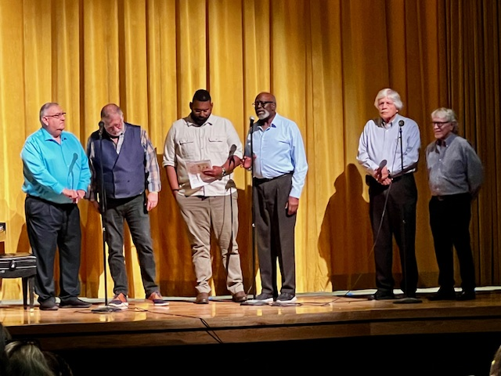
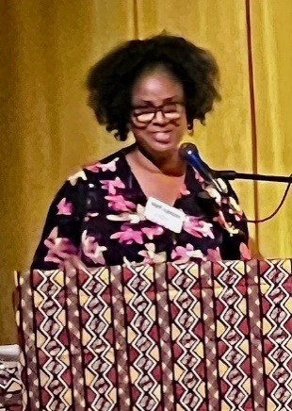
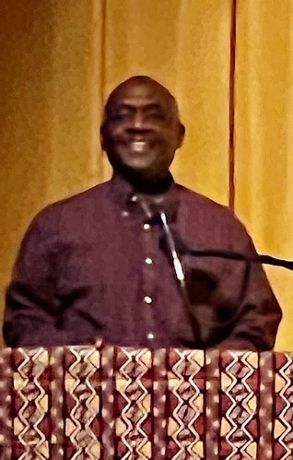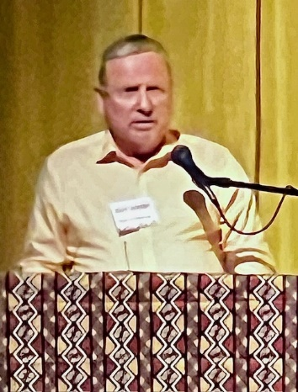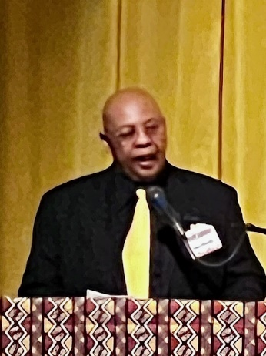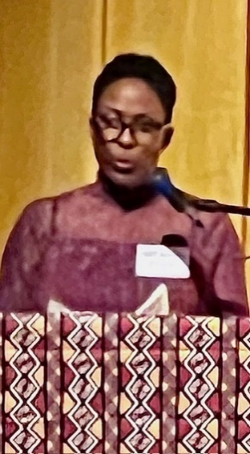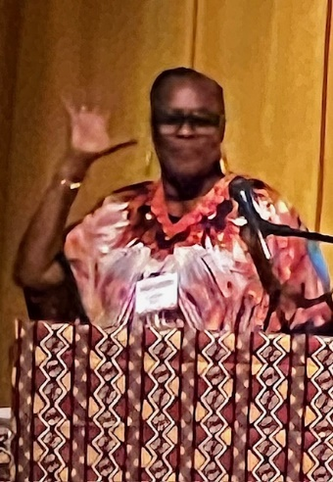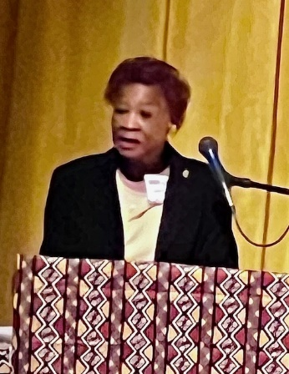

From Maxine Connor, Natural Resources Chair,
Waiting for a Time to Reevaluate the Citrus County Fertilizer Ordinance
At the end of last year’s Florida legislative session, when the state was determining the budget, it slipped in a provision with funding to study what effect reducing urban fertilizer would have on water quality. That, in effect, began a moratorium on any new or stricter fertilizer ordinances across the state until the end of this budget year, on July 1, 2024,
The resulting University of Florida IFAS report, Effectiveness of the timing of seasonal fertilizer restrictions on urban landscapes contains nothing that would justify relaxing urban fertilizer restrictions. In fact, the report made it clear that the Florida Consumer Fertilizer Task Force, back in 2007, was correct in its conclusion that a watershed-by-watershed approach, as opposed to one statewide rule.
The Legislature should let the moratorium sunset and allow local governments to protect their waterfront businesses, property values, and quality of life.

The Hernando County Commission rushed to pass their own "strong" urban fertilizer ordinance right ahead of the preemptive moratorium last May.
That prevents runoff of Nitrogen during the rainy season into our local springs, waterways, and ultimately the Gulf. Excess nutrients feed toxic algae blooms that kill fish and other water-dwelling animals, and smother native aquatic vegetation. The algae also causes respiratory illness in people.
Citrus County has a Fertilizer Ordinance that was passed in 2014. If the moratorium sunsets, that would allow our County Commissioners review the Ordinance and hopefully improve it by considering items such as a rainy season ban and introducing slow-release nitrogen. So much nitrogen has gone down into the aquifer that it comes up into the springs.
We have three first-magnitude springs in Citrus County: Crystal River and Kings Bay, Homosassa, and Chassahowitzka. They all have Basin Management Plans (BMAPs) from the DEP (Florida Department of Environmental Protection) because they are all impaired by excess nutrient pollution. The Homosassa and Chassahowitzka Springs Groups BMAP estimates urban fertilizer contributes 19% to Nitrogen loading for the Chassahowitzka and 24% for the Homosassa. The Kings Bay/Crystal River BMAP estimates urban fertilizer contributes 15% to Nitrogen loading.
Strictly regulating urban yard fertilizer so it doesn’t run off or leach into our springs, river, lakes, and estuaries is the most cost-effective way to reduce stormwater pollution locally.
A stronger fertilizer ordinance would reduce the nutrients going into our springs. This can be done without hurting lawn care workers’ livelihoods or diminishing the health of lawns because alternate lawn care products are available and more slow-release nitrogen can be incorporated.
Something could pop up in the new state budget (which will be determined very soon) that would preempt our county from improving the current fertilizer ordinance. Today 18 counties and more than 100 municipalities are protected by common-sense local policies that help reduce the flow of urban fertilizer pollution that fuels the harmful algae outbreaks that hurt our waterfront economies.
See the recent op-ed in the Citrus County Chronicle from February 29, 2024, written by Jacqui Thurlow-Lippisch, former commissioner and mayor for the town of Sewall’s Point: “Fighting for an ounce of prevention: Urban fertilizer ordinances work for Florida communities”
A Chronicle opinion piece on the fertilizer ordinance:
https://www.chronicleonline.com/opinion/editorials/the-issue-fertilizer-ordinance/article_c8f95fc8-de13-5be7-91b3-77a2fb91bdcd.html

2/29/24

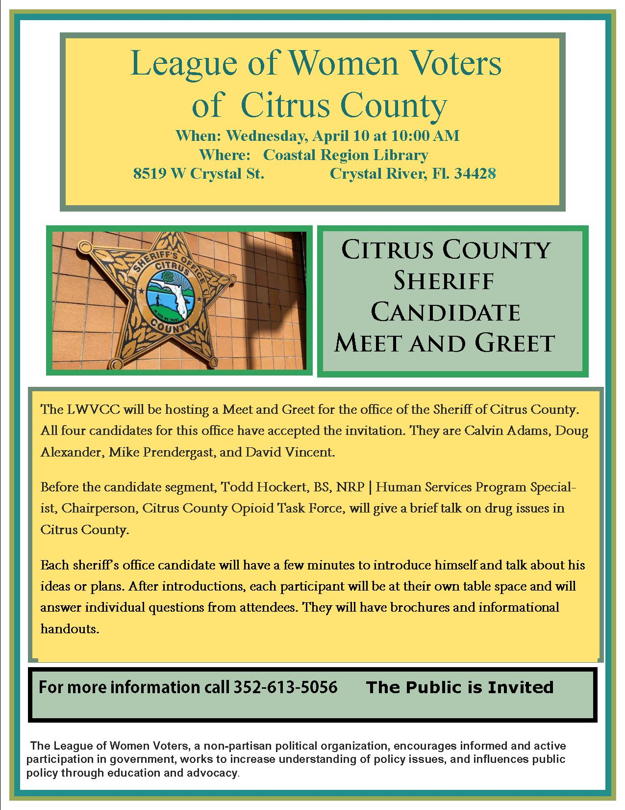

If you are interested in joining the
League of Women Voters of Citrus County,
Fill out the form below and mail it to us at
LWVCC, P. O. Box 1903, Lecanto, FL 34460

Name_______________________________
Address_____________________________
____________________________________
Email address_________________________
Phone (home)_________________________
Phone (cell)___________________________
Individual $65______
Household $90
Student Free
Susan B. Anthony $105*
Household $150*
*Includes $40 donation
Credit card name__________________________
Credit card number ________________________
Expiration Date, month and year______________

