LEAGUE OF WOMEN VOTERS OF
CITRUS COUNTY FLORIDA
NEWSLETTER, FEBRUARY, 2024
Vicky Iozzia is the Editor of this newsletter.
Our mailing address is LWVCC. P. O. Box 1903,
Lecanto, FL 34460

AT OUR FEBRUARY 13, 2024 MEETING DR. LAVON WRIGHT-BRACY WILL SPEAK ABOUT BLACK HISTORY AND HER EXPERIENCES WITH INTEGRATION. SHE WILL ALSO HAVE COPIES OF HER BOOK, “A BRAVE LITTLE COOKIE” AVAILABLE FOR SALE AND SIGNING. SEE THE FLYER AT THE END OF THE NEWSLETTER

OUR MARCH 13, 2024 MEETING FEATURES GERRY MULLIGAN, RETIRED EDITOR OF THE CITRUS COUNTY CHRONICLE. SEE THE FLYER AT THE END OF THE NEWSLETTER TO MAKE YOUR RESERVATION FOR THE LUNCHEON AT CAFÉ AROMAS IN LECANTO.
Please visit our facebook page and "like" us!
https://www.facebook.com/leagueofwomenvotersofcitruscounty

HAPPY FEBRUARY, 2024!
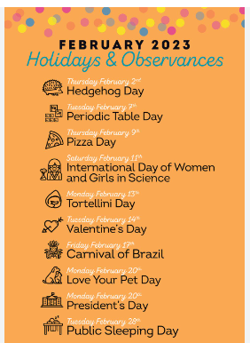
PLUS: February is Black History Month
and American Heart Month
Saturday, Feb 3, National Women Physicians Day,
Wednesday, Feb 7, National Girls and Women in Sports Day,
Monday, Feb 12, Lincoln’s Birthday,
Wednesday, Feb 15, Susan B Anthony’s Birthday
Saturday, Feb 17, Random Acts of Kindness Day,
Sunday, Feb 18, National Drink Wine Day,
Tuesday, Feb 20, National Love Your Pet Day

Contents:
Vicky Iozzia Page 4
Our January meeting, Dr. Jill Lewis-Spector Page 5 to 6
Martin Luther King’s Day Pages 7 to 8
December Chamber Luncheon Page 9 to 10
Proposed Constitutional Amendment Page 11
Rosemary Nilles Pages 12 to 14
Board of County Commissioners Information Pages 14 and 15
Jan Hall, From our League Archives Pages 16 to 18
Dates from our Supervisor of Elections, Welcome new members Page 19 to 20
Speakers Bureau Info Page 21
February meeting, Dr. LaVon Wright-Bracy Page 22
March Luncheon, Gerry Mulligan Page 23
Membership Information Page 24 to 25

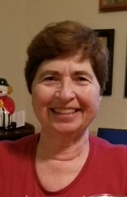
Vicky Iozzia, Co-President,
Speakers Bureau Chair, Newsletter Editor, Webmaster
This letter was published in the Citrus County Chronicle on January 10, 2024
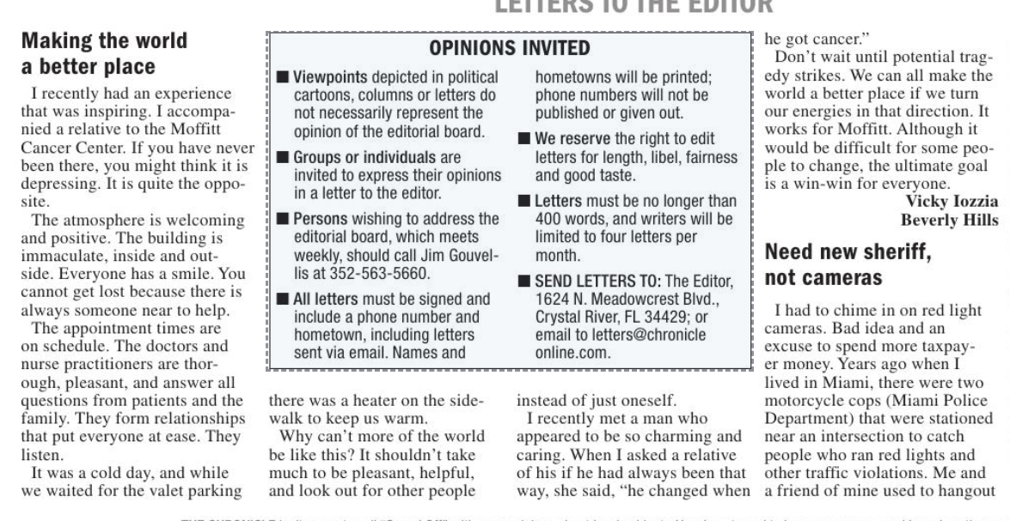
Our January 9, 2024 meeting
at the Coastal Region Library
Dr. Jill Lewis-Spector.
spoke about book bans
Her credentials are impressive. She was Professor Emerita of Literacy Education at New Jersey City University. She was President of the International Literacy Association. She has authored 8 books, numerous research articles, and been a keynote speaker on literacy throughout the US and in more than 30 countries.
The title of her speech was “Book bans and other hot topics”. Since this is a controversial topic, we were prepared for some controversy. There was none.
If you were not there, you are cheating yourself out of wonderful opportunities to hear great speakers and get pertinent information.
I am a Toastmaster so I listen to speakers and can’t help evaluating their effectiveness. When she spoke, the room was totally silent. The audience was entranced by her demeanor and the effectiveness of the information she was delivering.
Afterward the Board took her to lunch and enjoyed her company.
If you would like to see her presentation, email vickyiozzia@gmail.com and I will send it to you.
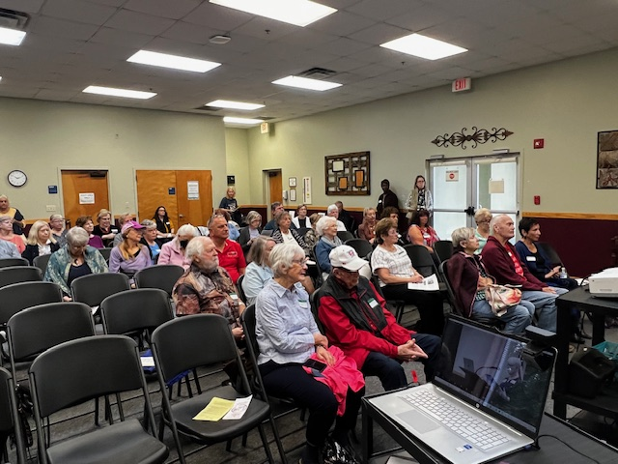
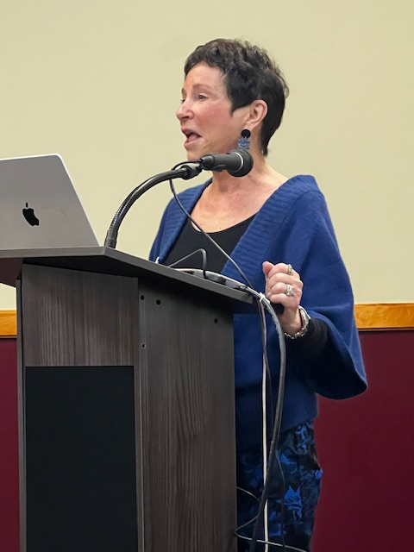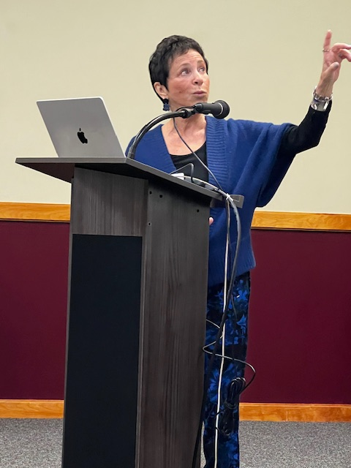

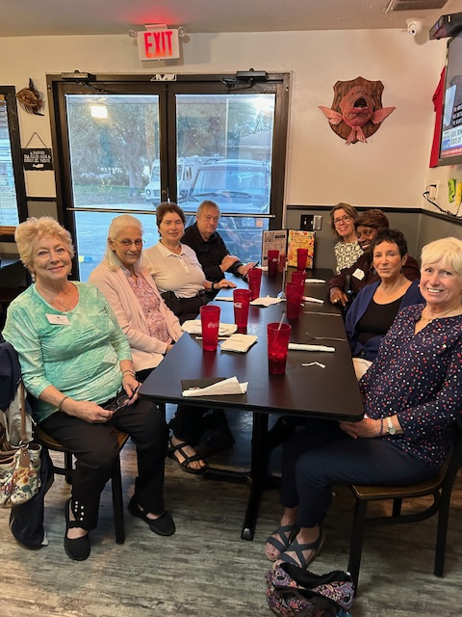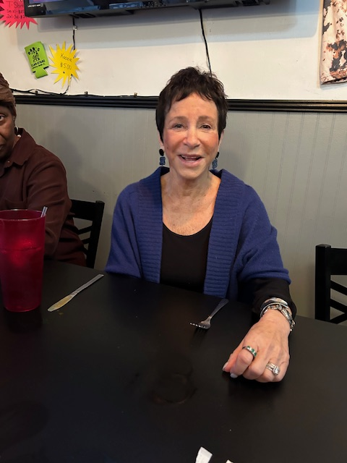

Martin Luther King Day, Monday, January 15, 2024

There were two MLK celebrations in our county. One was in Inverness, the other in Crystal River. The Crystal River High Color Guard led us in the Pledge of Allegiance. Children read or memorized parts of Dr. King’s “I have a dream” speech. Reverend Ronald Sutton spoke. The celebration was looking back at Dr. King, and looking forward to implementing his teachings.

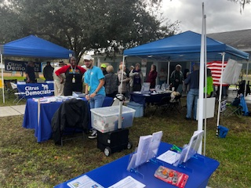
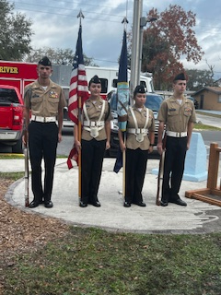
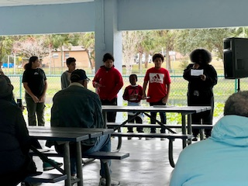
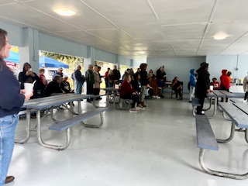
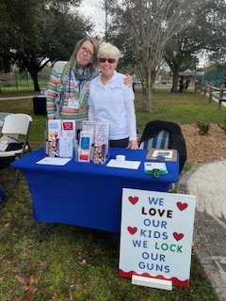
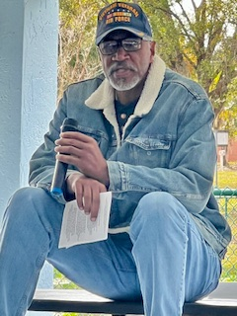

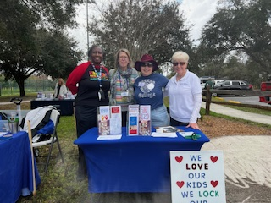

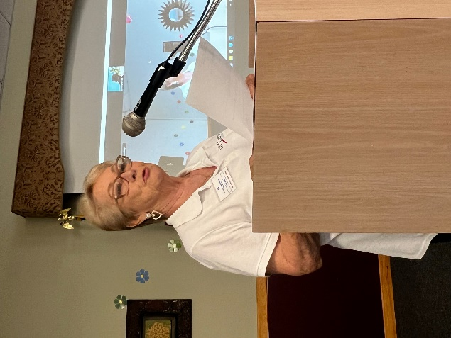

Judy Howe, Co-President
It was a very pleasant Chamber of Commerce Luncheon/Meeting that was held December 15, 2023, at the Citrus Hills Golf and Country Club. The event was hosted by The Businesswomen’s Alliance and sponsored by Seven Rivers Christian School. The Guest Speakers were Charlene Bostek, the Principal’s Secretary at Crystal River Primary School, Dr. Scott Hebert, Citrus County School District Assistant Superintendent, and Amy Crowel, Director of Assessment, Accountability and Monitoring for Citrus County School District.

All the speakers were very informative about Education in Citrus County. Graphs were provided to reference what was being spoken about. They made us all proud of the leadership and education in all our schools.

The highlight came when The Businesswomen’s Alliance announced that their group had raised $704,225 toward scholarships for our local high schools.

Dr. Scott Hebert left us with his personal quote: “Your Path Plus Your Choice Equals Our Future”.

An altogether lovely and inspiring luncheon.

Photos from the Chamber Luncheon:
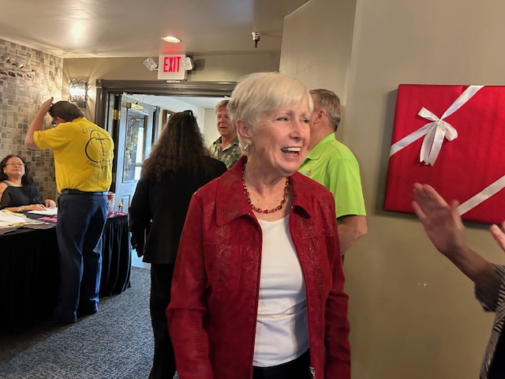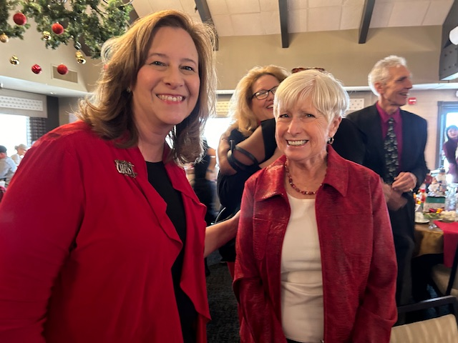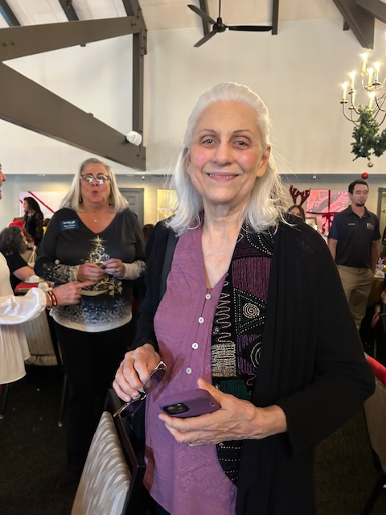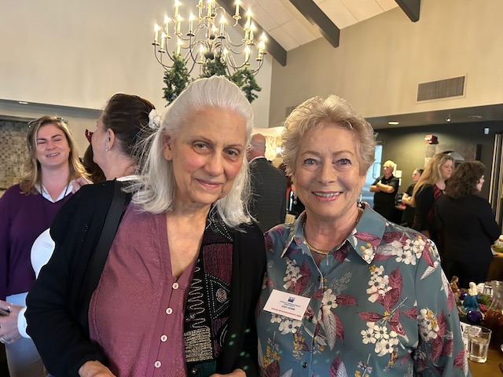

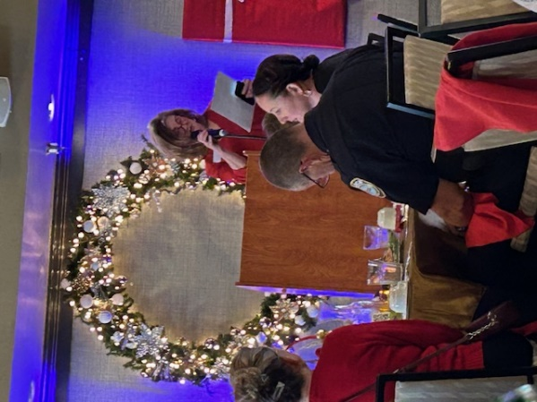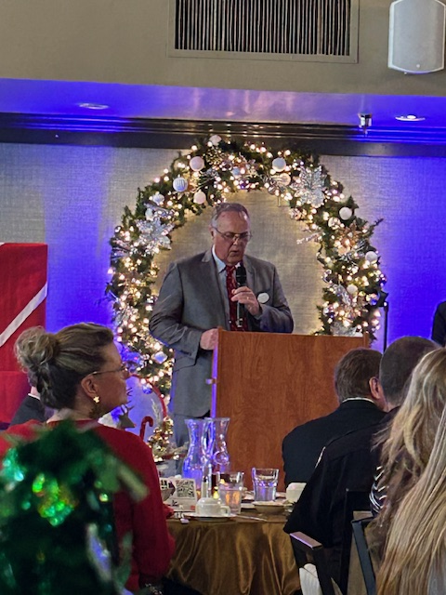
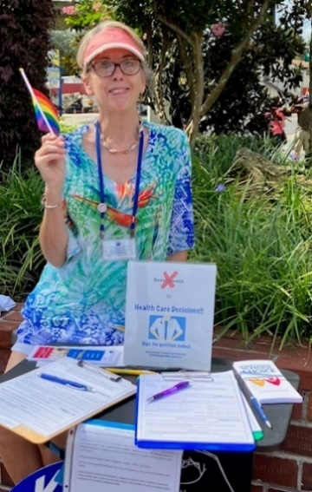
Peg Primeau, Secretary, Reproductive Health & Justice
Peg and many other people, volunteers and paid people, worked hard to get the required number of verified signatures to get this on the ballot.

By Jim Saunders News Service of Florida
TALLAHASSEE — Supporters of a proposed constitutional amendment aimed at ensuring abortion rights in Florida have submitted enough valid petition signatures to get on the November ballot, a key step in what could become the state’s biggest political battle this year.
The Florida Division of Elections website Friday morning showed that 910,946 valid signatures had been tallied for the proposal, which is sponsored by the political committee Floridians Protecting Freedom. That topped a requirement of submitting 891,523 signatures to qualify for the ballot.
Also, Floridians Protecting Freedom met a requirement to meet signature thresholds in at least half of the state’s 28 congressional districts. Unofficial totals on the Division of Elections website showed that the committee exceeded the thresholds in 17 of the 28 districts.

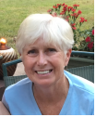

Protecting Our Teens in the Workplace
Rosemary Nilles

Protecting kids and teens is an adult responsibility! But controversial bills to weaken Child Labor Laws are moving quickly through the Florida Legislature. Florida’s official legislative session began on January 9th, following months of preparation and meetings.

Florida’s current Child Labor Laws were designed to protect health and safety, prevent workplace exploitation, and encourage completion of education while students gain valuable work experience. Employers are prohibited from scheduling 15–17-year-olds to work more than eight hours, or during school hours, or during the night when they have school the next day. Teens may not work more than 30 hours a week when school is in session, or for more than six days in a row, even when school isn’t in session. Employers must provide them a 30-minute break after four consecutive work hours. Exemptions can be requested based on a student’s life circumstances.
House Bill 49, “Employment and Curfew of Minors” was approved in committee in December. It would remove these protections except for 15-year-olds. Employers could schedule 16–17-year-olds for work during the night on school days, or for more than 30 hours a week during the school year, and for more than six days in a row. Mandatory breaks would be eliminated. HB 49 also preempts local governments from passing stricter ordinances. Amendments to lessen its harm were voted down.
Following public pressure, HB 49 was amended on January 10th to reinstate the prohibition on 16–17-year-olds working overnight on school days. Otherwise, employers can schedule teens ages 16-17 to work the same hours as workers 18 and older: more than six days a week, over 30 hours a week. Teens would be allowed the same breaks as older co-workers. Senate Bill 1596 also weakens child labor protections, to a lesser degree.
Roofing work is deemed a hazardous occupation in state and federal law and is generally banned for teens under 18. But SB 460, “Career and Technical Education” weakens current safety protections, allowing 16–17-year-olds to work on scaffolding, roofing, or building construction sites if they’ve received OSHA certification, and under supervision of someone age 21 or older.

Proponents say that teens should have more freedom to work if they choose, with less government interference. They argue that relaxing Child Labor Laws will help Florida’s severe labor shortage. HB 49’s sponsor, Rep. Linda Chaney shared, “This is an opportunity for families to be able to help themselves and build life skills that will serve them later in life and help our small businesses who will help our labor shortages all in one." http://tinyurl.com/5934b59k Powerful lobbying organizations back these bills.

These proposals are deeply concerning. Students, whose role is to obtain an education, are not the solution for labor problems. Too many work hours are likely to interfere with school performance and attendance. For some, the allure of what seems to be high wages may lead to dropping out of school, often leading to a lifetime of lowered earning potential. Economically deprived and immigrant students are most likely to be impacted.
Florida’s Child Labor laws have been strengthened over the decades. Yet Florida Policy Institute reports that child labor violations nearly tripled from 2019 to 2022. http://tinyurl.com/2375ak85 Our teens need more protections, rather than fewer.
There is some irony in these proposals to undo many of the current safeguards that were previously deemed important for our teens. Why would a state that claims to protect children weaken their protections in the workplace? This happens even as lawmakers study the chronic absenteeism that plagues Florida public schools.
The primary work of our teens is to be students. Protecting the education of young people is an investment in their futures. Lawmakers should let our kids be kids, prioritize their education, and solve the labor shortage with other innovative ideas. Further revisions can be expected as bills move rapidly through the legislature. Concerned Floridians should contact their legislators quickly.
- Rep. Ralph Massullo. 850-717-5023. ralph.massullo@myfloridahouse.gov
- Sen. Blaise Ingoglia. 850-487-5011. Ingoglia.Blaise.web@flsenate.gov

Rosemary Nilles is Vice President and Education Chair for League of Women Voters of Citrus County.

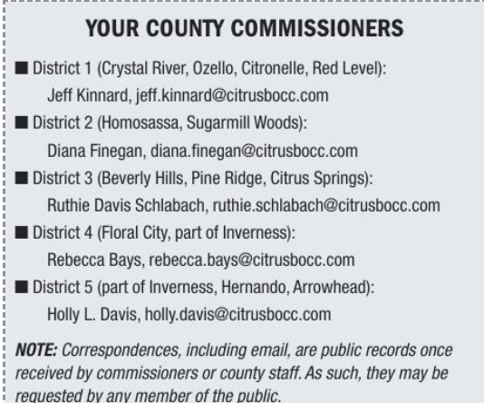

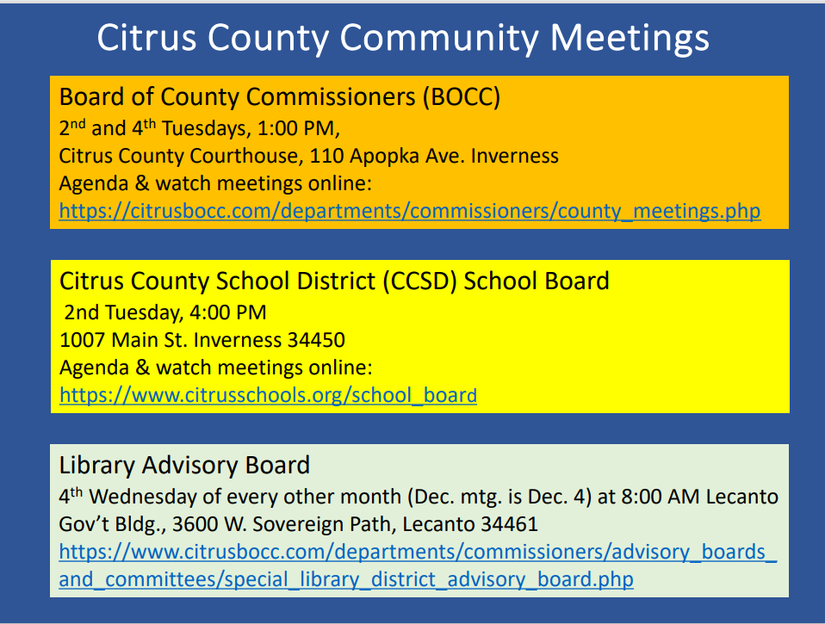

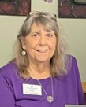
Jan Hall
“We stand on the shoulders of those who walked before us.”
Jan will be going through the archives of notes from our League and sharing them with us.
I was casually strolling through my archives of the LWVCC of the past and came
across this article. Gerry will be our guest speaker for the Annual Luncheon on
March 13 2024. We are celebrating Women’s History Month. I thought this would
be an appropriate past article for our newsletter. He made some very good points.
Please note his mention of the time it took for women to get the vote.
******************************************************************

Written by Gerry Mulligan. Date Unknown.
Upon reflection, I need to admit that the Chronicle has been part of an unhealthy
debate going on in this country over our national politics.
That absurdity of the debate has been played out on the editorial pages of the
newspaper and in some of our Sound Off calls. It is time for it to stop.
You know the opinions I am talking about. One letter writer will make wild claims
and then in a few days another partisan will write in and object to those claims.
Along the way, they both taking personal shots at each other for being un-American
or just plain dumb.
In the end, no opinions are changed and everyone ends up unhappy.
Many people just stop reading.
Over the past few years, we have frequently rejected letters from writers who make
accusations based on their political filter and not on the facts. But we have also
printed many letters and Sound Offs that have just gone too far.

In a most recent absurd case, two letter writers wanted us to sit down in a face-to-
face negotiation so we could all argue about who is right.
I would rather explain algebra to my dog.
The Chronicle is a local newspaper that focuses on what is happening in Citrus
County. I have staff members who have covered local government for more than 30
years and have a deep understanding of what is happening on the local level.
We have no such expertise on national affairs. We are not the arbitrators of the fact
and fiction presented to Americans today. What I do know is that the bitter
advocates on both sides of the debate are doing great damage to our nation.
In America, I would like to think we have a tradition of coming together to find
consensus on our problems. We can disagree with great emotion, but in the end,
we are still Americans.
Remember, it took more than 125 years for us to agree that women deserved the
right to vote. Is there anyone out there who still wants to argue that men and
women should not have equal rights? The great part about our constitutional form
of government is that it can withstand. The American who lives across the street is
not your enemy. They might be a citizen with a different political view than you
have, but in this country, we live together and grind through the issues until we find
resolution.
Today I am letting everyone know that we are going to tighten up the standards on
what kind of letters to the editor we publish in the Chronicle. We are wide open for
letters about local issues and I urge you to take advantage of that invitation.
The same standards will apply to Sound Off calls.

I want to hear about problems in our community or people doing great things. And
it’s fine if you want to criticize or praise local officials and their actions.
However, we are going to be much more selective about publishing opinions on
national issues, especially when it comes to vilifying the folks on the other side of
the debate. We are not experts on the national or international issues and we don’t
want to be.
In addition, we do not have the resources to spend hours fact checking many of the
claims that are made in the letters or Sound Off.
I personally blame social media sites such as Facebook and Twitter for the
deterioration of our civil discourse. In addition, there is a new class of political
professional who believe using fear and anger is a great way to win voters.
It might be good for the politicians, but it’s awful for the country.
We are going to try to be more responsible going forward. Letters on national
issues will be considered, but once the insults and name-calling begins, they will be
rejected. We are a local newspaper and we want to celebrate, criticize and opine
about the issues in our community.

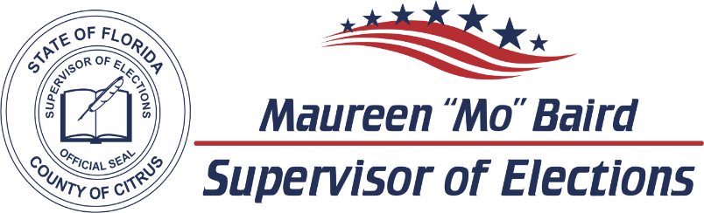

2024 CANDIDATE DATES TO REMEMBER

ELECTIONS
Primary Election | August 20, 2024
General Election | November 5, 2024

LAST DAY CANDIDATES CAN CHANGE PARTY FOR 2024 ELECTIONS  F.S. 99.021
Judicial April 23, 2023
County Office June 11, 2023

PETITIONS DUE  F.S. 99.095
Judicial Noon, March 25, 2024
County and Special District Noon, May 13, 2024

VALID PETITIONS NEEDED
Constitutional, County Commission, and School Board 1,222
Special District 25

RESIGN TO RUN  F.S. 99.012
Judicial April 12, 2024
County and Special District May 31, 2024

QUALIFYING PERIOD  F.S. 99.061
Judicial Noon, April 22, 2024 to Noon, April 26, 2024
County and Special District Noon, June 10, 2024 to Noon, June 14, 2024

Per Florida Statute, we may accept and hold qualifying papers 2 weeks prior to qualifying.

REGISTRATION BOOK CLOSINGS  F.S. 97.055
Primary Election | July 22, 2024
General Election  EARLY VOTING  F.S. 101.657 | October 7, 2024
Primary Election | August 9, 2024 to August 17, 2024
General Election | October 21, 2024 to November 2, 2024

Primary Election dates listed are tentative and subject to change by the Florida Legislature.
VoteCitrus.gov 352-564-7120
Citrus County Supervisor of Elections ~ PO Box 1870 ~ Lecanto, Florida 34460

WELCOME NEW MEMBERS!

Dr Elizabeth Orsay
Janet Skehan

WELCOME BACK TO THE LEAGUE!

Susan Moore

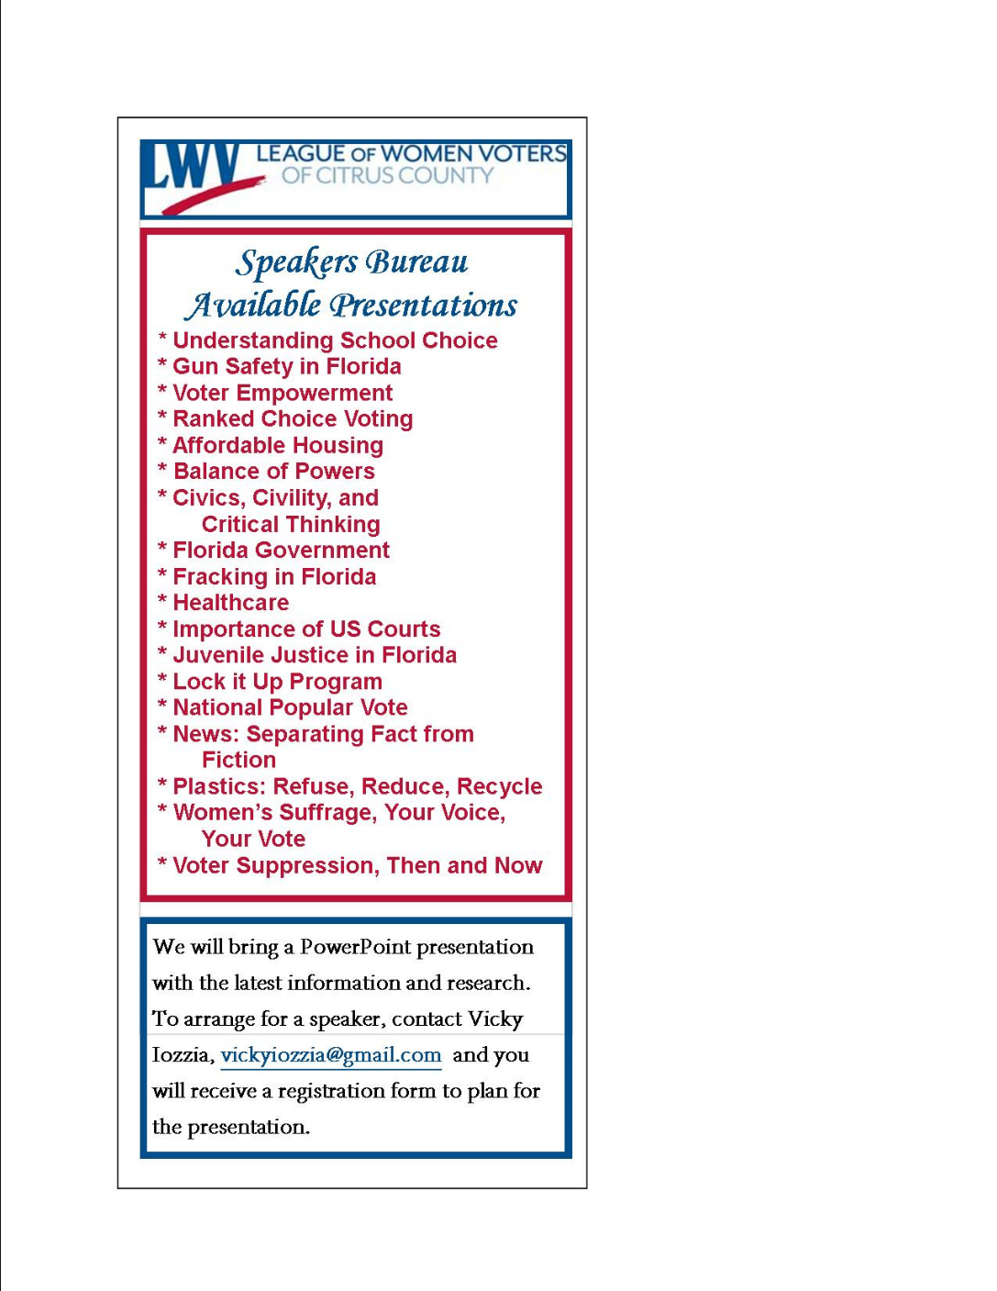

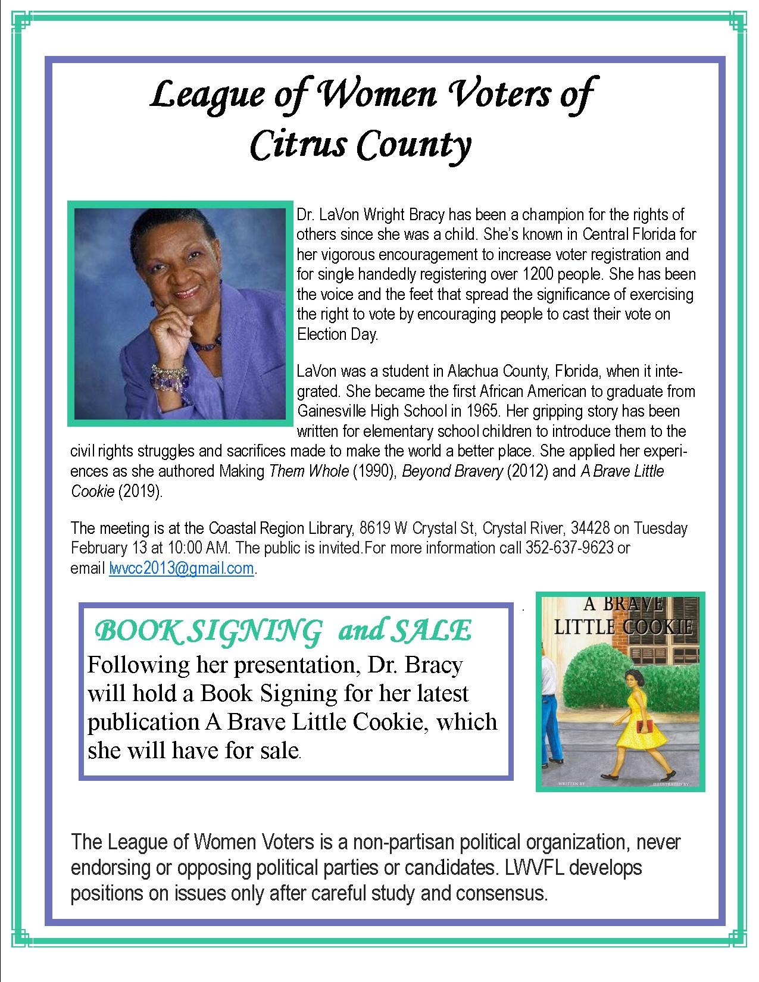
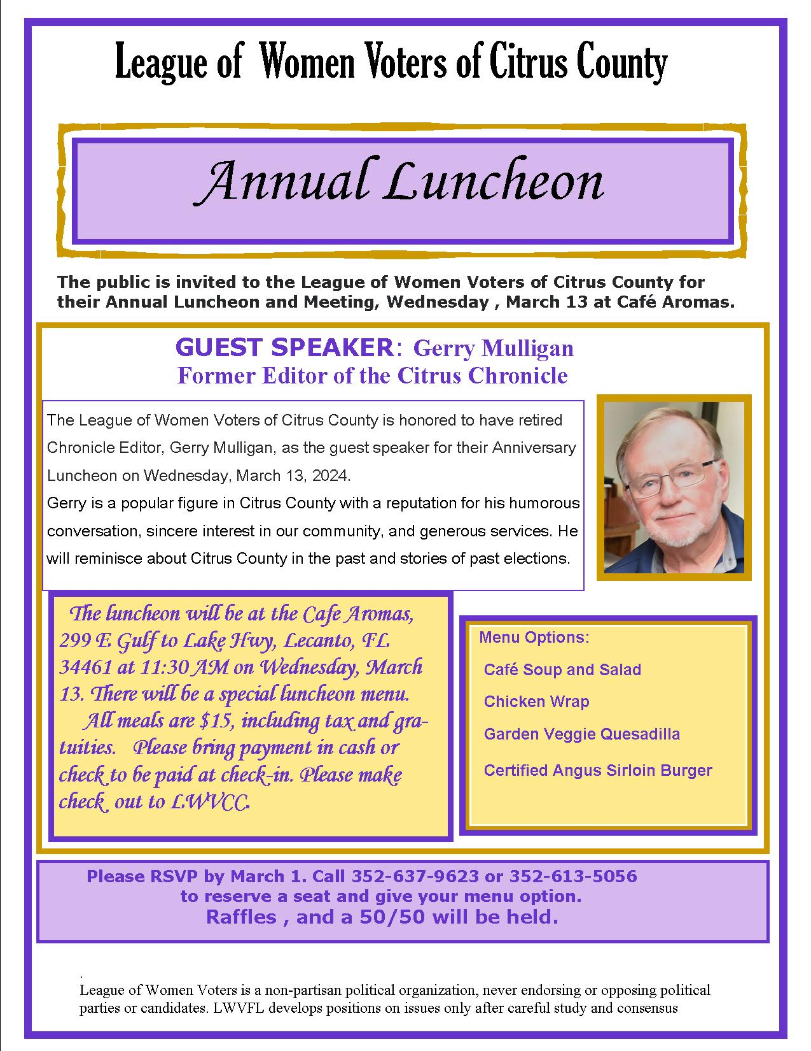

If you are interested in joining the
League of Women Voters of Citrus County,
Fill out the form below and mail it to us at
LWVCC, P. O. Box 1903, Lecanto, FL 34460

Name_______________________________
Address_____________________________
____________________________________
Email address_________________________
Phone (home)_________________________
Phone (cell)___________________________
Individual $65______
Household $90
Student Free
Susan B. Anthony $105*
Household $150*
*Includes $40 donation
Credit card name__________________________
Credit card number ________________________
Expiration Date, month and year______________

