LEAGUE OF WOMEN VOTERS OF
CITRUS COUNTY FLORIDA
NEWSLETTER, NOVEMBER, 2023
Vicky Iozzia is the Editor of this newsletter.
Our mailing address is LWVCC. P. O. Box 1903,
Lecanto, FL 34460
OUR NEXT MEETING IS ON NOVEMBER 13, 2023, AT THE CENTRAL RIDGE LIBRARY IN BEVERLY HILLS, AT 10 AM. OUR GUEST SPEAKER IS CREGG DALTON, PROPERTY APPRAISER. SCROLL DOWN TO THE END TO SEE THE FLYER
OUR DECEMBER MEETING IS DECEMBER 12, 2023, AT CAFÉ AROMAS IN LECANTO, AT 11:30 AM. SCROLL DOWN TO SEE THE FLYER AND MAKE YOUR RESERVATION.
Please visit our facebook page and "like" us!
https://www.facebook.com/leagueofwomenvotersofcitruscounty
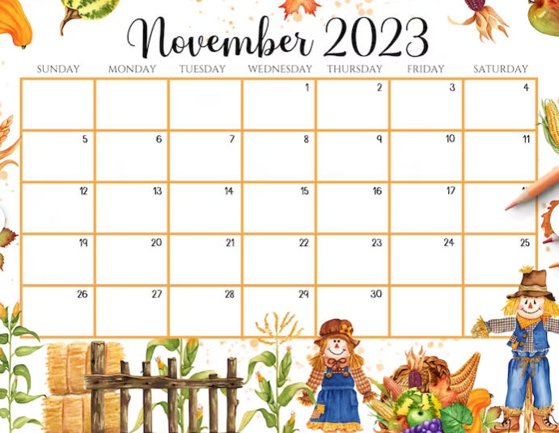
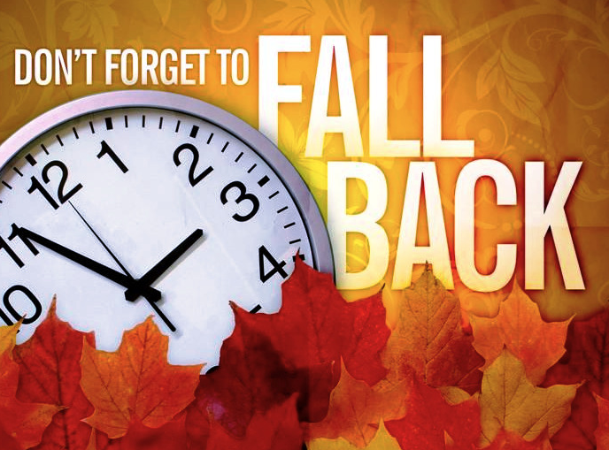
At 2:00am, Sunday, November 5th, 2023, clocks “Fall Back” one hour and we move more daylight into the morning hours for what’s known as “standard time.”

Contents:
Nancy Tomaselli Page 4
Welcome to our new board members! Page 5
Peg Primeau Pages 6-7
Linda Abels Page 8
Rosemary Nilles Pages 9-11
Maxine Connor Pages 12 - 14
Jan Hall Pages 15 - 17
Vicky Iozzia,
In the News, community meetings Pages 18 -19
September Luncheon Pages 20-21
October meeting Page 22
Rally 4 Love, Vicky’s speech Page 23-26
Speakers Bureau information Page 27
October meeting flyer Page 28
November meeting flyer Page 29
Answers to Peg’s Quiz Page 30
Application for Membership Page 31

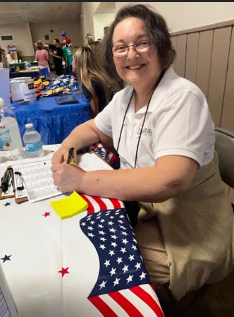
Nancy Tomaselli, our President, has resigned due to health issues. Her beautiful smile has graced our meeting for a long time. We want to thank her for all her dedication and hard work as President. We wish her renewed health and healing.

WELCOME TO OUR NEW BOARD MEMBER!

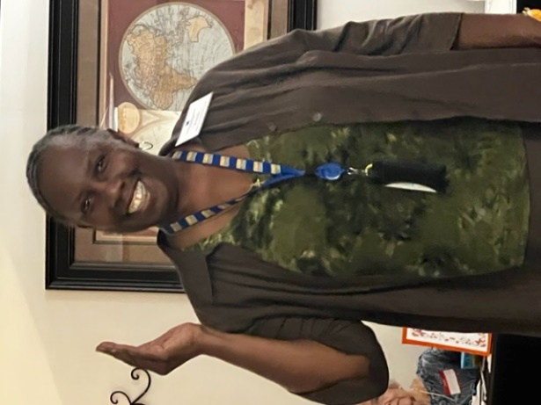
We are lucky to have our new board member, BJ Ezell. Among her multiple talents is the ability to inform us about information from the Health Department.
She told us at our last meeting that after a court decision, the State of Florida must now report to the public numbers of Covid cases and deaths.

We also welcome Beverly Brown. Photo and information to follow in the December Newsletter.

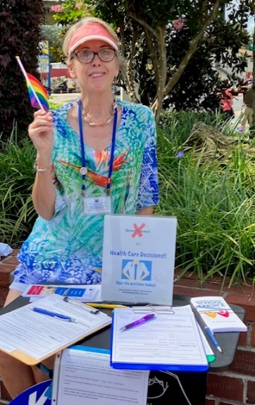
Peg Primeau, Secretary
Reproductive Health & Justice
TEST YOUR C.Q. (Contraception Quotient)
For each method, choose the letter that indicates how it works.
• Will you do better than the majority of people in the US? (Hint: low bar.)
• Are you better informed than the disinformation machine wants you to be?
_____ 1. Vasectomy
_____ 2. Condom/Diaphragm
_____ 3. Hormonal: BCP (Birth Control Pills) / ring / injection / patch
_____ 4. IUD (copper or hormonal)
_____ 5. Plan B (emergency contraception pill)

O. prevents Ovulation
F. prevents Fertilization
M. prevents Implantation
A. causes Abortion

True or False?
6. The contraception methods above do not end pregnancy. (They are not abortifacients.)
7. Nature lets go of a lot of naturally fertilized ova (40-50%)—they are sloughed off or reabsorbed before pregnancy (implantation) occurs.
8. Health-care providers (and lawmakers) determine “week of pregnancy” by counting from Day 1 of the last menstrual period (LMP), not from actual pregnancy (implantation).
9. Major risk factors for unintended pregnancies (46% of US pregnancies) are poverty and lack of knowledge about reproduction.
10. The Opill, an over-the-counter BCP, will be available in 2024 without age or gender restrictions on the purchaser.
11. At $1000, a vasectomy is a bargain compared to 10 years worth of the prescription methods.
12. In Florida, it is still legal to have an at-home medication abortion (best before 12 weeks of pregnancy); you take one dose of mifepristone followed by one dose of misoprostol.

The answer key to this quiz is at the end of the newsletter on Page 29.

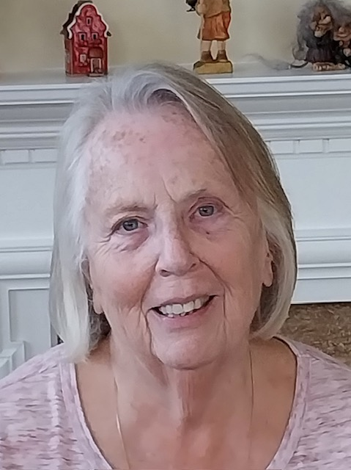

From Linda Abels,
Membership Chair
Membership
Currently we have 38 Active Members in our Local League. We are involved in a number of initiatives, i.e. preparing for the 2024 election, educating the public regarding environmental issues, updating the public on bills that are being worked on in Tallahassee, etc. That’s a lot of work for 38 members. Please consider asking friends if they have an interest in learning more about local issues facing our community and joining our group to help us as we strive to educate the residents of our community. In addition to helping our community, I am sure that you will make lasting friendships.

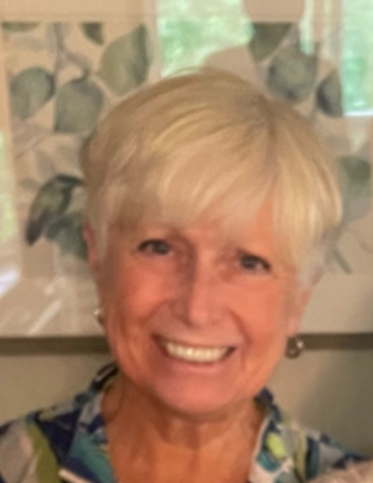
Speaking Out for The League: Legislative Delegation 2023
By Rosemary Nilles, LWVCC Board Member, Education Chair, Gun Violence Prevention (GVP) Chair
By the time you read this newsletter, Maxine Connor and I will have spoken on behalf of the League at the Legislative Delegation on October 30th . You may ask, What is Legislative
Delegation? This is the annual opportunity for citizens, groups, and government agencies to directly address our local State Legislators – Rep. Dr. Ralph Massullo and Senator Blaise
Ingoglia, with our concerns and priorities.
Maxine Connor and I usually share the three-minute time slot. On behalf of the League, we urge our state legislators to act in the best interest of Florida citizens. This year, Maxine’s topic is
Energy Conservation. These are my remarks:
“Good afternoon. Each year the League of Women Voters of Citrus County addresses you with some of our concerns and requests. As you know, we are a non-partisan organization.
Here are a few asks for the 2024 legislative session:
- First, Elections. You have made many changes to the election
process in Florida. LWV asks that funds be allocated to the Division of Elections and local elections officials with requirements that they use every means at their disposal to educate voters about these changes.
- Second, Gun Violence Prevention. This is another priority issue for the League for 2024.

- Firearms are the number one cause of child deaths in this country. Unsecured guns contribute to these statistics. The League asks you to strengthen our child access prevention laws (SB 176). States with strong child access prevention laws have lower gun death rates.
- In addition, unsecured guns are often stolen from cars, and then used to commit crimes.
- Therefore, we also ask that you provide funding for public awareness/education on safe storage along with incentives for buying gun locks and safes.
- In turn, we will continue to work with you to increase awareness of safe firearm storage in our homes and communities.
- We also ask you to increase awareness of Florida’s existing
Risk Protection Order law. There is $15 million in federal funding available from the Bipartisan Safer Communities Act that Florida did not access. Florida is the ONLY state with an existing RPO law that did not accept the funding and is only 1 of 5 states and territories to not do so.
- Please, hold the line on any expansion of ease of access to guns in our state, such as lowering the age to purchase a long gun (now at 21), permitting open carry, or changing the wording of the waiting period for background checks.
- We also ask you to protect sensitive places involved in elections from concealed carry. Not just the polling places. For the protection of our workers, the Supervisor of Elections offices, and any place where vote tally occurs should be designated as “No Guns Allowed.”
Thank you, and now Maxine Connor will speak.”

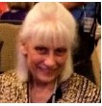
Maxine Connor,
Natural Resources Chair
NEWSLETTER UPDATE FOR LWVCC NATURAL RESOURCES

NOVEMBER, 2023
LWVFL MONTHLY CLEAN ENERGY ACTION TEAM SEPTEMBER ZOOM CALL
WEDNESDAY, NOVEMBER 15, 5-6 PM
THE CLEAN ENERGY TRANSITION IS UNDERWAY:

How Two Champions are Working to Educate/Activate &amp; Make a BIG Difference
Speakers:
Brian Stewart, Founder of Electrify America! Retired Nike VP – Sustainable Innovation
Robert (Bob) Loeb, Lead Volunteer, Founder supportAARPclimateaction.org
Members of the League of Women Voters of Citrus County will receive an email invitation. Feel free to share widely.
FLORIDIANS, PLEASE SIGN THE PETITION
FOR THE RIGHT TO CLEAN AND HEALTHY WATERS
DEADLINE: MAIL PETITIONS TO ARRIVE AT THE ADDRESS ON THE PETITION BY
DECEMBER 30
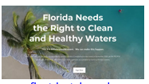
https://www.floridarighttocleanwater.org/

Florida registered voters, please go to https://www.floridarighttocleanwater.org/ to sign the statewide petition to get a state constitutional amendment for Right to Clean Water (RTCW) on the ballot for the 2024 election. The League of Women Voters of Florida
supports this and the LWVFL Natural Resources Chair has made it a legislative priority. This is a grassroots citizen effort. Contact maxineconnor@gmail.com if you would like to help work on this in Citrus County.
We are continuing to work on this UNTIL THE DECEMBER 30 TH DEADLINE. I would be happy to collect your petition and send it in. We will collect petitions at any League event. Let us know of other groups you belong to or that we can talk to or you could bring the petitions to a meeting. Please email maxineconnor@gmail.com for assistance or questions.
Fellow Floridians, we need your help!
Our health, economy and thriving ecosystems depend on clean water.
If you like boating, swimming, fishing, paddling, diving, or drinking clean water, sign the petition!
Time is running out!
We need 900,000 signatures by December 30, 2023 to qualify for the 2024 ballot.

The Right to Clean Water petition is a statewide citizens&#39; initiative to amend the Florida Constitution that would give all Floridians the right to hold the state government accountable for the failures of our environmental regulatory system which permits pollution and degradation of our waters and aquatic ecosystems. If our current laws were working, then we wouldn&#39;t have manatees dying in record numbers, 80% of our 1,000 springs impaired, the most polluted lakes and 2nd most polluted estuaries in the country, toxic blue-green algae and red tide in greater frequency and duration. Special intereststoo often have undue influence over environmental policy. A Constitutional right takes precedence over legislation that permits pollution. Registered voters, sign the petition and ask 5 friends to sign theirs. What else can I do to help? https://www.floridarighttocleanwater.org/resources
Pd. pol. adv. paid for by FloridaRightToCleanWater.org, 13300 South Cleveland Ave, Suite 56, Fort Myers, FL 33907

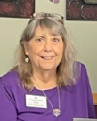
Jan Hall
The more things change,
the more they stay the same
We stand on the shoulders of those who walked before us.
Jan will be going through the archives of notes from our League and sharing them with us.
L W V OF CITRUS COUNTY NOTES FOR BOARD MEETING SEPTEMBER 30 ,2013
1:00 PM at Linda Myers’ home.
Topics to review include:
FL Land & Water Legacy/Amendment petitions-Kate Betsko has a
count of how many have been collected and where, when & who are
collecting; Follow up on Petition signing at Central Ridge Library-need more
volunteers;
FL’s rejection of Medicaid Expansion-Healthcare Expansion is the
correct term to be used. Nov 2 is targeted as a special meeting for a panel
discussion on this topic, so far only one speaker, Robert Adkins, Licensed
Insurance specialist and Navigator for BlueCross is on board;
Nat’l Voter Registration day event-Kathy O’Donoghue can report on our
participation and results, additional days and places include Oct 15th at the
Floral City Library(Marie Pettibone & Dottie Carson to collect petitions and
work on Voter Registration.) Any other venues planned?
Election reform-redistricting(LWV of Fl is suing the state on this issue);
Voters Rights Act repeal-very little has been heard on this;
Immigration Reform-also, shoved to the back;
Facebook- show more local news about the LWV OF CC; need
more pictures; schedule of upcoming events; show our Mission
Statement;
Joan Burnett mentioned that she would like to read the minutes
(Nancy Doyle was asked to take over as Secretary?)from
meetings on line since she is not able to attend the Tues. AM
meetings;
Citizens Academy-list from LWV OF CC: members who are participating:
Sheila Jacobs, Mary Perry, Lynn Boyle, Dorothy Carson, Eileen Fischer, Kathleen
Betsko ,Kathleen O'Donoghue, Marie Pettibone, and Betty Rudy. There are more!
Highlight upcoming events and who will be available for them-
specifically: Oct. Angela Vick, CC Clerk of the Court(Kate will not
be available), Nov Helen Spivey, Former State Representative and
environmentalist.
Voters Rights Act-LWVDC per Kathy O’Donoghue;
September 24 National Voter Registration day at the Crystal River
Mall w/Board of Election (how did it go and what other events are
planned?;
Preparing for coming events requires planning and organizing; are we
going to provide refreshments, honorarium for speaker, publicity, etc.
Report on events that have been represented by someone from the LWV OF
CC and plans for more events(Linda Myers).
Need for more volunteers and for Vice-President and Membership Chair.
BOCC meetings-Sheila Jacobs is reporting on these do we need volunteers
to sign up as LWV OF CC reps?
Need to confirm speaking engagements:
Oct 5- SW Democrats at Sugarmill Woods clubhouse, 10:00 AM;
Oct 10-Thurs. 6:00 PM at 7 Rivers GC-Crystal Paradise Estates Civic Club?
Oct 29-Tues. 3 to 6 pm meet w/State Rep Jimmie T Smith and State Sen
Charles Dean, CC Courthouse BOCC Chambers.

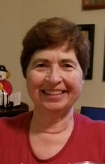
Vicky Iozzia, Acting President,
Speakers Bureau Chair, Newsletter Editor
In the news:
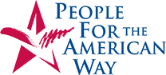
Vicky,
We are thrilled to share some exciting and encouraging news with you today.
Thanks to the advocacy of members like you, Scholastic has reversed their plans to create a separate book catalog that would segregate and make optional certain books featuring LGBTQ and race themes at their School Book Fairs.
Your petition signatures — over 7,500 and counting — have made a huge impact.
This victory is not just about a change in business strategy for Scholastic; it is a testament to the power of standing up for what is right. By joining forces, we have sent a resounding message that bigotry and censorship have no place in our society.
Together, we have safeguarded the diverse literary landscape that nurtures empathy, understanding, and acceptance among readers of all ages and backgrounds.
Your dedication has proven once again that when we come together as advocates for justice and equality, we can create real change. This victory belongs to every single one of you who signed petitions, shared our message on social media platforms or reached out directly to Scholastic.
With gratitude,
People For the American Way

For your information:
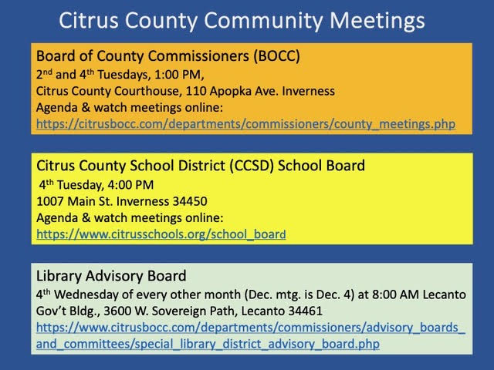

Our September 12, 2023 luncheon meeting at Café Aromas was well attended.
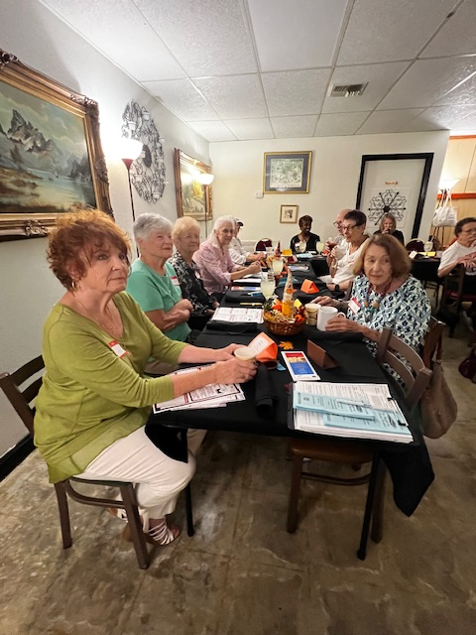
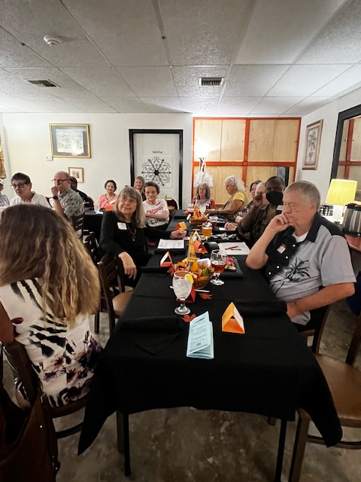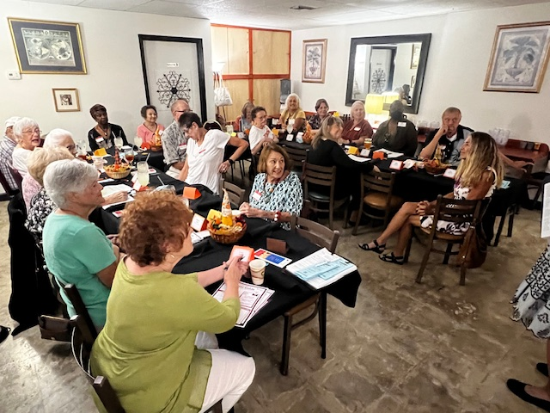

Our Tuesday, October, 2023 meeting
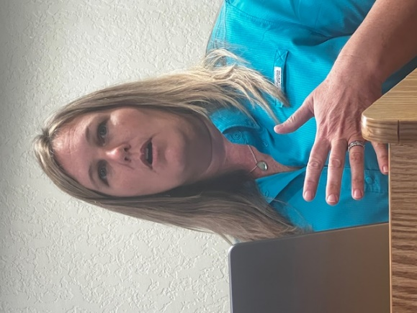
At our last meeting Kimberleigh Dinkins spoke to us about those wonderful animals, manatees. She is an employee of the Save the Manatee organization. These gentle animals need our protection. I was inspired to adopt a manatee. If you would like to, here is the link:
https://www.savethemanatee.org/how-to-help/adopt-a-manatee/meet-manatee-betsy/
It is only $25

I had received an email forwarded by Linda Myers (thanks, Linda) that there was a rally on Friday, October 20. I was asked to speak and I attended. I thought, for a moment, that I was back in the 60’s. The organizations represented included NOW of Greater Marion County, and Pride of Ocala. The traffic was heavy at the corner of 441 and 40, and many people listened to the inspired talks, all about loving each other. That’s not always so easy to do in these times.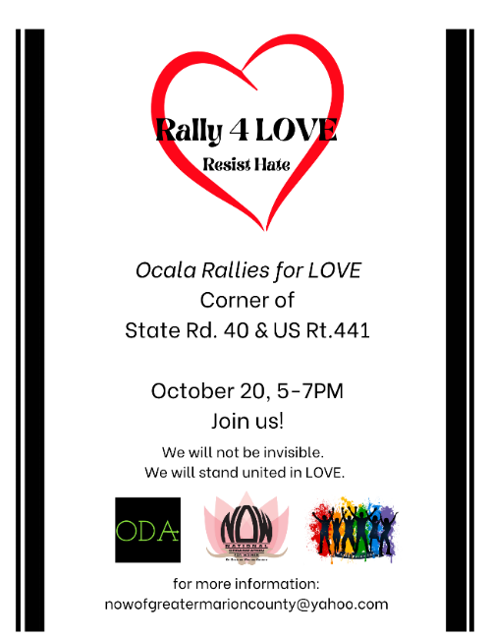s. 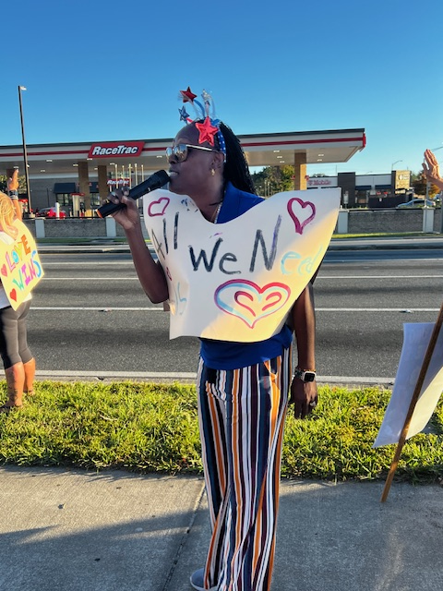
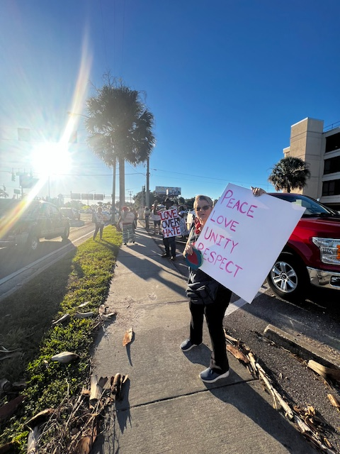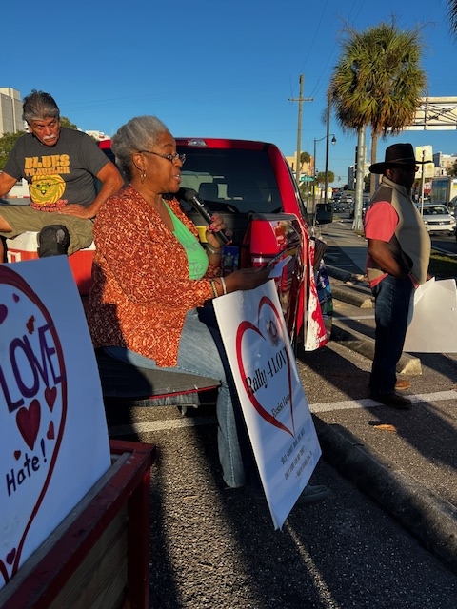
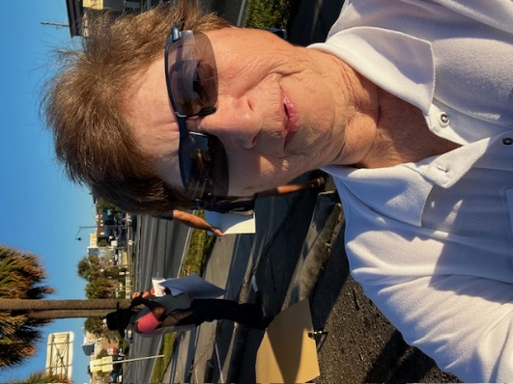We didn’t have selfies in those days, but I couldn’t resist.

Below is the speech I prepared for this event.
Be aware, Vote, and get others to vote.
When I received information on this rally, I contacted Pam because I think it is a great idea to rally for love. So many times, hate seems to be so much more powerful, like the destructive powers of a hurricane.
I am here today because I believe in love, and as the acting President of the League of Women Voters of Citrus County, I can tell you that the League message is
Be aware, Vote, and get others to vote.
Books are being banned. I recently bought 7 books to put on my ipad, all banned books.
This included the Diary of Anne Frank and Charlotte’s Web. What were the reasons? For Anne Frank: the protagonist enchanted by female nude statues, proposes to a friend that they show each other their breasts. For Charlotte’s web: Theme of death and animals talking.
Should people not be free to read about situations to learn from them? These same reasons could be used to ban television, movies, newspapers, magazines, and the internet. We don’t want that to happen.
Be aware, Vote, and get others to vote
The American Library Association is being targeted. In Citrus County the Board of Commissioners refused to fund the ALA because the President, Emily Dabrinski, is a lesbian and an avowed Marxist.
Emily said she is a Marxist. Not a communist, not a fascist, not a socialist, She is no danger to anyone. The real reason to defund the ALA is that the ALA is against banning books.
Be aware, Vote, and get others to vote
Curricula in our schools, from elementary to college, are being changed, accusing teachers of “indoctrinating” children. Give me a break. I am a retired teacher. Teaching is crowd control. There is no time for indoctrination.
Advanced placement classes in high school have been cancelled. The psychology classes include sexual orientation and gender identity, two very dangerous topics. The New College of Florida has undergone drastic changes of leadership and curricula based on conservative values.
Be aware, Vote, and get others to vote
Our tax dollars are being spent because Disney disagreed with the governor. People who disagree with his philosophy are escorted out of the room. Freedom means freedom for all of us. That’s what this country was founded on.
Roe vs. Wade is gone. Abortion is illegal after 15 weeks.
Voting is being restricted. The Office of Election Crimes and Security was formed, even though there is very little voter fraud in Florida. New laws have made registering and voting more difficult, making it more difficult for the League of Women Voters and other groups to register voters.
My advice to you is Be Woke! Take Woke as a badge of honor!
This term emerged from the African American maxim: stay aware, stay aware of the reality of racism and the other evils being advocated.
When you read or hear something political, Be aware, Vote, and get others to vote.
Listen to what people say and think of why they say it. Don’t internalize the hateful things they say about you. Let them bounce off of you. The people who advocate hate are ignorant and have lost their way. Pray that they will find out they have been brainwashed, and that they will be able to give and accept love.
Believe in love, the reason why people are here today, because if you don’t, life offers you nothing. Thank you for showing up today, and do your best to love even those who disagree with you.
Be aware, Vote, and get others to vote.

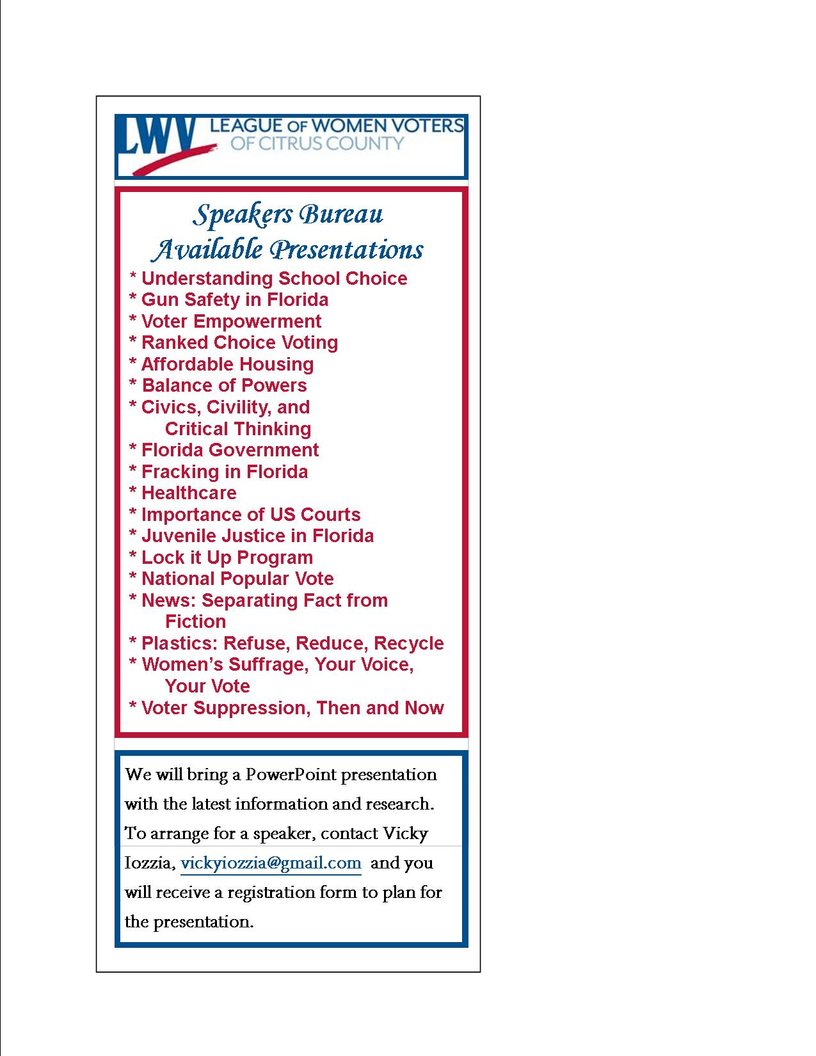

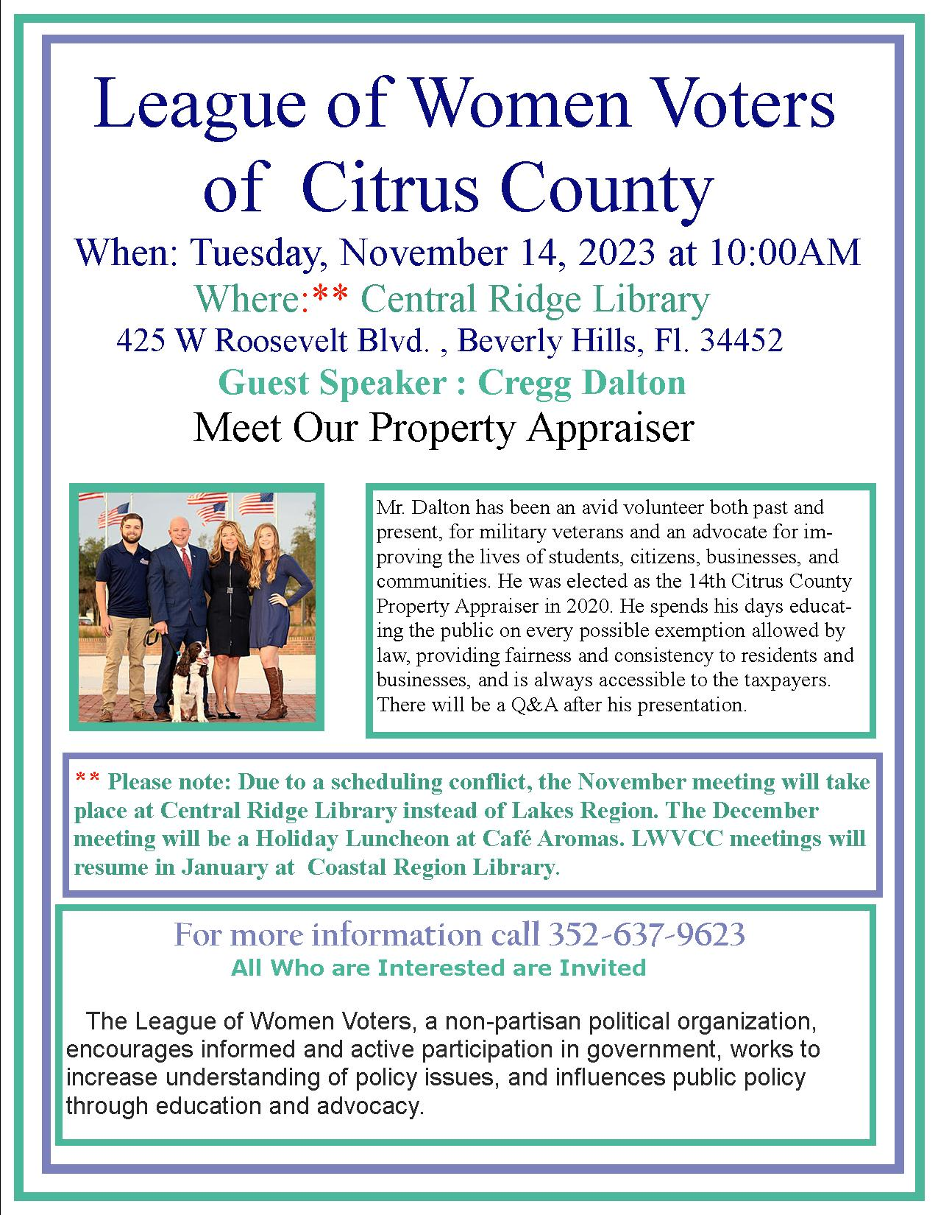
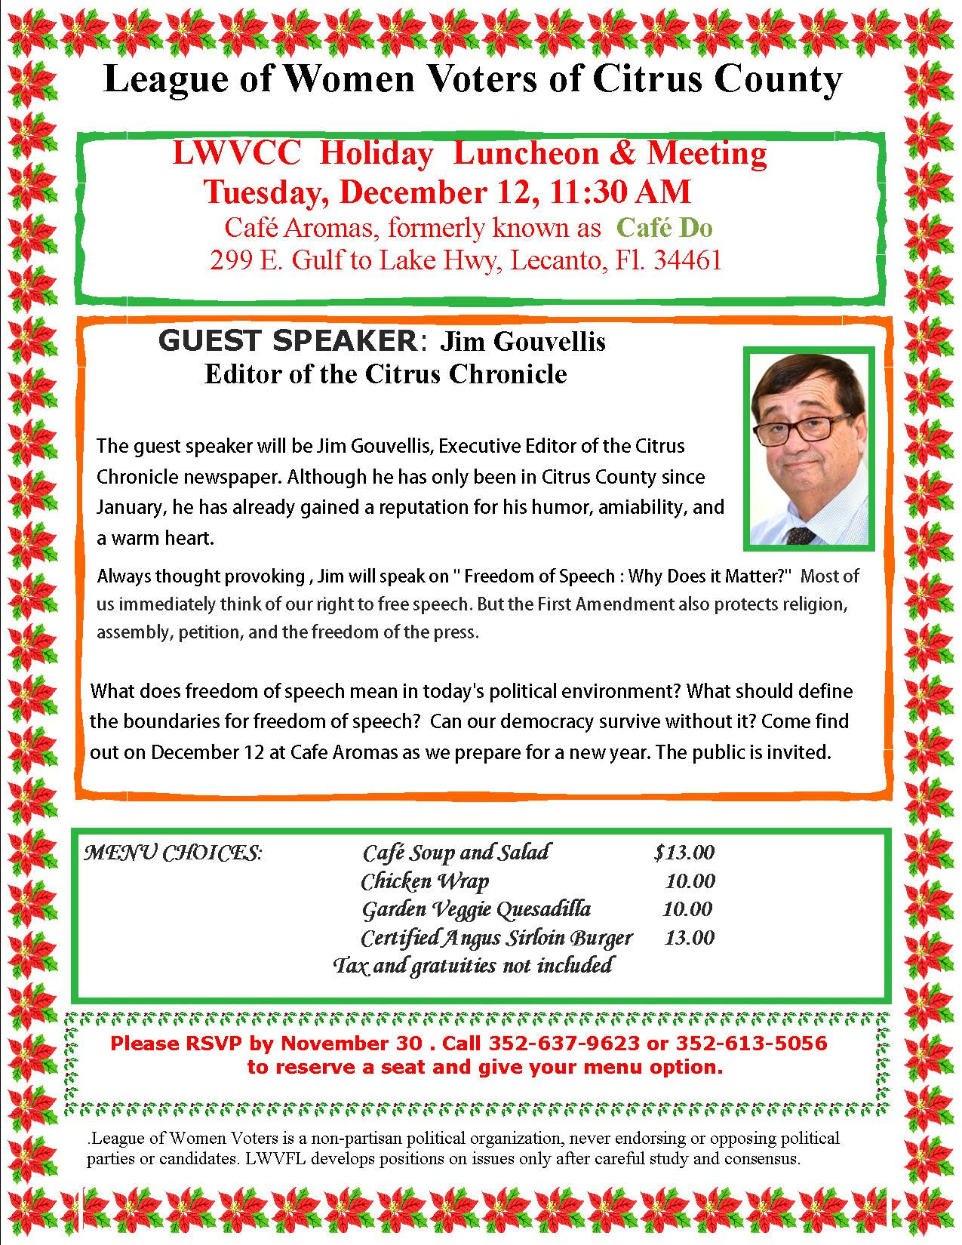

Here are the answers to Peg’s quiz. How many did you get correct?
KEY
- = F Vasectomy eliminates sperm from semen.
- = F Barrier methods prevent sperm from reaching eggs.
- = O Hormonal methods prevent ovulation, thus preventing fertilization.
- = F IUDs prevent sperm from reaching eggs (can also prevent ovulation).
- = O Plan B works only before ovulation, so hurry!
6.-12. All are TRUE.
About #6, don’t let anybody tell you otherwise.

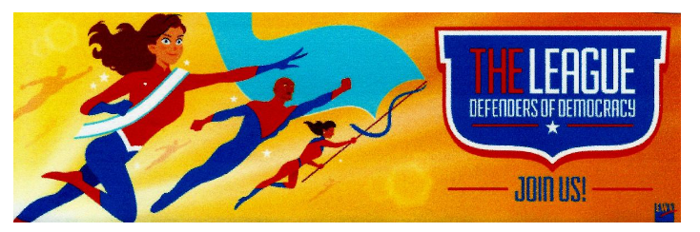

If you are interested in joining the
League of Women Voters of Citrus County,
Fill out the form below and mail it to us at
LWVCC, P. O. Box 1903, Lecanto, FL 34460

Name_______________________________
Address_____________________________
____________________________________
Email address_________________________
Phone (home)_________________________
Phone (cell)___________________________
Individual $65______
Household $90
Student Free
Susan B. Anthony $105*
Household $150*
*Includes $40 donation
Credit card name__________________________
Credit card number ________________________
Expiration Date, month and year______________

