LEAGUE OF WOMEN VOTERS OF
CITRUS COUNTY FLORIDA
NEWSLETTER, JANUARY, 2024
Vicky Iozzia is the Editor of this newsletter.
Our mailing address is LWVCC. P. O. Box 1903,
Lecanto, FL 34460
OUR NEXT MEETING IS
JANUARY 9, 2024 MEETING WILL FEATURE
DR. JILL LEWIS-SPECTOR TO TALK ABOUT EDUCATION AND BANNING BOOKS. SEE FLYER AT THE END OF THE NEWSLETTER

AT OUR FEBRUARY MEETING DR. LEVON BRACY WILL SPEAK ABOUT BLACK HISTORY AND HER EXPERIENCES WITH INTEGRATION. SHE WILL ALSO HAVE COPIES OF HER BOOK, “A BRAVE LITTLE COOKIE” AVAILABLE FOR SALE AND SIGNING.
Please visit our facebook page and "like" us!
https://www.facebook.com/leagueofwomenvotersofcitruscounty
WE MAY BE CHANGING THE DAY OF OUR GENERAL MEETINGS LATER ON THIS YEAR.
DETAILS IN THE FEBRUARY NEWSLETTER,
AS SOON AS EVERYTHING IS SECURED.

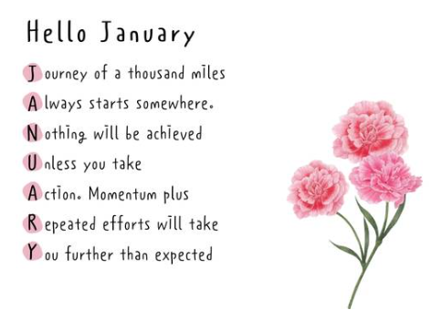
Here is a great New Years Resolution!
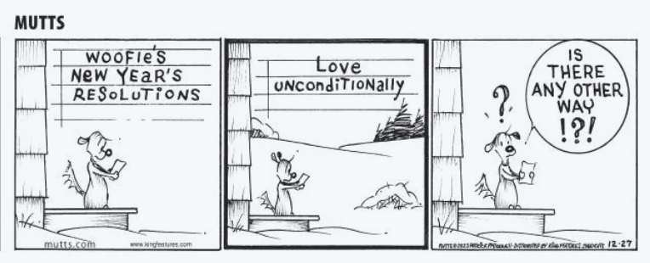

Contents:
Vicky Iozzia Page 4 to 5
Our December meeting – Jim Gouvellis Page 5 to 8
December meeting at Café Aromas Pages 9 and t0
Postcards, Peg Primeau, Sound Off, Bulletin Page 11 to 13
Linda Abels Page 14
Rosemary Nilles Pages 15
Citrus County Community Meetings Page 16
Jan Hall, From our League Archives Pages 17 to 20
Remembering Martin Luther King, Jr. Page 20
From Dr. BJ Ezell Page 21 to 23
Speakers Bureau Info Page 24
January meeting flyer, Dr. Jill Lewis-Spector Page 25
February meeting, Dr. LeVon Wright Bracy Page 26
LWVFL Accomplishments for 2023 Page 27 to 28
Membership Information Page 28 to 29

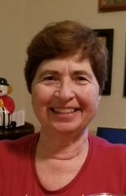
Vicky Iozzia, Co-President,
Speakers Bureau Chair, Newsletter Editor

This letter was published in the Citrus County Chronicle on December 15, 2023
I am tired of hearing how older people are useless and should be put out to pasture. Let’s look at older people who are proving that just because someone has many decades behind them, it doesn’t mean that they are not still vital, vibrant, and able to make a tremendous contribution to their fellow people.
Dolly Parton, age 77, made her first rock album, titled Rock Star, this year. It is number one on the Billboard country chart. (It is also the first time I can understand the words on many of the songs.) Her “Holly Dolly Christmas” was number one in 2020. Recently she performed in a Dallas Cowboy cheerleader uniform, looking great. Her Imagination Library has donated two hundred million books to almost three million children for free. Age has not hurt her.
Cher, no last name needed, also 77, made a Christmas album. It is number 1 on Billboard’s top holiday albums. She has sold more than one hundred million records. She also donated money and advocated for Operation Helmet to modify the insides of helmets to keep our soldiers safer.
Brenda Lee’s “Rockin’ around the Christmas tree” is the number one on the Billboard Hot 100 chart. She first sang that song when she was thirteen. She is now 79 years old.
Colonel Sanders started KFC at age 65. Laura Ingalls Wilder started writing at age 65. Estelle Getty attained success as Sophia in the Golden Girls at age 63. Grandma Moses painted until she was 78. Yuichiro Miura reached the top of Mount Everest at 80. Rosemary Smith was the oldest person to drive a Formula One car at 79. Harriette Thompson, a cancer survivor, completed her 15th marathon at 91 years old.
Yes, for some people, old age means pain and diminished capacity, but I am tired of younger people thinking that just because someone has many decades on this earth that they are impaired or useless. Age can give people wisdom that is useful for younger people. Some older people have talent, experience, and intelligence which is timeless.
I wrote to tell younger people your time will come when you take over the country. It must. I hope that you will do it with intelligence, open-mindedness, thoughtful reflection, and love. In the meantime please have respect for older people.

Our Tuesday, December 12, 2023 meeting
With Guest Speaker
Jim Gouvellis, Editor of the Citrus County Chronicle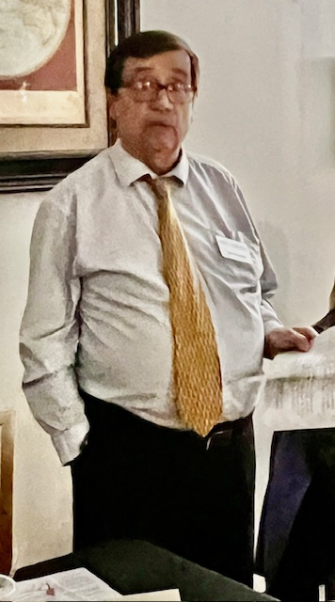
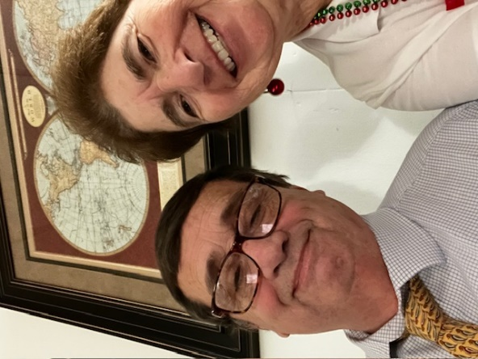
(I couldn’t resist a selfie with Jim. Vicky Iozzia, Editor)
If you did not attend this meeting, you cheated yourself out of the opportunity to meet Jim. We were not able to record his presentation. He began by saying that he is not a public speaker, and he wrote out what he wanted to say. At the end he gave me the text and said I could publish it here.
“The job of the newspaper is to comfort the afflicted and afflict the comfortable”
“While the United States has a proud tradition of upholding the right to freedom of speech and the press, it is crucial that we acknowledge and address the challenges faced by the press, particularly at the local level.
I remind you that our business is the only business mentioned by name in the Constitution. Obviously, our founders thought this freedom was essential to our democracy.
In the digital age, where information is abundant and instantaneous and not always truthful and accurate, the challenges to freedom of the press have become increasingly complex. Local journalism, in particular, grapples with many issues that can undermine its vital role in serving communities.
One significant challenge is the economic strain on local news organizations. As traditional revenue streams decline, many local newspapers struggle to sustain operations. This financial pressure can lead to staffing cuts, reduced coverage, and a diminished ability to hold those in power accountable. The public's right to know is jeopardized when local journalists are stretched thin or when investigative reporting takes a back seat to the more financially viable content.
The rise of misinformation and disinformation poses a serious threat to the integrity of journalism. Local news outlets, often with limited resources, may find it challenging to counteract false narratives and provide accurate information to their communities.
The erosion of trust in the media outlets can also have severe consequences for our democracy, as an informed citizenry is essential for a thriving society.
And when you are branded as the enemy of the people, it becomes even more difficult to garner the trust of the community. We are not anyone's enemy. Your local newspaper is the friend of the truth, we live and work here and really do care about what happens here.
But the branding of the press as the enemy by some of our national leaders has an impact right here in citrus county. Readers regularly complain that we are biased against Republicans. They regularly comment The Associated Press, one of the most middle of the road news services, is a leftist organization. A few months ago a reader told me that as the editor of a liberal, left-leaning newspaper, I was a boil in a certain part body part of America.
But the threats to freedom of speech and the press are more serious than just name calling. There are moves afoot to dilute libel laws, making it easier for politicians to sue news organizations for merely portraying them in a negative light, even when the published information is true. The aim of these proposals is to chill free speech.
Rights to freedom of speech can come in many forms. The recent retaliation against Disney for speaking out against a law that the company did not like is a good example of how a powerful government can seek to create a chilling effect when it comes to free speech. I am sure some less powerful companies will think twice before criticizing the government. Another attempt to create a chilling effect on free speech.
Local journalism plays a pivotal role in the shaping of the narrative of our communities. It sheds light on local issues, holds local public officials accountable, and provides a platform for community voices. Without robust local reporting, communities may lose touch with the challenges and triumphs that define their identity.
Many communities no longer have a credible local news outlet, leaving local governments to conduct their business with little to no scrutiny. Without local news outlets like ours, who will cover county and city government meetings? I would venture to say that government officials would conduct their business much differently if they knew the majority of its citizens didn't know what they were doing. We are fortunate that our community still has a local news source that provides that spotlight on local government.
In the face of these challenges, it is our collective responsibility to support and protect the institutions that safeguard our right to a free speech. By subscribing to local newspapers, engaging with local news outlets, and advocating for policies that support journalism, we can contribute to the resilience of our local media landscape.
We should commit ourselves to enduring that local journalism thrives. Our democracy depends on it, and our communities deserve the informed, vigilant, and dedicated reporting that only a free and robust press can provide.”
After this speech he proceeded to answer any and all questions. Among these were one of mine, asking now that the newspaper is not owned locally, does the company try to control content? He answered that they care about the number of papers sold and have not attempted to control content.
He said that the Editorial Board consists of nine members: t paid, 7 volunteers. They vote on topics and the consensus of the Board rules. He said they sometimes include letters by “knuckleheads.”
He also informed us that some newspapers don’t write editorials any more.
I was personally impressed with his presentation and glad to get to meet him. (VI)

Our December meeting was at Café Aromas. The service and food were very good! The meeting was well attended. Recognize any of these wonderful people?
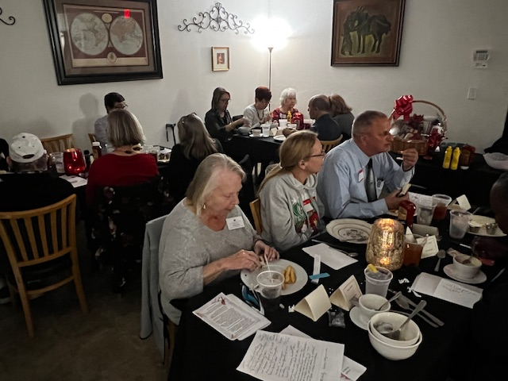

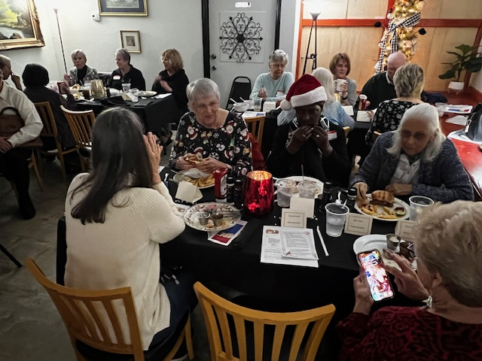

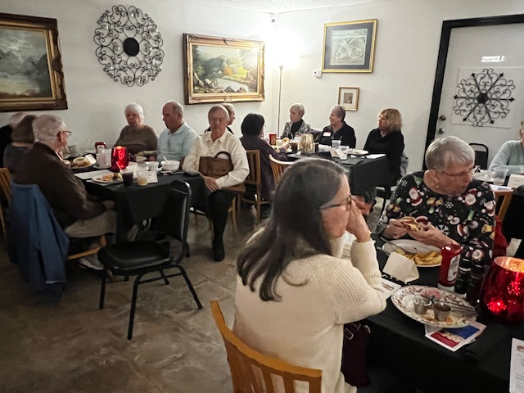
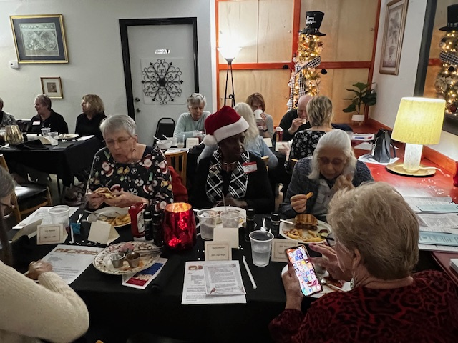

Did you know that our members are writing discreet postcards to people who have committed a non-violent felony and served their sentence, giving them information to get their voting rights back? Here are the members who have volunteered to do this: Beverly Brown did 200, Wanda Brown did 500, Mary Perry did 100, Jan Hall did 50, and Vicky Iozzia did 50.
If you would like to volunteer, it’s easy to do. You will get a list of people and stamps, and you address the post cards. Let Jan Hall know if you are interested in doing this. Her phone number is 352 637-9623.

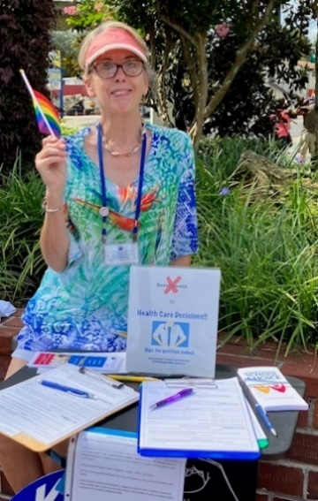
Peg Primeau, Secretary, Reproductive Health & Justice
(This letter was published in the Citrus County Chronicle on December 13, 2023.)
What do Clean Water, Marijuana, and Abortion Rights have in Common? Did you know that voters in Florida have a superpower? They can directly propose amendments to the Florida Constitution that will appear on the ballot for all voters to have a say. Only 15 other states allow this process. It’s called a direct citizen initiative.
Why would voters want to amend the Constitution? We might want to establish a more permanent right than a single statute would. We might want to address issues that legislators have avoided. We might want to change laws passed by the legislature that do not reflect the wishes of the constituents.
How does a proposal make it to the ballot in 2024? According to the office of the Florida Department of State Division of Elections: “In order to get a proposed amendment by initiative on the 2024 General Election ballot, a petition must be signed by 891,523 voters and the signatures must come from a number of electors in each of one half of the congressional districts of the state, and of the state as a whole, equal to eight percent of the votes cast in each of such districts respectively and in the state as a whole in the last preceding election in which presidential electors were chosen.”
Translation: To appear on the ballot requires validated petitions from at least 8% of 2020 Florida voters, to include 8% from at least 14 of our 28 Congressional Districts, all certified by February 1, 2024.
If your brain is not too full, more information on the petition process is on the state website at dos.fl.gov . On the “Initiatives” page you can read the full text of a proposed amendment, see the sponsoring organization, and track the petition validation numbers from county Supervisors of Elections. The Citrus SOE (votecitrus.gov) posts monthly reports on petitions as well. The amendments must also undergo financial-impact analysis and pass judicial review by the FL Supreme Court on clarity of language.
You may be aware of current petition-collection for amendments on the Right to Clean and Healthy Waters (validated petitions as of Dec. 7: 88,685), Adult Personal Use of Marijuana (1,033,769), and Limit Government Interference with Abortion (687,700). The Clean Water amendment—which gives legal leverage to citizens for enforcing existing laws—is unlikely to reach the threshold in time. The Marijuana amendment—which allows adult recreational use—has met numeric criteria. The Abortion amendment—which legalizes abortion up to viability—is likely to. Both amendments await judicial review.
These two initiatives have bipartisan support. According to the November poll from UNF’s Public Opinion Research Lab, 62% of voters (77% of Democrats, 53% of Republicans) would vote “yes” on the Abortion amendment, and 67% (78% of Democrats, 55% of Republicans) would vote “yes” on the Marijuana amendment.
Is a citizen initiative a lot of work and expense? Yes. The sponsoring organization is responsible for the costs of creating and printing the petitions, and for SOE costs for validating collected petitions. Campaigns rely on paid petition-gatherers as well as volunteers. The Marijuana amendment, for instance, is reported to have raised about $40 million.
Do you have to be a registered voter in Florida to sign a petition? Yes. (A petition can serve to “reactivate” your voter status if you haven’t voted lately— just check the box).
Does signing a petition commit you to a “yes” vote on the ballot? No, but that is the point of the initiative. Put it before the voters and let them decide.

How many votes will be needed to pass an amendment in 2024 and change the Florida Constitution? At least 60% of the votes cast.
To use your superpower, sign a petition now and, most importantly, VOTE in November, 2024.
This is a Sound Off piece from
December 24 praising Peg’s Article.
Go Peg!
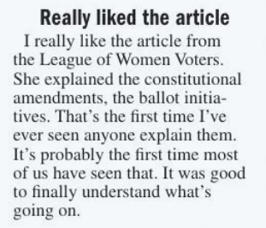
Bulletin from Peg Primeau: Today’s (December 29, 2023) reports indicate a total of 863,876 validated petitions, out of 891,523 required for the Amendment to Limit Government Interference with Abortion.
Also 13 of the necessary 14 Congressional Districts have exceeded their requirement. There is one more district within 31 petitions (!) of the goal. Counting will continue in January.
Judicial review is pending and due no later than April 1.
Yay Floridians Protecting Freedom!

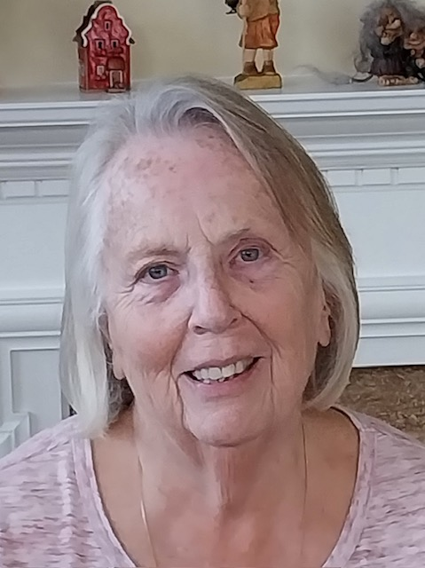

From Linda Abels, Membership Chair
Linda has a meticulous job, keeping track of all of our members and making sure that dues are paid.
Wouldn’t you like to make her job harder? You could give a membership gift to a friend. We are always looking for new members.

We also gratefully accept donations.

What’s Going On Here in Florida? By Rosemary Nilles

FYI
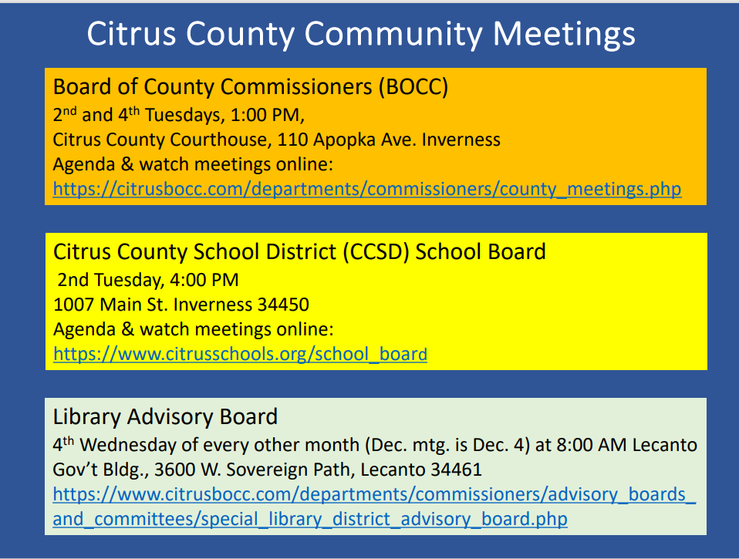

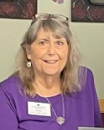
Jan Hall
“We stand on the shoulders of those who walked before us.”
Jan will be going through the archives of notes from our League and sharing them with us.
From 2014:

The LWV of Citrus County’s First Year

After an absence of twelve years, a new League of Women Voters of Citrus County (LWVCC) celebrated its first year with a luncheon, which will become an annual event. Fifty guests heard from the Florida League President, Deirdre Macnab, named one of Florida’s most outstanding citizens for the work she has done to promote the League’s mission.
As we reflect on the past year, we congratulate our enthusiastic and determined members who collected almost 1,100 local petitions for a Florida Land & Water Legacy amendment to be placed on this November ballot. Overall, the Florida League contributed over 25, 000 petitions to the required amount.
The League of Women Voters of Florida has endorsed this proposed Amendment that would protect hundreds of acres of land needed to ensure the State’s clean water supply and wildlife for generations to come without increasing taxes. If passed, 1/3 of the funds collected from the existing document stamp act will be used to purchase, restore or manage conservation and recreational land for ten years through the Florida Forever Program. A copy of the text for this ballot amendment can be found on our Facebook page.
Also a bill was introduced in Tallahassee to include many important protections for 38 Outstanding Florida Springs. This was the culmination of more than six months of collaborative work by the League of Women Voters of Florida, environmental groups and other stakeholders under the guidance and leadership of Senators Dean, Simmons, Simpson, Montford, and Hays. This bill calls for establishing the minimum flow and level for a spring, creates protections and specifies prohibited activities. Senator Dean’s stand and work on this issue is appreciated by the LWVCC. (Currently this bill is in the Florida House of Representatives for review and approval.)
The League is a nonpartisan organization that encourages informed and active participation in government, works to increase understanding of major public policy issues, and influences public policy through education and advocacy. We do not support or oppose any candidate or political party.
The League does take a stand on issues of concern to its members, after in depth study and by consensus of its members. We support state legislation for energy conservation and greater use of renewable sources such as solar energy. The League agrees with public policy that promotes conservation of fresh water.
As residents of Citrus County and concerned citizens of Florida we expect to continue to be involved in the environmental issues affecting us all. In addition we will explore other topics of local concern, selected by our members. Attend our meetings and let us know what interests you. You do not have to be a member to attend.
We are open to all men and women and meet regularly on the second Tuesday each month at the Central Ridge Library in Beverly Hills. Our meeting place changes occasionally.
For example, on May 14 the League will focus on the Rails to Trails, also called the Pathway to Paradise, and will meet at the Red caboose (Inverness Depot) on Apopka Avenue, for an optional walk or bike tour, followed by a presentation in the pavilion in the park.
Future articles will continue to focus on the issues affecting us all as citizens of this county, of this state and of this country. We will follow the ballot initiatives and voter issues in this especially important election year. With your help we can protect our right to vote, educate ourselves and others, and provide for facts to informed voters.

Contact us at lwvcc2013@gmail.com or like us on Facebook for details.
Contributed by the League of Women Voters of Citrus County

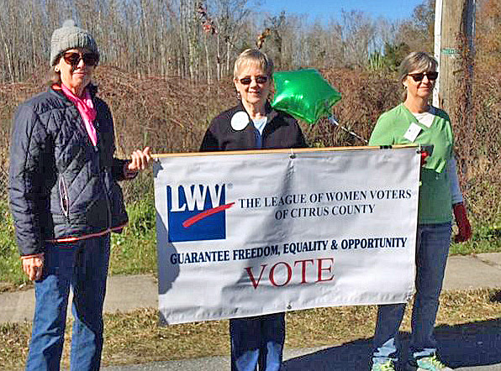
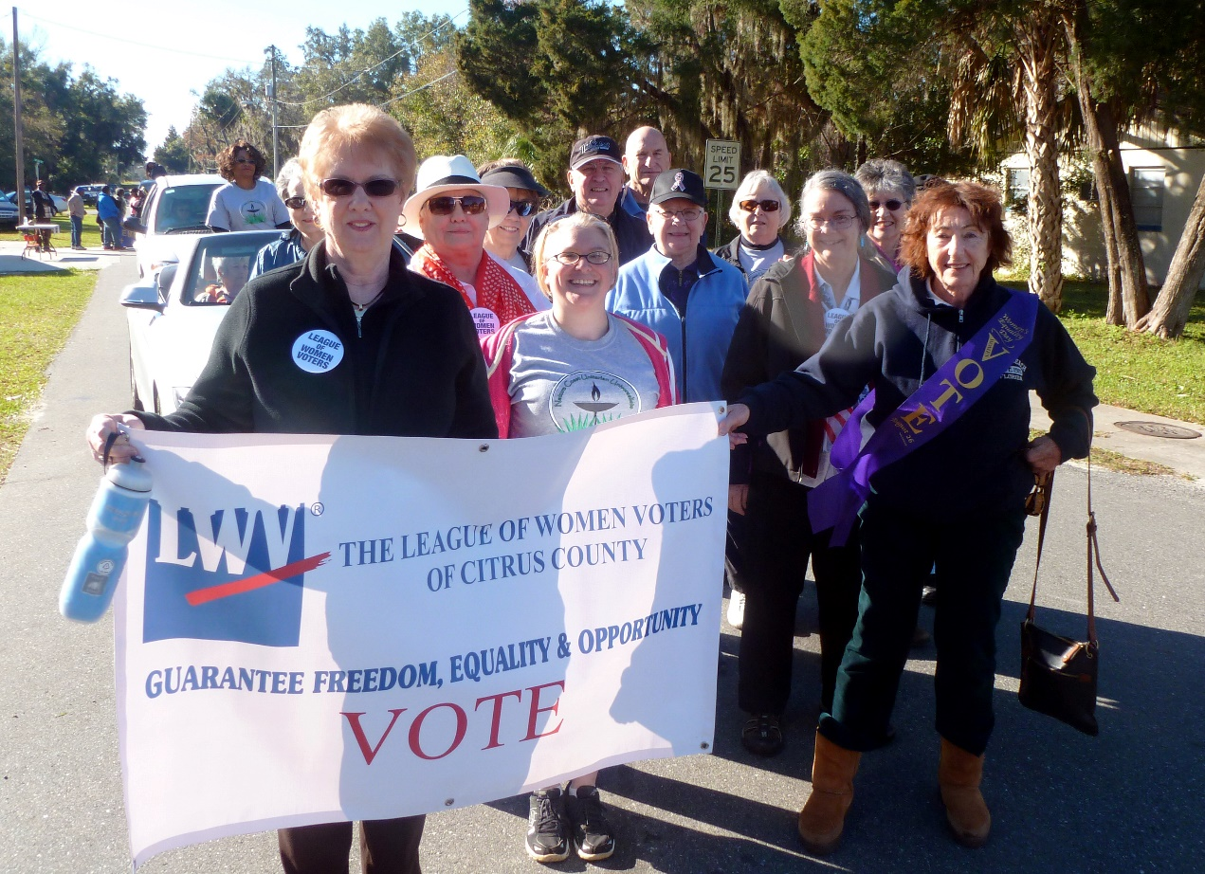
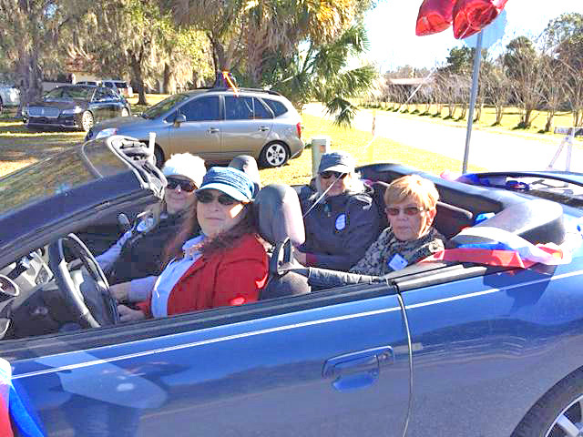
The photos above are from the 2015 Martin Luter King, Jr.
parade in Crystal River.
January 15 is Martin Luther King Jr. Day, a Federal Holiday to commemorate his life and legacy.

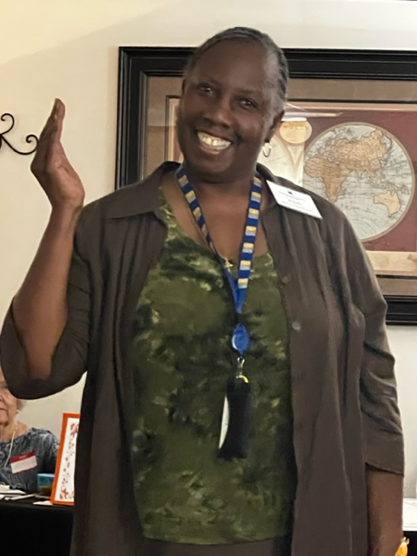
From Dr. BJ Ezell: 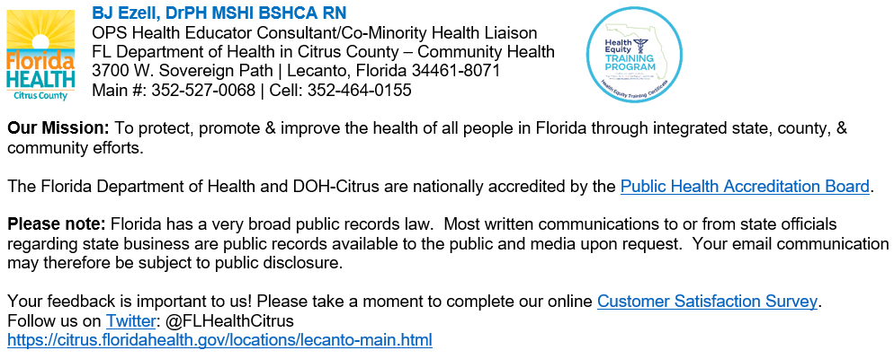
Dr Ezell has shared the following
Information regarding substance abuse:
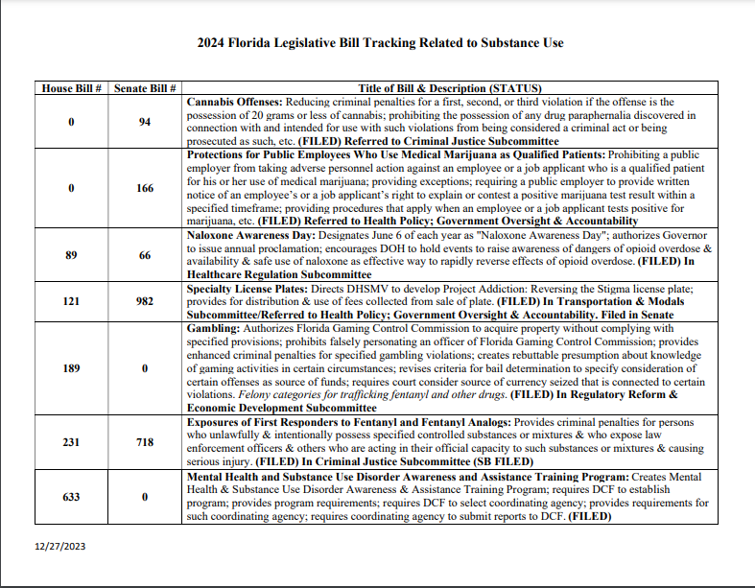

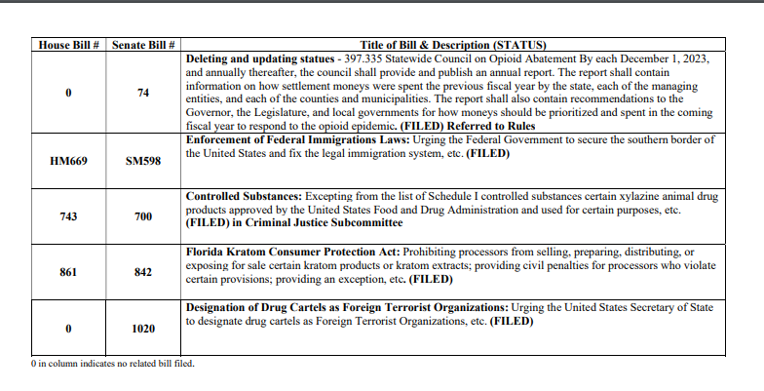

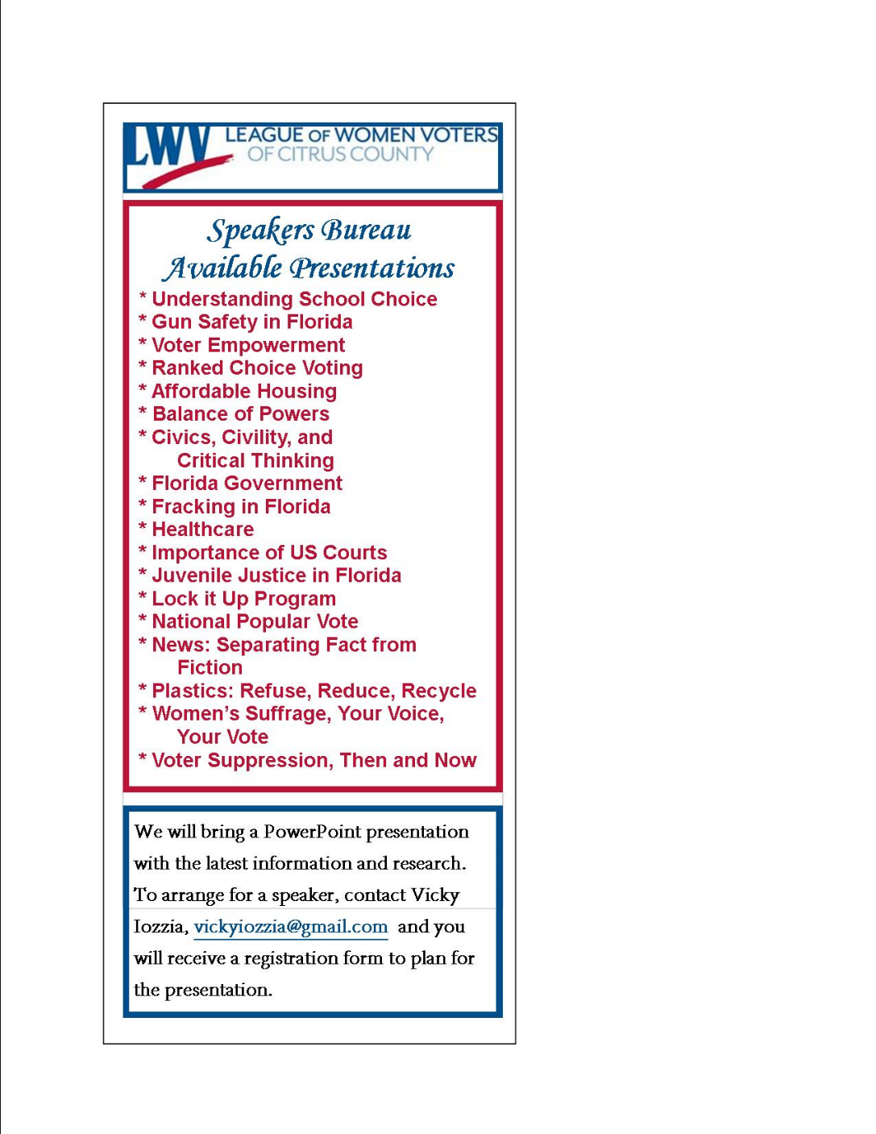

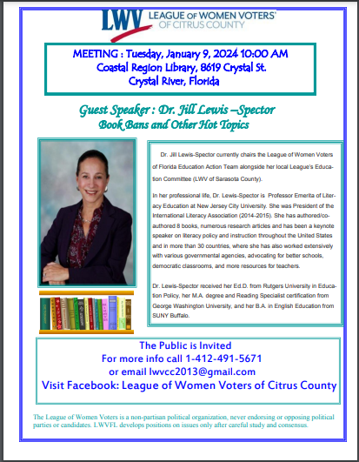

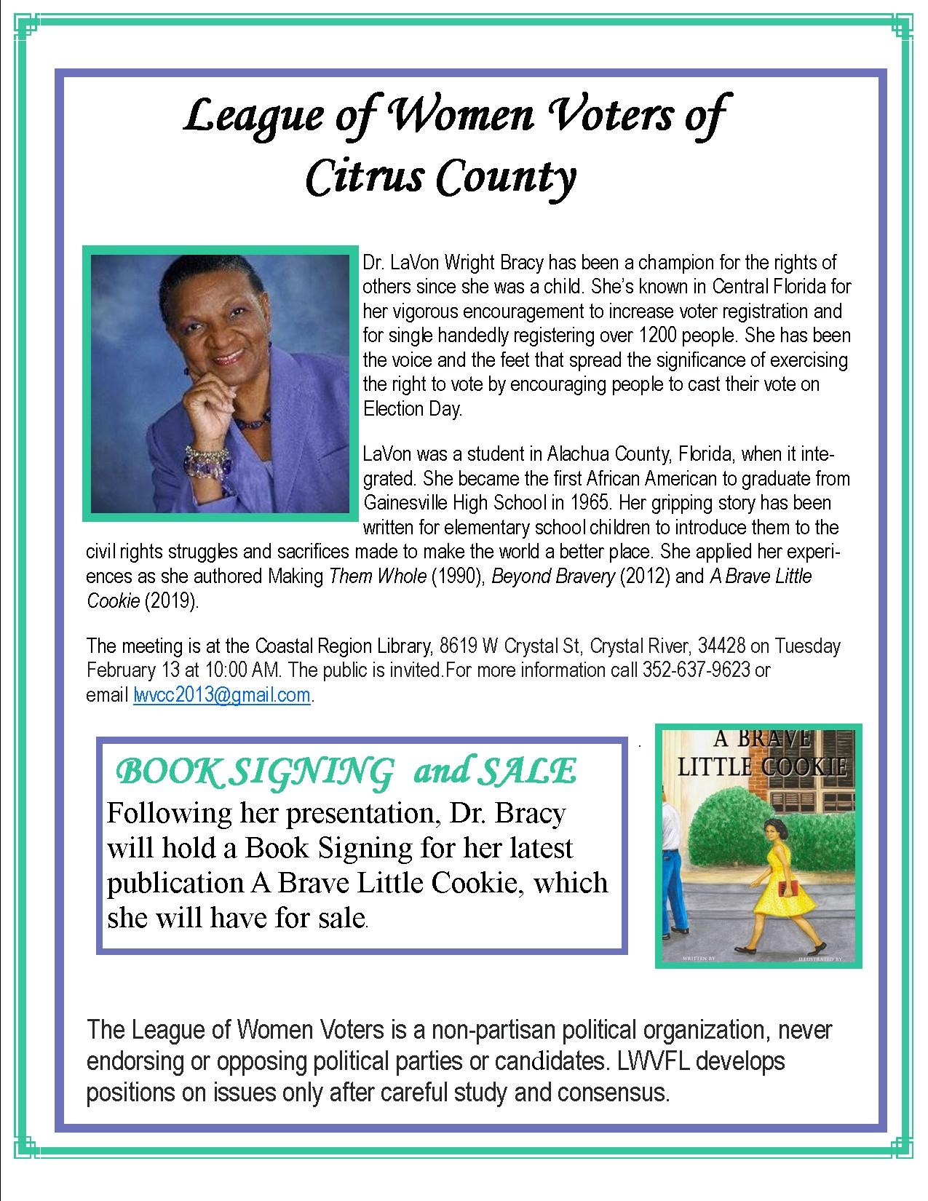
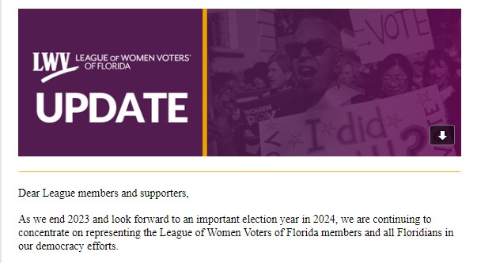
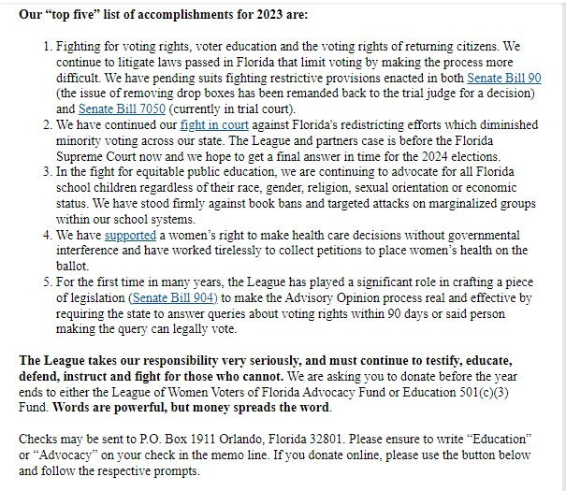
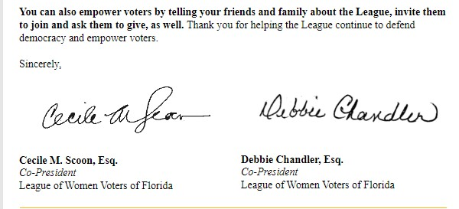

If you are interested in joining the
League of Women Voters of Citrus County,
Fill out the form below and mail it to us at
LWVCC, P. O. Box 1903, Lecanto, FL 34460

Name_______________________________
Address_____________________________
____________________________________
Email address_________________________
Phone (home)_________________________
Phone (cell)___________________________
Individual $65______
Household $90
Student Free
Susan B. Anthony $105*
Household $150*
*Includes $40 donation
Credit card name__________________________
Credit card number ________________________
Expiration Date, month and year______________

